**In Brief**

**Researching Your Ancestor in Education**

This guide has been developed to help you research the education of your ancestor from the early years through to further education and university, either as a pupil or teacher. The information presented here is designed to serve as a general introduction to this extensive topic.

Two useful databases for locating these records are [**Ancestry**](http://www.ancestry.co.uk) and [**Findmypast**](http://www.findmypast.co.uk). Both are available to use at Tameside Local Studies   
& Archives free of charge.

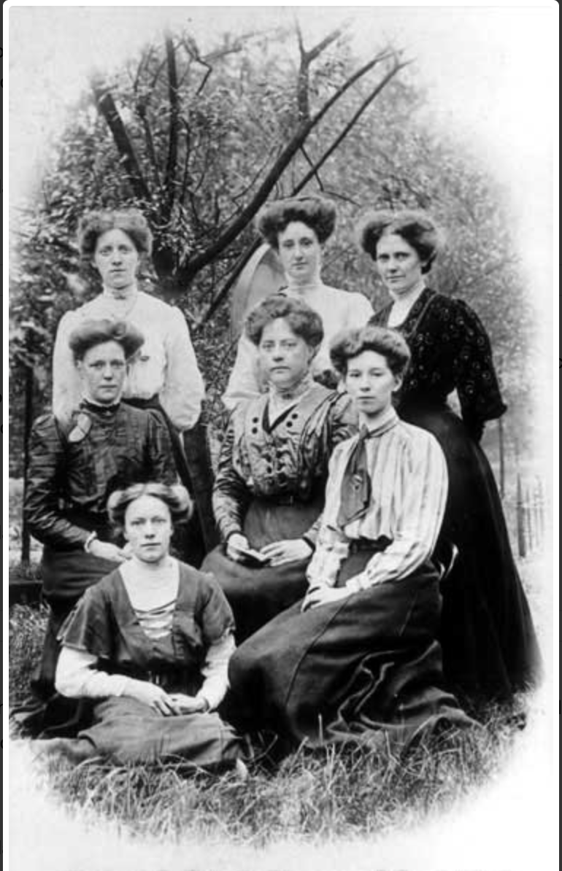

The staff of St Mary's School, Droylsden (c. 1907).

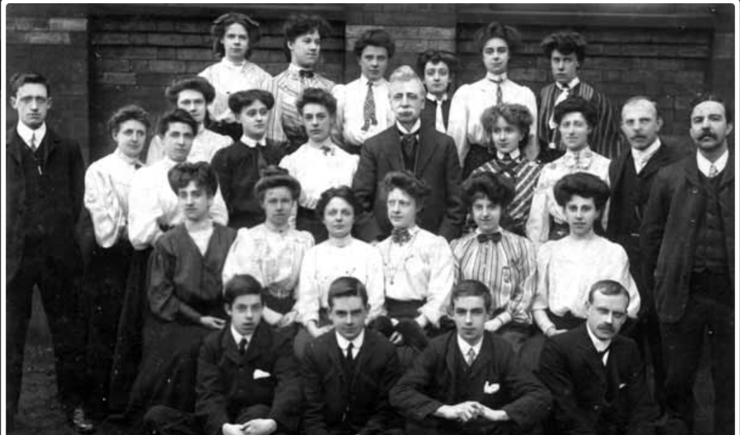

Albion School teachers, Ashton- under-Lyne. Abraham Park, headmaster (1874-1892), in centre of image.

**Nineteenth Century Education**

The history of universal education essentially began at the start of the nineteenth century with the introduction of National Schools by the Anglican Church and British Schools founded by the Quaker, Joseph Lancaster. As the century progressed more and more children began to benefit from education – even if this was only confined to the ‘three Rs’ (reading, writing and arithmetic) – as the state increasingly focused on funding educational institutions throughout the country. Charities and philanthropists also added something to the mix with the formation of ragged schools for the poor from 1818 onwards, inspired by shoemaker John Pounds’s free instruction of working-class children. In the same period further education was promoted with the expansion of vocational instruction, such as the formation of Mechanics’ Institutes. It was not until 1889 with the Technical Instruction Act, however, that the state involved itself in this area of education. This was further formalised by the 1944 Education Act which led to the establishment of Colleges of Further Education. The expansion of universities in the Victorian period also continued throughout the twentieth century.

For women, barriers to education remained in place throughout the nineteenth century and beyond. Prior to the ratification of the Education Act in 1870 which mandated a basic education for male and female pupils, middle and upper class girls received limited instruction in line with their supposed future prospects of marriage and housewifery. Women were also restricted from a tertiary level of education, as Oxford and Cambridge continued to refuse entry to female students well into the twentieth century. Other institutions were slow to open up their ranks to women, until the University of London in 1878 finally accepted female students on the same terms as men. Whilst female teachers were sanctioned in the school environment, they were forced to remain unmarried and received a much lower salary than their male counterparts.

**Note:** Because of data protection legislation, school admission registers are usually subject to restricted access.

95 years: Primary Schools

90 Years: Secondary Schools

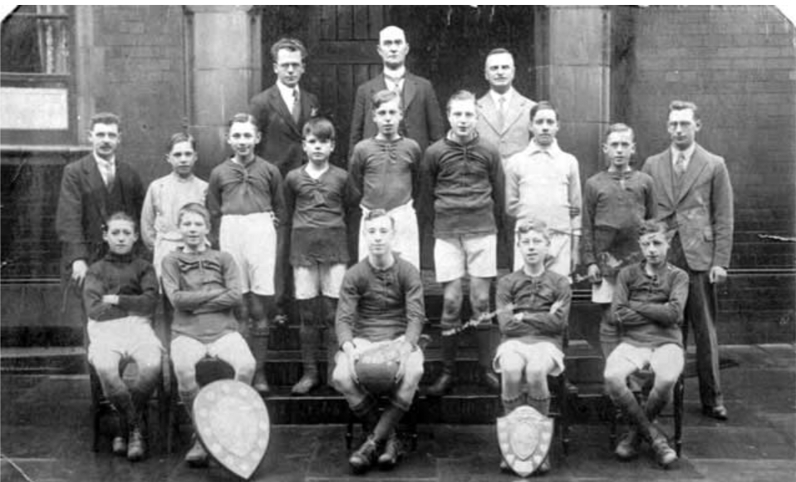

Leigh Street School (Hyde) Football Team (c1928)

[**Church of England Record Centre**](https://www.churchofengland.org/about/libraries-and-archives): This centre holds the existing records of the National Schools from 1811. No advance booking is required, but archives must be ordered at least 48 hours in advance. Email: [archives@churchofengland.org](mailto:archives@churchofengland.org). Search the [Church of England Catalogue](https://archives.lambethpalacelibrary.org.uk/calmview/) for details of the collection.

[**British and Foreign School Society**](https://bfss.org.uk/about-us/archive/)(BFSS): This society’s archives are a significant resource for research into nineteenth-century education. They are situated at the Old School House, 1 Hillingdon Hill, Uxbridge, UB10 0AA, as part of Brunel University Archives. Access is by appointment only and a research service is available. Email the archivist at [bfss.archives@brunel.ac.uk](mailto:bfss.archives@brunel.ac.uk) or phone 01895 267095.

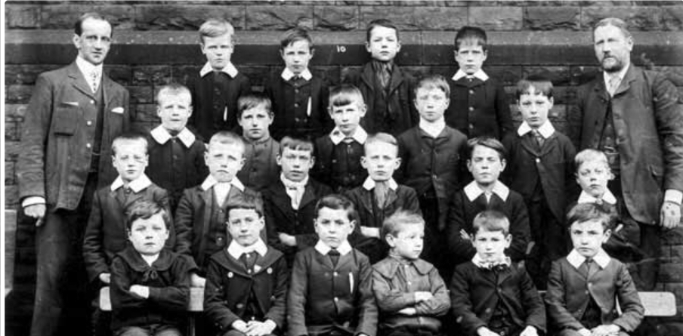

Hurst British School, (1905) Headmaster: Mr Cairns

[**Archives+**](http://www.archivesplus.org/):This service maintains archives for many of the Manchester Schools, including nineteenth century institutions such as the ragged schools that have now closed. For details on their holdings, consult the [Manchester Schools Source Guide](https://www.manchester.gov.uk/downloads/download/3949/collections_guides). Archives must be booked at least 24 hours prior to a visit at [Booking Archives in Advance](https://secure.manchester.gov.uk/info/448/archives_and_local_history/7378/access_our_archives_rare_books_and_collections/2).

[**1871 Education Census**](https://www.nationalarchives.gov.uk/help-with-your-research/research-guides/elementary-primary-schools/)**:** This census was a formal assessment of school places available throughout the UK. This data was required as the 1870 Elementary Education Act established a national system of elementary schools for all children. The information provided included population details, school accommodation, general correspondence, school expansions and closures and, sometimes, examination timetables with names and assessments of pupils. The register is held at the [National Archives](https://discovery.nationalarchives.gov.uk/browse/r/r/C6801?uri=C6801). Booking in advance of a visit is required.

[**National School Admission Registers and Log Books, 1870 -1914**](https://search.findmypast.co.uk/search-world-Records/national-school-admission-registers-and-log-books-1870-1914) **(Findmypast):** Included in this collection are over 7 million records from both English and Welsh counties. The transcript may include pupil name, date of birth, name of school, town and often the names of the parents. There is an accompanying list for those schools in the archive.

[**England, Cheshire School Records, 1782-1950**](https://search.findmypast.co.uk/search-world-Records/national-school-admission-registers-and-log-books-1870-1914) **(Family Search)**:These records provide a basic transcript for individual pupils. The information varies, but should give pupil name, father’s name, address, name of the school and date of attendance.

[**Britain, School and University Register Books (Findmypast)**](https://search.findmypast.co.uk/search-world-Records/britain-school-and-university-register-books)**:** These digitised records offer a wealth of information about former pupils and students. The collection provides biographical information and sometimes a school history. School magazines are also included.

[**Liverpool Schools**](http://www.liverpool-schools.co.uk/index.html)**:** This is a comprehensive site on the history of Liverpool schools. There is also a very useful section on early teacher training colleges. Included are links to Gore’s Liverpool Directories and transcriptions of some early college records (1899-1902) listing student name, father, occupation and address.

For queries email [info@liverpool-schools.co.uk](mailto:info@liverpool-schools.co.uk).

[**Children's Homes**](http://www.childrenshomes.org.uk/IS/)**:** This is an interesting site providing a historical background on various types of schools, such as Industrial Schools (includes Manchester), Charity, Approved and others. Information on where to access these archives is also provided.

**Girls’ Public Day School Trust:** The records of the Girls’ Public Day School Trust, founded in 1872, can be consulted at the [University College Newsam Library](https://libguides.ioe.ac.uk/c.php?g=482256). Booking is required prior to a visit, but the catalogue is online. Contact the archivist for more information and enquiries at [ioe.arch-enquiries@ucl.ac.uk](mailto:ioe.arch-enquiries@ucl.ac.uk).

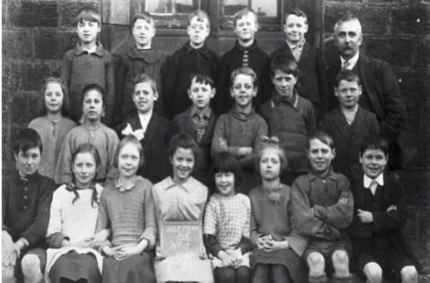

Mottram School Pupils: Longendale (1922)

[**Tameside Local Studies and Archives Centre**](https://localstudies.tameside.gov.uk/calmview/)**:** The centre holds a variety of school records including log books, school magazines and photographs. The catalogue is available to search online at [Tameside Archives Catalogue](https://localstudies.tameside.gov.uk/calmview/). For enquiries please contact the archivist at [archives@tameside.gov.uk](mailto:archives@tameside.gov.uk).

[**Tameside Image Archive**](https://public.tameside.gov.uk/imagearchive/)**:** This collection of local, searchable images – including schools – can add substance to a research project. Other archives services will have similar collections for their area.

[**Cheshire Local Studies and Archives**](https://www.cheshirearchives.org.uk/what-we-hold/schools.aspx)**:** An extensive collection of school records can be found here including school logbooks and school administration records. Check the catalogue [online](http://catalogue.cheshirearchives.org.uk/calmview/) and follow the instructions listed [here](https://www.cheshirearchives.org.uk/how-we-can-help/researching-our-records.aspx) to arrange a visit to view. A research fee may be required.

[**Lancashire Archives**](https://archivecat.lancashire.gov.uk/CalmView/default.aspx)**:** The centre holds a large collection of school material. Search the catalogue [online](https://archivecat.lancashire.gov.uk/CalmView/default.aspx) for details. For enquiries please see [Research and Enquiry](https://www.lancashire.gov.uk/libraries-and-archives/archives-and-record-office/enquiries-and-research/). Booking archives in advance of your visit is essential.

[**Teachers' Registration Council Registers 1914-1918**](https://search.findmypast.co.uk/search-world-Records/teachers-registration-council-registers-1914-1948) **(Findmypast):** These registers were started in 1902 as a direct consequence of the 1899 Education Act. The records cover over 100,000 individuals who taught between 1870 and 1948 when registration ended. The information includes the date of registration, training details and the school.

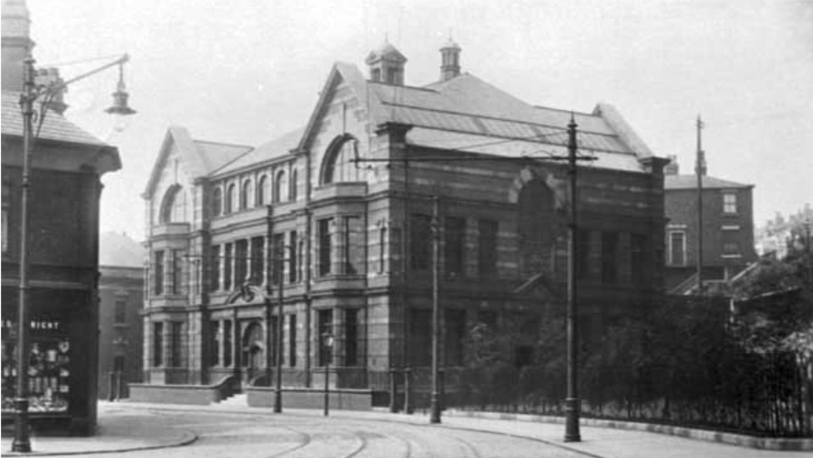[**University of London Students, 1836-1939**](https://london.ac.uk/senate-house-library/our-collections/special-collections/archives-manuscripts/university-london-students-1836-1939)**:** Digitised copies of lists of students and graduates are available for research purposes. Personal records are not included, however. Many on the lists are so-called ‘external students,’ registered at other institutions across Britain and attending the University of London for examination purposes. Contact [shl.specialcollections@london.ac.uk](mailto:shl.specialcollections@london.ac.uk). For details of students who attended the university after 1939, email the University Transcript Office at [transcripts@london.ac.uk](mailto:transcripts@london.ac.uk). There are some limitations due to data protection. Details of students who left less than 85 years ago will only be provided if the researcher has the student’s permission or the student has died.

Stalybridge Technical School, opened December 28th, 1910

[**British Newspaper Archive**](http://www.britishnewspaperarchive.co.uk/)**:** This database contains a wide range of local and [national newspapers](https://www.britishnewspaperarchive.co.uk/), many of which hold details of schools and universities, staff appointments and examination results. Access is through pay-per-view or subscription. Alternatively, a search can be carried out through [Findmypast](https://search.findmypast.co.uk/search/us-and-world-newspapers). Tameside Local Studies & Archives Centre holds local newspapers on microfilm from 1859.

[**UK, City and County Directories 1600s - 1900s**](https://www.ancestry.co.uk/search/collections/1547/) **(Ancestry):** Directories can be a useful source of information for tracing the history of a school and for researching the community.

[**National Library of Scotland Town Plans**](https://maps.nls.uk/towns/)**:** Consult the town plans of England for a look at school and university buildings (OS maps 1840s-1890s). OS English County maps from the 1580s to 1950s are also available to look at online at [County Maps](https://maps.nls.uk/counties/).

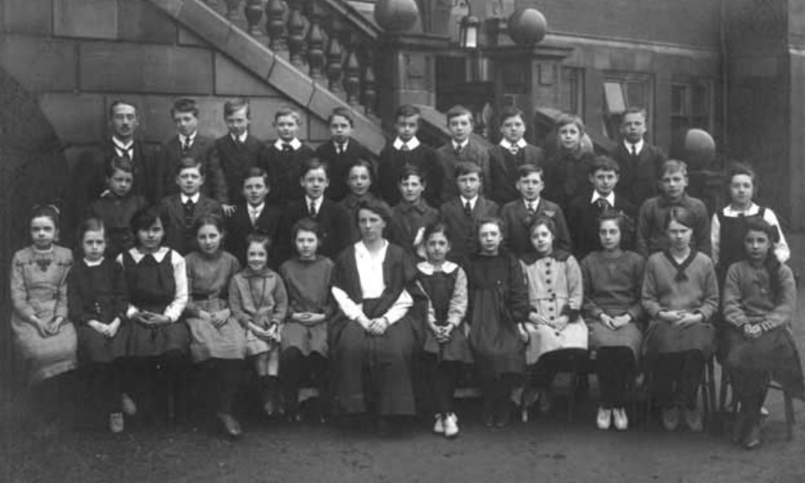

Hyde Grammar School pupils, c1920

**Census:** Since 1841 the census or population count has been taken every ten years for England and Wales (except for 1941). Accessible records date from 1841-1921 as the 100-year closure rule applies. Census entries except 1921(only on [Findmypast](https://www.findmypast.co.uk/1921-census)), are available on both [Ancestry](https://www.ancestry.co.uk/search/categories/ukicen/) and [Findmypast](https://search.findmypast.co.uk/search-united-kingdom-records-in-census-land-and-surveys), providing details of everyone in a particular household on ‘census night’, always a Sunday. [Findmypast](https://www.findmypast.co.uk/search-address) offers an address search facility. Census returns commonly show the occupations of the individuals listed.

[**Records of Students in the Archive of the University of Liverpool**](https://libguides.liverpool.ac.uk/library/sca/universityarchive)**:** Approaching individual universities is another avenue to pursue. There are a variety of records in this archive including graduation data, postgraduate papers and student publications. Try a name search of the database. All records may be subject to data restrictions. For more information contact via email [scastaff@liverpool.ac.uk](mailto:scastaff@liverpool.ac.uk). [Liverpool University Press Cuttings, 1875-2000](https://sca-archives.liverpool.ac.uk/Record/120723/Description#tabnav) may include the names of individual students, their work, publicity and obituaries.

[**Manchester Grammar School First World War Archives**](http://www.worldwar1schoolarchives.org/manchester-grammar-school/): Try approaching an individual school for historical pupil information. These archives consist of digitised school magazines (1914-20) covering the war period and are a fascinating repository of information about the educational record of individual pupils. The school also holds an extensive archive collection which may be helpful for research purposes (<https://www.mgs.org/2011/the-mgs-archives>).

**Next Steps**

**1.** Why not visit the University of Leeds Special Collections to look at the College of Preceptor Papers? This body was formed by a group of Brighton schoolteachers to promote professional standards in the educational field. Granted a Royal Charter in 1849, it became the College of Teachers in 1998. The archive includes minutes and other material such as policy papers (1847-1985). To visit email [specialcollections@library.leeds.ac.uk](mailto:specialcollections@library.leeds.ac.uk).

**2.** Take a trip to the British Schools Museum at Hitchin. With Victorian lessons in an original classroom dating from 1810, there is a lot to discover about early education.

**3.** Carry out some research at the [Institute of London (IOE), University College, London](https://www.ucl.ac.uk/library/using-library/libraries-and-study-spaces/ioe-library) where archive material from 1797 is held. It is a useful collection to explore the history of education and may shed some light on the life of your ancestor.

**4.** Have a look at the [**University of Leeds Special Collections Archive**](https://library.leeds.ac.uk/special-collections/subject-theme/631)**, a** fascinating repository of past teaching methods, educational philosophy and history. You can also learn more about the development of the university with its student and academic life.

**Further Reading**

McGarry, A. (2014) *The Girls Who Walked Away.*  Kibworth Beauchamp, Matador.

Stanhope-Brown, James (1991) *Angels from the Meadow*. Woodford, Pothecary

Kelly, Thomas. (1992) *A History of Adult Education in Great Britain*. Liverpool, Liverpool University Press

.



Albion School teachers, Ashton-under-Lyne. Abraham Park, headmaster (1874-1892) in centre of image.