In Brief
Researching a World War One Soldier
This guide has been developed to help you research the service of a World War One soldier.
Two useful databases for locating a soldier’s records are Ancestry and Findmypast. Both are available to use at Tameside Local Studies
& Archives free of charge.
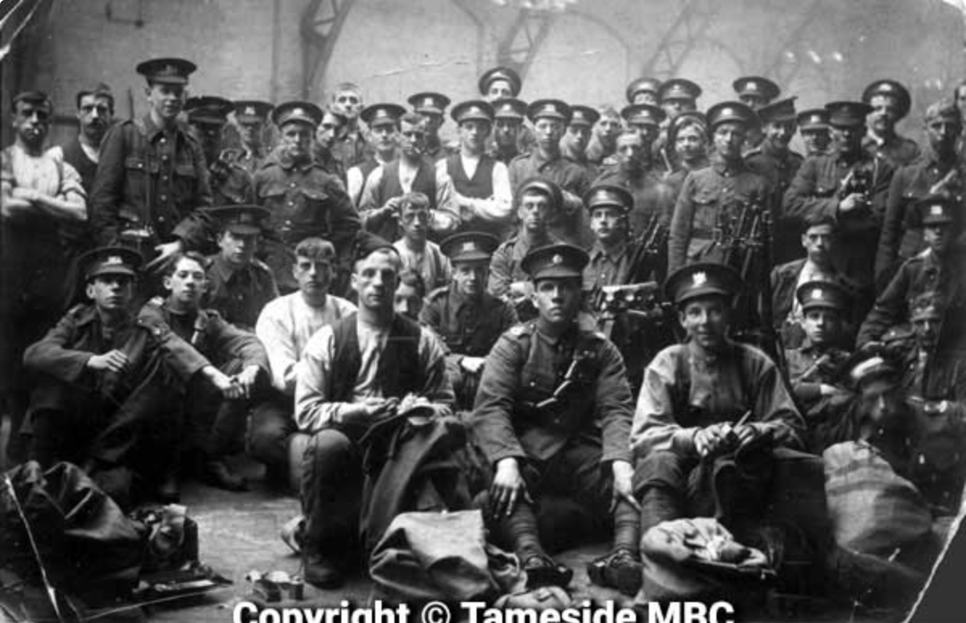
9th Manchester Regiment, Stalybridge (c. 1914).

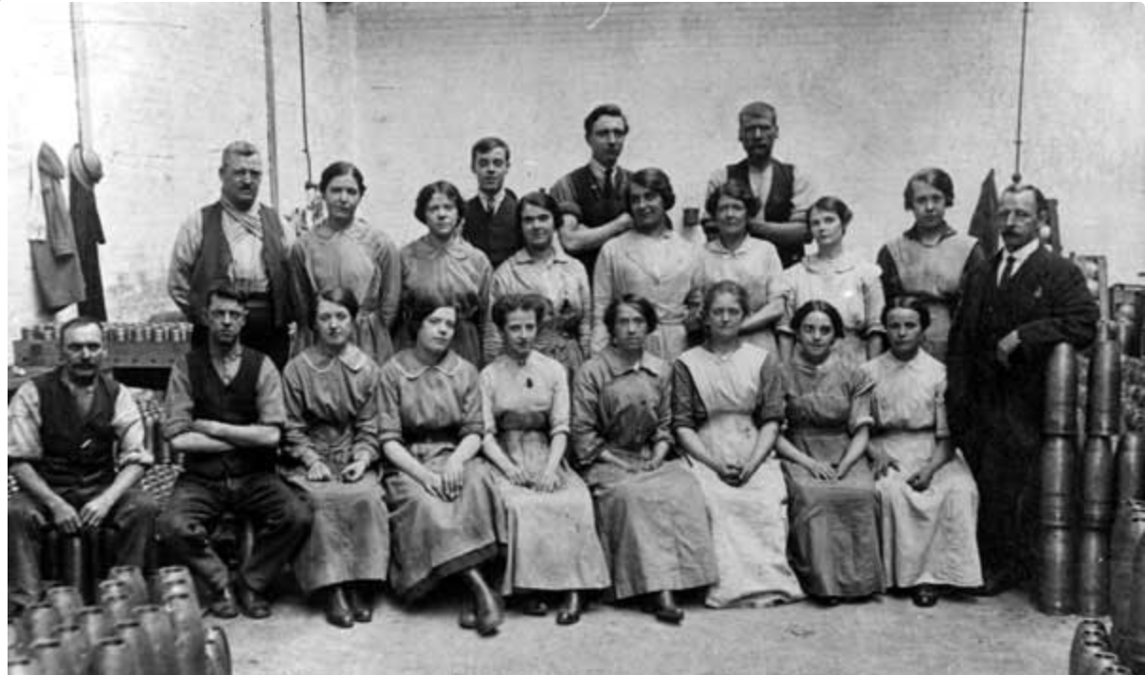
Workers at Armstrong Whitworth Munitions Factory, Openshaw (c. 1914).

Service Records: These are the official army records for an individual soldier. Unfortunately, 60% were destroyed in a bombing raid in World War Two – those that survive are known as the ‘burnt records.’ They include name, address, physical characteristics and army service. These records have been digitised and can be viewed on Ancestry and Findmypast.

Medal Rolls Index Cards, 1914-1920: These cards were compiled by the Army Medals Office during World War One. The information provided covers name, rank, regiment and sometimes battalion, in addition to the solder’s medal entitlement. Additional data may state whether the soldier served overseas and in what ‘Theatre of War.’ Gallantry awards are sometimes included such as the DCM (Distinguished Conduct Medal). The page number in the Medal Rolls is also provided. These can be viewed on Ancestry and Findmypast.

Campaign Medal Rolls: These show which medals were actually issued to each soldier and can be found under UK WW1 Service Medal and Award Rolls, 1914-1920 on Ancestry. The register may contain name, rank, regiment and medals awarded.

Silver War Badge Roll, 1914-1920: In September 1916 this badge was issued to those who had served in the UK and overseas and had been discharged through wounds and/or illness. It was designed to be worn with civilian clothes and each badge had a unique number. The rolls have been digitised and can be viewed on Ancestry, Findmypast and the National Archives. The information includes name, age, birthplace, occupation, marital status and regiment.

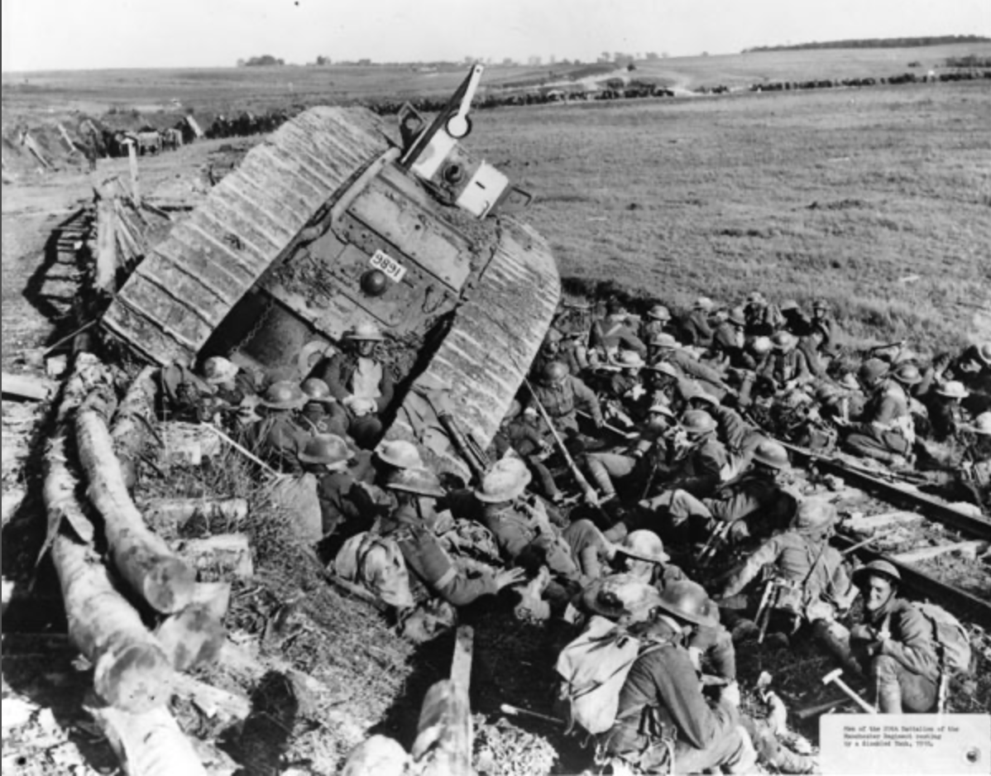
Soldiers from the 20th Battalion Manchester Regiment rest by a disabled tank (c. 1918).

Commonwealth War Graves: All First World War casualties are recorded by the Commonwealth War Graves Commission. Search by name, service number, regiment and cemetery /memorial.
Casualty Lists: The National Library of Scotland has digitised the weekly casualty lists between 1914 and 1918 (also available on Findmypast). These lists show whether a soldier is missing, wounded, a prisoner of war or killed in action.
British Armed Forces, First World War Soldiers’ Medical Records: These records have been digitised by Findmypast and give details of the injury and where the soldier was treated.
British Armed Forces and Overseas Deaths and Burials Index, 1796-2005: This register, archived on Findmypast, records birth and death dates, location and country.
Find a Soldier’s Will: The database covers the period 1850 – 1986. To access a copy of the will the charge is £10.
UK, Army Register of Soldiers’ Effects, 1901-1929: These records are held at the National Army Museum London, but can be viewed on Ancestry. They state how much money was owed to a soldier who died in service and who would receive this. The information includes name, rank, number, regiment and next of kin.

British Army World War 1 Pension Records, 1914-1920: These are pension records of non-commissioned officers and other ranks who were discharged from the army due to a disability received whilst in service. They are available to view on Ancestry.

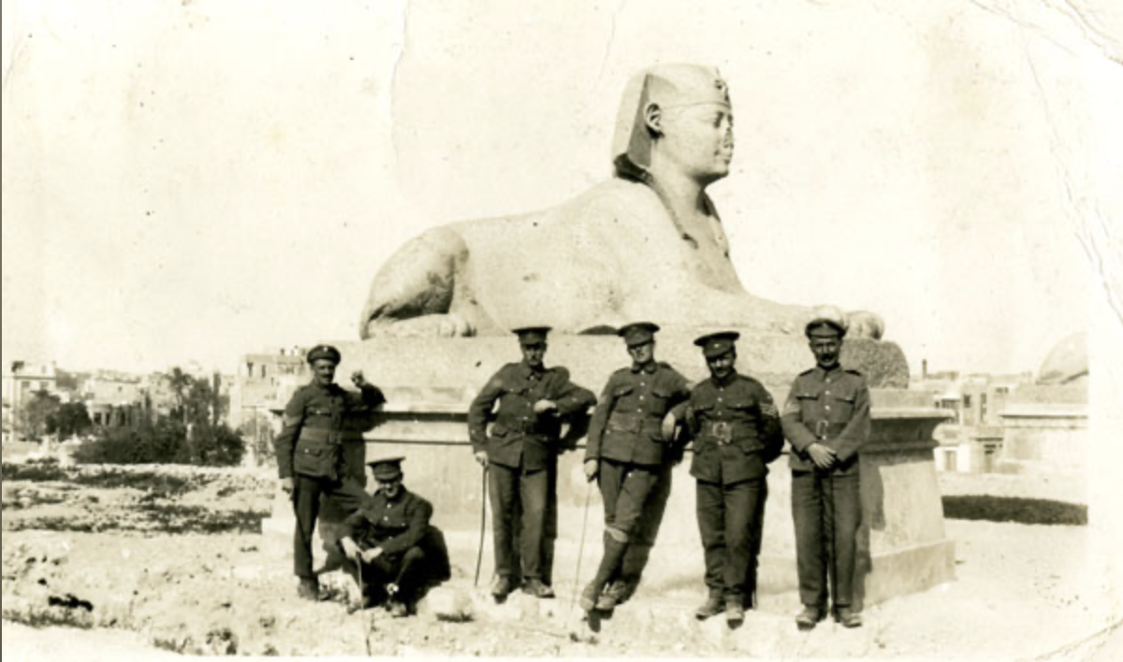
Officers from the 7th Battalion Manchester Regiment posing in front of the Sphinx at Alexandria (c. 1915).

British Armed Forces, First World War Widows’ Pension Forms: The original forms are held at the National Archives. They can be viewed on Findmypast in the form of an image and transcript. The information recorded here encompasses name, service number, regiment, service, cause of death, marriage details and any children.

The Gazette: This journal, founded in 1665, combines the London, Belfast and Edinburgh official journals of record. Search online for information on despatches, officer appointments and promotions, medal awards and citations.
UK, Citations of the Distinguished Conduct Medal, 1914-1920: This medal is awarded for exceptional bravery to non-commissioned officers and other ranks. The database of over 25,000 citations can be viewed on Ancestry and searched by name, regiment, corps or unit. The register covers soldiers who served throughout the British Empire.

British Army Lists: These army officer records can be viewed online on Findmypast (British Army, Army Lists, 1839-1946). Details include name, service, promotion, salary and a short military biography. The lists (1913-1918) can also be downloaded as a PDF from the National Library of Scotland.

British Army, Bond of Sacrifice: Officers Died in the Great War 1914-1916: This set of books has been digitised on Findmypast and includes the names of officers who died between 1914 and 1916. There is a photograph of each officer together with a short biography.

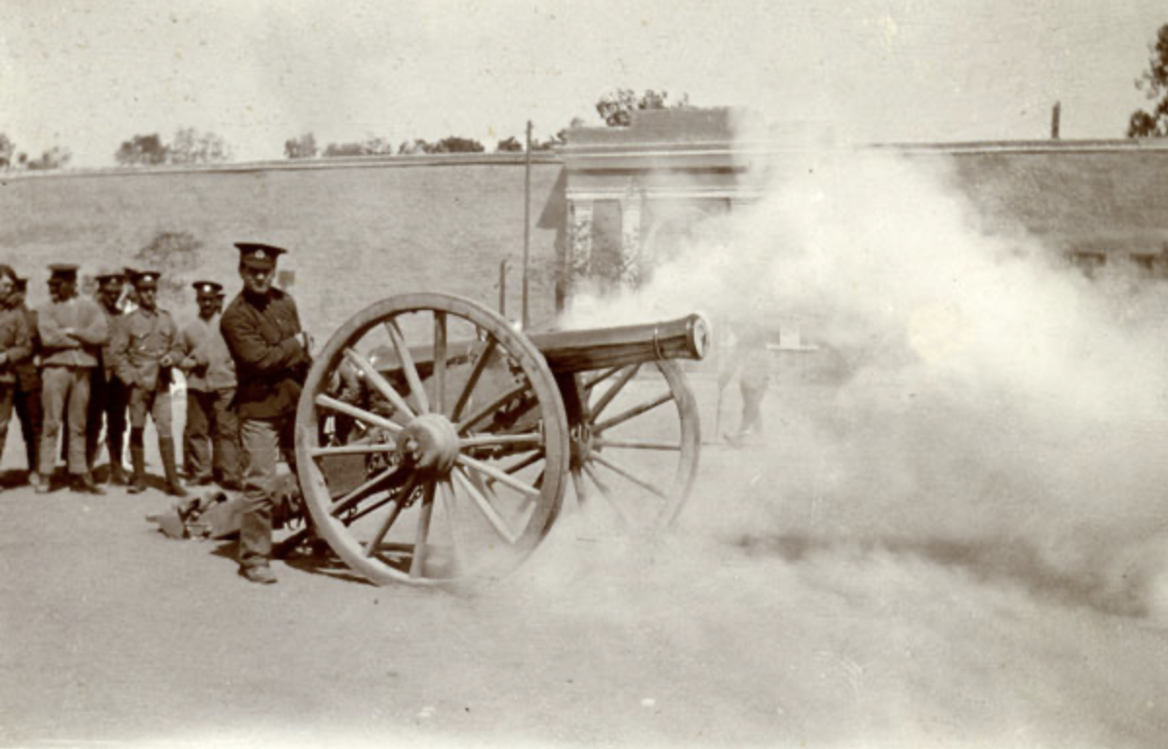
Time gun being fired, 6th Volunteer Battalion Manchester Regiment, Cairo (c. 1914).

Unit War Diaries: These documents provide a daily account of the activities of an army unit. They were often written by a junior officer and covered those units serving at home as well as in the various theatres of war. They contain contextual information when researching a soldier and may contain maps and plans. Some war diaries have been digitised by the National Archives. Charges apply. A selection are also available on Ancestry at UK, WW1 War Diaries (France, Belgium and Germany), 1914-1920 and UK, WW1 War Diaries (Gallipoli and Dardanelles), 1914-1916.

British Newspaper Archive: this database contains a wide range of local and national newspapers often recording a particular soldier’s service, deaths and campaign information. Access is through pay-per-view or subscription. Alternatively, a search can be carried out through Findmypast. Tameside Archive Centre holds the local newspapers covering 1914-1918. The Ashton Reporter has been indexed and can be searched via name of soldier when visiting the centre.

British Army, Deserters and Absentees in Police Gazette 1914 -1919: Lists of absconders were published in the Police Gazette and included names, occupations, last known address and any distinguishing marks.

War Memorials Register: The Imperial War Museum aims to produce a comprehensive list of war memorials throughout the UK. There is a photograph of each memorial with a list of the names commemorated. Searching the online list is by name and/or memorial.

Prisoners of the First World War, the ICRS Archives: These records have been digitised by the International Prisoner of War Agency (ICRS). Information on each prisoner was transferred to a collection of index cards numbering 5 million. The search is by name, nationality and whether civilian or military.

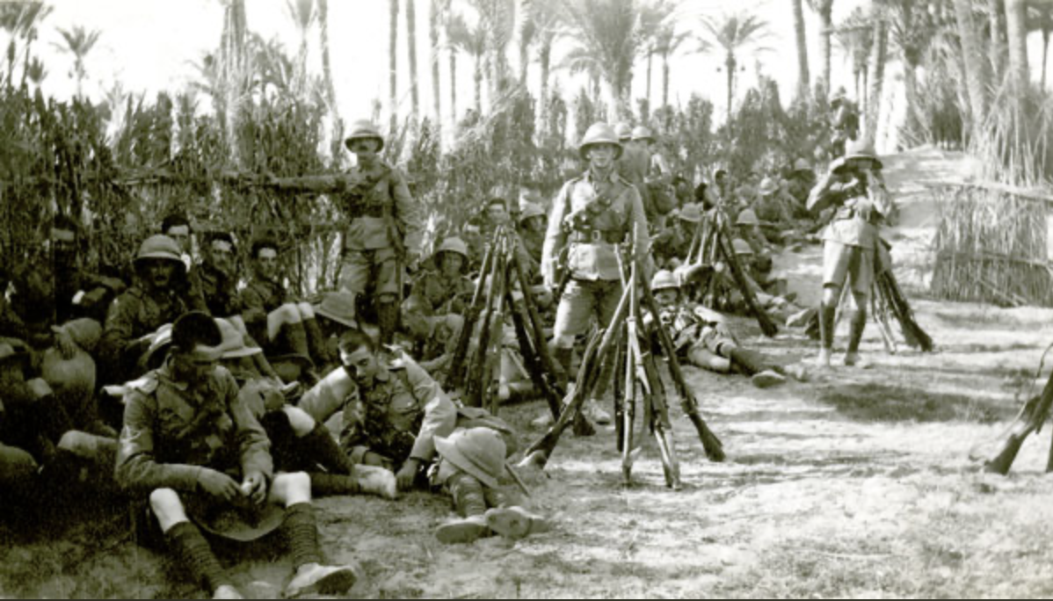 The 6th Volunteer Battalion Manchester Regiment at rest on the desert near Alexandria (c. 1914).

Absent Voters Lists: Because of the General Election in 1918 these lists were compiled to ensure that all soldiers over 19 years would still be able to vote. The information includes name, home address and service details which can be extremely useful if the service record has not survived. These have been digitised on both Findmypast and Ancestry. The Long Long Trail also has a comprehensive list including an online free search for some of the lists.

Next Steps
1. If a soldier went to public school or university consult either the school magazine online or university website for biographical information. One example is Manchester Grammar School.

2. Visit The Long Long Trail, a project ‘researching soldiers of the British Army in the Great War of 1914-19.
3. Shaping our Sorrow is an online exhibition organised by the CWGC examining the concepts of mourning and remembrance after the devastating
death toll in World War One.
4. Locate a Regimental Museum and relevant archive collection
for further research.

Further Reading
Fowler, S. (2017) Tracing Your Army Ancestors. 3rd ed. Barnsley, Pen and Sword.

Hartley, J. (2011) 6th Battalion The Manchester Regiment in the Great War. Barnsley, Pen and Sword.

Reed, P. (2010) Great War Lives. A Guide for Family Historians. Barnsley, Pen and Sword.

06/20

