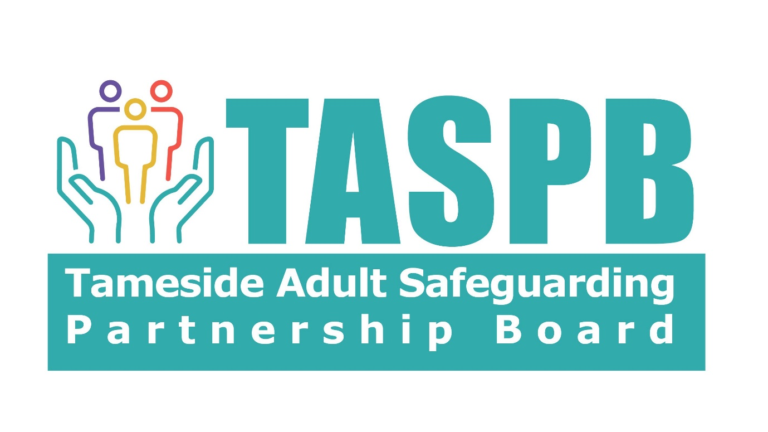

Adults Complex and High-Risk Panel (CaHRP):
Terms of Reference

Purpose
This meeting is to aid discussion re. support to manage the risk in situations, where there is evidence that agencies have already tried to work together to mitigate the risks. In addition, other options such as Section 42 safeguarding process; Section 9 Care and Support Assessment and/or Section 11 refusal of assessment have also been considered. A CaHRP referral will be considered at this meeting when an individual continues to place themselves at risk of serious harm or death and they have the capacity (recorded rationale) to understand the risks posed to them but are either unable or unwilling to engage with agencies.
The CaHRP referral will:-

- provide an opportunity to identify additional support to help problem solve cases and bring in senior safeguarding leads and heads of service/department for oversight of cases.
- to share concerns about high-risk cases involving multiple agencies in a timely way to increase the safety, health, and wellbeing of high-risk individuals.
- to ensure a lead agency has been identified
- to ensure the lead agency and lead professional are supported through a multi-agency risk assessment and management plan that provides professional support to all those at risk
- to ensure that the right people are involved in the Team Around the Adult (TAA) meetings.
- to discuss barriers in practice and see if agencies can identify any additional solutions.
- to develop and gather insights on trends and gaps in service delivery.

Responsibilities
Members will: -
- Advise and support Practitioners in their organisation who are referring Adults what information is required to be presented at the CaHRP
- Acknowledge best practice and multi-agency working, supporting the lead agency and professional to explore all available options to continue to support the Adult referred.
- Be accountable for ensuring that actions set are implemented and confirm what impact on the Adult’s wellbeing on the register will have.
- Implement a regular reporting framework, monitor progress, identifying developing gaps, risks and issues that need to be addressed.
- Report to TASPB the effectiveness of safeguarding practice in the context of CaHRP highlighting areas of best practice or areas for improvement and escalate any concerns re multi-agency working
- Strive for 100% attendance and commitment to CaHRP
- Be supportive of a learning environment and safe space for reflective practice
- Have authority within their agency to agree actions which may be outside of usual pathways/criteria or be able to escalate concerns for further discussion within their agency.

Referrers will: -

- Recognise that CaHRP is not a substitute for failings in the system.
- Define vulnerabilities of the Adult
- Confirm the value of the Adult being on the register would have.
- Provide a summary for Panel of:-
  - Key issues
  - What is working well for the Adult.
  - Risk Assessment completed at the TAA meeting.
- Provide summarised updates and confirm if the actions had a positive impact and improved the situation.

Membership
The meeting will be chaired by the Principal Social Worker or Strategic Safeguarding Lead
For the meeting to be quorate representatives will include: -
- The lead agency and professional who will continue to play a key role in the case.
- The referrer
- Principal Social Worker
- Designated Safeguarding Lead ICB
- Representative for Vulnerable Adults from GMP
- Partnership Manager Community Safety and Homelessness
Additional Members required at the meeting: -
- Representative from Safeguarding Team Pennine Care NHS Foundation Trust
- Representative from Integrated Care NHS Foundation Trust Safeguarding Team
- Members from Partner Organisations as required to aid the discussion of the outcome of the Referral.

Frequency of Meetings
Meetings will be Scheduled monthly on the same day and time for 2 hours.

Accountability and Governance
The Chair for the meeting reports quarterly to TASPB
TASPB meeting will be alerted to any issues that require immediate attention.

Process
- CaHRP referrals and action log will inform the agenda
- TASPB Business Manager and Business Support will facilitate the administration of the meetings, this includes setting up of meetings and completing an action log
- A Register of CaHRP referrals will be maintained by TASPB and the Chair of the meeting will provide a quarterly report to TASPB

Review of the Terms of Reference will be 6months from the first date of the CaHRP

