The Manchester Regiment Gazette

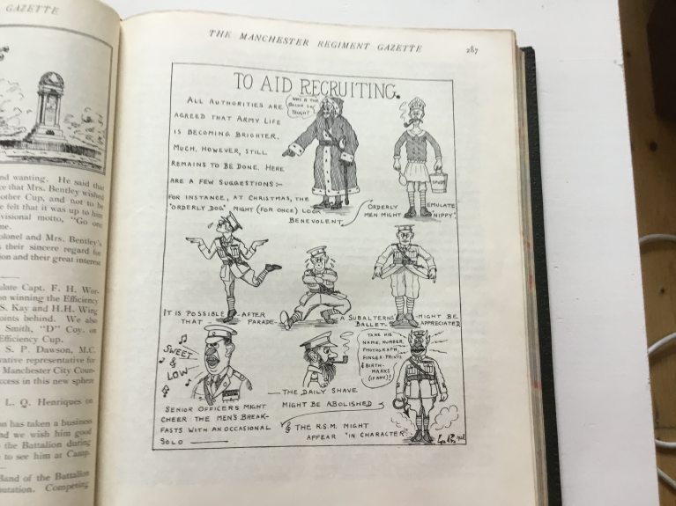
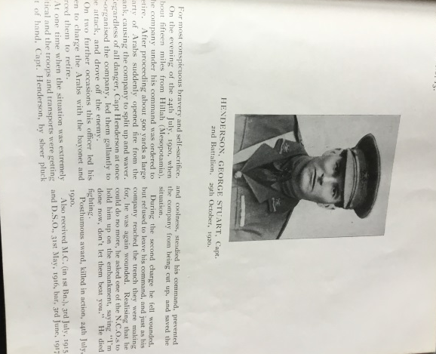
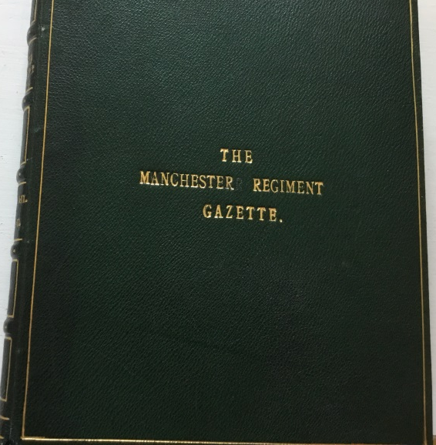

MR2/20/15 – MR2/20/40
How did these start? Here is a letter from the Colonel of the Manchester Regiment writing to the editor in 1913 about the Manchester Regiment Gazette. The Gazette was published from 1913 until 1958.
‘Army and Navy Club Pall Mall SW London 18th April 1913
My Dear Thorneycroft
I have only just returned from abroad and hasten to write you a line to welcome the first issue of The Manchester Regiment Gazette. I was very glad to hear that the Regiment was about to possess a newspaper of its own, and I congratulate you upon having courageously assumed the responsible and onerous task of editor. We all owe you a debt of gratitude for your public spirit and esprit de corps.
Everything which tends to unite all the Battalions of the Regiment and to promote and strengthen the good feeling which subsists between the Regiment and the great city from which it is named should be fostered and encouraged, and I am convinced that under your editorship the Manchester Regiment Gazette will have this effect. In wishing The Manchester Regiment Gazette a long and prosperous career I know that I am expressing the desire of all the ranks of the Manchester Regiment.
Yours sincerely
W Osborne Barnard Major General Colonel The Manchester Regiment’
Editor’s notes
It is with fear and trepidation that I present this first number of the MRG and beg all readers to be blind to its many faults and to accord it their hearty support.
I should like to thank those who have already become annual subscribers for the hearty way in which they have backed me up and for the many good wishes they have sent me for the success of the paper. At the same time there are many who have not yet become annual subscribers and who ought to do so at once.
Suggestions and criticisms are asked for and will be gratefully received, and I hope that every member of the regiment, past and present will take a personal interest in the Gazette and do his best to make it the very best of its kind, and one of which the regiment may be proud. I may in this first issue be accused of giving more prominence to some battalions than others but that is not my fault as some Battalions have sent me more copious notes and articles than the others.

Vol V11. No 1 January Number 1930
1st Battalion Notes
Battalion Soccer Team
Up to the time of going to press we have only played four games in the Folkestone and District League- Won one, lost one and drawn two. Owing to the demand of the 2nd Battalion on last year’s team, we have undergone reconstruction and have been very fortunate to pick up an entirely new forward line, all youngsters from the depot. They are showing promise and will do well as soon as they can understand each other. They require a little more practice in moving into favourable positions, in receiving the ball, and anticipating what their chums are going to do. They have developed the habit of moving fast when on the ball and keeping forward. It is just that little cohesion in front of the goal that we now require and all will be well. It is particularly noticeable that the talent in general is there. What we really need is a strong captain to keep them to together and control them properly; somebody with sufficient forcing power to prevent that chopping and changing during the game and keeping down the individualism of the centre-half. Somebody that can realise the best game to adopt to beat the ground and opponents and early detection of the weak spots in their opponent’s defence and causing the run of the game to develop accordingly. If we can get this done, and can keep them together for a time, we should see better results next season.
Rugby Notes
Our Rugby Season opened this year on the 25th September, the first game being with the “Tonbridge Wednesday” at Tonbridge…
Numbers of trial games have been played with a view to finding new talent and several members have been earmarked for further trials.
Saturday, October 26th was a combination of outing and game for we visited the R.A.F. Station at Eastchurch which is about 45 miles away and rather a tiring journey in a charabanc. We anticipated a very hard game and we prepared for it too. Unfortunately when the game had been in progress for about ten minutes, Pte Vernon, the stand-off half met with a serious injury which necessitated his leaving the field for the remainder of the game. This rather unbalanced the team for a time, who, despite the loss of a man played a hard game. Our wing three-quarter too was unfortunate in mistaking a goal post to which he was proceeding. Having already crossed our opponent’s goal line, he was making for a post belonging to another field, but was intercepted and thus lost what would, without doubt, have been a try. This resulted in us being defeated by 13-10.

Sergeants’ Mess Notes
We are in full swing again with our functions. The usual fortnightly socials between
ourselves and the monthly dances for the Garrison are very popular, entirely free and no increase in prices. All borne by our voluntary subscription to the entertainment account.
The socials are developing somewhat. We introduced Musical Chairs for the Ladies and Members. The first one we tried; Currie had a go. Although he did not succeed in winning, he got too near the final to make it comfortable for us. He put so much energy into the game that he broke every chair he tried to sit upon. Fortunately for us, a Fire Master Course intervened which he had to attend. This prevented him from attending the next social. In the meantime the committee had to decide between two alternatives; either putting the Bar up to Currie or increasing the subscription to keep up the chairs. Currie won.
The ladies are getting on very well with their game. We have always understood that they received private practice in the Quarters by the different cliques at Whist in preparation for the envelopes, but we never dreamed that they would go so far as to train for the chairs. What wonderful skill they show to outwit each other. There is not a trick of the trade left out. Their footwork in moving the chairs into a favourable position is wonderful. Their handling (which has since been barred) put our Rugger team to shame. Now they have the Soccer team weeping with their footwork. “Take it Wi’ Ye” is not in it.
From a musical point of view, what a pity Mrs. Tommy was not discovered earlier. She is of great success and easily puts our stars in the shade. Her songs are very original and well sung but her parody on Tommy’s Rummy was a great turn. She does not require so much humouring as the others we know; always willing to oblige. Unfortunately, by the time this is in print she will have left us to entertain the members of the 2nd Battalion.
We have a rival game to the rummy now in cribbage. It has developed so far as to cause one member to take the bread out of another member’s mouth by poaching on his reserves to find the necessary for his game. We wonder how far this member will go, if there is really no limit to his methods of finding the means...

Vol VII No. 3 July Number, 1930
The Fifth Re-Union Dinner
The Fifth Re-union Dinner of the Old Comrades’ Association took place at Wellington Barracks on Saturday, 26th April, 1930.
The night was fine and about 50 of the 60 who came from the 1st Battalion made the journey by char-a-banc. A party of 28 came up to London from the Depot and about 40 ex-members of the Regiment made up the 126 who sat down to dinner in the Dining Hall of the Scots Guard. An excellent dinner was provided…
Brig- General J. H. Abbot-Anderson, C.B. (in the Chair) in a few well- chosen words expressed his delight to see so many present and still hoped to see more. He then proposed the toast of “His Majesty the King” which was sung with orchestral accompaniment.
Brig-General J.H. Abbot-Anderson then rose and proposed the toast of “The Regiment” which was accorded musical honours…
The response to the toast of “The Regiment” was given by Lieut-Col. B.C. Freyburg, V.C., C.M.G.,D.S.O.,L.L.D., who rose amidst applause.
General Watson and Comrades: I rise with pride to reply to the toast of the evening, a toast which awakens proud and pleasant memories in us all, whether serving or whether you have left the Colours. It is customary at these dinners to give an account of doings of the Regiment since we last met. As you know, the 2nd Battalion has moved to Secunderabad, which is an important station and is one of the great Training Centres of India. The Foreign Service Battalion is much stronger than the Home Battalion and our 2nd Battalion must be a fine sight on parade because they are overstrength by as many men as we are under. We have sent two fine drafts to India- one in September last of 150 Other Ranks and one in February of 74. I can tell you that they were men who would be a credit to any Regiment (loud applause). We have also sent out three Officers, viz.,Major Burrows, Mr Venour and Mr.Woolsey. The 2nd Battalion, as is traditional in the Regiment, have a fine boxing team and have won the Indian Southern Command Championship and thus qualified for the Semi-final of all India. No results have yet come through…
I now want to touch upon another matter. We as you know, are recruited from one of the most depressed areas for employment in England. Poverty stalks the home of many and I can assure you that a great number of the men of the Regiment send weekly from their small pay to help keep the homes of their parents going. The present day soldier is a strong healthy sportsman with National instincts and as good a citizen as his brother in civilian life (Cheers). I hope you will now forgive me for digressing for a moment from the terms of the toast.
There is a subject which is weighing very heavily upon those of us who served in the War. There is a movement, either unconscious or premeditatd, which depict the war-time soldier as a man drenched in vice, and sodden with drink. They show in most of their books and plays men who are supposed to be heroes, who were neurotic wrecks, if not actual cowards. I don’t know what the motive of these writers can be. If they are writing for gain, it is, in my opinion, unclean and tainted money. We who served know the truth about the War (Hear Hear). Had the great British field army been one part as cowardly or drunken as has been depicted by some writers the War would have been lost in a week. I can tell you that in all my four years’ of experience of war I saw only four men drunk and nobody shot for cowardice. On the other hand I saw hundreds of men risk their lives daily with no thoughts other than of doing their duty (Hear Hear). I emphasise these facts not because it is necessary to you older soldiers who fought in the War, but because there is a new generation of young men growing up and it is our solemn duty to those who have gone, to see that their memory is cherished by those who come after them (Hear Hear).
Gentlemen, I make no apologies for these last remarks. We who are serving to-day have every reason to be proud of the great traditions of the British Army during the War, and you who have left should realise that the spirit of 1914-1918 has not diminished and that you have every reason to be proud of the great Regiment to which we all belong.

Obituary
Brigadier-General H.C.G.Westropp

It is with very great regret that we have to announce the death on April 7th last, at “The Little House,” Marlow-on-Thames, at the age of 68, of Brigadier-General Henry Charles Westropp.
General Westropp, who was a son of late Sir Michael R Westropp, Chief Justice of Bombay, was born on May 26th, 1861 and educated at Eton, and first received his commission in The Manchester Regiment, from the Militia on 12th May,1883. He was promoted Capt.,31st May 1890; Major,15th December,1900; Lt-Colonel, 6th October,1907, and retired 24th February, commanded 111th Infantry Brigade (Manchester 1912…
He joined up again for the Great War and City Battalions), in December,1914, being promoted Hon. Brigadier-General, 11th April,1917.
General Westropp was Adjutant of our 1st Battalion from 18th April, 1892, until,17th April,1896, and Adjutant of 5th Battalion Lancashire Fusiliers from 13th July,1896, until 31st May,1892. During this period he saw active service in South Africa and took part in the operations in Orange River Colony from June to July, 1901, in Cape Colony, July 1901 to May 1902. He was mentioned in Despatches, London Gazette, 29th July 1902, and received the Queen’s Medal with four clasps.
General Westropp commanded our 2nd Battalion from 6th October 1907 until February 24th 1912. He married in 1894 a daughter of Lieut-Colonel J.H.Lowndes, of Baunston, Northamptonshire, and leaves three sons.
Even after his retirement General Westropp’s interest of love of his regiment never tired or slackened, and his death is a very great loss, not only to those who knew him personally, but to every member of the regiment. He was Chairman of the Committee which compiled the History of the Regiment after the Great War. It was in great measure due to him and the information that he had collected that in 1923 we had the ‘fleur-de-lys’ restored as our regimental badge.
On several occasions he acted as President of the Regimental Dinner Club, and he also did a lot of work in the preliminaries of starting the Regimental Re-union. In fact General Westropp was a true son to his Regiment and never so happy as when doing something to help it. He is indeed a great loss to the regiment, and our sympathy goes out to Mrs Westropp, who always so ably seconded his efforts on behalf of the regiment and to his three sons in their great loss.

The Ninth Battalion the Manchester Regiment
A glance at the square of the armoury on any of the drill nights would be ample proof of the keenness and will to learn of the N.C.O’s and men of the Battalion in the various branches of the work. Whether it be men of the newly formed Machine Gun Company, or the latest joined boy drummer, all are eager to try and make themselves proficient and fit to perform the duties of a soldier by the 10th of August. Recruiting in the Battalion has been most successful during the past winter, 150 men having joined since September and it is fully expected that the 20 men still required will be obtained in the next week or so.

Colonel J.F. Plunkett
D.S.O., M.C., D.C.M

His many friends in the Manchester Regiment will be very delighted to hear of the honour conferred upon Lt-Col. J.F. Plunkett, D.S.O, M. C., D.C.M, who has been gazetted a Military Knight of Windsor. Colonel Plunkett was Adjutant of this unit from 1920 to 1922. Earlier in his career the Colonel was R.S.M of the 2nd Bn. Royal Irish Regiment, and served with such distinction during the Great War as to merit thoroughly his present high rank, and the distinguished position he has taken up at Windsor.
____________________________

Visit to the Theatre
On Friday evening, the 28th March Officers and their wives, and friends, visited the Ashton Theatre Royal to witness the performance of the well known musical comedy “The Lilac Domino” by the Ashton Amateur Dramatic Society. The show was exceedingly well produced, and reflected great credit on all who had assisted in making it such a huge success, the general opinion being that the Society had exceeded its many previous successes. After the show supper was served in the Officers’ Mess, the principals and officials of the Society being the guests.
___________________________
Death of the Mayor of Ashton
It is with the deepest sympathy that we have to record the death of Dr. C. S. Spencer who died on the 12th March during his year of office as Mayor of Ashton-u-Lyne. His death was due to “psittacosis.” The news of his death came as a great blow to all the community. The town paid homage to its chief citizen on Saturday, the 15th March. The service was held at the United Methodist Church, the late Mayor’s Chaplain, the Rev F.J. Wharton officiating.
During the late Mayor’s short term of office he had been amongst us on many occasions, and always expressed great interest in the welfare of the Unit.
Divisional Tactical Scheme
The Divisional Scheme was held in the region of this year’s Camp at Kinmell Park, on the 15/16th March. The Officers of the Battalion who were present enjoyed the schemes very much, and also the conference held in Rhyl during the afternoon of the 16th…
_______________________________

Recruits’ Inspection
On Monday, June 2nd, at 7.30p.m the Commanding Officer inspected the recruits, who have been accepted into the Battalion this year. In their new uniforms this body of men, numbering 89, looked very well indeed, and certainly they had taken considerable pains previous to arriving at the Armoury to present a good appearance on parade. The Arms and Squad drill movements were carried through really well, and reflected great credit on the permanent staff, who always give of their best from the many years of experience which they possess. After the inspection a Hot Pot Supper was partaken of in the Canteen. The Officers, N.C.O.’s and the recruits who had been inspected formed the company. After the meal the Commanding Officer made a short speech in which he urged the young soldiers to settle down to their work with keenness, and to endeavour to live up to the traditions of the Battalion. He also said he hoped the necessary 20 or so men would come forward so that the Battalion could go to camp this year at full strength. The remaining part of the evening was spent in enjoying an excellent programme of music provided by friends of the Officers, and some of the recruits, who plainly and successfully showed that they also possessed musical talents.
______________________________________

Miscellaneous
We congratulate Major W. M Barrett on attaining his majority (London Gazette d./d. 25th April), and also wish him the best of success in his command of “D” Company, the newly formed Machine Gun Company.
We have now amongst us 2/Lieu. T. Walton who was gazetted on March 7th. We sincerely hope that he will have a happy time with the Battalion, and enjoy his work. This officer is posted to “A” Company.
A loss to the Machine Gun Company and the Battalion, is the transfer from the active strength of the unit to the Reserve of Officers, of Capt. S. Torkington. Capt. Torkington has recently removed to the Midlands. We sincerely hope that he will continue to keep a great interest in the Battalion in spite of his transfer, and that we shall see him on many future occasions, and possibly, at the Annual Camp.

