**A Proud Heritage - a brief history of the Manchester Regiment**

**63rd Regiment of Foot**

**Pre 1881**

The Seven Years War in 1756 resulted in an expansion of the British army. On April 21st, 1758 the second battalion of the 8th Regiment of Foot or King’s Regiment was renamed the 63rd Foot (the precursor of the 1st Battalion Manchester Regiment). The battalion was well travelled. In 1775 it was sent to America as reinforcements for the American War of Independence. With the withdrawal of the British troops in December 1882, the 63rd Foot was posted to Jamaica and given the title ‘The 63rd West Sussex Regiment.’ From 1800 the 63rd did not have a permanent base, spending some time in Ireland from 1803-1807 and in Australia from 1829-1832, stationed in Tasmania. The regiment served in the Crimea between 1854 and 1855, and was then sent to Halifax, Nova Scotia until 1865, taking part in the second Afghan War in 1877.

**1881**

In 1881 Hugh Childers, Secretary of State for War, imposed significant changes on the structure of the army. Single battalion regiments like the 63rd were ordered to amalgamate with another similar battalion to form one regiment comprising of two battalions. The 63rd joined with the 96th Regiment of Foot to become the 1st and 2nd Battalions Manchester Regiment. The depot at Ashton-under-Lyne (Ladysmith Barracks) provided a permanent base for the regiment.

In 1881 the 1st Battalion was posted to India. They left there in 1882 and spent the next fifteen years in Britain. In 1899 the Ist Battalion arrived in South Africa and travelled towards Ladysmith to fight in the South African or Boer War.

**96th Regiment of Foot**

The 96th Regiment of Foot raised in 1761, had a chequered history, being disbanded and reformed several times. On the 6th February, 1824 a new 96th was formed at Salford Barracks, later to become the 2nd Battalion Manchester Regiment. The 96th moved to a number of locations over the next twenty years including Canada, West Indies, New South Wales where it guarded convict ships, and also India. The 2nd Battalion Manchester Regiment fought in the South African War until 1902 and then sailed for the Channel Islands in June 1904 before returning to Britain.

**World War 1**

The regiment expanded to 42 battalions. Twenty seven battalions served abroad and fought in all theatres of war- in France, Belgium, Italy, Salonika, Gallipoli, Egypt, Palestine and Mesopotamia. Eleven Victoria Crosses were awarded to soldiers of the regiment.

**The Inter War Years 1919 -1938**

Both the 1st and 2nd Battalions were involved in the war against terrorism in Iraq, Palestine, Ireland and Burma.

In 1922 the 1st Manchester Regiment left the Channel Islands to join the British Army of the Rhine, returning to Britain in 1927. After being posted to Egypt in 1936 the battalion was converted to a Vickers Machinegun Battalion and was sent to Palestine to deal with an Arab rebellion known as ‘The Great Revolt’. In 1938 the battalion moved to Singapore.

In 1920 the 2nd Manchester Regiment arrived in Mesopotamia as part of the garrison there. The battalion departed for India in 1922 and remained there for ten years. By the beginning of World War 2 the battalion had returned to Britain.

**World War 2**

The structure of the Manchester Regiment underwent a significant change. The Territorial Force had been reformed in the early 1920’s to become the Territorial Army. The battalions of the Manchester Regiment were assigned to one of three infantry brigades (127th Manchester, 126th East Lancashire and 42nd East Lancashire).

**Post War 1945-1958**

After the war the two regular battalions joined together to form the 1st Battalion which served in Germany, 1948-51, in Malaya,1951-54 and then in Germany again until amalgamating with the King’s Regiment, Liverpool in 1958. In 2005 this regiment became part of the newly formed Duke of Lancaster’s Regiment.

**The Story behind a Victoria Cross**

The allegiance and bravery of the soldiers of the Manchester Regiment was never in doubt.

A Victoria Cross was awarded posthumously to Captain George Stuart Henderson, VC, DSO & Bar, MC, 2nd Battalion, Manchester Regiment in Hillah, Mesopotamia (now Iraq).

Captain George Stuart Henderson 5th December, 1893 - 24th July, 1920

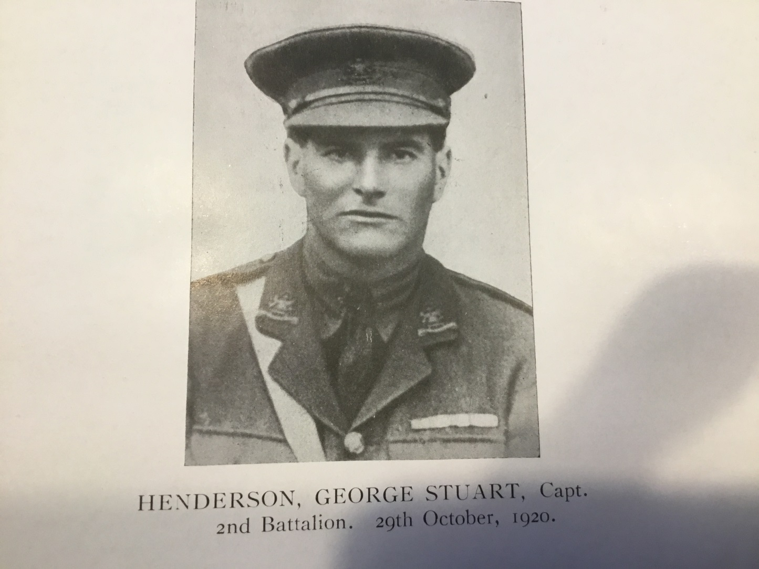

Taken from the London Gazette, October 29th, 1920.

*‘For most conspicuous bravery and self sacrifice. On the evening of the 24th July, when about fifteen miles from Hillah (Mesopotamia) the Company under his command was ordered to retire. After proceeding about 500 yards a large party of Arabs suddenly opened fire from the flank, causing the Company to split up and waver. Regardless of all danger, Captain Henderson at once reorganised the Company, led them gallantly to the attack and drove off the enemy.*

*On two further occasions, this officer led his men to charge the Arabs with the bayonet and force them to retire…During the second charge he fell wounded, but refused to leave his command, and just as the Company reached the trench they were making for he was again wounded. Realising that he could do no more, he asked one of his N.C.O’s to hold him up on the embankment, saying ‘I’m done now, don’t let them beat you.’ He died fighting.’*