In Brief
Researching Graves – Think Beyond the Cemetery
This guide has been developed to help you locate and research family graves.

Two useful databases for finding out about the lives and deaths of your ancestors are Ancestry and Findmypast. Both are available to use at Tameside Local Studies and Archives free of charge.
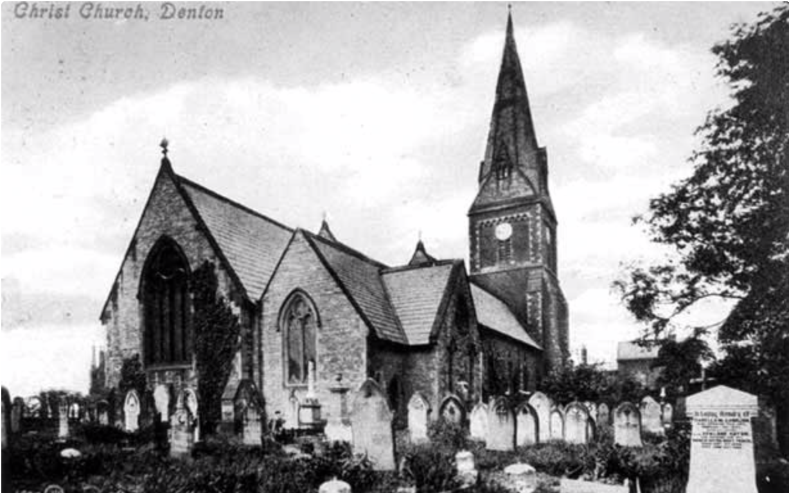
Exterior of building and graveyard, Christ Church, Denton.

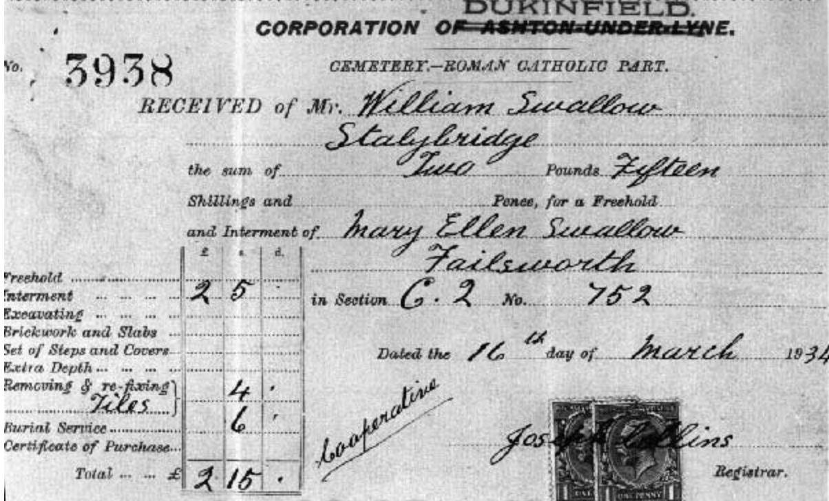
A bill from Dukinfield Corporation Cemetery dated March 1934 for the interment of Mary Ellen Swallow, signed by Joseph Collins, registrar.

Gravestones are important primary sources for family history research. The information gained from these markers can be corroborated and expanded through a number of useful online tools. Digital databases can also be used to locate the burial place of the deceased.
Deceased Online: a database preserving statutory cremation and burial records. The basic search index is free to use. The advanced search is either pay-per-view or subscription. This register can also be found on Ancestry and Findmypast as the UK, Burial and Cremation Index, 1576 – 2014.
Civil Deaths Registration: from 1837 deaths were recorded countrywide by local registrars. This information was submitted to the General Register Office. For a searchable database of the quarterly civil registration indices for England and Wales (1837-1915, 1916-2007), visit Ancestry. Using the index allows one to order a copy of the death certificate for a fixed charge. Findmypast offers the same service. Its records contain a direct link to the online ordering of death certificates.
General Register Office: to order death certificates online from 1837, visit the above address. For postal requests, write to Certificate Services Section, General Register Office, PO Box 2, Southport, PR8 2JD. Tel: 0300 123 1837

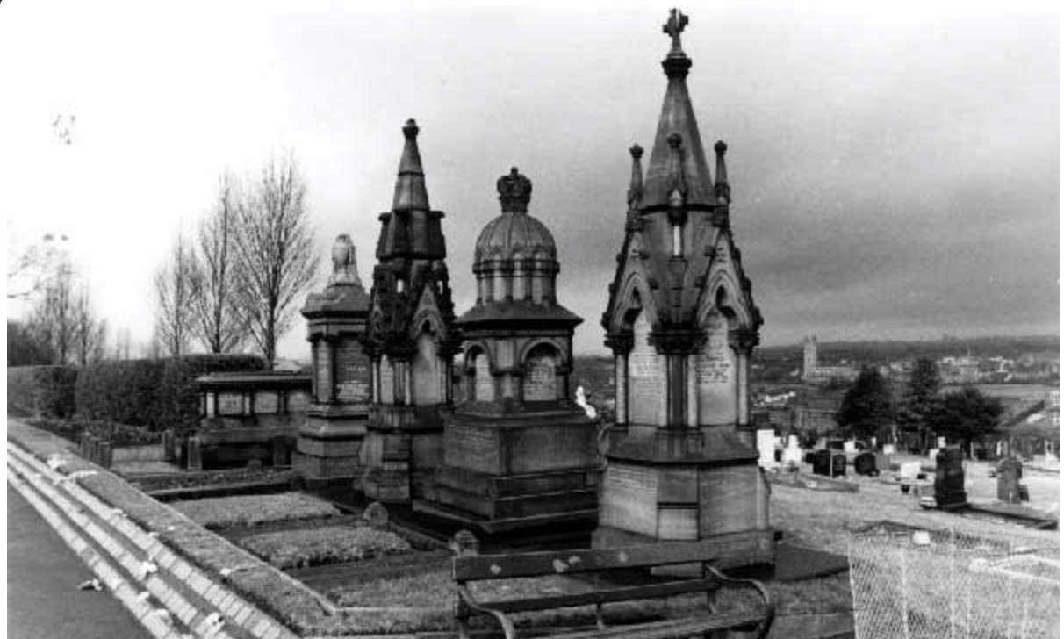
Tombs adjacent to the chapel, Dukinfield Cemetery.

Parish Burial Registers: before 1837 burials were recorded by the parish. Consult available church registers for these entries. Many have been digitised and/or microfilmed. Contact local history libraries and archive centres for more information. See a list of parish records held by Tameside Local Studies & Archive Centre here.

Local authority records: many council websites are in the process of digitising burial records. The Tameside Borough Burial and Cremation Record, a civil register containing over 300,000 entries, provides details including burial plot, location of grave, age at death and whether a service was held.
Manchester Libraries Burial Records: Archives + hold burial records from 1837 on microfilm for Gorton Cemetery, Manchester General Cemetery, Philips Park Cemetery and Southern Cemetery. Arrange a consultation in person. More information is here.

Free BMD: This database includes transcripts of death indexes 1837 – 1993.
Cheshire BMD: This site holds birth, marriage and death indexes for the county, including Tameside entries. Certificates can be ordered online.

Find a Grave: this global website contains entries recording over 180 million memorials and is fully searchable by type of burial marker, name and death date. Many photographs of graves have been uploaded.
Billion Graves Cemetery Index: a site containing over 12 million global records of headstones together with location.
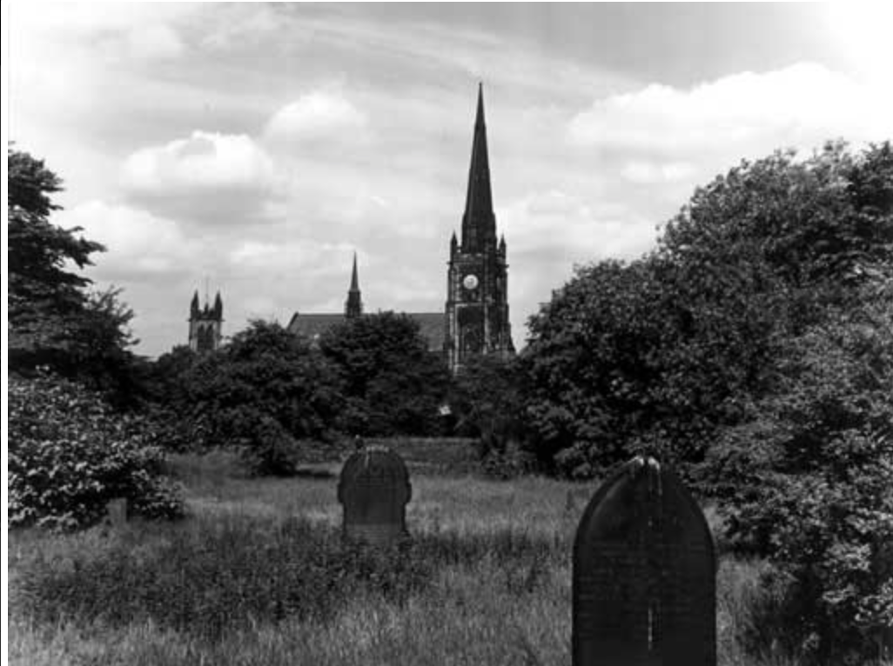
Ashton Parish Church of St Michael’s, new cemetery, clock tower and nearby church tower.

England & Wales National Probate Calendar (Index of Wills and Administrations) 1858-1995: This database, maintained by Ancestry, holds records from the Principal Probate Registry established in 1858. Prior to this church courts held responsibility for proving wills. Two such prerogative bodies, Canterbury and York, represented the two provinces into which the country was divided. Wills were also proved by lower courts within these districts depending on financial circumstances. For more information, see the guide to ‘Wills or administrations before 1858’ at The National Archives.

Find a Will: this website allows the user to search the index for the will or probate of any individual who passed away in the UK from 1858 to the present day. These documents can be ordered from the appropriate Principal Probate Registry or appropriate District Registry online through this service or by post using the form located here. Charges apply.
British Newspaper Archive: this collection contains a wide range of local and national newspapers publishing obituaries and coroners’ reports. Access is through pay-per-view or subscription. Alternatively, a search can be carried out through Findmypast. Visit FamilySearch for a database of the obituaries held by the British Newspaper Archive.
Local Newspapers: libraries and archive centres hold copies of local newspapers, including those currently unavailable on the British Newspaper Archive. These may contain obituaries or articles reporting deaths in the region. Tameside Archives and Local Studies has a variety of local newspapers on microfilm such as the Ashton Reporter from 1855.
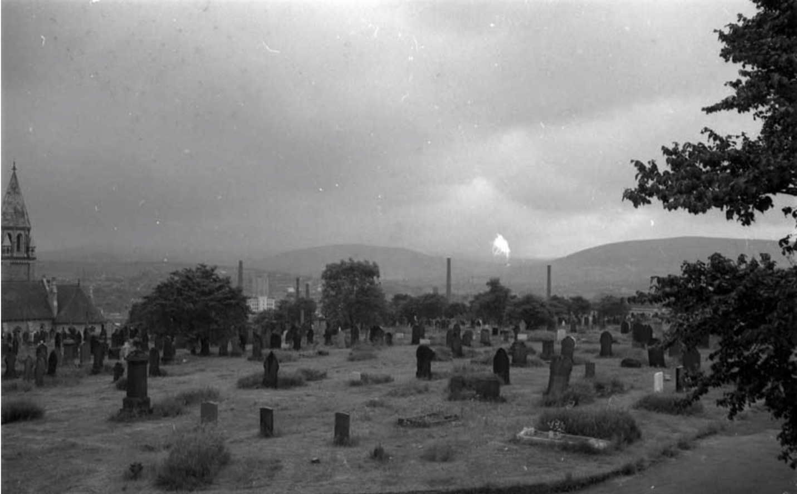
Dukinfield Cemetery. Chapel and crematorium on the far left (c. 1977).

Next Steps
1. Visit the Society of Genealogists and search the memorial inscriptions in their extensive library catalogue.
2. Log on to the National Archives and explore their selection of famous wills (1552-1854).
3. Consult the minutes of council cemetery and burial committees to find out more information on the administration of local cemeteries.
4. To find out more about the business of death in the 19th and 20th centuries, why not plan a visit to the Coffin Works Museum in Birmingham? This factory produced coffin furniture for over one hundred years, serving the funerals of Winston Churchill and the Queen Mother.

Further Reading
Annal, D. (2020) Birth, Marriage and Death Records. A Guide for Family Historians Barnsley, Pen and Sword.

Heritage, C. (2015) Tracing Your Ancestors through Death Records. A Guide for Family Historians. Barnsley, Pen and Sword.

Raymond, S.A. (2012) The Wills of our Ancestors. A Guide for Family & Local Historians. Barnsley, Pen and Sword.
05/2020

