In Brief
Researching Your House History
This guide has been developed to help you research the history of your house.

Two useful databases for finding out about your house and who lived there are Ancestry and Findmypast. Both are available to use at Tameside Local Studies and Archives free of charge.
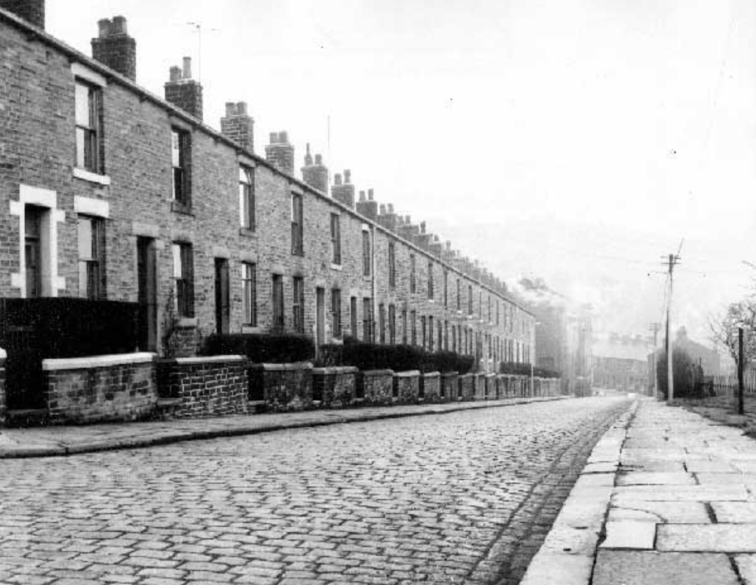
Hanover Street, Mossley (1995).

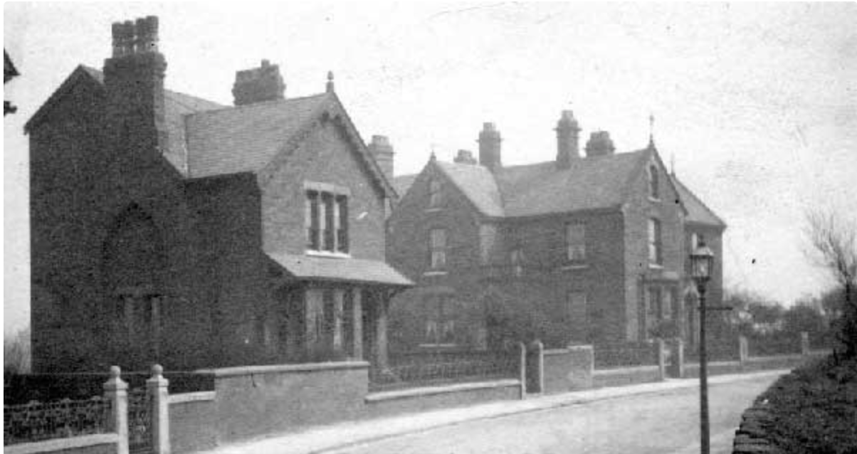
Cemetery Road, left to right: Fern Bank, Kent Villa, Astley Villa, Dukinfield, c.1910.

Title Register: this document provides ownership information for a property, including leasehold or freehold, purchase price and covenants. Go online to the Land Registry to check these details. Charges apply.
Title Plan: This has information on property area, boundaries and title number.
Apply to the Land Registry. Charges apply.

Title Deeds: these are paper documents relating to ownership of the property. You may hold these already. If not, check with your solicitor or mortgage company.
National Heritage List for England: this is a searchable, online database for listed buildings. A map search is also available.
Listed Buildings Tameside: this site gives details regarding buildings of particular architectural interest, including local and national groups interested in their protection.
Valuation Office Survey 1910-1915 (Lloyd George Domesday Survey): this unprecedented survey of land and property offers two types of records in the form of large-scale OS maps (known as ‘plans’) and field books. The former act as an index to the latter. Both are held at the National Archive. Over 9 million houses are covered. The online Valuation Office Map Finder permits the ordering of plans without an in-person visit. London records can be consulted online at The Genealogist. Subscription required. Those pertaining to West Yorkshire are available at Ancestry. Field books containing information on Greater Manchester can be seen at Central Library.
Old Maps Online: this collection consists of over 400,000 maps indexed from collections worldwide. Those held date from the 16th century onwards.
National Library of Scotland: this database holds a variety of maps covering the whole of the UK, including those commissioned by Ordnance Survey between the 1840s and the 1950s. An online tool offers comparison between historic OS charts and modern mapping.
Cheshire Tithe Maps Online: this collection gathers almost 500 maps dating from 1837. These documents show land ownership, buildings and land use.
Trade Directories: these registers were compiled to further trade and commerce. Inhabitants of towns and cities are listed by address and occupation. A range of directories are available such as Pigot’s, Slater’s and Kelly’s. Some can be consulted online on Ancestry. They are also available in book format and on microfiche. Tameside Local Studies and Archives holds a selection of local directories from 1772.
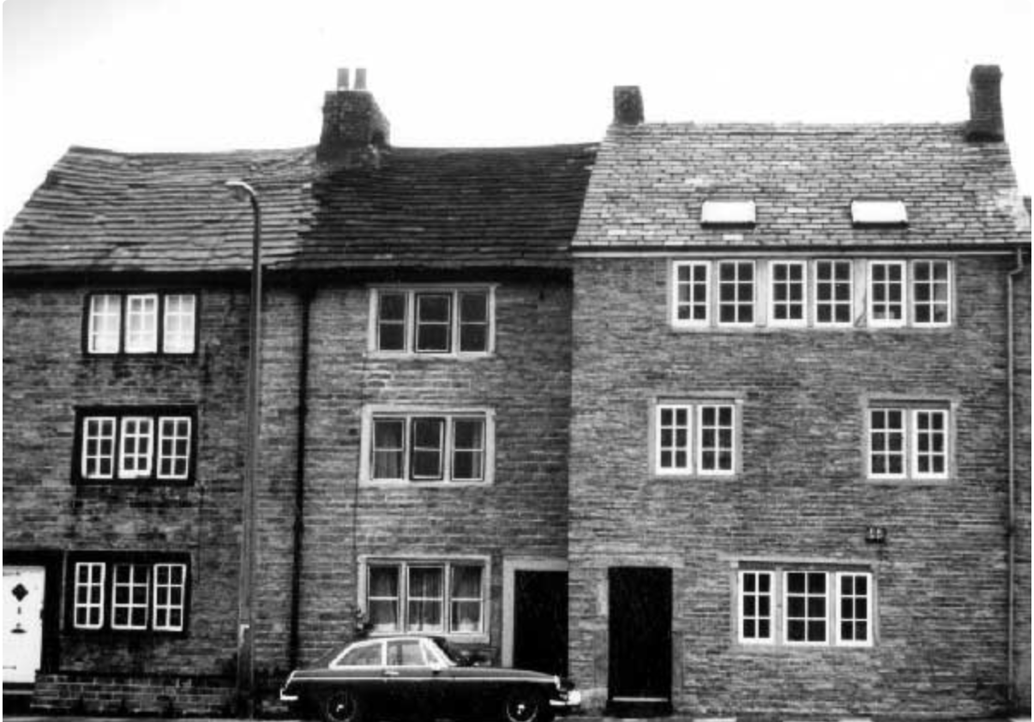
Weavers Cottage, Ashworth Lane, Mottram (c.1986).

Census: since 1841 the census or population count has been taken every ten years for England and Wales (except for 1941). Accessible records date from 1841 – 1911 as a 100 year closure rule applies. Census entries are available on both Ancestry and Findmypast, providing details of everyone in a particular house on ‘census night’, always a Sunday. Findmypast has an address search facility which is particularly useful when researching house history.
1939 Register on Findmypast: this register, taken on September 29th 1939, provides details of the civilian population. Over 40 million people are recorded (excluding military personnel unless they were on leave at the time). The originals are kept by NHS Digital (formerly the Health and Social Care Information Centre). For those born less than 100 years ago, the record is closed unless that person has died. The index is free to search either by name and/or address. Charges apply for the full record.
Rate Books: These local tax records are arranged by street, usually listing both the home owner and tenant (if applicable). The Manchester Rate Books (1706 –1900) can be found on Findmypast. Tameside Local Studies and Archives hold a selection of rate books associated with the borough. Search the catalogue here.
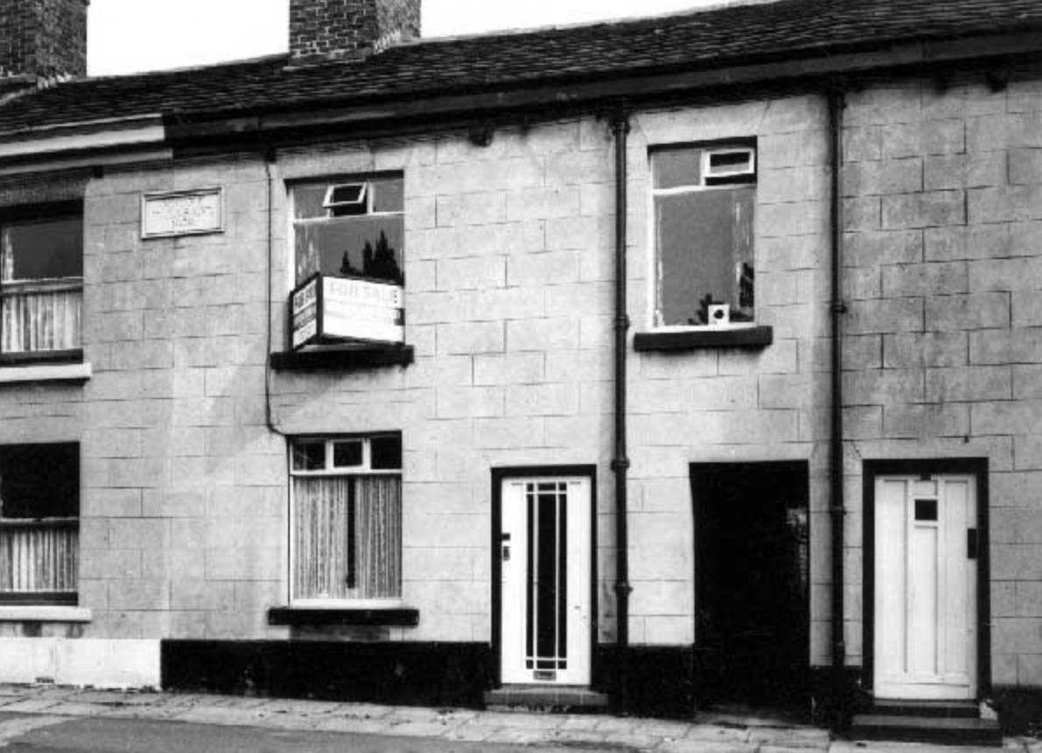
House for sale, Mount Pleasant, Hyde (c.1967).

Electoral Registers: the British Library maintains the national collection of electoral registers - lists detailing people eligible to vote - from 1832 to the present day. These are available to search on both Ancestry and Findmypast.
Sale Catalogues: these particulars often contain plans and images. Auction booklets may include the listed contents of sold properties. Check the catalogue at Tameside Local Studies and Archives for those in the borough.

Images: Consult local family history societies and archive centres for access to image collections, many of which include pictures of properties in the area. The image archive at Tameside Local Studies and Archives can be viewed here.
House Histories: there may be a book written about your house. Check with your local studies and archives centre. Research into general property history may also prove useful in your search. Relevant books can be obtained at your nearest library. See the catalogue at Tameside Local Studies and Archives for items in the borough.
British Newspaper Archive: this database contains a wide range of local and national newspapers publishing house adverts and details of sales. Access is through pay-per-view or subscription. Alternatively, a search can be carried out through Findmypast.
Local Newspapers: libraries and archive centres hold copies of local newspapers, including those currently unavailable on the British Newspaper Archive. Tameside Archives and Local Studies has a variety of local newspapers on microfilm such as the Ashton Reporter from 1855.
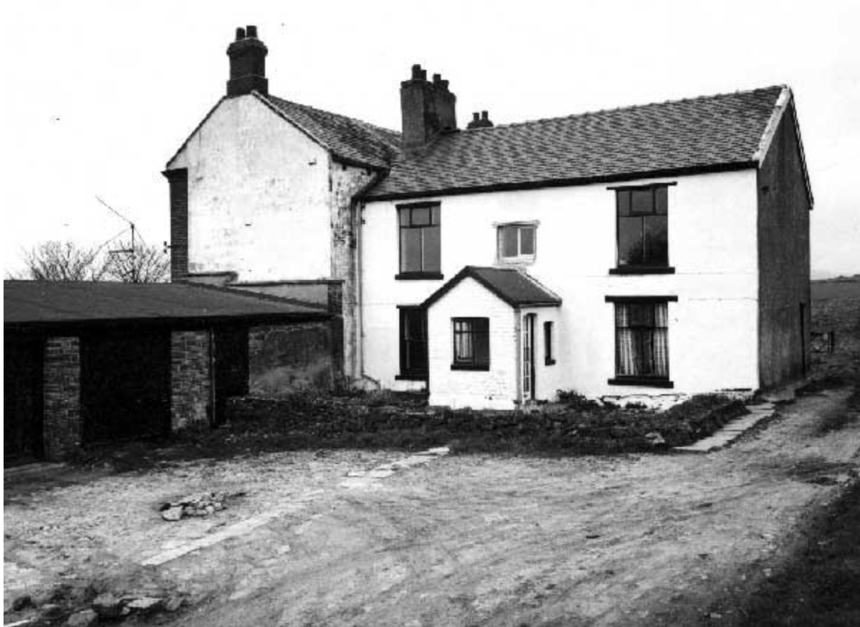
House for sale on Joel Lane, Gee Cross (c.1967).

Next Steps
1. Visit the National Archives and explore the research guide on tracing the history of your house.
2. Why was your house built? Walk around your local area and look for clues regarding the history of your community.
3. Why not plan a visit to the Museum of the Home in London? Current exhibitions showcase home and domestic life from the 1600s to the present day.
4. Consult the Victoria County History (VCH) series. Dating from 1899, these guides provide a detailed overview of each UK county.

Further Reading
Backe-Hansen, M. (2019) House Histories. The Secrets Behind Your Front Door. Stroud, The History Press.

Barratt, N. (2006) Tracing the History of Your House. 2nd ed. The National Archives.

Blanchard, G. (2013) Tracing Your House History. A Guide for Family Historians. Barnsley, Pen and Sword.
05/2020

