**In Brief**

**Researching a Second World War Soldier**

This guide has been developed to help you research soldiers in the

Second World War.

Two useful databases for locating military records are [**Ancestry**](http://www.ancestry.co.uk) and [**Findmypast**](http://www.findmypast.co.uk). Both are available to use at Tameside Local Studies   
and Archives free of charge.

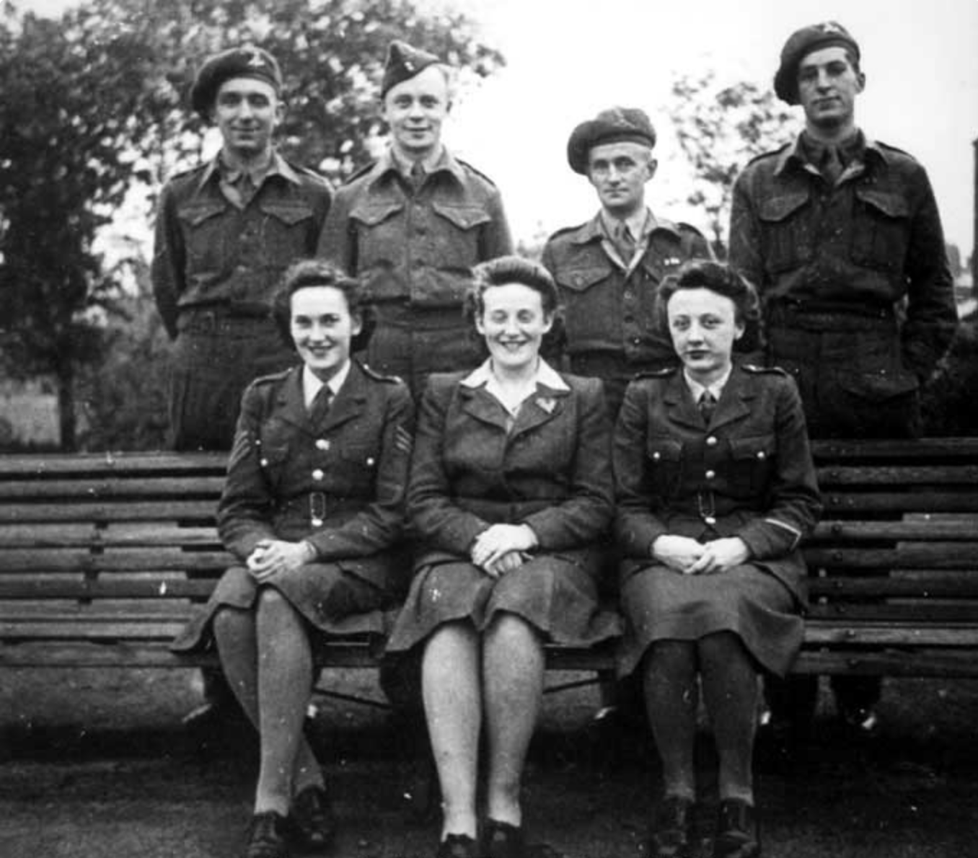

Royal Army Pay Corps, Albion School Office - group in King George VI Park,   
Ashton-under-Lyne (1939-1945).

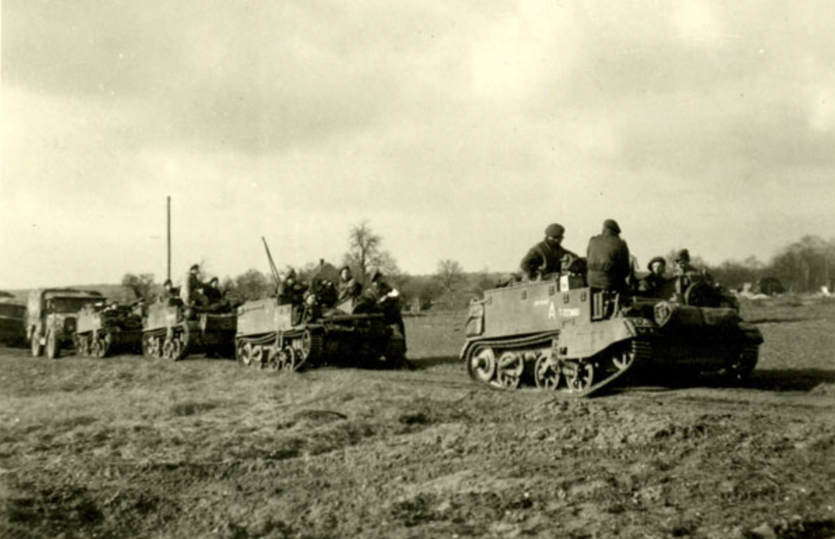

Machine Gun Carriers of ‘A’ Company moving into action for the attack on Weeze – 1st Battalion (1945).

**Service Records:** the British Army kept detailed paper records for every soldier. Next of kin may obtain a copy of these documents. Charges apply.

Please contact the Army Personnel Centre at the following address:

Army Personnel Centre, Disclosures 4 (Historical), Mailpoint 555,   
Kentigern House, 65 Brown Street, Glasgow G2 8EX  
Tel: 0141 224 2507 Email: [disc4@apc.army.mod.uk](mailto:disc4@apc.army.mod.uk)

**Commonwealth War Graves:** All Second World War casualties are recorded by the [Commonwealth War Grave Commission](http://www.cwgc.org). Search by name, service number, regiment and cemetery /memorial.

**British Army Unit War Diaries:** Second World War battalion diaries are held at [The National Archives](http://www.nationalarchives.gov.uk). These can only be viewed in person. Advance ordering required.

**Personal Diaries:** Archive services often hold personal diaries. Examples of these can be found in Tameside Local Studies and Archives which maintains the Manchester Regiment collection. Check the [catalogue](http://localstudies.tameside.gov.uk/calmview/).

**Mentioned in Despatches:** These official reports were written by a commanding officer and sent to the War Office before being published in [The Gazette](http://www.thegazette.co.uk) between 1939 – 1951. They may mention names of individuals commended for bravery.

**British Army Casualty Lists 1939-1945:** These can be found on [Findmypast](http://www.findmypast.co.uk/) and the listsincludes officers and other ranks who were killed, wounded or missing. Rank, service number, date/ type of casualty and battalion are recorded.

**Soldiers’ Wills:** These documents can be ordered at [Find a Will](https://probatesearch.service.gov.uk/#soldiers), a database containing wills registered between 1850-1986, including those left by soldiers killed during the Second World War. There is a charge of £10.

**UK Army Roll of Honour 1939-1945:** This can be found on [Ancestry](http://www.ancestry.co.uk/) andincludes place of birth, rank, regiment and death date.

**UK British Prisoners of War 1939-1945:** Accessed via [Ancestry](http://www.ancestry.co.uk/) thislists name, rank, regiment, POW number, camp number and location.

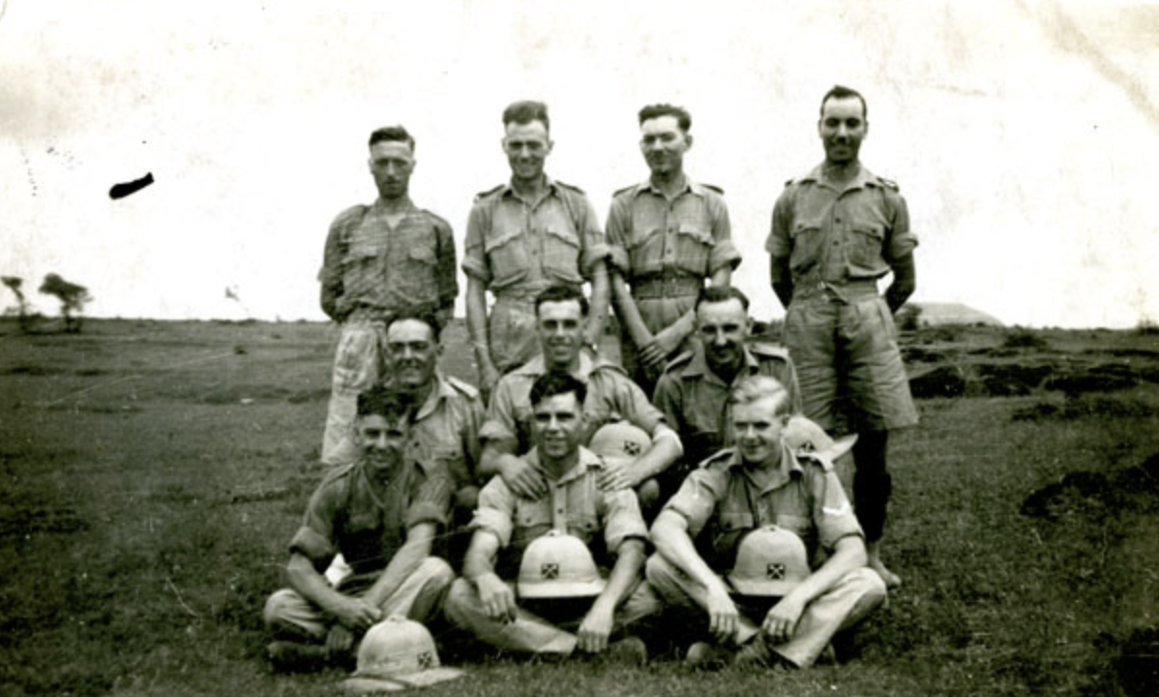

Group of men from 2nd Battalion Manchester Regiment, India (1942).

**British Armed Forces and Overseas Deaths and Burials Index, 1796-2005 on** [**Findmypast**](http://www.findmypast.co.uk)**:** This records birth and death dates, place and country.

**Second World War Medals:** Campaign medal rolls are not available to search online. To access these records, please write to the Armed Services Medal Office at the following address:

MOD Medal Office, Room G36, Innsworth House,

Imjin Barracks, Gloucester, GL3 1HW

Email: [DBS-medals@mod.gov.uk](mailto:DBS-medals@mod.gov.uk)

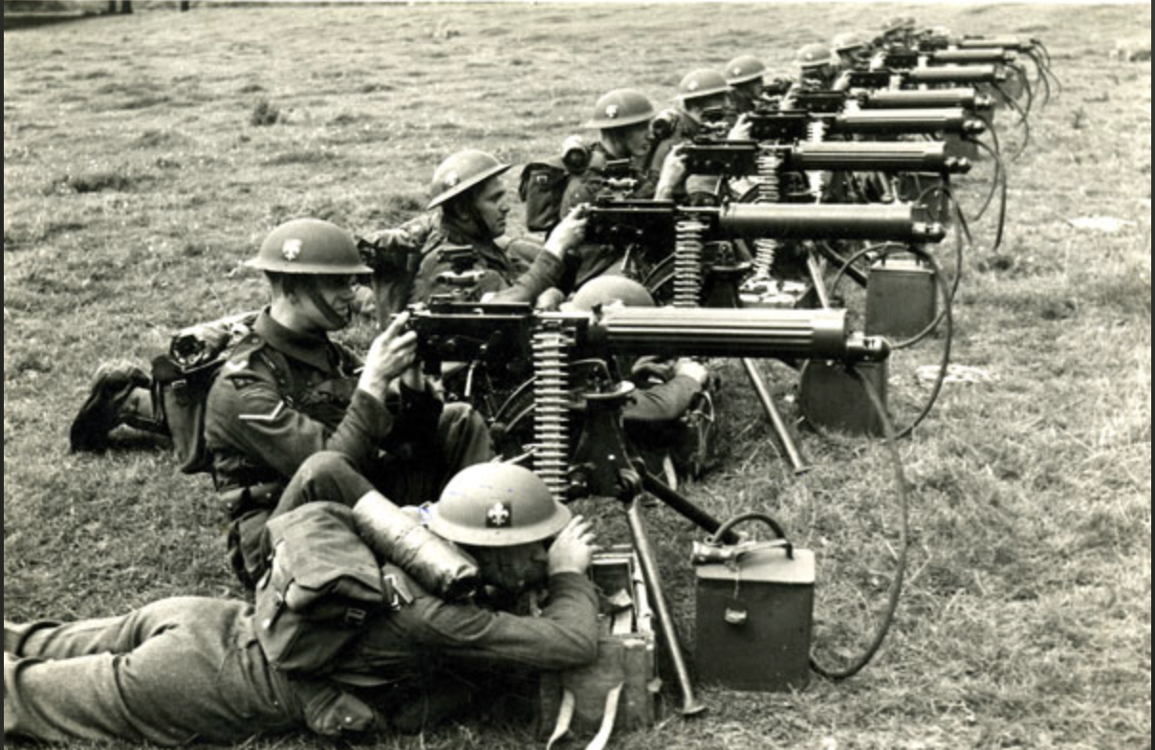

9th Territorial Army Battalion Soldiers using machine guns (c. 1939).

**1939 Register on** [**Findmypast**](http://www.findmypast.co.uk/)**:** This was a survey of the civilian population used for issuing ration books and ID cards. It can be searched by name and/or address.

[**British Absent Voters List (1939)**](https://www.ancestry.co.uk/search/collections/61320/)**:** this register was taken to guarantee voting rights by proxy or postal application to all servicewomen and men over the age of 19 when absent on active service. The information maintained includes civilian address, service numbers, rank and regimental data.

[**British Newspaper Archive**](http://www.britishnewspaperarchive.co.uk/)**:** This database contains a wide range of local and [national newspapers](https://www.britishnewspaperarchive.co.uk/) often publishing military obituaries and accounts of combat. Access is through pay-per-view or subscription. Alternatively, a search can be carried out through [Findmypast](http://www.findmypast.co.uk/).

**Local Newspapers:** Libraries and archive centres hold copies of local newspapers, including those currently unavailable on the [British Newspaper Archive](http://www.britishnewspaperarchive.co.uk/). Tameside Archives and Local Studies has a variety of such newspapers on microfilm such as the *Ashton Reporter* from 1855.

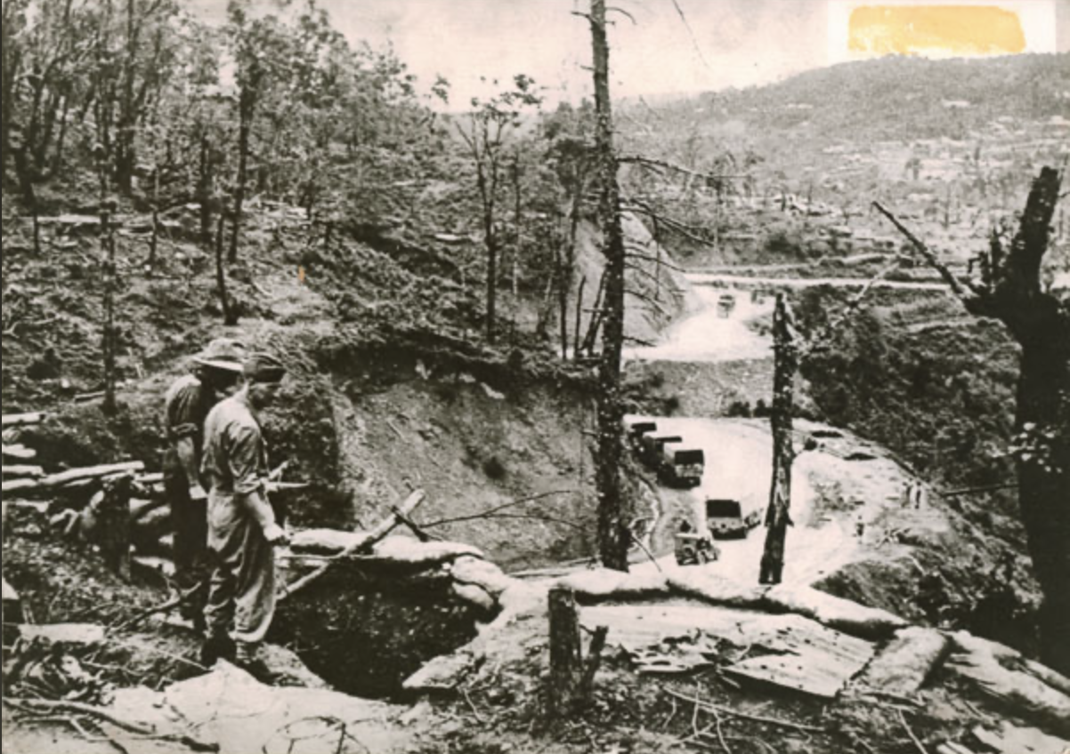View of the Kohima battlefield, Manchester Regiment 2nd Battalion, India (c. 1944).

**Next Steps**

**1.** Visit [the National Archives](http://www.nationalarchives.gov.uk) and search the collections online or in person. They have produced a guide to help your research in the Second World War.

**2.** Visit the [Imperial War Museum](http://www.iwm.org.uk) and search the collections either   
online or in person.

**3.** Visit the National Arboretum at Alrewas, near Lichfield, Staffordshire,   
the [UK Centre of Remembrance](http://www.thenmaorg.uk).

**4.** Locate a Regimental Museum and relevant archive collection   
for further research.

**Further Reading**

Fowler, S. (2017) *Tracing Your Army Ancestors*. 3rd ed. Barnsley, Pen and Sword.

Goulty, J. (2012) *Second World War Lives*: *A Guide for Family Historians*. Barnsley, Pen and Sword.

Tomaselli, P. (2011) *Tracing Your Second World War Ancestors*. Barnsley, Pen and Sword.

**05/2020**