**Rules Book**

**The Officers’ Mess Rules of the Second Battalion, Manchester Regiment c1900**

MR1/19/1/8

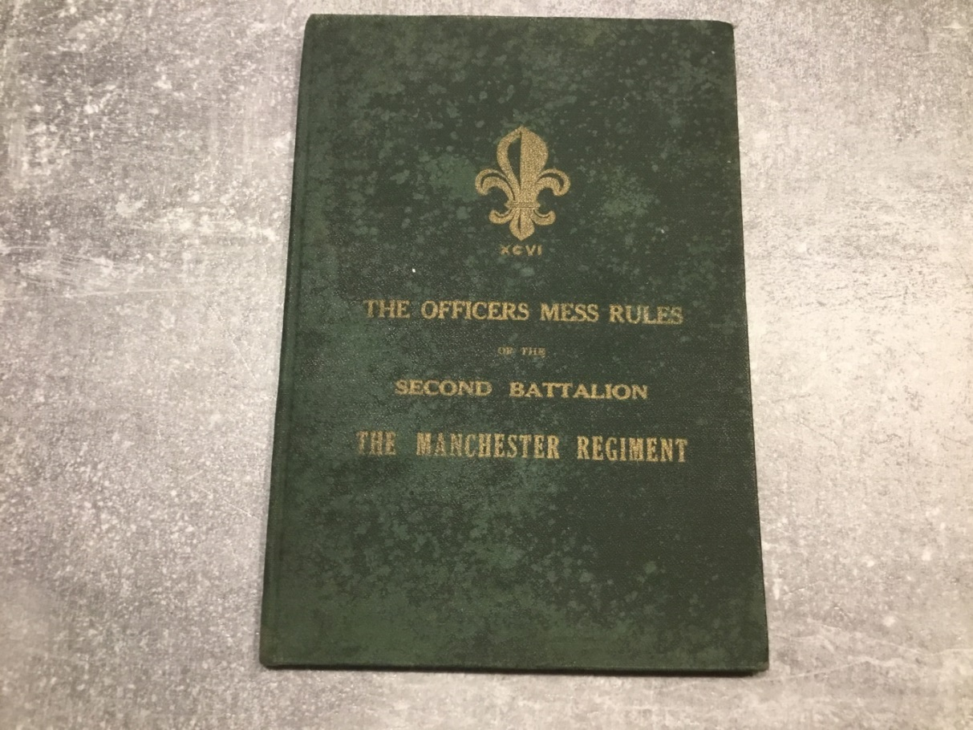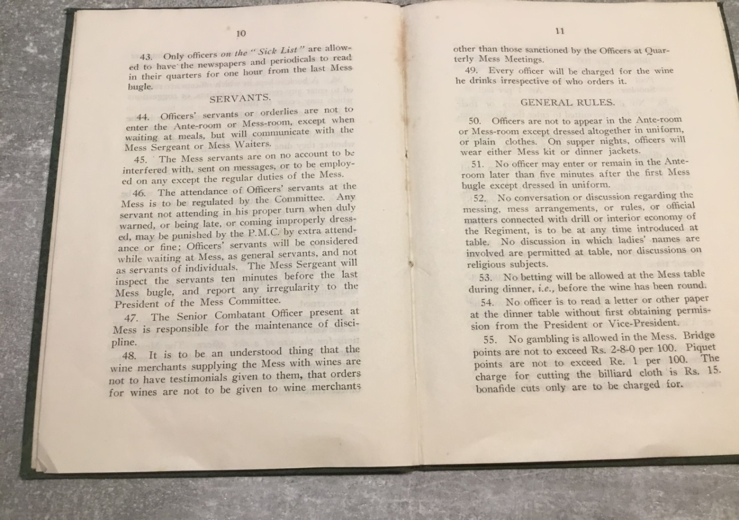

**Members**

1. Every commissioned officer of the Battalion shall be a member of the Mess, and all unmarried officers must be Dining Members.

2. Married officers, when their wives and families are absent, are also to become Dining members.

**Honorary Members**

3. The officers of the 1st Battalion, and the Officer Commanding and officers of the Regimental Depot, are *ex-officio* Honorary Members of the Mess.

**Mess Committee**

7. A Committee shall be appointed, consisting of a President, who is not to be under the rank of Captain, and two Members. The duties of the Committee will be to take charge of, and inspect quarterly, the various articles of Mess property, and keep correct inventories of the same, to keep a correct account of the wines, and see that the daily and monthly accounts are correctly made up. The President, Mess Committee will settle all monthly and other accounts due to the tradespeople and others.

11. The President, Mess Committee will cause the daily mess and wine accounts to be placed on the side table for inspection each day by noon, all accounts being completed up to and for the preceding day. Should any member of the Mess discover an error he is to mention it to the President of the Mess or one of the Committee, who will have it rectified; but unless the error is discovered in the course of two days, the Member complaining will not be entitled to any redress without reference to the Committee. No alteration of the wine accounts is to be made without the sanction of the President of the Mess Committee.

13. The whole of the Mess premises, including kitchen, scullery, larder, etc, are to be inspected daily either by the P.M.C or one of the Committee.

14. The P.M.C. is responsible that the Visitors’ Book is correctly kept, and that calls are returned within a reasonable time. The President and Vice-President for the week will return calls for all that week, and will initial the visitor’s book to show this has been done.

**President and Vice-President of the Week**

16. There will be a President and Vice-President for the week, irrespective of the Mess Committee, which duty will be taken in turn by all officers. (The senior dining-member being excepted) the senior will sit as President, the junior as Vice-president; a President and Vice-President-in-Waiting will also be appointed.

The names of the President and Vice-President as well as in-waiting will be posted in the Mess-room on Saturday night and Sunday morning.

17. The President is to check any irregularity that may take place at table and, if necessary, appeal to the senior officer present.

18. Should either President of Vice President be prevented from dining at Mess, he must arrange with another officer to sit for him. The President for the week will not dine out except by permission of the Commanding Officer.

19. The President and Vice-President are to be in the Ante-room ready to take their chairs when the dinner is announced. They are not to vacate their chairs without appointing a successor as long as the wine is on the table, if it is necessary for either the President or Vice-President to leave the table the President must obtain the permission of the Senior Officer present at the table, the Vice-President the permission of the President. If the President is obliged to leave the table on account of duty, or for some necessary purpose, having obtained permission of the Senior Officer present, he must depute another officer to act for them.

20. The Vice-President will not leave the table after the wine has been round until the President rises or notifies that he does not require him to remain any longer.

21. After dinner the wine is under the direction of the President of the week who is to see that it is passed once on nights other than guest nights and twice on guest nights before, cigars, coffee and liquors are handed round.

22. 1. After the wine has been passed round twice, and the coffee and cigars handed- the

snuff horn will be placed by the Mess Sergt. on the President’s right.

2. The President will take the snuff horn with his left hand- open the lid- stir the snuff

and tap the horn with the hammer near the 96th badge.

3. He will then close the lid and polish the Cairn Gorm with the right cuff of his Mess

Jacket.

4. The right arm will then be passed through the horn and the lid will be opened with

the left hand. The spoon will be extended to the officer on his left and the horn will

then be passed ‘with great ceremony’

5. The officer on his left will then help himself to snuff placing it on the hollow behind

the left thumb and forefinger. The hares foot will then be used to remove any snuff

not taken. He will then close the lid and take the horn with his left hand and proceed

as in 3 and 4.

**Meals**

23. The usual hours for meals shall be as under:-

Breakfast -7.30 to 9.30 a.m (Sundays 10.a.m.)

Luncheon- 12.30p.m. (Sundays 12-0 p.m.)

Dinner - 8.30 p.m. unless otherwise ordered.

No supper will be served after 9.30 on Saturdays and Sundays.

24. Officers requiring breakfast before 7.30 a.m. must warn the Mess Sergeant the previous

evening.

25. Any officer coming late to dinner is not to be served with any dish that has been

removed from the dining room

26. Continual unpunctuality at dinner on the part of any officer is to be brought to the

notice of the Commanding Officer. There should be no vacant seats at dinner. Dining

Members who may be dining out are to write their names in the book provided before 2

p.m. on the day of dining out. This rule applies to officers proceeding on leave.

31. Officers’ own servants, properly dressed, must wait at early dinners.

34. No officer will be allowed to have a meal in the Ante-room at any time, and no

refreshment except wine, spirits, beer, tea, coffee, biscuits and sandwiches, and

such like, can at any time be supplied there.

35. No member of the Mess who is not on the Committee shall, at table or any other time,

speak to the Mess Sergeants, Mess Waiters, or other servants, in terms of

disapprobation, or otherwise, relating to the messing or attendance, nor shall give

directions on any point connected with their duties (except, during dinner, the President

and Vice-President of the week).

**Officers on the Sick List**

39**.** An officer placed on the Sick List will be struck out of Mess until he returns to

duty.

40. Meals, etc., will be supplied to him from the Mess if he so desires, but his own servant

must fetch from the Mess such articles as are required.

42. Necessary articles of table equipment may be allowed out of the Mess, with the P.M.C’s

sanction, *for the use of a sick officer*. The Mess Sergeant will keep a list of the articles

lent, and the officer concerned is held responsible for their safe return. Loss or damage

must be made good by the officer concerned.

43. Only officers *on the “Sick List”* are allowed to have the newspapers and periodicals to

read in their quarters for one hour form the last Mess bugle.

**Servants**

44. Officer’s servants or orderlies are not to enter the Ante-room or Mess-room, except

when waiting at meals, but will communicate with the Mess Sergeant or Mess Waiters.

45. The Mess servants are on no account to be interfered with, sent on messages, or to be

employed on any except the regular duties of the Mess.

46. The attendance of Officer’s servants at the Mess is to be regulated by the Committee.

Any servant not attending in his proper turn when duly warned, or being late, or coming

improperly dressed, may be punished by the P.M.C. by extra attendance or fine:.

Officers’ servants will be considered while waiting at mess, as general servants, and not

as servants of individuals. The Mess Sergeant will inspect the servants ten minutes

before the Last Mess bugle and report any irregularity to the President of the Mess

Committee.

**General Rules**

50. Officers are not to appear in the Ante-room or Mess-room except dressed

altogether in uniform, or plain clothes. On supper nights, officers will wear either

Mess kit or dinner jackets.

51. No officer may enter or remain in the Ante-room later than five minutes after the first

Mess bugle except dressed in Mess uniform.

52. No conversation or discussion regarding messing, mess arrangements, or rules, or

official matters connected with drill or interior economy of the Regiment is to be at any

time introduced at table. No discussion in which ladies’ names are involved are

permitted at table, nor discussions on religious subjects.

53. No betting will be allowed at the Mess table during dinner, *i.e*., before the wine has been

round.

54. No officer is to read a letter or other paper at the dinner table without first obtaining

permission from the President or Vice-President.

56, No dogs belonging to officers or their friends are to be permitted to enter the Mess-room,

Ante-room or passages.

57. Smoking in the Mess-room is forbidden until after luncheon, and then only with the

permission of the senior officer who may happen to be present…

Smoking after dinner is permitted in the Mess-room, as soon as the wine has been.

round the second time.

Pipes are permissible in the Ante and Billiard rooms, but never in the Mess-room at any

time.

61. On guest nights, all Members of the Mess (married or single) will be present at dinner.

All (except those on duty) will remain at the table until the senior officer present rises or

notifies that officers may leave the table.

71. Officers are requested to keep their letter racks clear of opened correspondence.

72. Cloaks, swords, etc, are to be taken off and left in the appointed place.

78. Every officer on joining is to pay a joining subscription of five pounds (£5).

81. An officer coming in late for dinner shall invariably apologise to the President of the

week.

83. All officers on leave in England pay the same share of all Mess expenses, Regimental

Fund etc, as for Officers on leave in India.

85. Every officer is to provide himself with a copy of these rules.