In Brief
Researching the History of a Business
This guide has been developed to help you research the history of a business.
Two useful databases for locating business records are Ancestry and Findmypast. Both are available to use at Tameside Local Studies
& Archives free of charge.
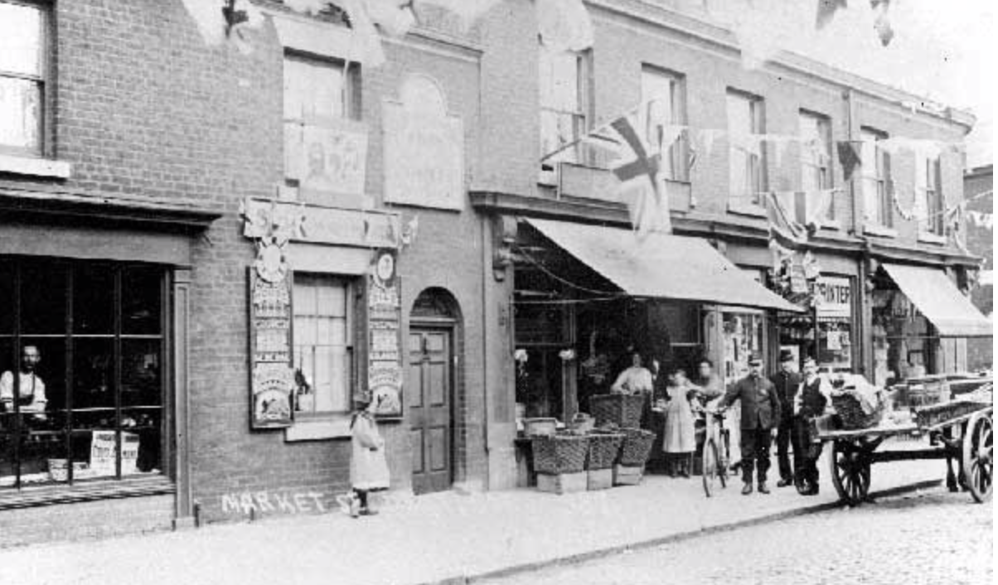
Market Street, Droylsden, decorated for the Coronation of George V, showing Tebbutt’s Shoe Repairer, Hawley’s Greengrocer, Greenup’s Printers and Sykes’s Drapers (1911).

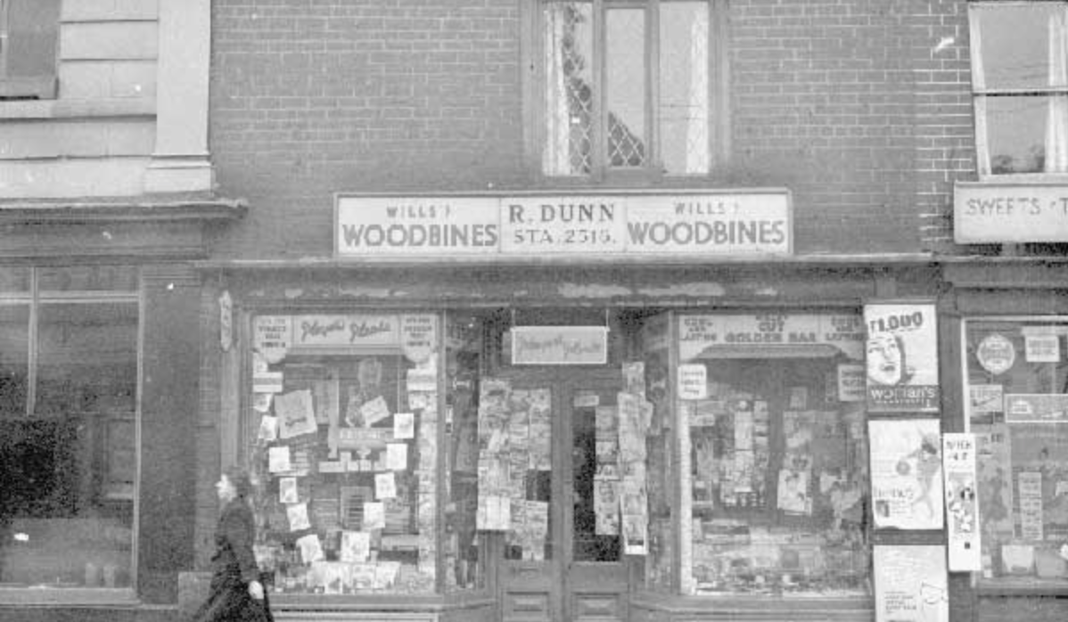
21 Market Street, Stalybridge, showing R. Dunn’s Tobacconist and Newsagent (1960).

Companies House: this government agency provides an online index of live, registered UK companies available to search by name, number or address free of charge. The information documented includes type of business, office address, previous addresses if still trading, directors and whether it is still in business. Further information on a company can be requested for a fee.
Email: enquiries@companieshouse.gov.uk

Companies House Information Centres: three regional centres for England and Wales, Scotland and Northern Ireland cover the records for companies with registered offices in their respective countries. Documents pertaining to specific businesses are held by Companies House for twenty years after they have been dissolved.

Companies Office Cardiff: This centre maintains a card index to companies dissolved before 1 January 1963. Charges apply for individual searches. The catalogue shows whether the information has been transferred to the National Archives.
Email: enquiries@companieshouse.gov.uk
The Gazette: This journal, established in 1665, is the British government’s most significant journal of record, combining The London Gazette, The Belfast Gazette and the Edinburgh Gazette. The publication comprises official statutory notices. Search online for company information including profiles, insolvencies, bankruptcies, liquidation and receiverships.
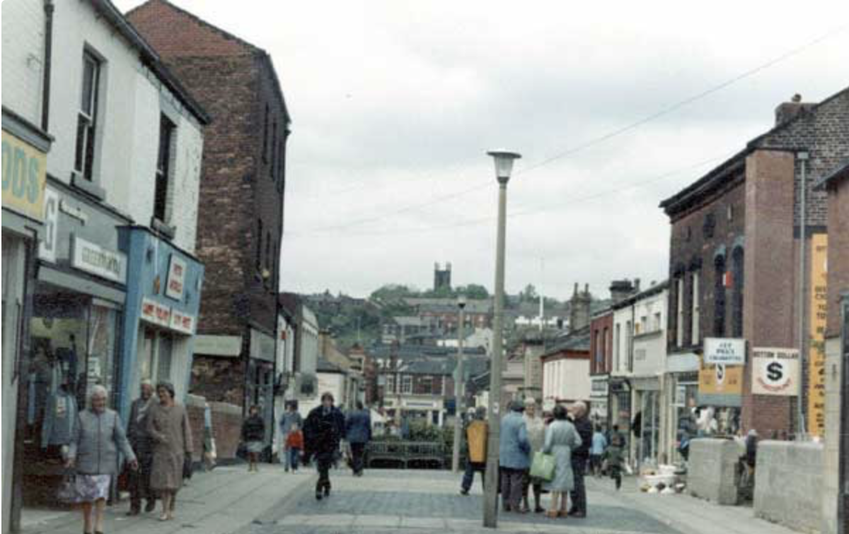
Melbourne Street, Stalybridge (1989).

Trade Directories: These are an essential source for business research. Most date from the late eighteenth century onwards. The registers can usually be searched by name, address and occupation. The most useful volumes are Pigot’s and White’s, two sets dating from the 1820s, and Slater’s and Kelly’s from the 1840s. A comprehensive collection is free to search online at the University of Leicester Special Collections. These can also be found online at Ancestry, City and County Directories, 1600s – 1900s. Holdings of various local directories from 1772 are held at Tameside Local Studies and Archives.

British Phone Books (1880 – 1984): Available on Ancestry, these phone books have been digitised from the BT Archive and contain 280 million names. The registers include the Classified Business Sections as well as the Personal Name Directory. Local Yellow Pages directories from 1966 and telephone directories from 1920 (incomplete run) can be consulted in hard copy at Tameside Local Studies and Archives. Businesses listed from 1996 can be searched online at Yellow Pages Business. There are over 2.9 businesses on the database.
Companies before 1860: For businesses dissolved prior to this date, consult the Board of Trade records at the National Archives. These include information relating to private companies and joint stock companies.

The Register of Business Names: This register, covering the period 1917-1982, preserves a list of companies where the name of the business is different from the owner. Unincorporated companies including partnerships and sole traders are also recorded. The series is held by the National Archives and is arranged by registration numbers and year. Book in advance and visit in person.
Stock Exchange Yearbook: Established in 1875, this annual publication offers biographical summaries of public companies registered on the London Exchange, detailing their history and activities in addition to recording dates of corporation, business addresses and directors’ names. The National Archives maintains an incomplete holding of these volumes covering the period 1909-1990. Book in advance and view in person.
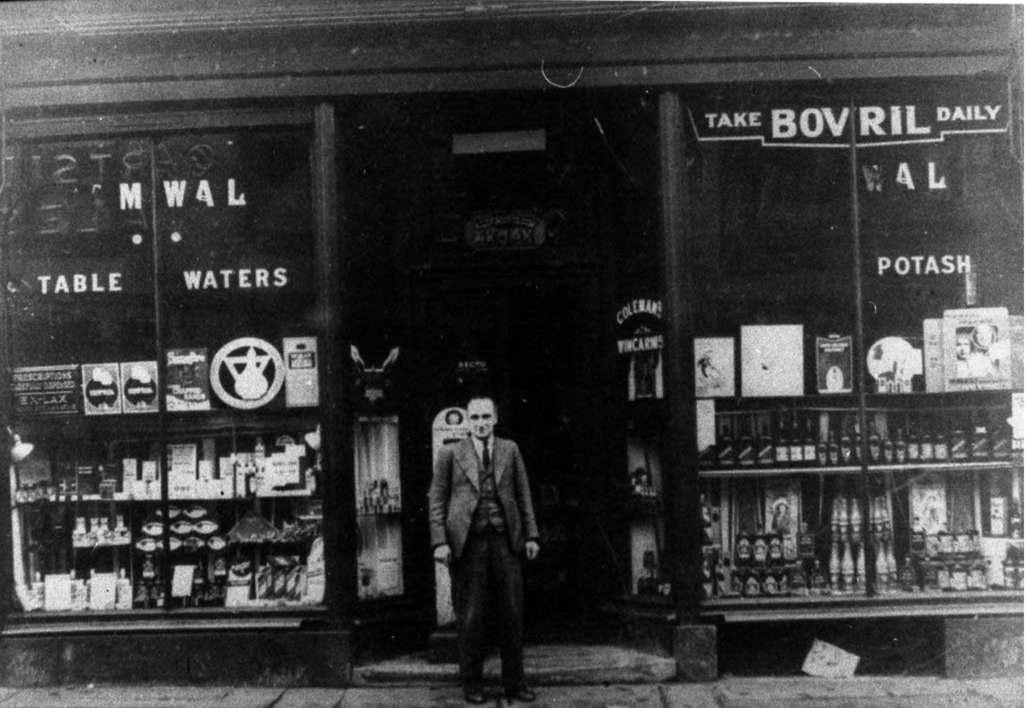
Chemist Shop, Bottom Mossley (1920).

Census records: Censuses taken between 1841 and 1911 are available to search on both Ancestry and Findmypast. They can help establish the name(s) of the individual(s) involved with the business, the geographical area concerned and the timeframe of operations.

Manchester Guardian: This publication is particularly useful when researching local businesses in the North West. A membership of Manchester Libraries is required to search digitised copies covering the period 1821 – 2003. Free to use.

Rate Books: These documents, annual records providing details of property owners and tenants, often give clues to a specific business. The Manchester Rate Books (1706 –1900) can be found on Findmypast. Tameside Local Studies and Archives hold a selection of rate books associated with the borough. Search the catalogue here.
Census 1841-1911 The censuses are available to search on both Ancestry and Findmypast. They can help establish the name of the individual(s) involved with the business, the geographical area and the timeframe.

British Newspaper Archive: this database contains a wide range of local and national newspapers publishing advertisements and other information on businesses. Access is through pay-per-view or subscription. Alternatively, a search can be carried out through Findmypast.
Local Newspapers: Libraries and archive centres hold copies of local newspapers, including those currently unavailable on the British Newspaper Archive. Tameside Archives and Local Studies has a variety of local newspapers on microfilm such as the Ashton Reporter.
Grace’s Guide: This website serves as an online guide to the history of British companies, products and people from the nineteenth century to the present day. Search by name of company and/or county. Free to use.
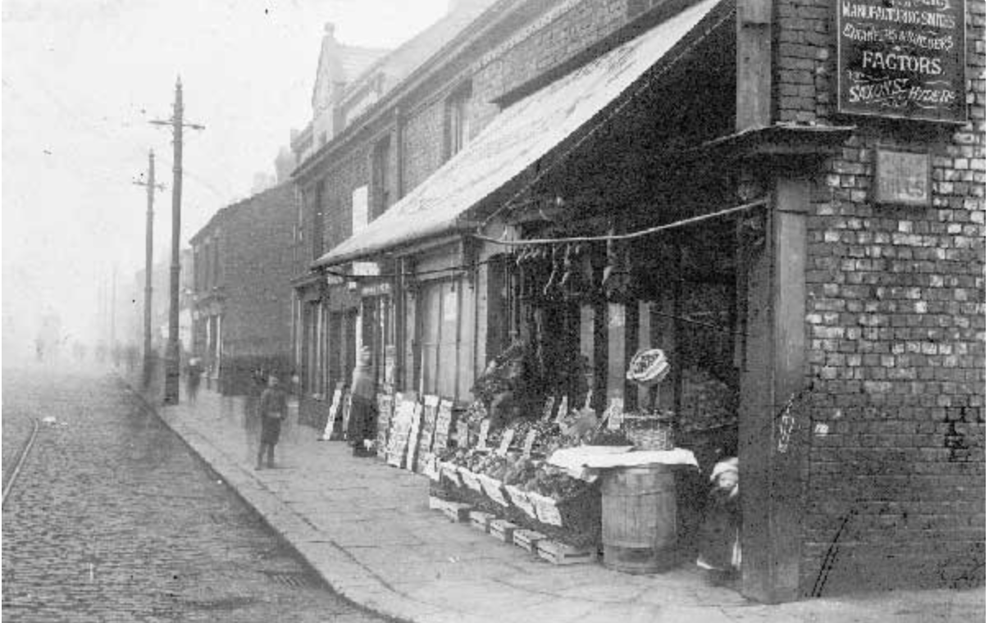
Grocer’s Shop, Stockport Road, Denton.
Goad Plans: This collection consists of street maps showing town centre shops and businesses in great detail. Started in the late nineteenth century, the Charles E. Goad Company was the largest producer of plans for fire insurance agencies. The British Library holds a comprehensive catalogue of these maps covering the period 1895-1924, a series representing the most important towns and cities in Britain. Tameside holds a selection of these sheet plans for the borough from the 1960s. For access to more Goad plans a subscription service is available at the Goad Portal-Experian.

Next Steps
1. Visit The National Archives in person to look at business records. Booking in advance is required.

2. Contact archives centres to look at business holdings including council records.
3. Plan a trip to the People’s History Museum to consult and explore trade union material.
4. Why not attend the The British Library in person to look at their collection of trade literature from the period 1880-1940? Booking in advance required.

Further Reading
Armstrong J. and Jones S. (1987) Business Documents: Their Origins, Sources and Uses in Historical Research. London.
Orbell, J. (2009) A Guide to Tracing the History of a Business. Chichester, Phillimore & Co.
Probert, E. (1994) Company and Business Records for Family Historians. Federation of Family History Societies.
06/20

