Access Statement for Portland Basin Museum
2018-19

This access statement does not contain personal opinions as to our suitability for those with access needs, but aims to accurately describe the facilities and services that we offer all our guests/visitors.
Access Statement for Portland Basin Museum
Introduction
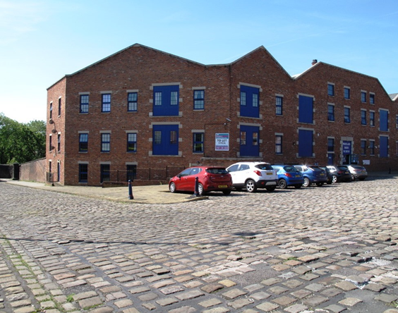
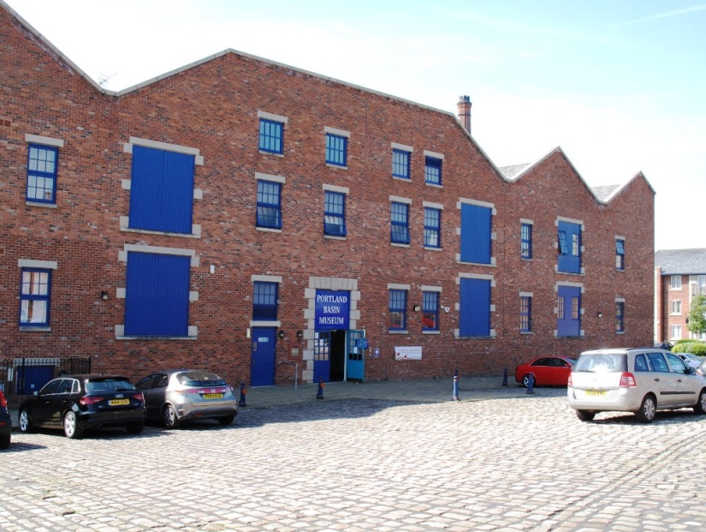
Portland Basin Museum is housed within the restored nineteenth century Ashton Canal Warehouse in Ashton-under-Lyne approximately 7 miles/11.2km east of Manchester City Centre and approximately 1 mile/1.6km south of Ashton-under-Lyne Railway Station, Metrolink Stop and Bus Station. The museum overlooks the canal junction where the Peak Forest Canal, the Ashton Canal and the Huddersfield Narrow Canal meet. The approach to the Museum is via a gradual decline over uneven cobble stones to the main entrance, reception area/shop and ground floor of the museum from where the remainder of the museum can be accessed by stairs and lift.
Immediately outside the main entrance is a large free public car park including 6 designated parking bays. Ashton-under-Lyne is located just off Junction 23 of the M60. From Junction 23, take the A635 into Ashton-under-Lyne following signs for the Town Centre and follow the brown signs that depict a canal boat to Portland Basin Museum.
The lower ground floor of the museum can be accessed, independently from the main entrance, from a doorway on the waterwheel wharf side to the rear of the museum. This entrance can be approached by continuing over the cobble stones to the left of the museum, through a gateway on the right and over the waterwheel wharf side comprising of fairly even paving stones and cobbles. You should leave at least 1 hour to go around the museums 2 floors.
You can also enjoy an independent cafe connected to the Museum on the lower ground floor when the museum is open and the museum houses a shop selling a range of souvenirs on the ground floor.
Attendants are on duty throughout the museum should you require any assistance. 1 wheelchair is available free of charge from the reception area and guided tours of the galleries are available by prior appointment. The museum's full range of exhibitions, events and activities can be found on our website at: www.tameside.gov.uk/museumsgalleries.
The museum is a member of the Visit England Visitor Attraction Quality Assurance Scheme (VAQAS).
We look forward to welcoming you. If you have any queries or require any assistance please phone 0161 343 2878 or email portland.basin@tameside.gov.uk.
Pre-Arrival
- For maps of how to reach us and to help plan your journey by car or public transport please use a journey planning website; simply enter your postcode and ours, which is OL7 0QA to get directions.
- The nearest railway station is Ashton-under-Lyne, which is 1 mile/1.6km away (approx. 20-25 minute walk). Taxis are not available at the station. The nearest taxi-rank is approximately 1 minutes walk away to the side of Ashton-under-Lyne Town Hall.
- The nearest bus stop is opposite the railway station but services do not run directly to Portland Basin Museum.
- Drivers can park for free in a car park immediately outside the museum’s main entrance when spaces are available.
- The Ashton-under-Lyne Metrolink stop is adjacent to the Bus Station which is located at the end of the 'Eccles to Ashton-under-Lyne' line.
- The Museum/Canal system is located in a commercial and industrial area of Ashton-under-Lyne with tarmacked roads and pavements. When leaving the stone pavement the road is then cobble stones to the front and side of the museum, providing a fairly uneven surface.

Car Parking and Arrival
- There is extensive parking on site for approximately 100 cars/coaches and motor cyles including 6 clearly marked spaces for those with mobility issues, nearest to the main entrance. The remainder of spaces are between 4 and 25 metres or approx. 13 and 82 feet from the main entrance.
- The car park surface is cobble stones throughout with a paved path leading to the main entrance along the length of the museum and to both sides of the museum entrance. The car park is well lit at night.
- There is a drop off point at the main entrance, with a dropped kerb.
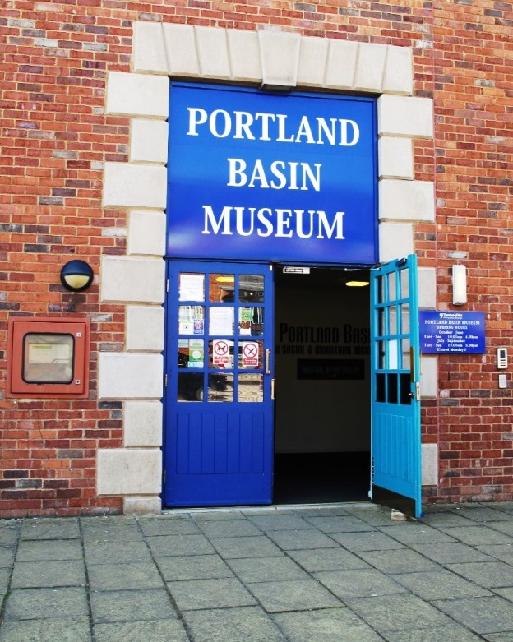
- The main entrance to the museum is through a reasonably heavy double door, with no automatic opening system. 1 side of these doors, which open outwards, is open when the museum is open, depending on weather conditions. The width of these double doors when open is 192cm/75.5 ins (1 side open: 95cm/38ins). The subsequent entrance area is a shared space with other tenants of the Portland Basin complex.
- It is in this space that the buildings communal lift, to the museum's lower ground floor, can be accessed to the far right of the entrance door. The main entrance to the museum is always open during opening hours and leads off this communal space, with very limited seating.
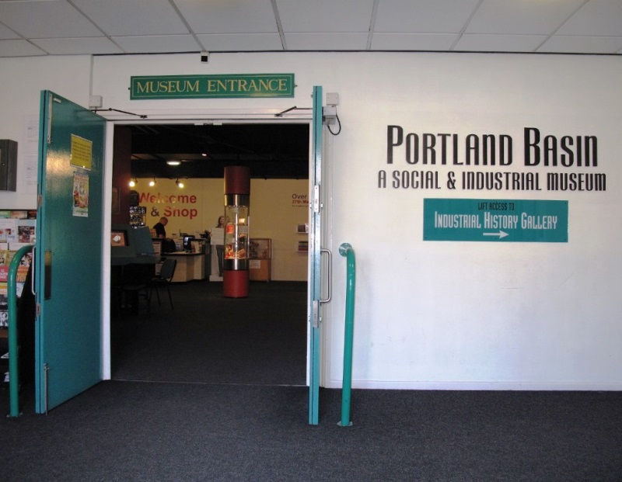
- The details of the lift are as follows. 8 person or 630Kg max. capacity with a drive through design to the museums lower ground floor. The lift is always available when the museum is open with a door width of 88cm/34.5 ins. The inside length of the lift is 140cm/55ins. and the operation buttons are accessible from a seated position.
- There are no steps between the main entrance to the museum and the first floor of the museum shop, reception, first floor exhibitions, toilets and baby changing facility and the flooring is a grey short pile carpet and is well lit with natural and artificial ceiling lighting.
- The main museum double-door entrance measures a width of 150cm 59ins and are both open when the museum is open.
Main Entrance, Reception and Ticketing Area
- Admission to the museum is free.
- The main entrance is situated on the ground floor with step free, level access, throughout the ground floor.
- There are some free-standing chairs in this area.
- The floor surface is a grey short pile carpet.
- The area is evenly and well lit with overhead lighting from spot lights.
- There is a lowered section of the reception/shop desk.
- A wheelchair loan is available, free of charge, on request.
- A grey short pile carpeted stairway leads from the main reception area to the museums lower ground floor via 27 steps (3 levels of 9 steps) with hand rails on both sides of the stairway.
Attraction (displays, exhibits, rides etc.)
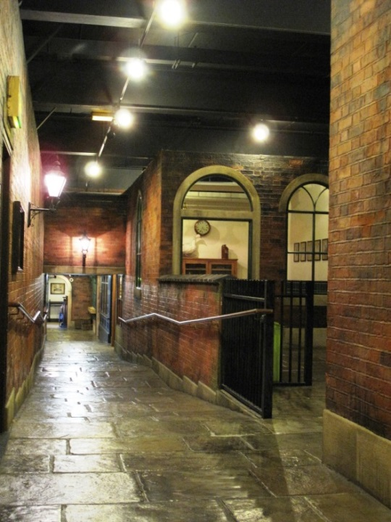
- The museum combines a lively modern interior with a peaceful canal side setting. It is an exciting family friendly museum, with something for all the family. Enjoy our temporary exhibition, and step back in time on our 1920s street (converted to a 1914-1918 street between 2014-2018), as the sights and sounds of bygone Tameside are brought to life. Take a look into our kitchen and parlour to find out how we used to live. Visitors can explore the area's industrial heritage and discover what life was like down the mines, or on the farm. Find out more about local crafts and industries and marvel at our historic machines. Younger children will love our 'Nuts and Bolts' educational play area, suitable for children under 5 located on the lower ground floor. The floor of which is of an even paving stone design with natural and artificial lighting throughout.
- A free tour of the museum is available by prior appointment for small groups.
- There is only 1 internal door on the lower ground floor, to the bottom of the stairs and outside the lift. This is a double 'fire' door which is reasonably light to open with a width of 148cm/58 ins. All the displays on the ground floor are accessible without going through any other internal doors.
- There is regular seating opportunities around all galleries with standalone chairs.
- The flooring on the ground floor is both grey short pile carpet and paving stones which are largely even and navigable by wheelchair users. The carpeted area of the main reception area declines gradually over a paving stoned street with horizontal handrails down each side. Some of the period 'sets', at the bottom of the street, have a wooden floor. The lower ground floor is paved throughout with a paving stone design but is largely even and navigable by wheelchair users with metal safety barriers around much of the industrial machinery on display.
- There are interactive touch screens located in the main foyer of the museum on the ground floor which can be accessed from a sitting or standing position.
- Interpretation boards are all in large text, and have pictorial representation where applicable. All are at a maximum top height of 190cm/75 ins from the ground.
- Lighting in the galleries is generally moderate and even with spot lighting. However, some areas are more dimly lit to aid preservation of the exhibits and to create period atmospheres.
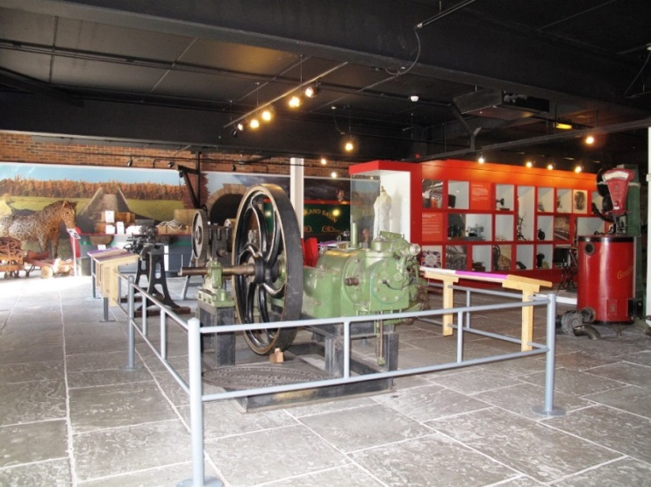
- Some background sounds compliment some of the period sets with automatic sensors in use.
- The doorways to each set are a width of 3 feet/92cm, with slight variation between them.
- Canal boat trips are operated by 3 independent narrow boat companies from immediately outside the museums' lower ground floor. Times and fares can be found from Tameside Canal Boat Trust on 07482188026.

Public Toilets
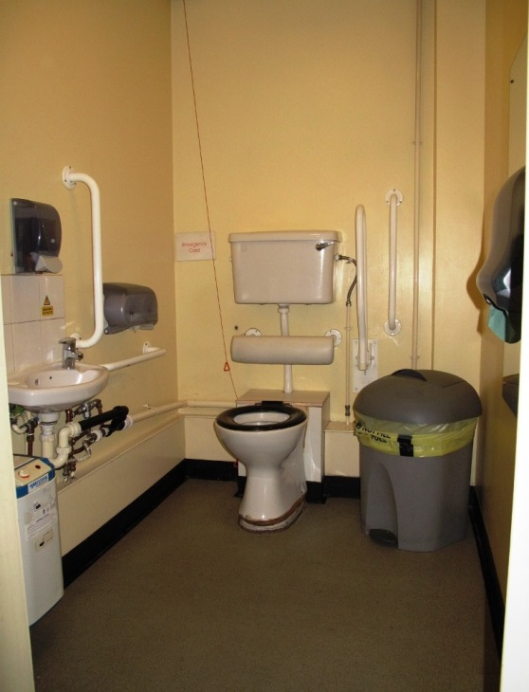
- Public toilets are located on the ground floor immediately to the left on entering the main entrance and are step/ramp free from the rest of the space. There are separate toilets for men and women with 6 cubicles in each.
- A unisex accessible toilet is located to the left of the main entrance on the ground floor. There is one door to pass through which opens outwards. The door width is 82cm/32ins and is light in weight to open.
- A further unisex accessible toilet, located on the lower ground floor is opposite the lift to the floor and at the bottom of the stairs leading down from the ground floor.
- Both unisex accessible toilets have large opening handles and grab rails (both fixed and drop down varieties).
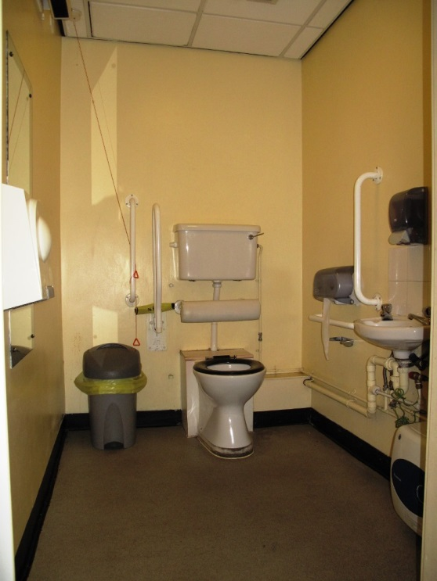
- A key is not required to lock/unlock either toilet.
- The sink in the ground floor accessible toilet is fitted with a lever style tap while the lower ground floor is fitted with mixer taps. Both accessible toilets have a paper towel dispensers, hand dryers and mirror as well as hand sanitiser. No dispensers are higher than 97cm/38ins from the floor. Both unisex toilets have an emergency pull cord.
- Both accessible toilets have a light switch to the left on entry.
- Clear directional signage is used to indicate locations of all toilet facilities.

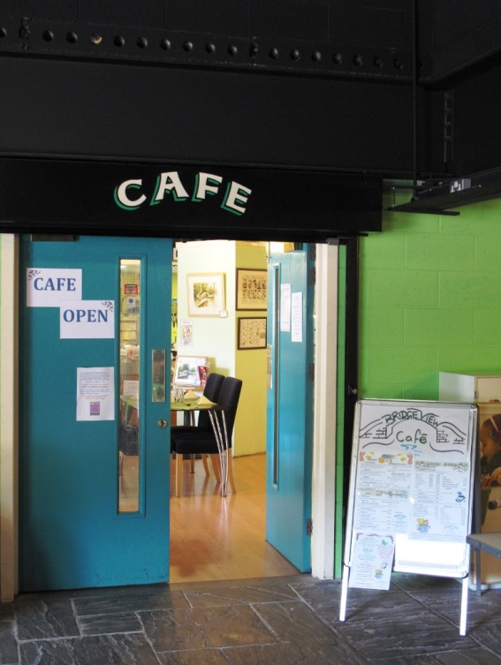
Catering
- Inside the museum there is a designated refreshments area, on the lower ground floor, where visitors can eat/drink their own food.
- The museum shop sells a small selection of confectionary which can only be consumed in the lower ground floor refreshment area.
- Lighting in all areas is a mixture of natural daylight and overhead spot lighting.
- A cafe adjoining the museum on the lower ground floor is operated independently of the museum. For latest details please call 'Bridge View Cafe on 0161 343 6785 or visit www.bridgeviewcafe.co.uk.
- The main entrance to the cafe, from the museum, measures 63"/160cm wide and is through double doors 1 side of which is always open when the cafe is open and through which there is level, ramp/step free access into the cafe.
- The cafe has approximately 14 tables and 50 free standing chairs without arms along with sofa seating for approx. 5 people. The clearance height of the tables is 29"/72cm and the tables are well spaced and can be reconfigured on request.
- The cafe space is well lit with a combination of ceiling spot lights and natural daylight.
- The light wooden laminate flooring is level throughout the cafe.
- Special dietary requirements can usually be catered for by prior request.
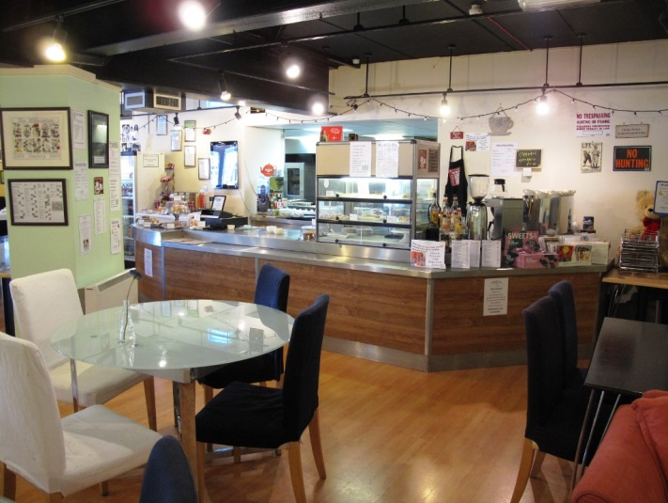
- Large print menus are available on request
- White crockery contrasts with the overwhelmingly dark wooden table tops.
- 2 high chairs are available on request.
- The cafe is counter-service but assistance is available on request with items carried to tables.
- Specials are written on the board behind the counter and staff can run through the menu on request.
- The cafe can also be accessed outside of the museum's opening hours via steps from outside the museum (approach to the right and side of the main museum entrance) and wharfside access to the rear of the cafe
Outside Seating Area:
- Through 2 double doors there is a designated cafe seating area. The full width clearance of these doors is 5 feet/153cm, opening outwards.
- This seating area contains 7 wooden benches with matching wooden and metal chairs which are very heavy to move.
- The clearance height of these tables is 25"/63cm
- The seating area is even and paved in natural stone.
The Cafe Toilets:
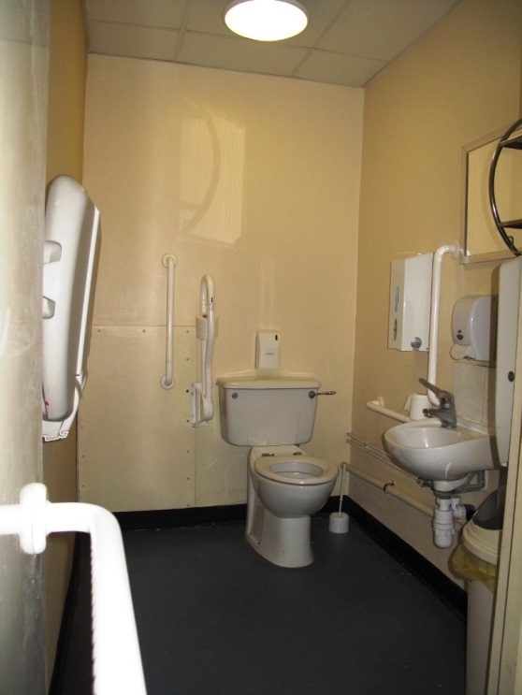
- The cafe toilets are through a 'fire door' accessible only from inside the cafe. This door opens inwards and is fairly light to move and the whole space is level, ramp/step free with blue vinyl linoleum flooring.
- There is a 'gents' toilet and a separate accessible/baby change/ladies toilet which are all well-lit from ceiling lights.
- The accessible toilet contains baby change facilities.
- The accessible toilet opens inwards with a horizontal grab rail on the back of the door. The width of the door is 32"/80cm wide.
- The height of the toilet from the floor is 18"/45cm and there is room on the left to maneouvre to the toilet from a seated position.
- The wash basin is 27"/70cm from the floor and there are 2 horizontal and 2 vertical grab rails. There is a hand sanitiser, paper towels and mirror.

Shop(s)
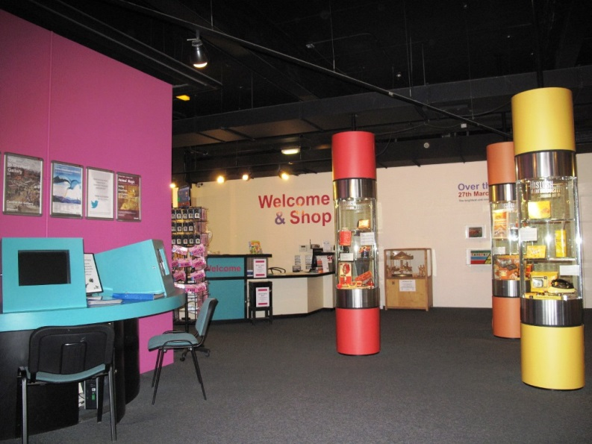
- There is a shop with a range of souvenirs and books etc. which can be accessed directly from the main entrance/reception area.
- The shop is level throughout.
- A low level desk & counter are provided.
- There is ample room within the shop for several large wheelchairs to manoeuvre and turn at the same time.
- There are tall display racks and other merchandise available from a seated position.
- There is often easy listening music playing across the reception area.
- Staff can offer assistance if required.
- We have a hearing loop system (please ask at the reception desk for details).
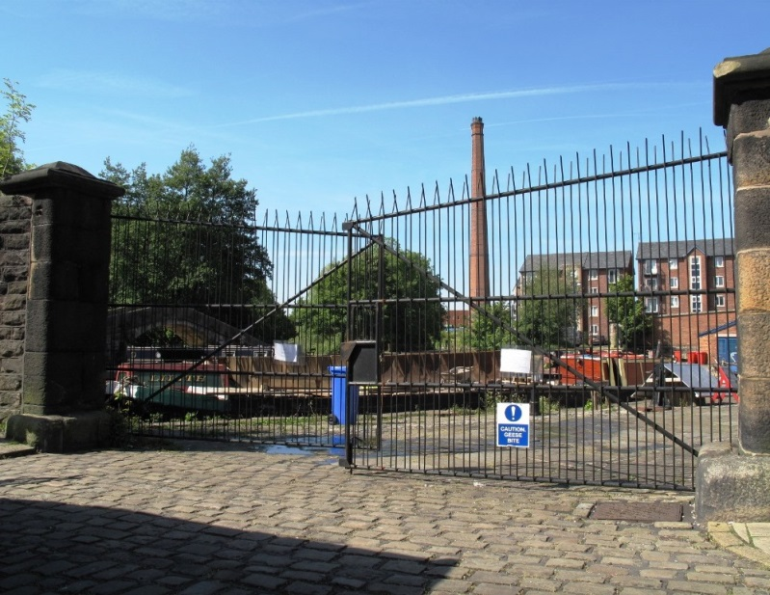
Grounds and Gardens
- Access to the wharf sides is via 2 large gateways that are approx. 12 feet/3.7metres wide and through which vehicles can drive by prior appointment.
- Access to the museum's lower ground floor, from the wharf sides, are via two 'push bar' double-doors which are open when the museum is open with a width of 5 feet/153cm.
- The rear of the museum's lower ground floor opens onto 2 wharf sides with fairly even paved stone flooring and cobbles with direct access to the canal.
- There is a small picnic area on the waterwheel wharf side along with a bicycle rack and wooden bench seating area.
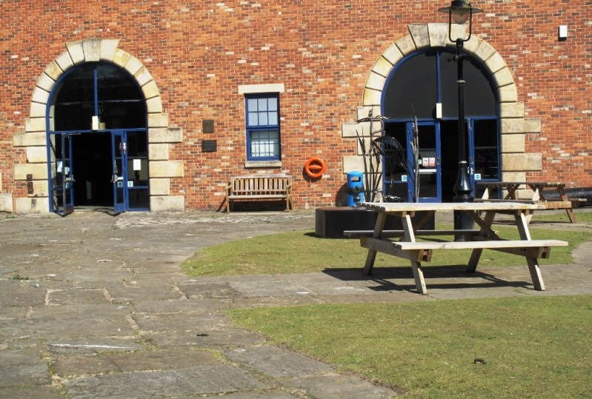
- A large number of Canadian Geese can be found on both wharf side areas and canal waterway at various times of the year making the area slippy and noisy at times.
- The main pathways are approx. 9 feet/ 275cms wide.
- Between pathways there are grass areas, which are fairly even underfoot.
Additional Information
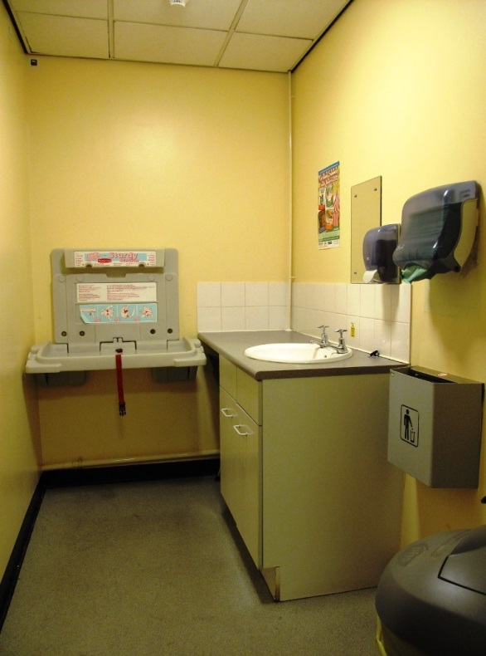
- There is a designated baby changing facility with level access from the main entrance to the museum on the ground floor level.
- Selected staff have received equality awareness training and dementia awareness training.
- We have a set of evacuation procedures – should you require it someone will assist you with evacuation out of the building.
- We welcome trained assistance dogs. A water bowl is available for assistance dogs on request.
- Reception staff can offer guidance on other local and regional points of interest.
- Clear signage is used throughout the museum using a variety of fonts, sizes and colour schemes.

Future Plans
- We constantly review the content of our website, endeavouring to make it as accessible as possible.

Contact Information
Address (Inc postcode): | Portland Basin Museum Portland Place Ashton-under-Lyne Tameside OL7-0QA.
Telephone: | 0161 343 2878
Email: | portland.basin@tameside.gov.uk
Website: | www.tameside.gov.uk/museumsgalleries/portland
Grid Reference: | SJ 934 986
Hours Of Operation: | Opening times: Tues-Sun, 10am-4pm. Closed Monday except Bank Holidays.
Local Accessible Taxi: | 1. Radio Cabs - 0161 330 2090. 2. Cavalier Radio Cars - 0161 338 5500. 3. Stamford Cars Uk - 0161 339 4411.
Local Public Transport: | 1. Transport for Greater Manchester - www.tfgm.com/Pages/default.aspx. 2. National Rail Enquiries - 08457 484950.

