**In Brief**

**Researching a Nineteenth Century Soldier**

This guide has been developed to help you research the service of a nineteenth century soldier. Only the more general and extensive records have been included.

Two useful databases for locating a soldier’s records are [**Ancestry**](http://www.ancestry.co.uk) and [**Findmypast**](http://www.findmypast.co.uk). Both are available to use at Tameside Local Studies   
& Archives free of charge.

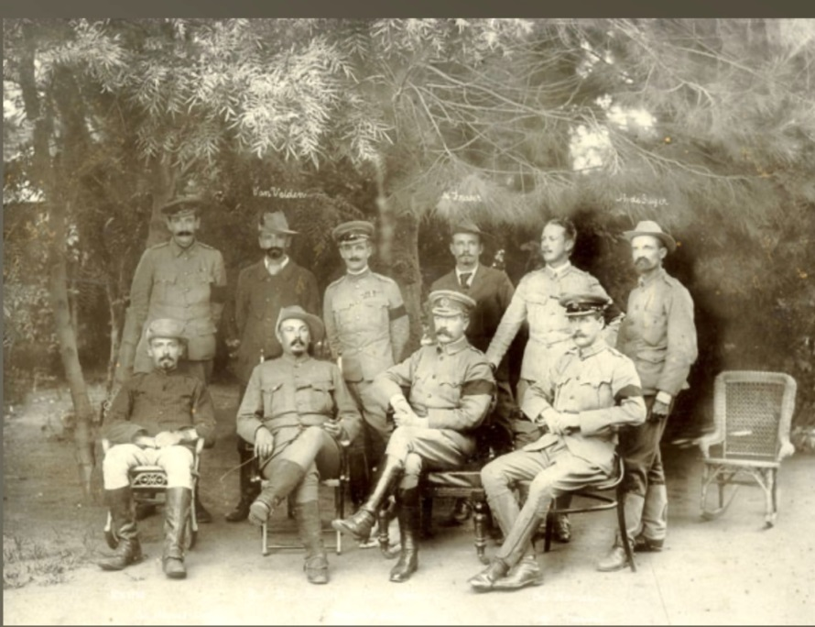Lord Kitchener and Boer Leaders with staff officers in 1901. Lord Kitchener and his fellow officers are wearing black armbands for the death of Queen Victoria.

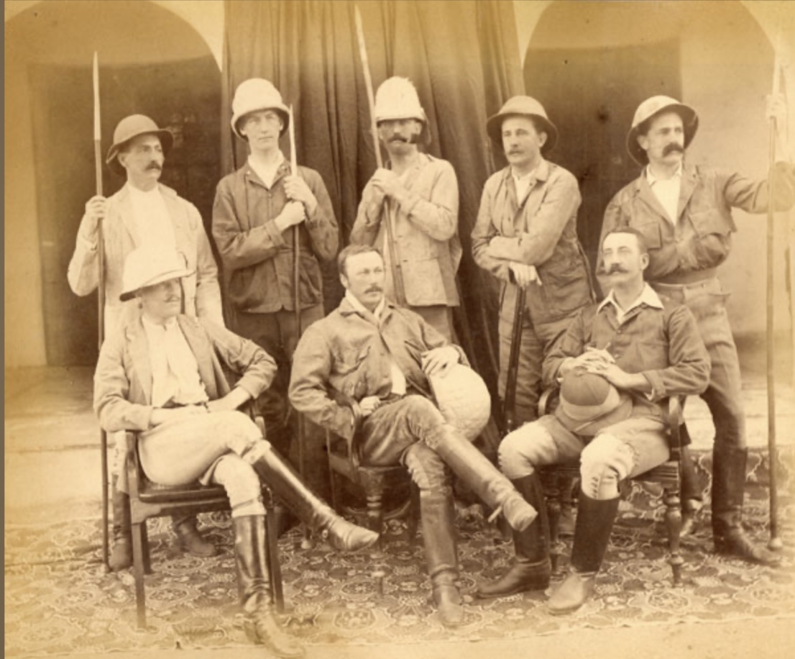

2nd Battalion officers in Agra, North West Province, India, 1889.

**British Army Officers**

**War Office: Annual Army Lists 1766-1879:** These are held at the [National Archives](http://discovery.nationalarchives.gov.uk/browse/r/r/C14273) on digital microfilm. The lists pertain only to records from the regular army and are arranged by regiment. Officer information includes name and commission. Free to access.

**Officers' Service Records 1764 - 1913:** These digitised records are held at the [National Archives](https://www.nationalarchives.gov.uk/help-with-your-research/research-guides/british-army-officers-1913/) and can be searched by the name of the officer. Free to access.

**Sandhurst Registers or the** **Register Volumes Collection 1783-1964:** This repository, held at the [Sandhurst Collection](https://sandhurstcollection.co.uk/online-collection/register-volumes?), contains records of each cadet who attended RMA Sandhurst during this period. The digitised personal records may contain name, attendance, date of birth, school attended, religion and family information. Charges apply for each record viewed.

[**British Army Officers' Widows' Pension Forms 1755 -1908**](https://search.findmypast.co.uk/search-world-Records/british-army-officers-widows-pension-forms-1755-1908)**:** This database is hosted by [Findmypast](https://search.findmypast.co.uk/search-world-Records/british-army-officers-widows-pension-forms-1755-1908) and comprises digitised material from the War Office now held by the National Archives: officers’ birth certificates, wills and personal papers. The widows’ pension applications include significant life events and family details and were completed when an officer died on active service or was on half pay. The collection can be searched by the name of the officer in question and may include the following: full name, place of birth, regiment, marriage and death date and the name of the spouse. Similarly, **UK, Pension Applications for Widows and Family of Military Officers, 1776 -1881** can be consulted on [Ancestry](https://search.findmypast.co.uk/search-world-Records/british-army-officers-widows-pension-forms-1755-1908).

[**Harts Army List 1840**](https://search.findmypast.co.uk/search-world-Records/harts-army-list-1840) **(Findmypast):** The annual ‘unofficial’ list was first started in 1839 by Colonel H. G. Hart. He was given permission to consult extensive military records as part of the compilation process. Over 40,000 names of officers are documented, together with their commission and service dates. The list is arranged by regiment and provides a brief service history plus details of medical staff, resignations and deaths, covering the period between 1839 and 1915. The **Harts Army List 1888** – also on [Findmypast](https://search.findmypast.co.uk/search-world-Records/harts-army-list-1888) – offers similar information.

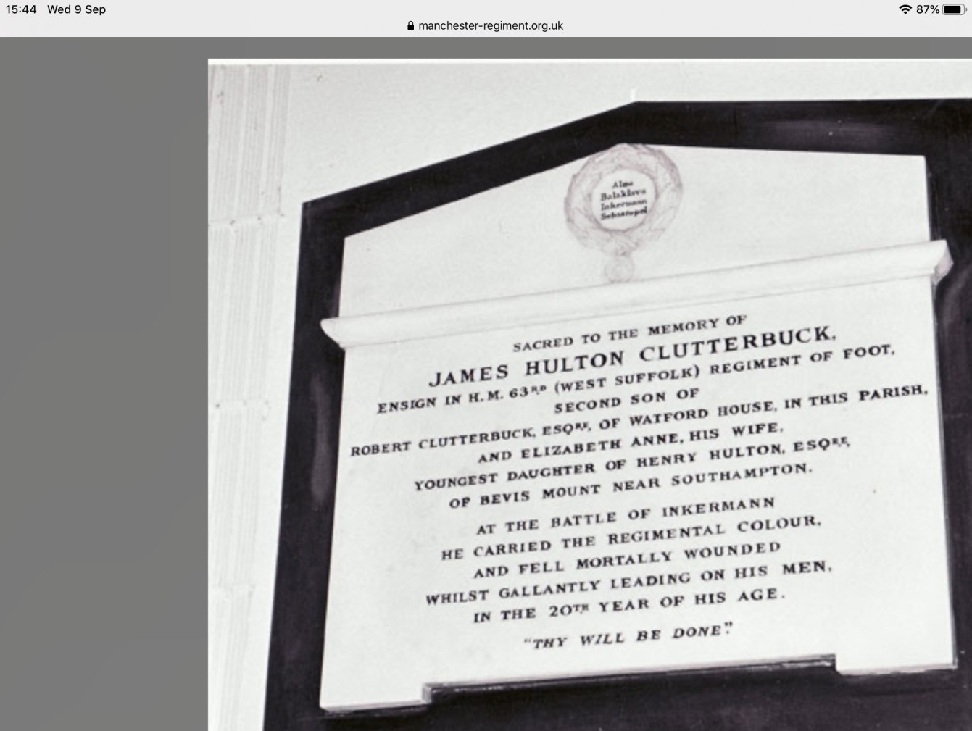

A memorial to Ensign James Hulton Clutterbuck of the 63rd Foot. He took part in the Crimean War in 1854 and was killed carrying the Regimental Colour at the Battle of Inkerman.

[**British Army, Army Lists 1839 - 1946**](https://search.findmypast.co.uk/search-world-Records/british-army-army-lists-1839-1946) **(Findmypast):** The first official record of British Army officers was started in 1702 in manuscript form with the first published list produced in 1740. This document comprising serving regular, militia and territorial army officers was an annual publication from 1754-1879 and published quarterly from 1879-1922. The information provided includes name, birth details, rank, unit and outline of service. From 1939 onwards the army lists are classified information and not available for public viewing.

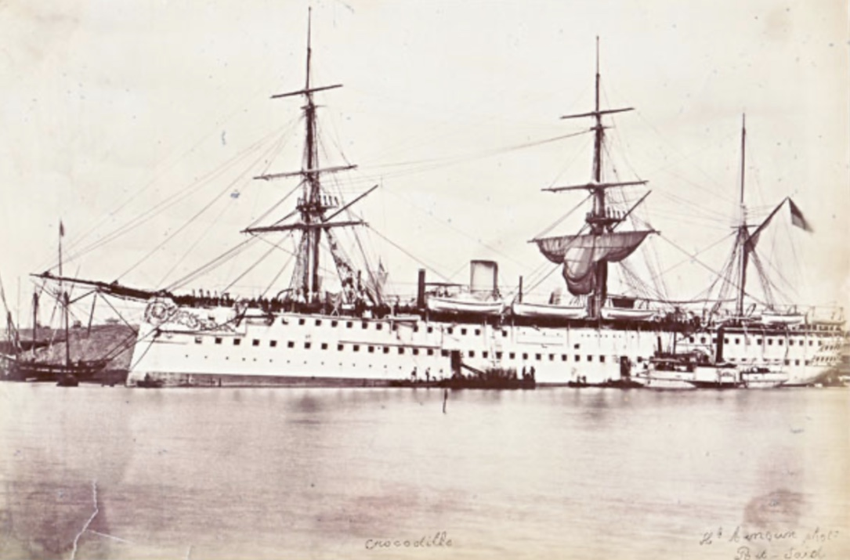 HMS Crocodile, commissioned in 1870. This ship carried the 96th Regiment of Foot from India to the UK in November and December 1873.

**Regular Army including Officers**

**Muster Rolls:** The **British Army muster rolls and pay lists c.1730-1898** are held at the [National Archives](https://www.nationalarchives.gov.uk/help-with-your-research/research-guides/british-army-muster-rolls-pay-lists-1730-1898/#2-what-were-muster-rolls) in annual volumes arranged by series. If a soldier did not receive a pension these records may be the only way of finding out personal information. It is necessary to know the name of the regiment before starting a search, with the exception of the muster rolls for the Battle of Waterloo where a name search can be carried out. The muster rolls were completed on a monthly and quarterly basis for pay and service purposes. They may give enlistment dates, service and discharge dates. A personal visit is needed to consult the original document. See also the **UK, British Army Muster Books and Pay Lists, 1812-1817** held by [Ancestry](https://www.ancestrylibraryedition.co.uk/search/collections/60546/).

**British Army Service Records, 1760 - 1939:** These documents on [Findmypast](https://search.findmypast.co.uk/search-world-records/british-army-service-records) have been compiled from a range of original sources. They are particularly useful for researching a nineteenth century soldier and include name, place of birth, service details, the date of attestation, pension and death date if deceased whilst on active duty. World War 1 service records on Ancestry must also be checked for details of pre- war service (if they have survived): [**UK, British Army World War 1 Service Records, 1914 - 1920**](https://www.ancestrylibraryedition.co.uk/search/collections/1219/)

**Anglo-Boer Records, 1899-1902:** A number of sources were used to compile these records on [Findmypast](https://search.findmypast.co.uk/search-world-Records/anglo-boer-war-records-1899-1902). The information provided covers name, service number, unit regiment, medals and awards, casualties and memorials.

**Courts martial and desertion in the National Archives 17th-20th Centuries:** The [National Archives](https://www.nationalarchives.gov.uk/help-with-your-research/research-guides/courts-martial-desertion-british-army-17th-20th-centuries/) holds a wide range of court martial records. Some have been digitised. Others require a visit in person or order for the documents to arrive digitally or by post. Charges apply.

**UK, Military Deserters, 1812-1927:** This [Ancestry](https://www.ancestry.co.uk/search/collections/60961/) resource has been mainly compiled from the Police Gazette publication. The information held preserves name, place and date of birth, service details and desertion penalty.

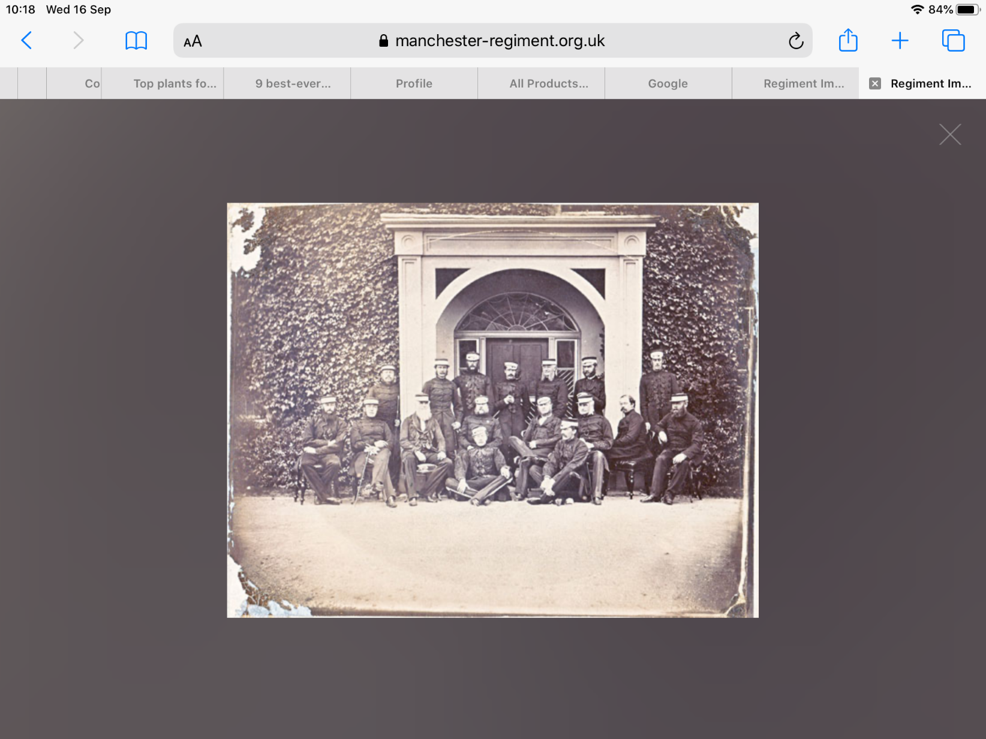

A group of instructors or staff officers at the School of Musketry, Hythe, Kent. Circa 1860.

**Army Deserters 1828-1840:** This [index](https://search.findmypast.co.uk/search-world-Records/army-deserters-1828-1840) covers over 35,000 British born soldiers. Desertion was relatively common during this period especially amongst younger recruits. The punishment was either flogging or branding. Many men were recaptured or returned voluntarily.

**British Campaign, Gallantry and Long Service Medals:** This set of records held by [Findmypast](https://search.findmypast.co.uk/search-world-Records/britain-campaign-gallantry-and-long-service-medals-and-awards) covers the various branches of the Armed Forces and was created from a range of sources. The information provided may include name, date, occupation, medal, cause of injury and/or death depending on the original record. [Ancestry](https://www.ancestrylibraryedition.co.uk/search/collections/1686/) provides a similar database (**UK, Military, Campaign Medal and Award Rolls, 1793 - 1949).**

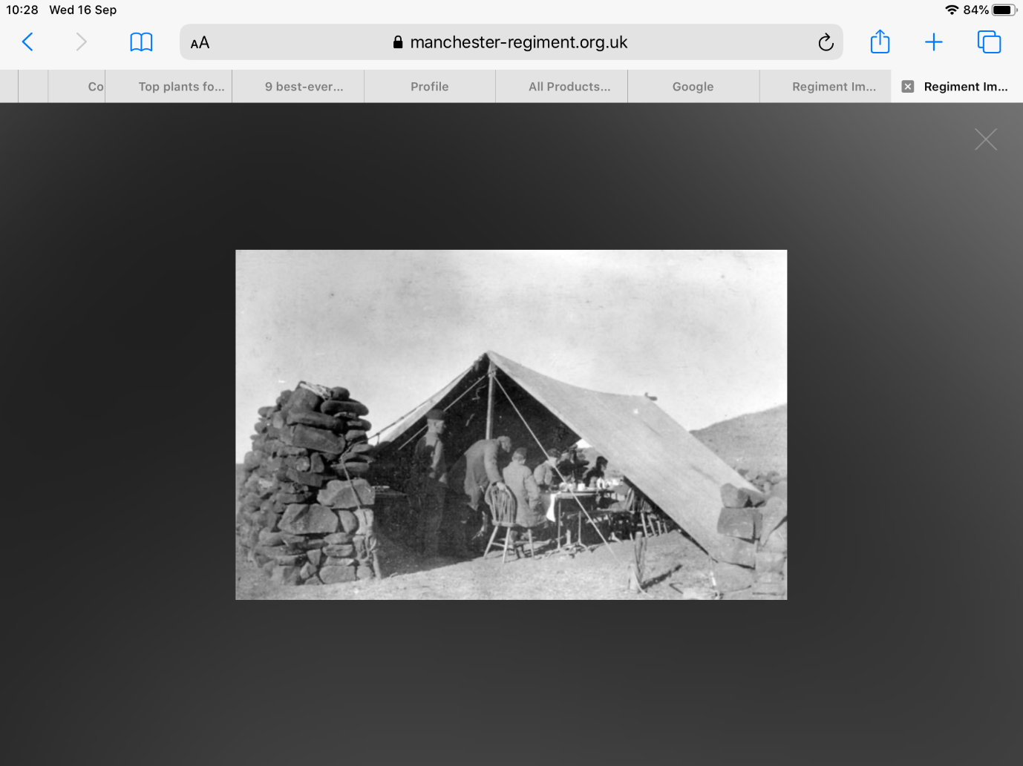Officers’ mess on the Veldt in South Africa circa 1900.

**British Army, Worldwide Index 1841:** This [index](https://search.findmypast.co.uk/search-world-Records/british-army-worldwide-index-1841) is derived from muster rolls and pay lists between April and June 1841. Taken from both British Army regiments and the East India Company’s own armed forces, the information provided includes name, rank and location of the regiment at that period. Similar sources (without the East India Army Company records) are the [**British Army, Worldwide Index 1851**](https://search.findmypast.co.uk/search-world-Records/british-army-worldwide-index-1851)and[**British Army, Worldwide Index 1861**](https://search.findmypast.co.uk/search-world-Records/british-army-worldwide-index-1861)**.**

**Royal Hospital Chelsea: Length of Service Pensions:** The admissions books from 1823–1920 have been digitised at the [National Archives](http://discovery.nationalarchives.gov.uk/details/r/C14325) and can be searched by keyword. A range of information is provided depending on the date of the admission book. From 1857 detailed service records are included.

**British Armed Forces and Overseas Baptisms:** A range of digitised sources from the General Register Office and the National Archives make up this [collection](https://search.findmypast.co.uk/search-world-Records/british-armed-forces-and-overseas-births-and-baptisms). Records include details about families of military personnel and the registration of British Armed Forces posted overseas. Documents preserved date from 1761–2005, although not all relate to the military.

**British Armed Forces and Overseas Deaths and Burials:** This [database](https://search.findmypast.co.uk/search-world-Records/british-armed-forces-and-overseas-deaths-and-burials) is made up from a number of different sources and includes both civilian and military personnel. It dates from 1796 and may include all of the following – name, birth and death dates, place and details of active service.

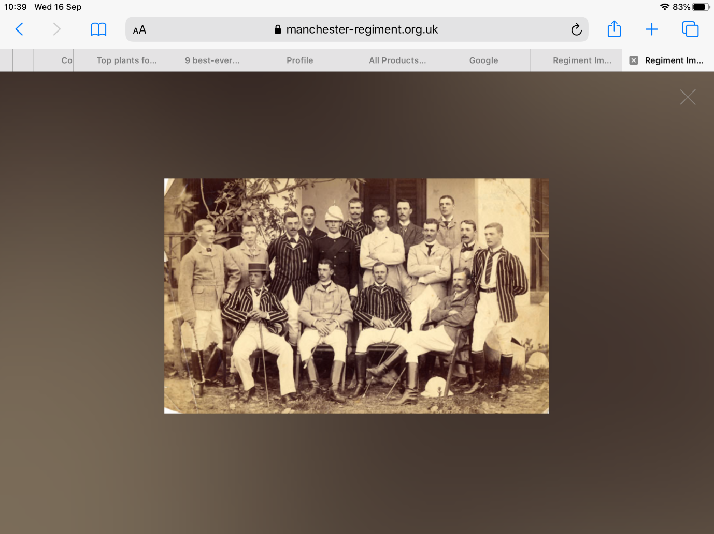Subalterns of the 2nd Battalion Manchester Regiment in 1894, Dinapore, India.

**UK, Casualties of the Boer War, 1899-1902:** This list maintained by [Ancestry](https://www.ancestrylibraryedition.co.uk/search/collections/1912/) (and also available on Findmypast) includes details of over 54,000 soldiers who were wounded or killed in the Boer War. For the first time soldiers and their families were listed on the census. Statistics show that 264,000 officers and other ranks were included on forms completed by census enumerators.

**Soldiers’ Wills:** Most soldiers made wills before embarking on a military campaign. Before 1858 the wills were mainly proved at the Prerogative Court of Canterbury (PCC) in London. These have all been indexed and can be viewed through the [**Online Records Service**](https://www.nationalarchives.gov.uk/help-with-your-research/research-guides/wills-1384-1858/) at the National Archives. Charges apply. After 1858 a national system was established with district probate registries. The latter records are available on Ancestry under [**Wills & Probates, Estate and Guardian Records**](https://www.ancestrylibraryedition.co.uk/search/categories/clp_wills/). Copies of wills can be ordered by post from [**Leeds District Probate Registry**](https://www.probateforms.info/leeds-district-probate-registry/) at:

York House,

31 York Place

Leeds

LS1 2ED.

**UK, Army Registers of Soldiers' Effects, 1901-1929:** These documents can be found on [Ancestry](https://www.ancestry.co.uk/search/collections/60506/) and have been digitised from the archives held by the National Army Museum. The information provided includes name, service number, date of birth and death, trade and next of kin. Earlier records relating to the periods 1862–1880 and 1880–81 are held at the National Archives under WO25/3475-3501.

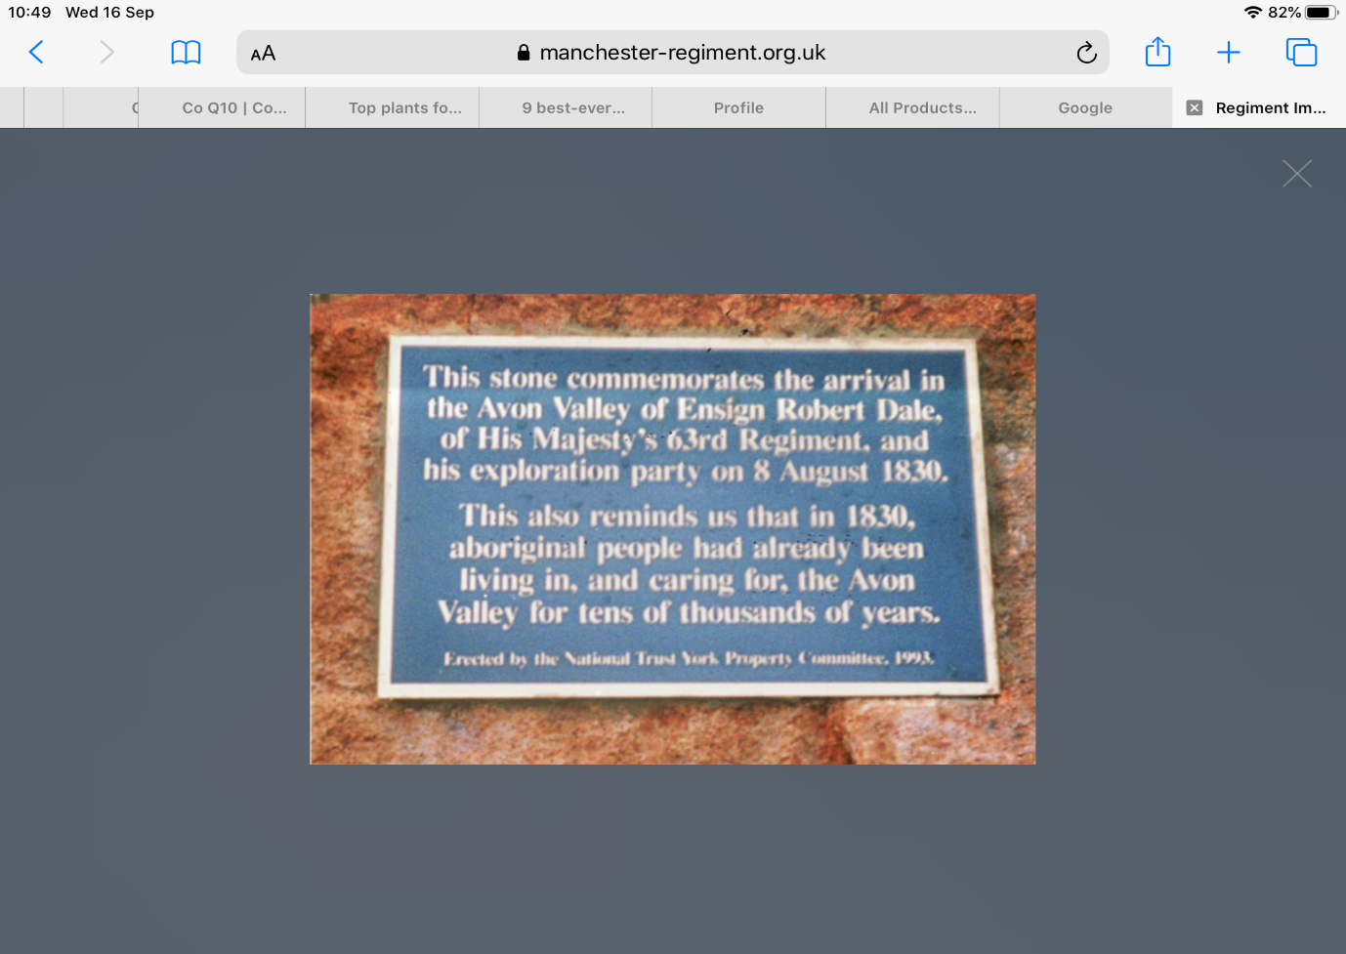

This plaque commemorates the arrival of the British in the Avon Valley near Perth, Western Australia.

**Royal Hospital, Chelsea: Disability and Royal Artillery Out-Pensions Admission books:** These [records](http://discovery.nationalarchives.gov.uk/details/r/C14324) date from 1715–91 and include the details of soldiers either in the regular army or militia who were discharged from active service and given a disability pension. The information held preserves name, age place of birth, service and discharge.

**UK, Royal Hospital Chelsea Pensioner Admissions and Discharges, 1715 - 1925:** From the 1860s the pension administration centre for the British Army was based at the Royal Hospital, Chelsea. Some soldiers relinquished their pensions and became inmates at the hospital, whilst many more lived an independent life outside the hospital and were in receipt of an out-pension. This particular set of records only covers soldiers who served for at least twelve years. The information held contains a personal description, with both service and discharge details. The index can be viewed as usual at [Ancestry](https://www.ancestry.co.uk/search/collections/60917/), but an All Access Subscription is required to peruse the record in full.

**Records of Militia Regiments:** These 568 volumes date from 1759–1925 and are held at the [National Archives](http://discovery.nationalarchives.gov.uk/details/r/C14276). A personal visit is required for consultation. The records consist of enrolment books, pay lists, officers’ returns, statistics, court martial records, birth, baptism and marriage records. The militia was a reserve force dating from 1757 up to 1881 when the Childers reforms reorganised the British Army.

[**The Gazette**](https://www.thegazette.co.uk/awards-and-accreditation/ww1)**:** This journal, founded in 1665, combines the London, Belfast and Edinburgh official journals of record. Search online for information on despatches, officer appointments and promotions, medal awards and citations.

[**British Newspaper Archive**](http://www.britishnewspaperarchive.co.uk/)**:** This database contains a wide range of local and [national newspapers](https://www.britishnewspaperarchive.co.uk/) often publishing military obituaries and accounts of combat. Access is through pay-per-view or subscription. Alternatively, a search can be carried out through [**Findmypast**](http://www.findmypast.co.uk/).

**Next Steps**

**1.** Visit the [**Wellcome Librar**y](https://wellcomelibrary.org/collections/archive-guides/war-and-medicine/) to view material on the British Army and medical matters in the nineteenth century.

**2.** Explore the [**Templer Study Centre**](https://www.nam.ac.uk/collections/templer-study-centre). This is a research facility open to the public. Visiting and pre-ordering is by appointment only via the following email address: [info@nam.ac.uk](mailto:info@nam.ac.uk). The centre holds an extensive range of regimental and campaign histories.

**3.** Have a look at the online exhibition commemorating the Battle of Waterloo (‘The Nearest Run Thing You Ever Saw’) curated by King’s College, London.

**4.** Consult the website [**AngloBoerWar.com**](https://www.angloboerwar.com/). Established by a military historian, this resource provides a useful background to the conflict through a range of articles. Other information includes medal awards with lists of individual names.

**Further Reading**

Fowler, S. (2017) *Tracing Your Army Ancestors*. 3rd ed. Barnsley, Pen and Sword.

Robinson, J. M. (2016) *Tracing Your Boer War Ancestors*. Barnsley, Pen and Sword.

Murphy, G. (2009) Where Did That Regiment Go? Cheltenham, The History Press.

09/20