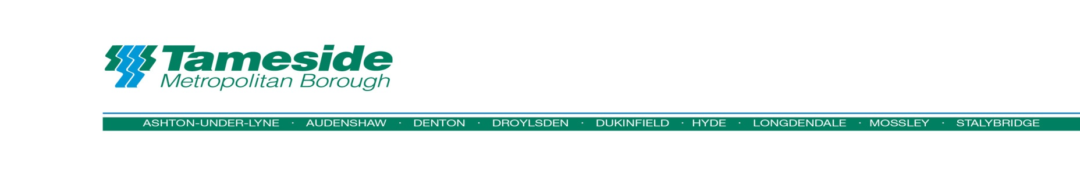
BUSINESS RATES RETAIL DISCOUNT APPLICATION

Full Details of Applicant
Name of ratepayer:
Address of Property for which relief is sought:

Correspondence address:

Business Rates account number:
Email address:
Telephone Number:

Declaration
I can confirm that the following qualifying criteria is met in respect of the Business Rates liability as detailed:
- The business premises are occupied
- The business premises rateable value is less than £51,000
- The business premises are used for the sale of goods, provision of a listed service (details can be found at www.tameside.gov.uk/business/rates or used for the sale of food and/or drink to visiting members of the public.
Qualification is subject to state aid rules (see below), please complete below declaration
Signed…………………………………… Print Name……………………………………………..
Business Role…………………………………..Date……………………………..

State Aid Rules
To establish whether you are eligible to receive De Minimis Aid, you must declare the full amount of De Minimis Aid which you have already been granted during the previous two fiscal years and the current fiscal year. Any assistance that may have been received from any public body might be a De Minimis Aid. This could be from Central, Regional, Devolved Governments (or agencies) or a Local Authority.
Please complete the statement of previous aid received under the De Minimis exemption (below) and arrange for a director of your business to sign the declaration. This information will be used to assess your eligibility to receive rate relief.
Statement of previous aid received under the De Minimis Exemption
I can confirm that ……………………………………………………has received the
following De Minimis Aid during the previous 3 fiscal years (this being the current fiscal and the previous two fiscal years)
Value of Aid received:

Date of Aid received:

Nature of Aid:

Name and address of organisation providing the Aid:

IMPORTANT NOTICE
It should be noted that Tameside Metropolitan Borough Council must be notified immediately of any assistance or aid subsequently received by the applicant under the De Minimis exemption.
DECLARATION:
I hereby certify that full details of any assistance received under the De Minimis exemption have been declared on this form and, if none have been entered, it is confirmed that no such awards have been made to the applicant. I also certify that the particulars given are correct and I am aware that if incorrect information is supplied, it will invalidate an award and may constitute a criminal offence.
Signed:
Print Name:

Business Role:
Date:

Further information regarding relief
The Council will not grant relief where the business is deemed to have a detrimental impact on neighbours and communities.
The individual merits of each application will be considered taking account whether the business supports the Council’s wider objectives.
The Council reserves the right to decline an application or withdraw any relief granted where it is appropriate to do so, and particularly where a business has had their licence to operate reviewed or refused in the last 12 months. Where such an event arises the business ratepayer will be advised in writing.
Section 47 of the Local Government Finance Act gives Tameside Council the billing authority discretion to reduce the payment of non-domestic rates. Guidance has been provided by the Department for Communities and Local Government (DCLG) but it is for each authority to exercise its own powers under this provision. All applications are processed in line with the Councils Discretionary Rate Relief Policy.
Any award of relief is subject to the provision contained in De Minimis Regulations (EC 1407/2013) and governed by the limits included in these regulations.

The completed application form should be returned to:
Business Rates Service
Tameside Council Offices
PO Box 304
Ashton-Under-Lyne
OL6 0GA
Email: businessrates@tameside.gov.uk

