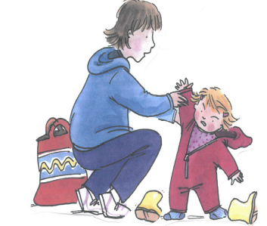

TAMESIDE & GLOSSOP EARLY ATTACHMENT SERVICE
ARE
PRESENTING A ONE DAY TRAINING COURSE
ON

TODDLER DEVELOPMENT

We will explore:

Normal Toddler Development
Typical Parent/Toddler Conflict
When to be Worried and the Approach that You Can Use

This training would be best suited to people who have completed the 2 day Early Attachment Training

This training will be held on:

Tuesday, 20 June 2017
9.15 a.m. to 4.00 p.m.

at:

Greenside Lane Children’s Centre
Droylsden

Please contact Jakki Minton (j.minton@nhs.net) to book a place

