Tameside & Glossop Neonatal Mental Health Pathway for Parents & Infants - briefing to healthcare professionals
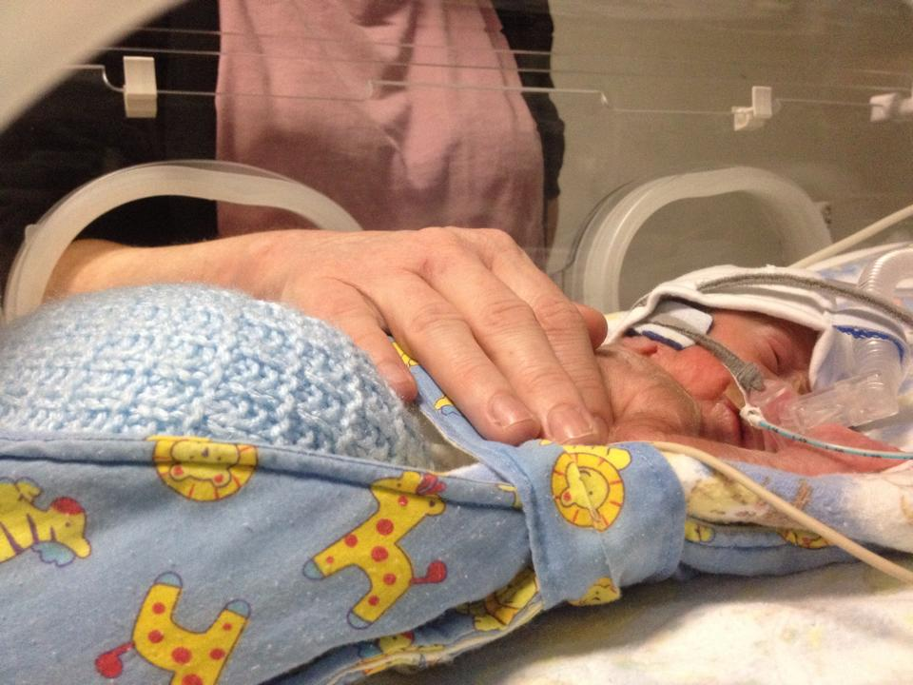
Dear colleagues
We would like to introduce the new neonatal mental health pathway, which has been developed with the contributions and collaboration of families and colleagues from different services.
It aims to promote and support the mental and emotional health of parents of neonatal care babies, the babies themselves and their families.
We recognise the stress and worries associated with having a baby who needs neonatal care and also the longer-term outcomes for these children.
We can provide support from admission to the neonatal unit and until the child is 5 years old.
Parents and partners may have had a difficult pregnancy or traumatic birth, struggling with being separated from their baby or struggling with the transition to parenthood. Mental health issues can also be a worry either pre-existing or as a result of these experiences.
Babies born prematurely or unwell need neonatal care and this increases the need for their parent’s presence more than ever. However this is often disrupted because of the need for medical intervention.

Specialist support is available via the Early Attachment Service. If you think a family/parent/ infant would benefit from our service in relation to their neonatal experience please give us a call on 0161 716 3569 (EAS)
The Maternal Mental Health Service can also offer psychological support specifically for women and families affected by their maternity experience including loss. Please give us a call on 0161 271 0188, option 4 (MMHS)
Spoons is a charity that supports families who experience neonatal care in Greater Manchester. For more information contact care@spoons.org.uk

