Annotating PDF’s on the iPad.

There are various apps that allow PDF files to be annotated, the following shows how to annotate using the Books app.

- Ensure Books app is installed / updated on the iPad

- Open the PDF you want to annotate using the Books app

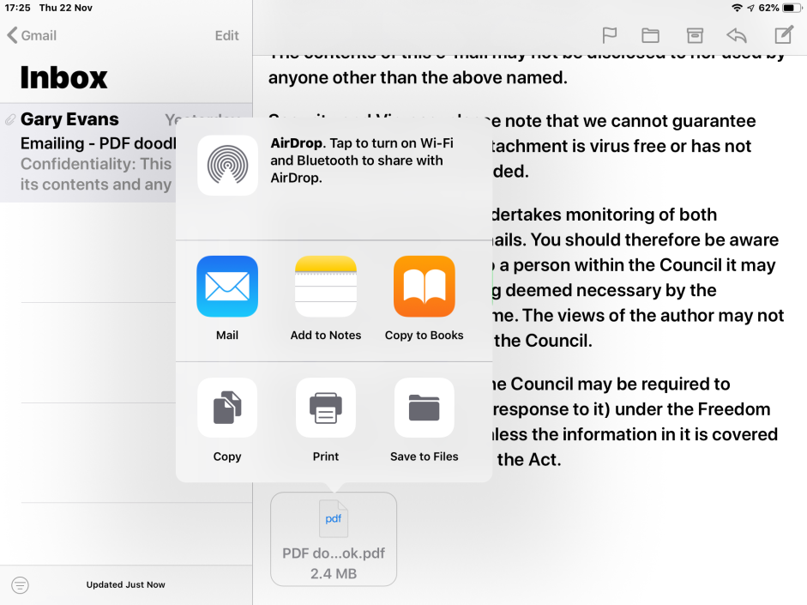

When it opens in Books select the pen icon

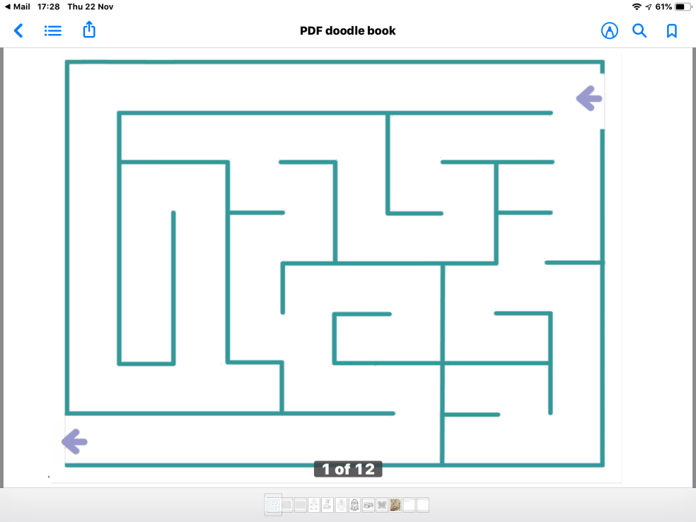
You will then see a selection of drawing tools at the bottom of the screen.

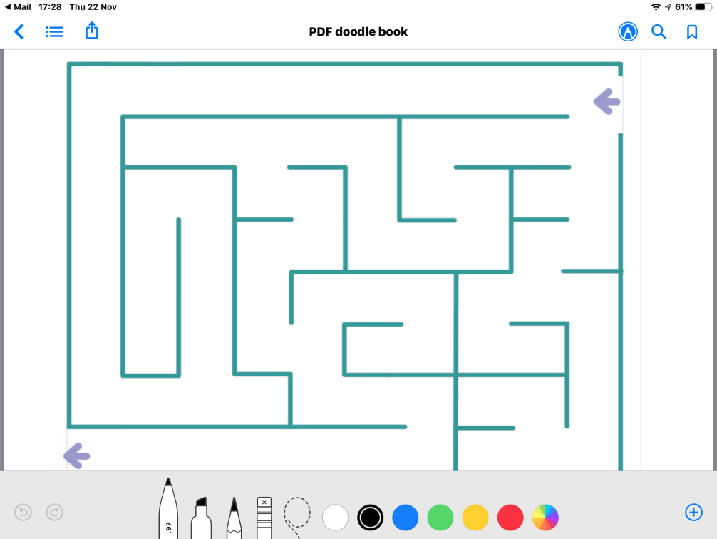

The tools include a pen Highlighter

Pencil Eraser Selection tool
Selecting the pen, highlighter or pencil twice will allow you to choose how thick and how dark you want it to appear.

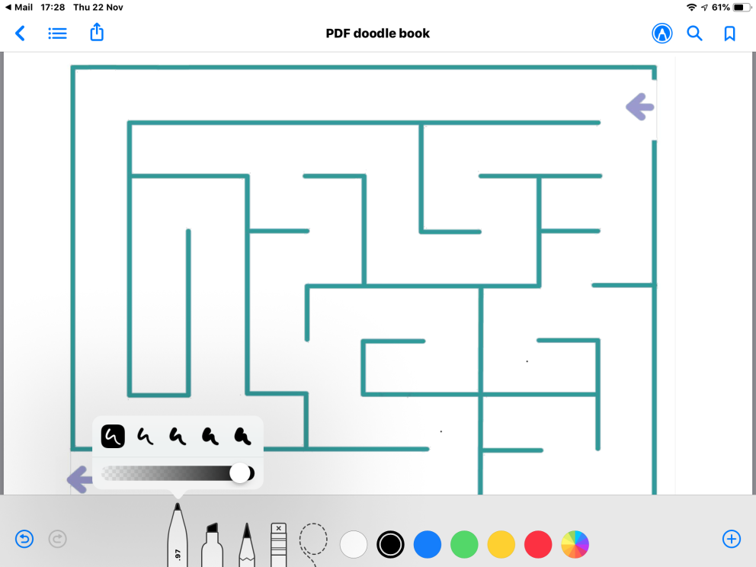

Different colours can be selected including a colour palet.

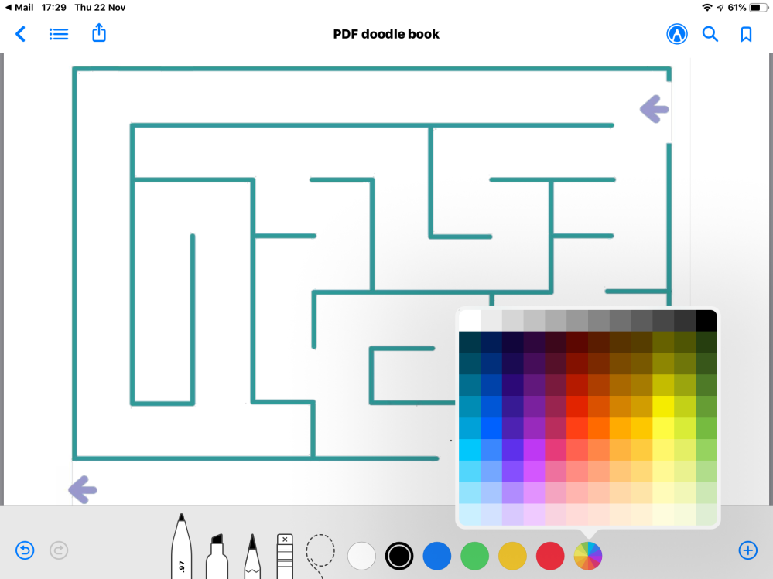

Using the selection tool you are able manipulate what you have added to the PDF by simply drawing round what you want to change.

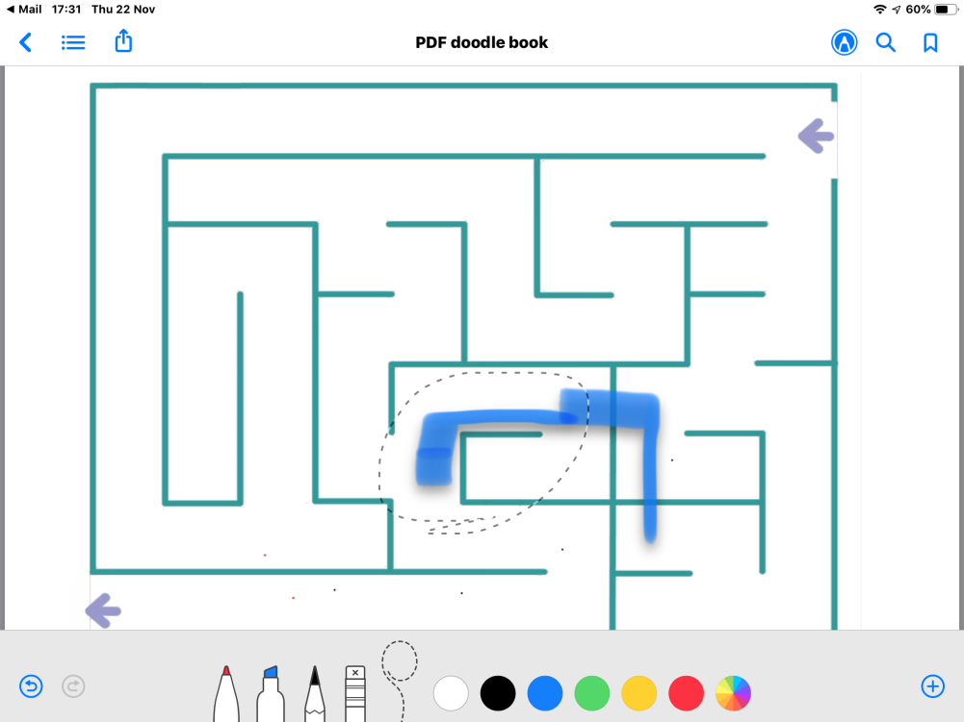

Then you can choose to Cut, Copy, Delete or Duplicate.

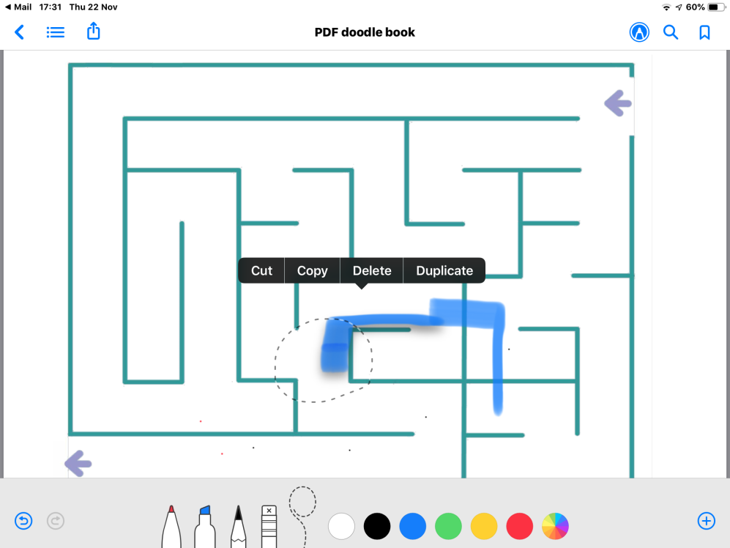

On the right hand bottom corner of the screen there is a plus sign in a circle that brings up a menu to add Text, Signature, Magnifier and a small selection of shapes.

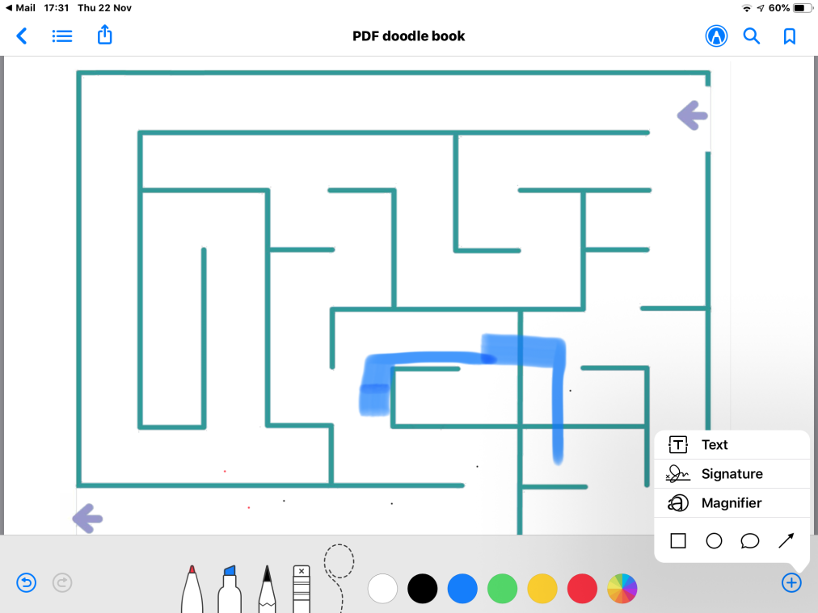

Adding text.

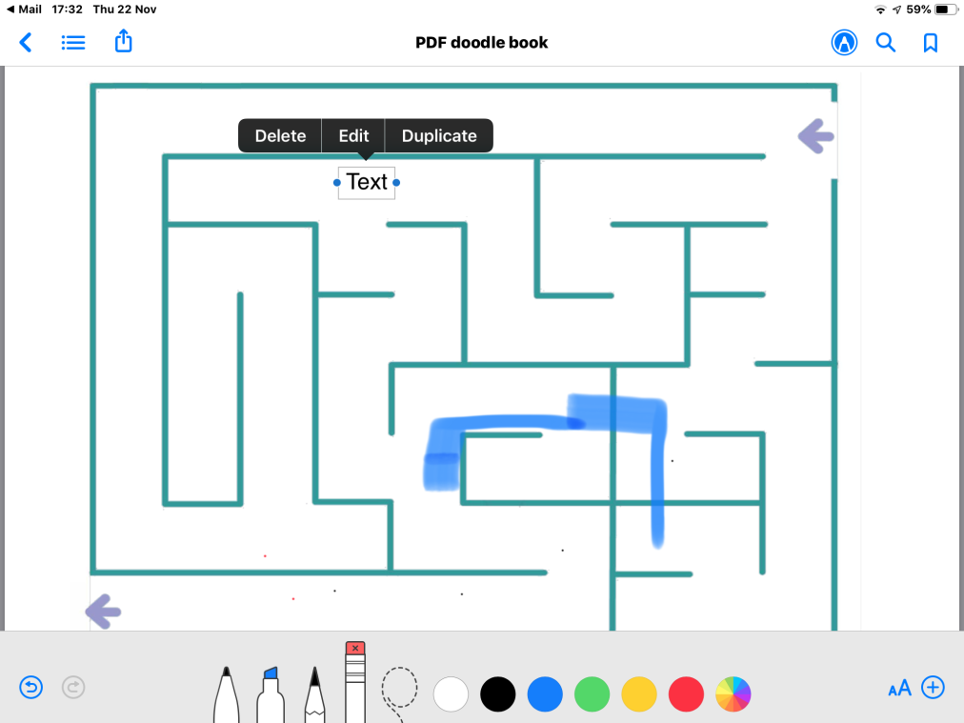

After the text has been added.

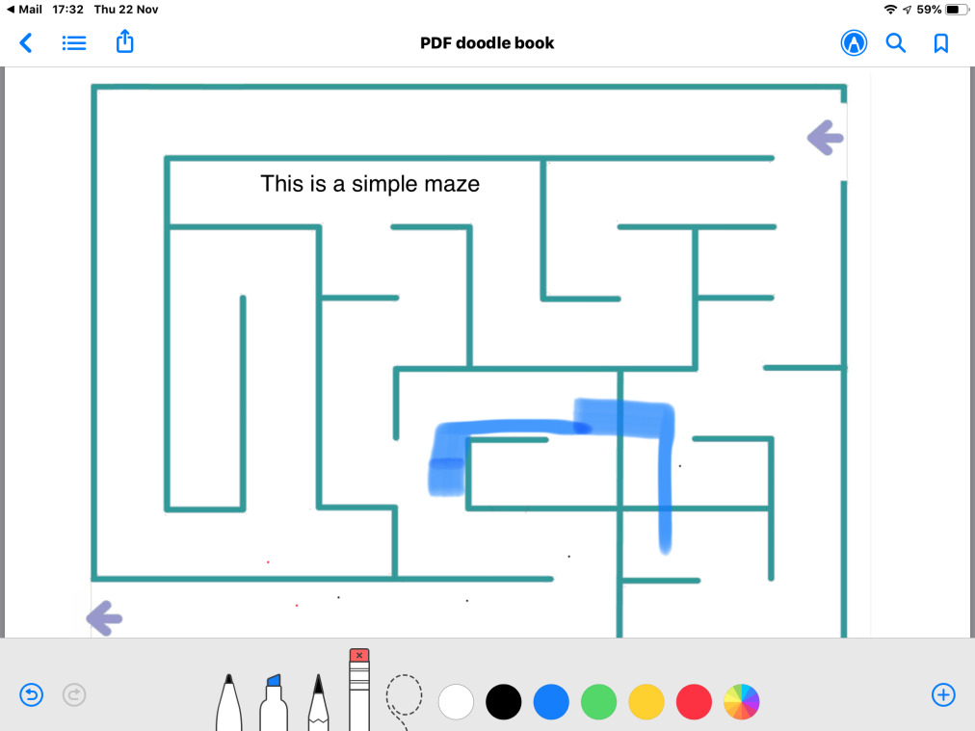

Adding signature.

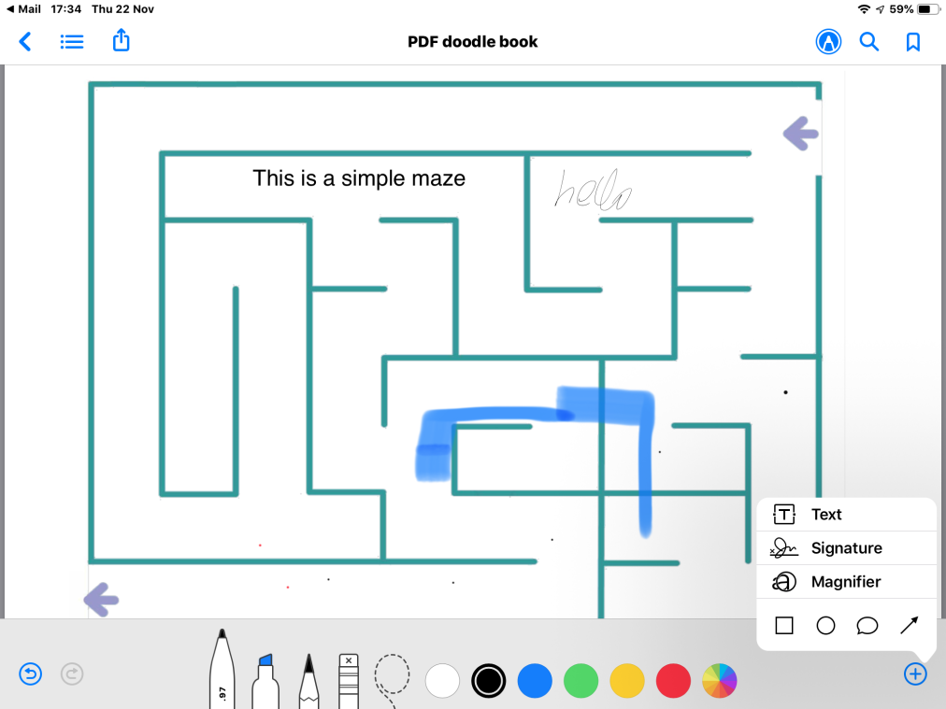

Multiple magnifiers can be added.

