Setting up Kindle app on an iPad and accessing send to Kindle email address.

- Install Kindle app on iPad
- Login using Amazon account
- From the Kindle app home screen select MORE

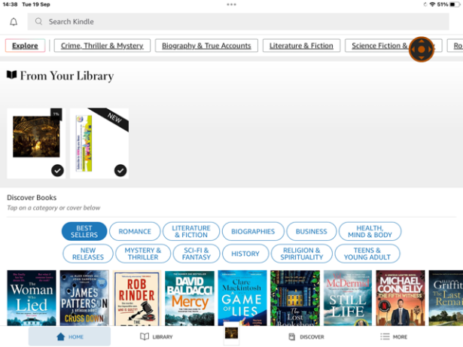

- Select Settings

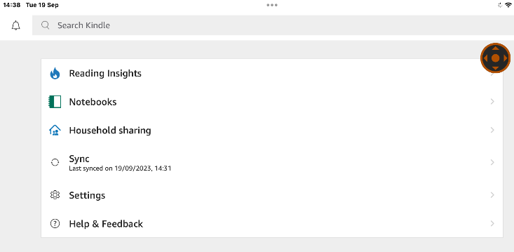

- Send to Kindle email address is shown on this screen

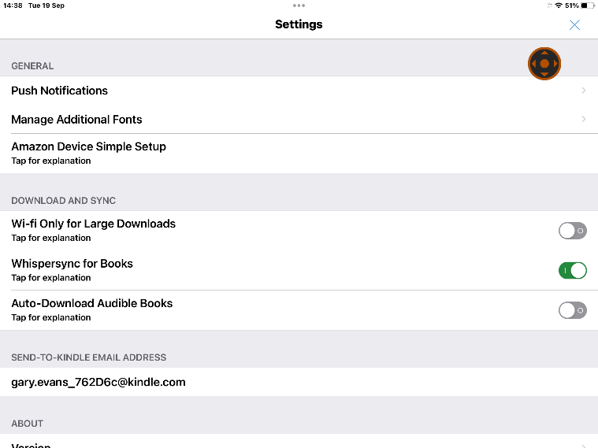
joe.bloggs

Checking for new document

- From the Kindle app home screen select MORE

- Select Sync

Any new documents should then appear on your home screen.

