Delivering services differently in response to Covid-19
Youth Clubs and some other public facing buildings have been closed since Thursday 19 March 2020 as Tameside Council works to protect the community and redeploy its workforce and resources to deliver essential services differently in response to Covid-19 (Coronavirus).
Tameside Council Executive Cllr Brenda Warrington said: “Clearly this is a step which we would avoid if at all possible, however our duty to protect the public and our workforce and to follow government guidance has to take precedence".
Tameside Youth Service is still providing services as detailed below:
Tameside Youth Council is continuing to meet using a virtual platform. If you wish to join Tameside Youth Council, to represent the voice of young people, please email:
Melissa on Melissa.hopwood@tameside.gov.uk
Katrina on Katrina.perry@tameside.gov.uk
Due to the closure of our buildings, our Youth Workers are out doing detached across Tameside. If you would like a catch up with a Youth Worker please text the number next to the area you live in. A member of staff will text you back to arrange a time and place with you:
Mossley, Monday evening Text Paul on 07583000543
Ashton Town Centre & West End, Tuesday evening Text Diane on 07971599414
Hyde, Dukinfield, Stalybridge, Tuesday evening Text Paul on 07583000543
Denton & Haughton Green, Wednesday evening Text Diane on 07971599414
Audenshaw & Droylsden, Wednesday evening Text Karen on 07970467277
Local Parks, Wednesday afternoon, Text Paul on 07583000543
Stalybridge, Ashton, Denton, Thursday evening Text Riz on 07866934830
Hurst Cross, Broadoak, Ashton Town Centre, Thursday evening Text Paul on 07583000543
Hattersley, Hyde, Thursday afternoon, contact Karen on 07970467277
Tameside Youth Service is now on Instagram, check it out and follow us.
We are setting weekly challenges for young people to get involved in, as well as an opportunity for you to learn new skills or contact a Youth Worker.
You can also keep up to date with Government announcements and how this may affect you.
As well as try out some of our quick and simple cooking ideas.
Keep you to date with what is happening and different ways to get involved.

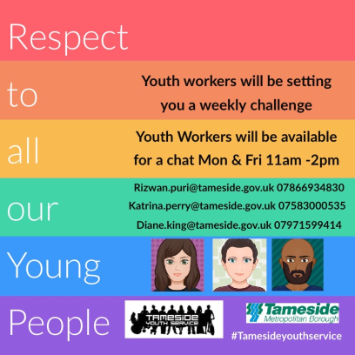

We are currently working on our summer programme, keep checking in to stay updated

