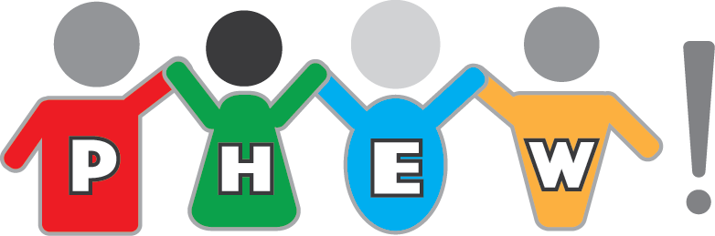

**(P**hysical **H**ealth and **E**motional **W**ellbeing!)

PHEW! is an organisation with charitable objectives with the aim of supporting families with a child/young person who is struggling with physical health problems, and/or emotional difficulties which are making them ill.

**Training event:**

**Understanding and managing anxiety in young people**

**Facilitated by Dr Joy Harris, Consultant Clinical Psychologist and guest speakers (to be announced).**

**On Monday 25 April 9am-4.30pm at the 4C Community Centre, Taunton Road, Ashton-under-Lyne OL7 9DR**

**Prebooking is essential as there are limited places**

**Come along and learn more about anxiety in young people, with workshops looking at anxiety and trauma, challenging behaviour, neurodevelopmental difficulties, and other conditions comorbid with anxiety. Browse our information stalls and discuss where help and further advice is available**

Tickets = £3 per person, this includes entry to the workshop and tea/coffee/cold drinks. Please email Dr Joy Harris on phewspdw@gmail.com to buy tickets.

**This event is open to children and families, and also to professionals in health, education and social care.**

Our assistant psychologists will be organising craft activities at the back of the Hall for younger children so parents and older children can concentrate on the workshop

**(P**hysical **H**ealth and **E**motional **W**ellbeing!)