Greenhouse Gas Report – 2021/22
- Introduction

A requirement from Government is for Local Authorities to publish their greenhouse gas emissions in the form of a greenhouse gas report on an annual basis. This report provides information on greenhouse gas (GHG) emissions from our own estate and operations.
The report shows that we have reduced our carbon emissions by 58% since 2008/09 baseline year.
View details of the requirement for local authorities to publish their greenhouse gas emissions .
- Greenhouse Gas Report 21/22

Over the years we have lost a number of buildings from the portfolio and have recalculated the baseline to reflect this. For example we will no longer report emissions of Academy Schools.
This report details Tameside MBC's Greenhouse Gas emissions from 2008/09 (Baseline Year) to 2021/22 and shows that we have reduced our emissions by 13301 tonnes CO2e from our baseline year - 2008/09 (Scope 1+ 2+3 emissions). The Government recommends that the Council report Scope 1 and 2 emissions, whereas the reporting of Scope 3 emissions is discretionary. At present, our reporting from scope 3 emissions is minimal. In reality, scope 3 emissions can make up a large proportion of an organisation’s total emissions; we intend to capture more of these emissions for reporting in future years.
- Organisational Information

Tameside Metropolitan Borough Council is situated in the borough of Tameside which lies to the east of Greater Manchester, stretching inland from the urban hub of Manchester to the moors of the Peak District; there are 226,000 people living in the borough at present.

4. What Areas of Activity Have We Considered?

Electricity, gas and oil data has been collated from all the Council corporate estate buildings (scope 1). State primary and secondary schools are now included in Scope 3 (this currently excludes Academy Schools emissions from the year that they move to Academy Status, PFI schools, Sports Trust buildings and buildings that the Council own but that are leased out to other non-Council occupiers (estates buildings)). We have accounted for street lighting electricity consumption and fuel consumed from the Council’s fleet of vehicles has also been accounted for.

- Reporting Periods
Reporting periods relate to the financial year from 1 April to 31 March. The baseline year is 2008/09.
- Targets

In February 2020 Tameside Council declared a Climate Emergency and set a target for the Council and community to be carbon neutral by 2038, in line with our commitments within the Greater Manchester 5 Year Environment Plan.

Although we have successfully reduced Council emissions by 58% from our base year we still have more to do to reach carbon neutrality across the organisation and Tameside. We now need to build on our current success and produce an ambitious plan to reduce our emissions to ensure we meet our target.

- Operational Scope and Data Collection
We have measured our scope 1, 2 and 3 emissions as shown below. Street lighting has also been included under scope 2 and 3. We have followed the GHG protocol for the measurement and reporting of our emissions and have used the DEFRA / BEIS GHG conversion factors within the report. The carbon emissions for gas, oil and natural gas have not been corrected for the weather.
Scope | Description | Relevance to TMBC | Source of Data
1 | Direct emissions – activities owned or controlled by TMBC that release emissions straight into the atmosphere. They are direct emissions. | Gas and oil fired boilers in TMBC buildings | Information from supplier statements and utility bills.
 |  | Fuel consumed by vehicle fleet | Fuel management system and fuel cards providing vehicle-specific data
2 | Energy Indirect emissions – emissions that are a consequence of Council activities but which occur at a source not owned or controlled by the Council | Electricity generated for use in buildings and from street lighting. | Information from supplier statements and utility bills
3 | Other Indirect – emissions that are a consequence of the Council’s operations that occur at sources the Council does not own or control and that are not classed as scope 2. | Gas and oil fired boilers in schools. Transmission and distribution of the Council’s purchased electricity | Information from supplier statements and utility bills
- Breakdown of Greenhouse Gas Emissions

This report provides the latest data on Tameside Councils greenhouse gas emissions from 2008/09 to 2021/22
 | Baseline Year 2008/09 | 21/22
Scope 1
Total Gas Corporate | 2794 | 2135
Total Oil Corporate | 0 | 0
Total Fleet Fuel | 2433 | 2009
Total Emissions Scope 1 | 5226 | 4143
Scope 2
Total Electricity Emissions Scope 2 | 11038 | 2801
Scope 3
Total Gas Corporate Schools | 1925 | 1488
Total Oil Corporate Schools | 1098 | 49
Total Electricity Generation Schools | 2304 | 675
Total Electricity Transmission and Distribution Emissions Scope 3 | 1171 | 304
Total Emissions Scope 3 | 6498 | 2516
Total Emissions Scope 1 + 2 + 3 | 22762 | 9460

- Tameside Council’s Carbon Reduction Progress

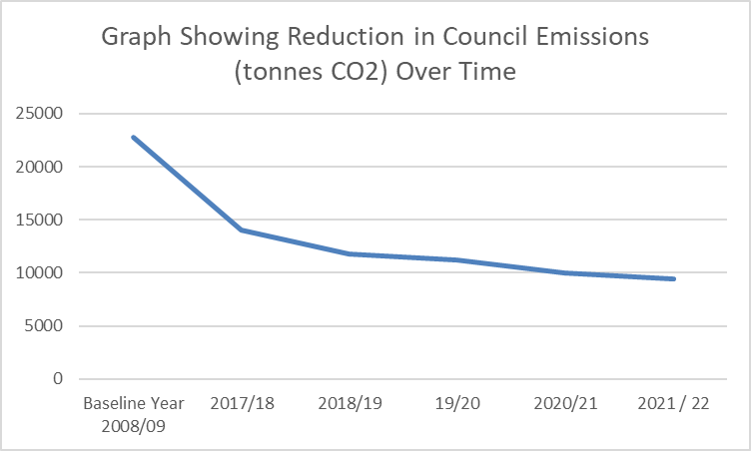

The above graph shows the overall CO2 emissions reduction since the baseline year. This represents a 58 % reduction in emissions.

Emissions from Gas Usage

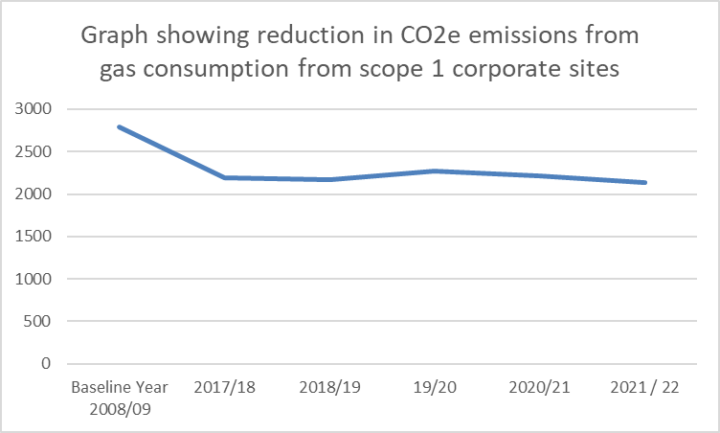

Emissions from gas usage have reduced by 24% since the base year

Emissions from Electricity Usage – Buildings / Schools and Street lighting

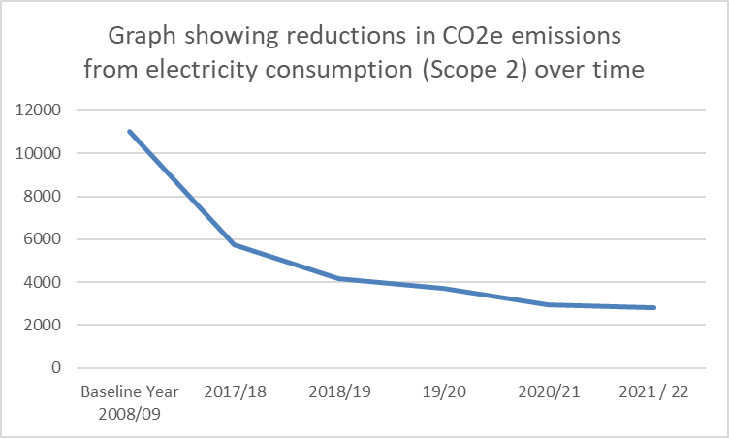

Electricity emissions have reduced by 75% from the base year. Some of this will have been due to decarbonisation of electricity on the grid. In addition, switching street lighting to LED and installing solar PV on a number of Council buildings will also have assisted in these reductions.

Emissions from Street Lighting

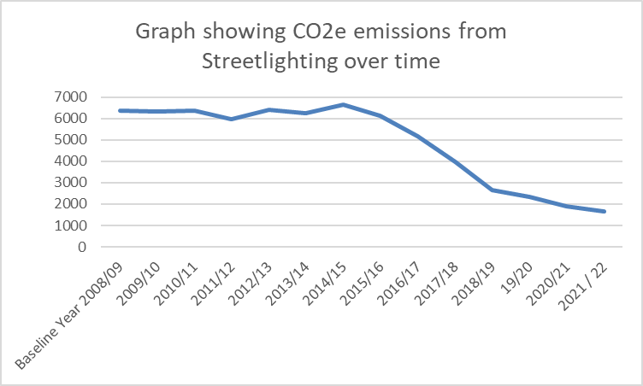

LED street lighting started to be installed in 15/16 across Tameside with a rolling replacement program still ongoing but with the majority of columns now replaced.

Emissions from Council Fleet

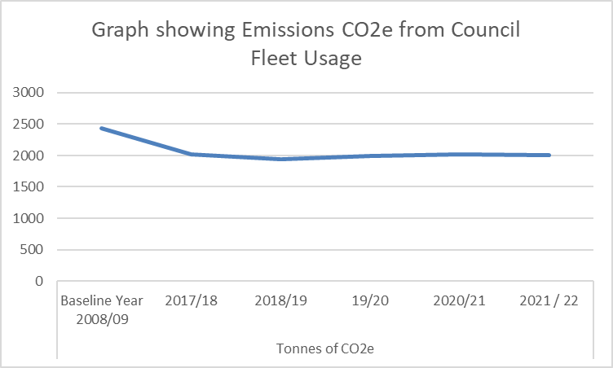

Fleet emissions have reduced by 17% since the baseline.

Tameside Council’s Carbon Management Activity Progress

- We have achieved a 58% reduction in emissions since the baseline year.
- LED lighting installations have taken place across a number of our corporate sites.
- LED street lighting improvements are still ongoing across the borough. Phase 2 which will tackle the borough’s main roads started in 20/21. The main roads consist of around 7400 lanterns that will be changed to conventional luminaires with around 500 lanterns that are heritage. The main roads consist of around a third of our lighting stock.
- We have solar PV on 5 of our buildings including the new Council Offices. 4 Schools now have solar PV installed.
- We are carrying our analysis of our corporate estate to determine priorities for improving insulation, energy efficiency and opportunities for renewable technologies.
- We now have 10 x Electric Vans on our fleet. These were delivered in January 2020.
- We have undertaken a fleet replacement programme and fleet is now Euro 6 and CAZ Compliant
- 14 new electric charging points have been installed across our depots / sites to assist us with moving to a greener fleet.
- We have increased investment in driver training and all drivers receive annual training.
- We launched the council Bike to work scheme to help employees to purchase bikes and equipment using salary sacrifice
- Accessing £14 million funding for walking and cycling improvements across the borough
- Work has commenced on the heat exchanger at Dukinfield Cemetery, which will be replaced in 2021 for an energy efficient model.
- Rationalized the Council’s buildings portfolio
- Been awarded circa £4 million from BEIS to decarbonise a number of buildings across the portfolio in phases 1 and 3a of PSDS funding
- Developed a strategy and accompanying action plan with a number of task groups to ensure delivery of actions.
- Developed a carbon literacy training course for roll out to all staff over the coming months.

- Conclusion
Tameside Council has achieved a 58% reduction in carbon emissions since our base year of 2008/09. This is a significant improvement but we are aware that we have much more to do to meet our target to be carbon neutrality by 2038. Data we have obtained from the Tyndall Centre in Manchester indicates that we must reduce our emissions by 14% year on year if we are to achieve this target.

Meeting this target will be a significant challenge but we will continue to improve our energy efficiency and to move our buildings and transport away from fossil fuels. We are also determined to fully embed carbon and air quality management into all areas of our operations.
A key point to note is that the council’s own emissions are a fraction of the Boroughs total emissions, these emissions are beyond Tameside Council’s direct control and will require a collaborative approach across all sectors of Tameside in order to reduce these.

