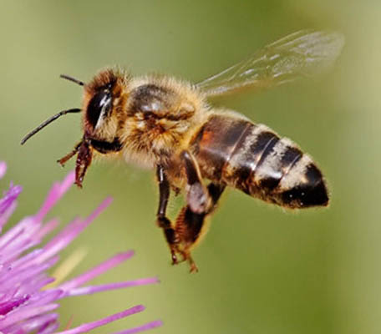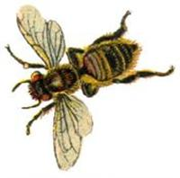

**Average size: 14mm  
Colour: Yellow-black**

**Honey Bee (Apis mellifera)**

**The phrase ‘as busy as a bee’ is duly earned because a bee must visit 4000 flowers in order to produce a mere teaspoon of honey!**

**For the survival of the Honeybee, it’s important to remember that they will only sting if they are severely provoked.**

**Lifestyle**

**Honeybees are social insects and live in colonies; the smallest of hives will be home to around 20,000 bees, whilst the largest can hold a staggering 100,000 bees. Each hive includes one queen bee, hundreds of drones (males) and thousands of workers. All of the worker bees are female, but they do not breed, it is the job of the queen bee to produce the offspring. Over Wintertime they hibernate until Springtime in Colonies.**

**Threats  
Have you ever considered what would happen if a foraging honey bee stumbled across a nest that has been treated with pesticides? Well, honeybees are able to accidentally carry the contaminated honey back to their hive, which can result in the death of an untreated nest, resulting in even more bees being killed unnecessarily.   
Honeybees are under threat worldwide due to virulent viruses against which they have no natural defences. The majority of wild colonies have died out, and without the help of beekeepers and the public, all honeybees could disappear within a matter of years.**

**Maintenance  
As honeybees are becoming extinct, it is important that they are not seen as pests and only killed under extreme circumstances. This is also because they are one of the most beneficial creatures alive today.** **One third of the global crop production depends on pollination and honeybees pollinate a great deal of the food that we eat. Without honeybees, we would struggle to produce enough food to feed the whole of the population. Therefore all conditions must be examined before they are treated. Currently, we have several beekeepers who are willing to collect swarms of bees that are accessible and we are looking for even more beekeepers that are willing to be added to this list. If you’re interested, then please give your details to our call centre on 0161 342 8355.**

**Points to consider before deciding to destroy a bees nest**

* **Is the nest accessible for a beekeeper to remove the nest to a hive? If yes, we can provide the public with contacts for local beekeepers that will be more than happy to remove the nest free of charge.**
* **Have people been stung by the bees? Or are they at risk because of the nests location?**

**If a nest is not causing any risk to public health then please leave it BEE.**