REGISTER OF PUBLIC PATH ORDERS

Date of Application | 08/01/21 | Legislation used for order | S.119 HA
Case Officer | Michael Hughes  0161 342 3704  michael.hughes@tameside.gov.uk
Town | Stalybridge
Location | Sidebottom Fold
Effect of order | To divert part of Footpath Stalybridge 95
Applicant | Mrs Helen Salvini and Mrs Mel Price  The Barn  Sidebottom Fold  Stalybridge  Cheshire  SK15 3QZ
Properties along route | The Barn, Sidebottom Fold  Sidebottom Fold Farm, Sidebottom Fold  The Old Original, Sidebottom Fold
Status of decision | Approved at Speakers Panel – Order to be advertised
Application documents:

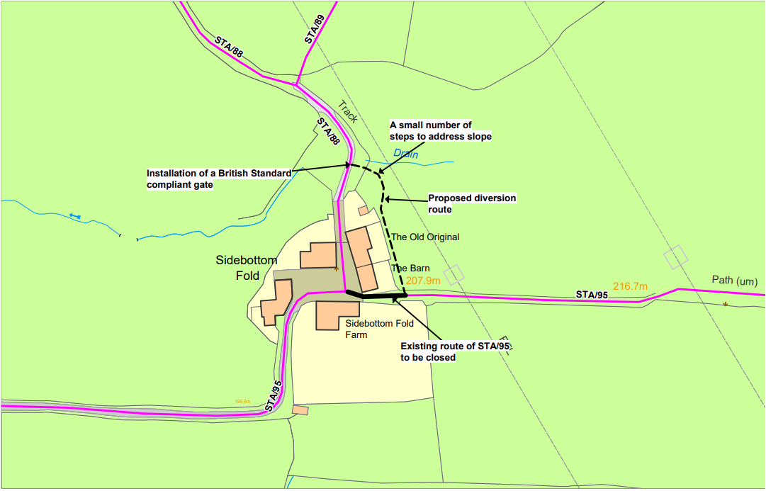

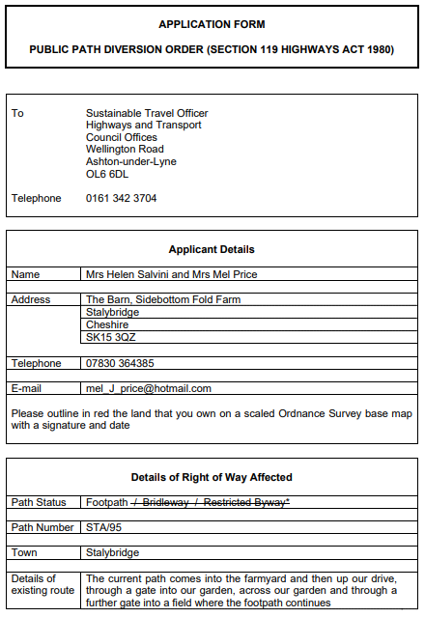
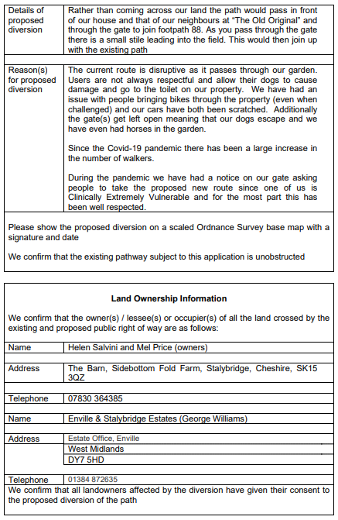

REGISTER OF PUBLIC PATH ORDERS

Date of Application | 25/06/19 | Legislation used for order | S.257 TCPA
Case Officer | Michael Hughes  0161 342 3704  michael.hughes@tameside.gov.uk
Town | Ashton
Location | Former site of Hartshead High School, Lees Road
Effect of order | To divert part of Footpath Ashton 50 and stop up part of Footpath Ashton 51
Applicant | Croft Transport Planning & Design  Hill Quays  9 Jordan Street  Manchester  M15 4PY
Properties along route | 4 – 18 (even) St Christopher’s Avenue, 1 – 2 Woodlands Road, 39 – 43 (odd) St Christopher’s Road, 1 and 3 Greenhurst Lane
Status of decision | Diversion of Ashton 50 confirmed  Objections received to stopping up of Ashton 51
Application documents:

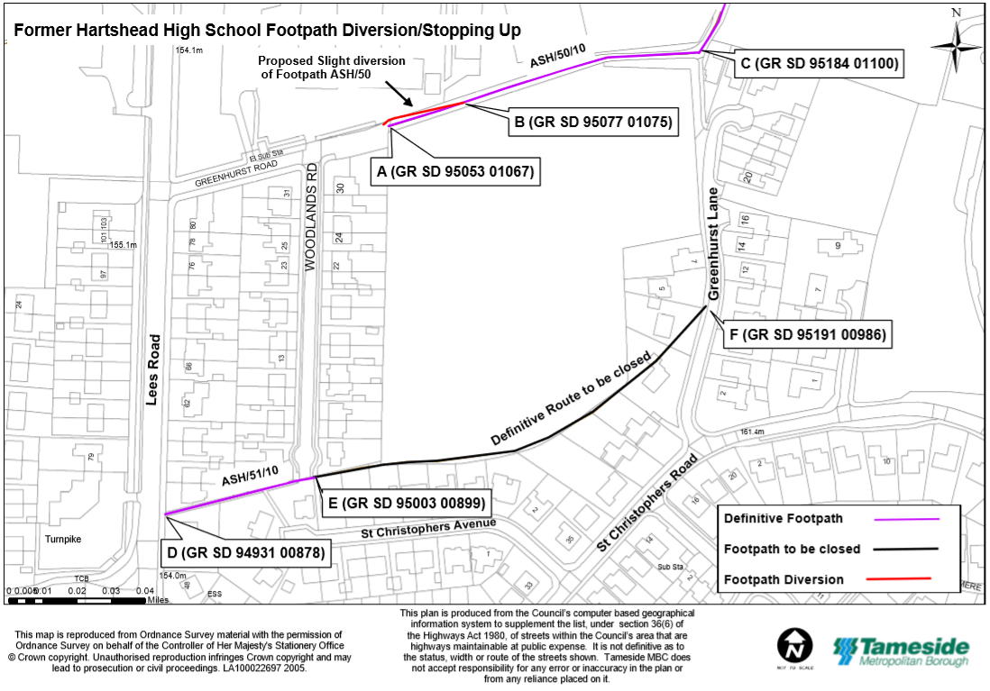
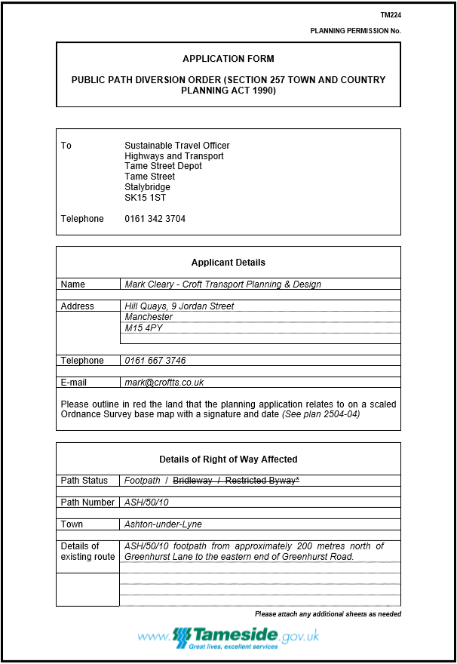

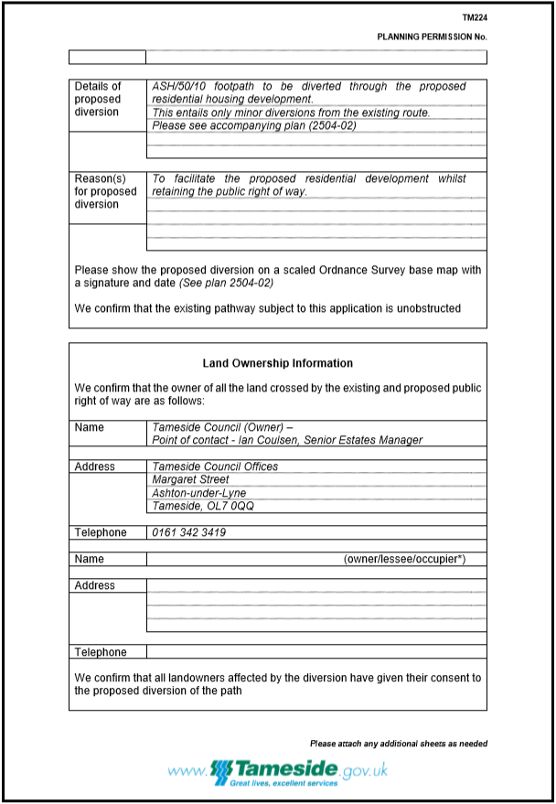

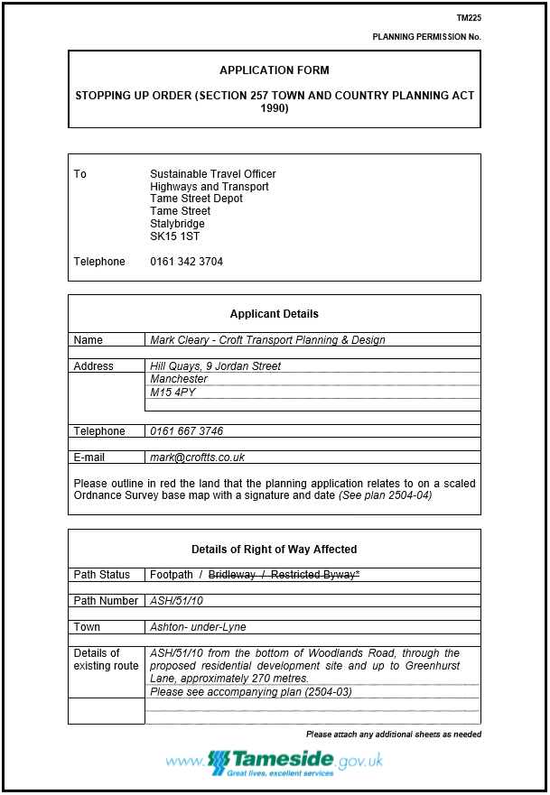

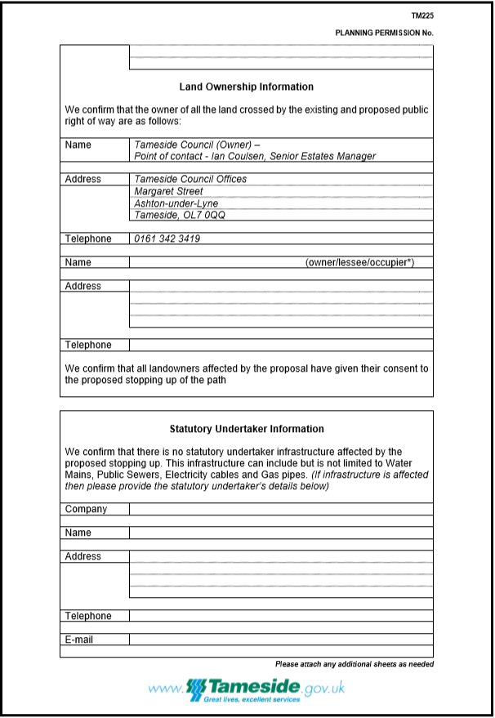

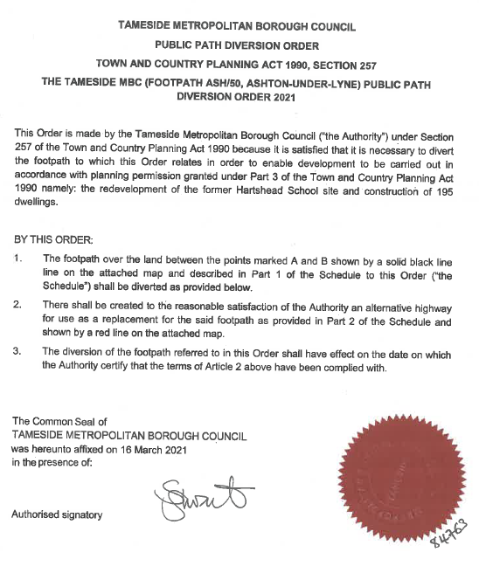
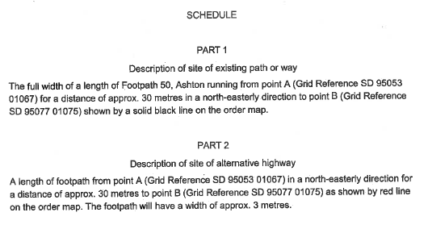
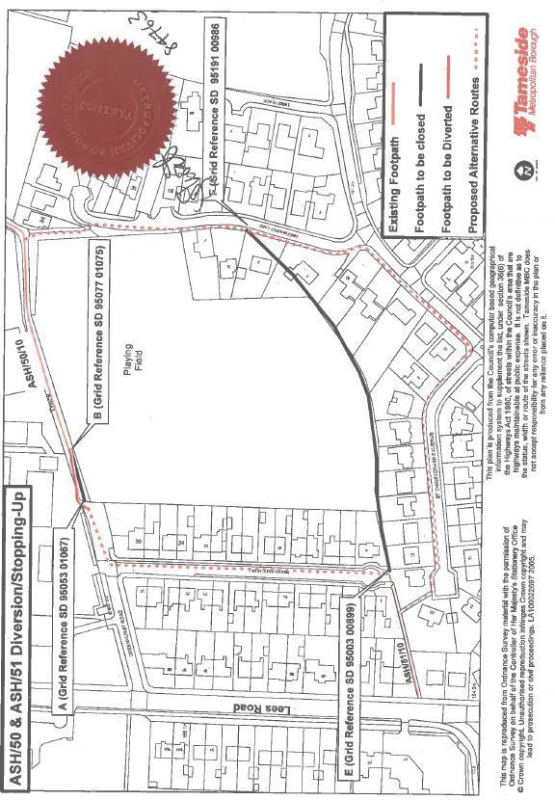

REGISTER OF PUBLIC PATH ORDERS

Date of Application |  | Legislation used for order | S.119 HA
Case Officer | Michael Hughes  0161 342 3704  michael.hughes@tameside.gov.uk
Town | Hyde
Location | Land to south east of Ash Tree Road
Effect of order | To divert part of Footpaths Mossley 43, 44, 45 and 46
Applicant | Philip Wager  Lower Matley Hall  Mately Lane  Hyde  SK14 4EG
Properties along route | N/A
Status of decision | Refused – A revised proposal under S.116 Highways Act 1980 is under consideration.
Application documents:

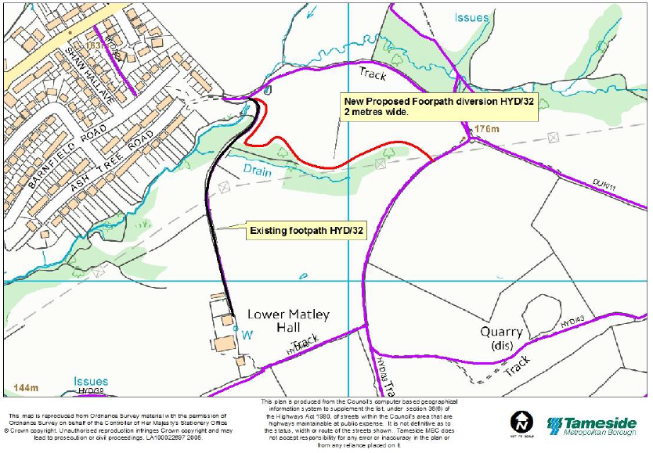

REGISTER OF PUBLIC PATH ORDERS

Date of Application | 21/05/18 | Legislation used for order | S.257 TCPA
Case Officer | Michael Hughes  0161 342 3704  michael.hughes@tameside.gov.uk
Town | Mossley
Location | Land between Micklehurst Road, Earnshaw Clough, Richmond Crescent and Huddersfield Road
Effect of order | To divert part of Footpaths Mossley 43, 44, 45 and 46
Applicant | CPUK  Chadwick House  Maple View  Skelmersdale  WN8 9TD
Properties along route | N/A
Status of decision | Refused – A revised proposal in under consideration
Application documents:

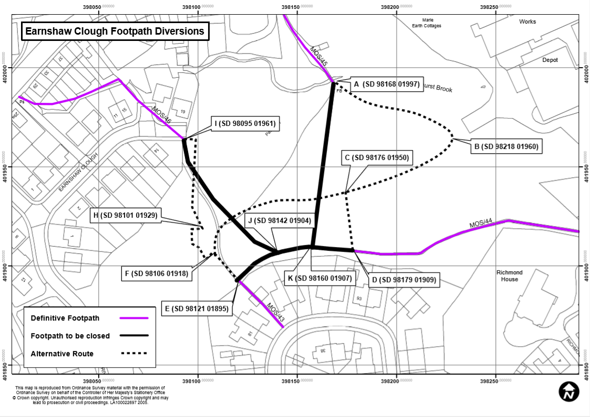

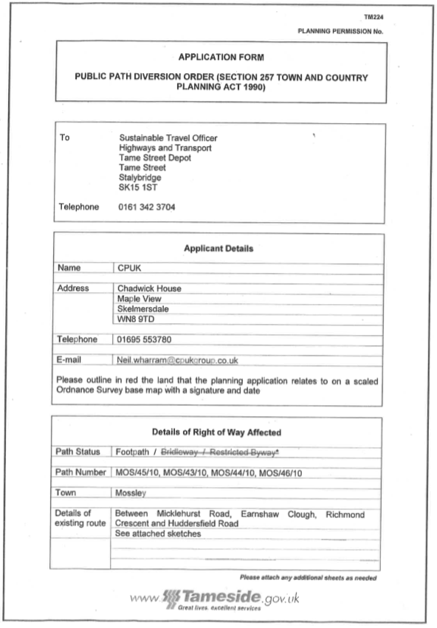

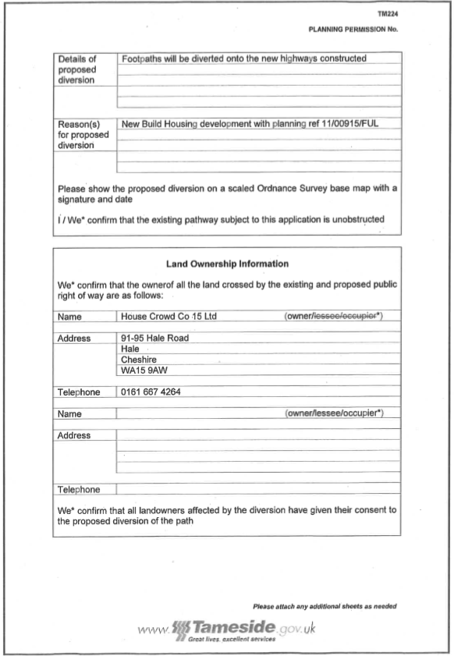

REGISTER OF PUBLIC PATH ORDERS

Date of Application | 27/10/17 | Legislation used for order | S.119 HA
Case Officer | Michael Hughes  0161 342 3704  michael.hughes@tameside.gov.uk
Town | Mossley
Location | Footpath MOS/169 at Midge Hill
Effect of order | To divert part of Footpath Mossley 169
Applicant | Tim Shaw  11 Midge Hill  Mossley  Ashton-under-Lyne  OL5 0RT
Properties along route | 11 Midge Hill, Mossley, OL5 0RT
Status of decision | Approved at Speakers Panel. Order to be advertised
Application documents:

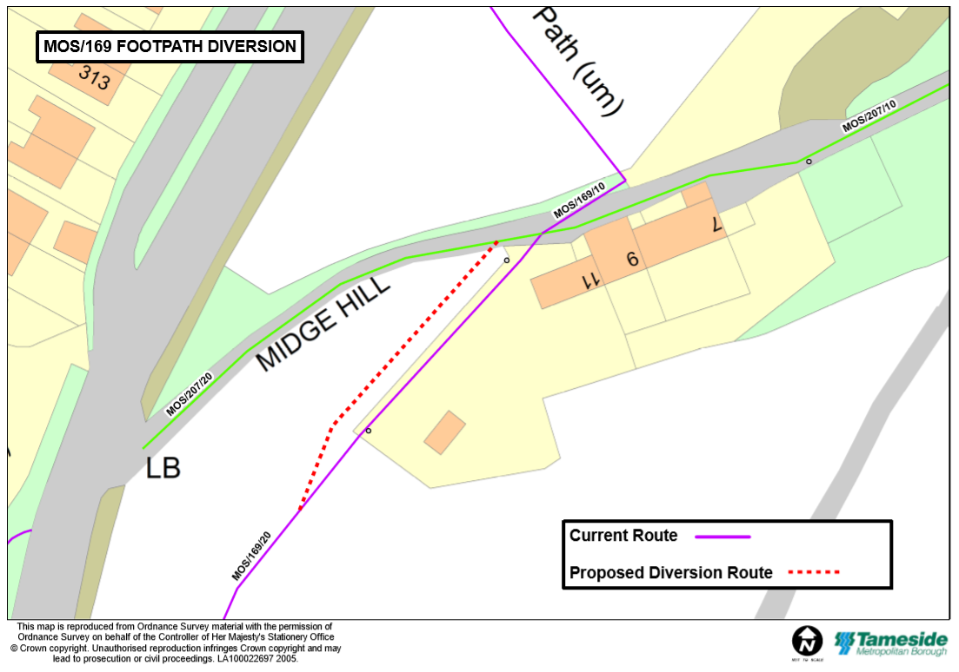

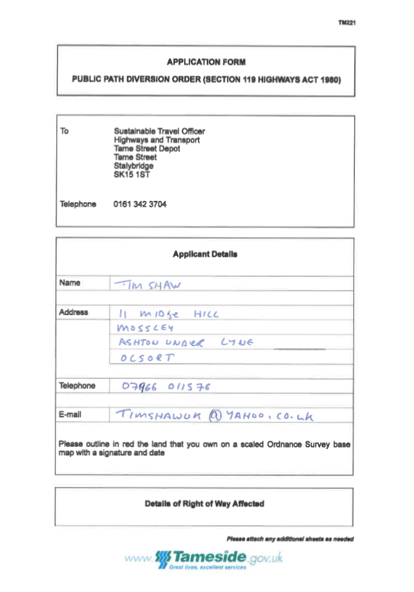

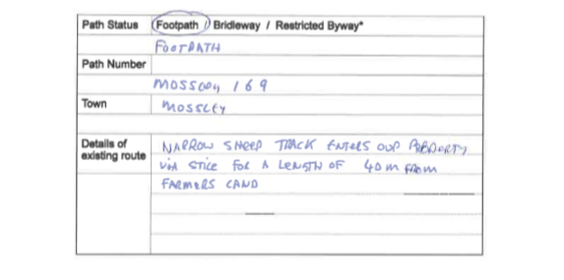
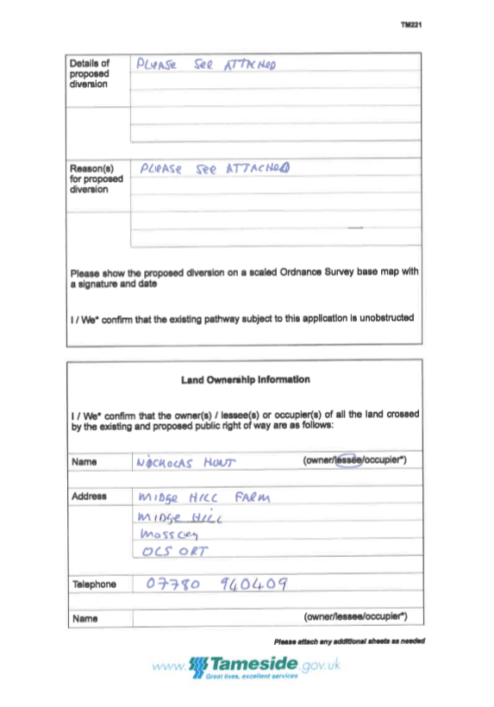

REGISTER OF PUBLIC PATH ORDERS

Date of Application | 22/03/16 | Legislation used for order | S.257 TCPA
Case Officer | Michael Hughes  0161 342 3704  michael.hughes@tameside.gov.uk
Town | Hyde
Location | At Raglan Farm (Start: SJ 97788 95938 Finish: SJ 97778 95932)
Effect of order | To divert part of Footpath Hyde 43
Applicant | Wendy Mackie  Raglan Farm  Mottram  Hyde  SK14 4EG
Properties along route | Raglan Farm, Mottram, Hyde, SK14 4EG
Status of decision | Pending
Application documents:

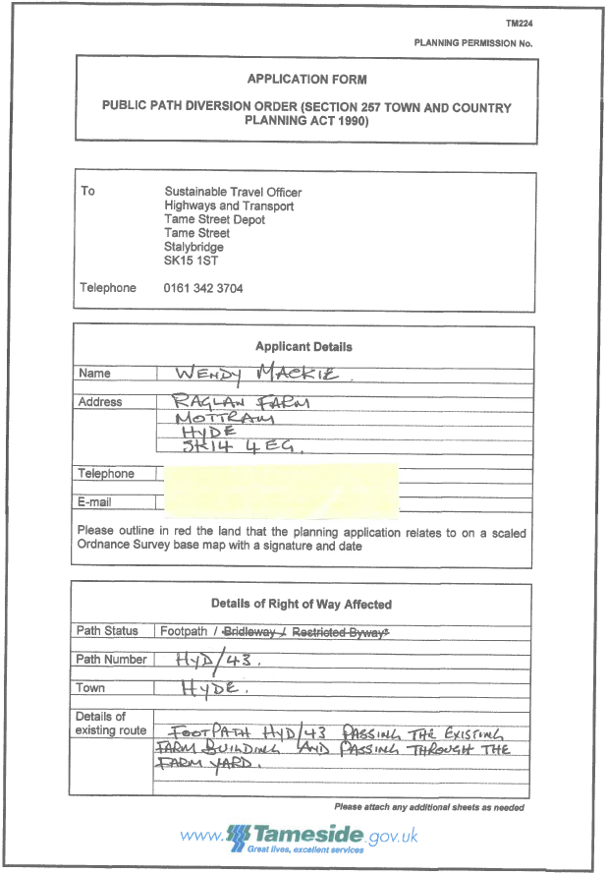

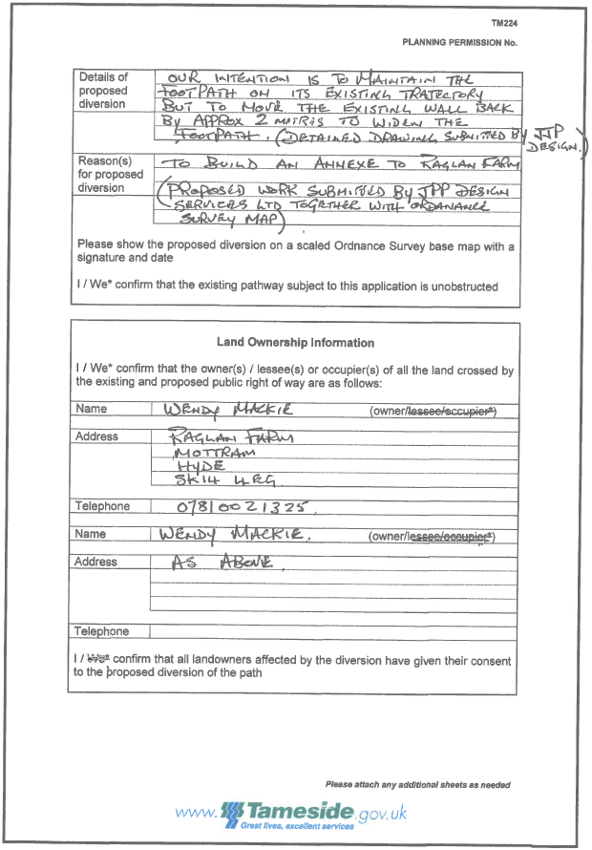

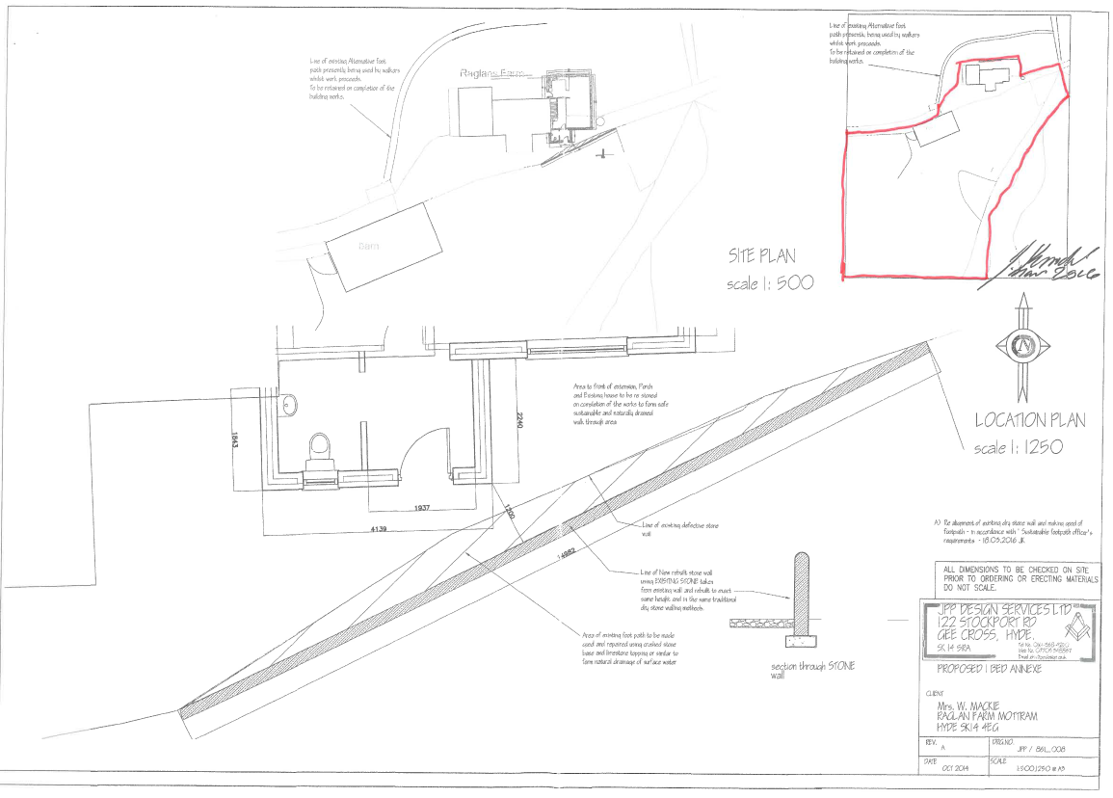

REGISTER OF PUBLIC PATH ORDERS

Date of Application | 12/03/16 | Legislation used for order | S.119 HA
Case Officer | Michael Hughes  0161 342 3704  michael.hughes@tameside.gov.uk
Town | Stalybridge
Location | At Sidebottom Fold Farm (Start: SJ 98054 98158 Finish: SJ 97995 98116)
Effect of order | To divert part of Footpath Stalybridge 95
Applicant | Mrs Helen Salvini and Mrs Mel Price  The Barn  Sidebottom Fold Farm  Mottram Old Road  Stalybridge  SK15 3QZ
Properties along route | The Barn, Sidebottom Fold Farm, Mottram Old Road, Stalybridge, SK15 3QZ
Status of decision | Rescinded
Application documents:

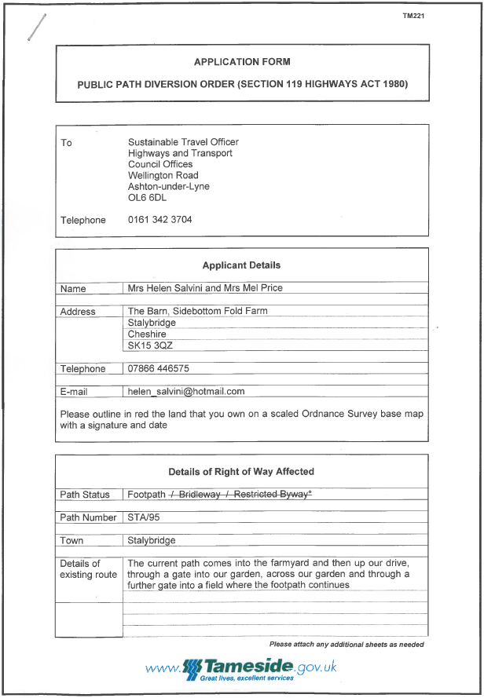

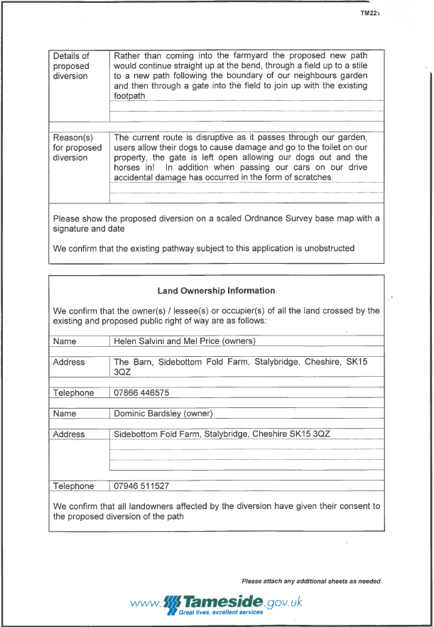

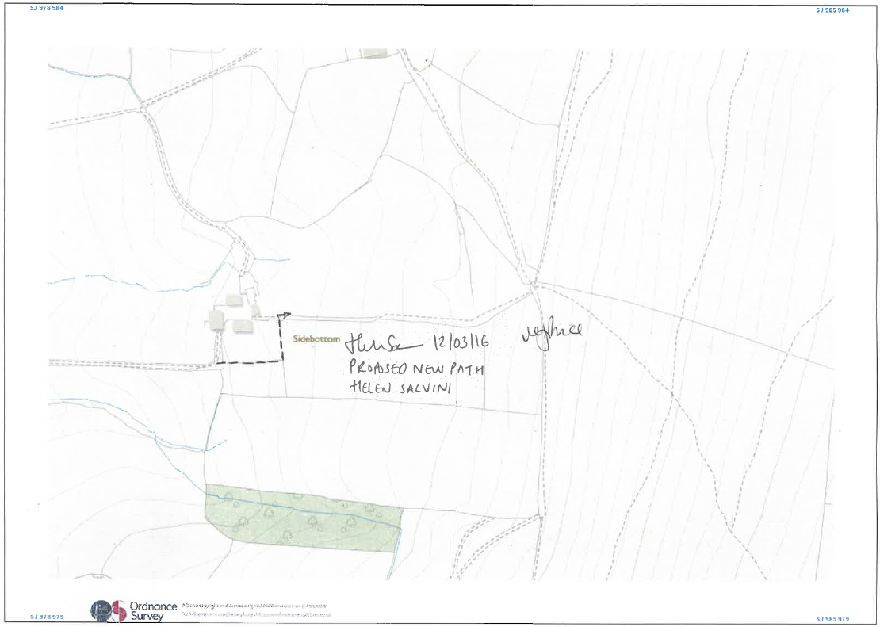

REGISTER OF PUBLIC PATH ORDERS

Date of Application | 26/11/15 | Legislation used for order | S.119 HA
Case Officer | Michael Hughes  0161 342 3704  michael.hughes@tameside.gov.uk
Town | Audenshaw
Location | At Boothdale Drive, Audenshaw (Start: SJ 90269 96947 Finish: SJ 90533 97050)
Effect of order | To divert Footpath Audenshaw 18
Applicant | Tameside MBC  Dukinfield Town Hall  King Street  Dukinfield  SK16 4LA
Properties along route | 1 – 31 (odd) Boothdale Drive, Audenshaw, M34 5JU
Status of decision | Approved on 26/11/15 by the Droylsden and Audenshaw District Assembly. Objections received to order.
Application documents:

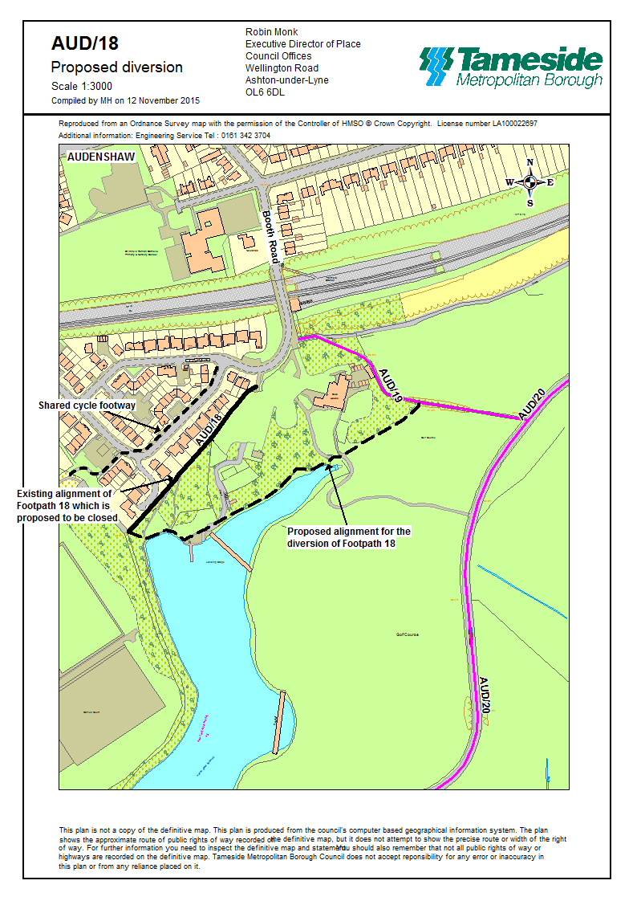

REGISTER OF PUBLIC PATH ORDERS

Date of Application | 05/02/15 | Legislation used for order | S.119 HA
Case Officer | Michael Hughes  0161 342 3704  michael.hughes@tameside.gov.uk
Town | Longdendale
Location | At Thorncliffe Barn (Start: SK 00199 96799 Finish: SK 00319 96632)
Effect of order | To divert Footpath Longdendale 19
Applicant | Mike Savage  Thorncliffe Barn  Thorncliffe Farm  Hollingworth  SK14 8JJ
Properties along route | Thorncliffe Barn, Thorncliffe Farm, Hollingworth, SK14 8JJ  Thorncliffe Hall, Hollingworth, SK14 8JJ  The Stables, Thorncliffe Hall, Hollingworth, SK14 8JJ
Status of decision | Approved on 06/06/15 by the Hyde and Longdendale District Assembly. Order to be advertised.
Application documents:

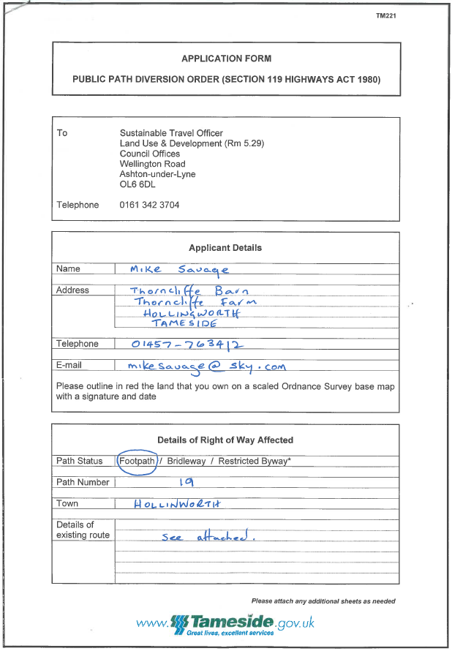

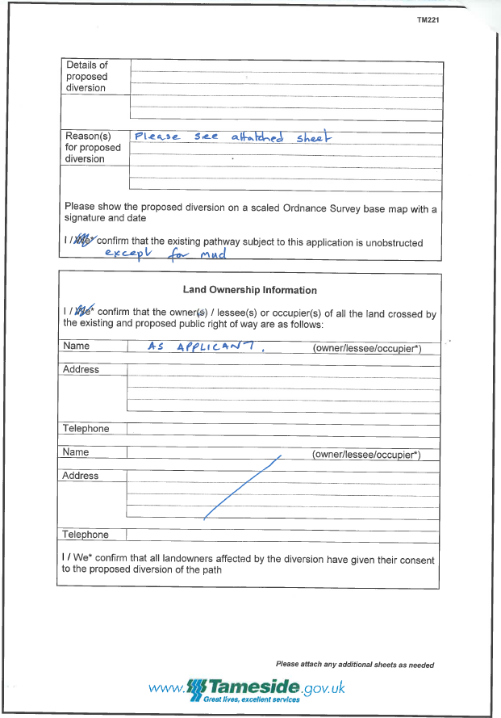

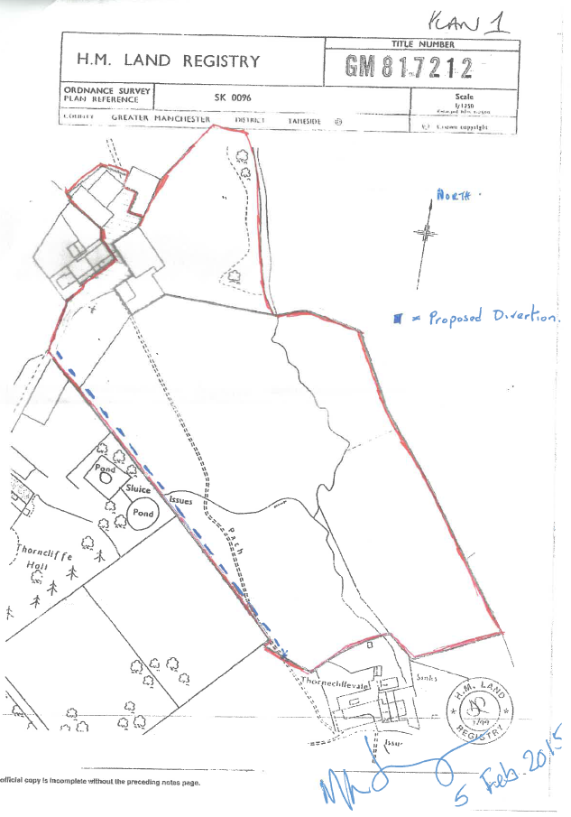

REGISTER OF PUBLIC PATH ORDERS

Date of Application | 25/10/10 | Legislation used for order | S.119 HA
Case Officer | Michael Hughes  0161 342 3704  michael.hughes@tameside.gov.uk
Town | Hyde
Location | At Lumn Farm, Hyde (Start: SJ 97319 92905 Finish: SJ 97344 92701)
Effect of order | To divert Footpath Hyde 154
Applicant | K D Stockton  Lumn Farm  Apple Street  Hattersley  Hyde  SK14 3AN
Properties along route | Lumn Farm, Apple Street, Hattersley, Hyde, SK14 3AN
Status of decision | Pending
Application documents:

