**Tasty eggy bread**

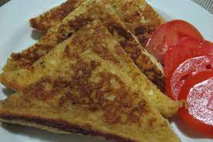

**Ingredients**

2 medium eggs

1 tbsp milk

2 slices of white or brown bread

1tbsp butter

**Method**

Crack the eggs into a shallow bowl, add the milk and lightly beat. Season with a little salt and pepper if desired

Dip each slice of bread into the egg mixture and soak up all of the liquid

Heat a frying pan over a medium heat and add the butter to melt

Swirl the butter around the pan, when its beginning to foam add the bread and fry for 1 minute of each side or until golden brown

Transfer to a plate and service with a topping of your choice for, crispy bacon, baked beans, fried tomatoes or fruit compote

**Tips: -** frozen fruit is another good nutritious store cupboard item you can defrost as much or as little as possible

Baked beans are a good source of protein and can count towards your 5 a day

Use whole milk or milk made up with skimmed milk powder for extra calories

SIMPLE

FOOD

MENUS

**Avocado & Poached egg on toast**

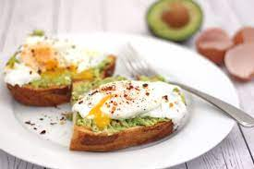

**Ingredients**

1-2 slices of toasted bread

1 egg

½ avocado

**Method**

Fill a saucepan with about 3 inches (8cm) of water. heat until the water simmers gently

Break the cold egg into a small dish or saucer. Holding the dish just above the simmering water, gently slip the egg into the water

Cook in a barely simmering heat until the white is et and the yolk is cooked as desired 3-5 minutes

Peel, core and slice the avocado and later onto the toasted bread

Remove egg from the water drain well and serve on top of the avocado

Tip :-Add a sprinkle of paprika or pepper to season

**Garlic and cream cheese and courgette soup**

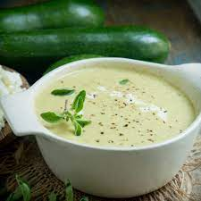

**Ingredients**

1 finely chopped onion

2 chopped garlic cloves(optional)

2 courgettes skins on in chunks

Garlic cream or similar can also use plain cream cheese

Any stock cube vegetable, chicken, beef etc

**Method**

Fry the onion and add garlic if desired

Add the courgette, fry for about a minute then add stock about half a pint

Simmer for 3 or 4 minutes or until the courgette is soft

Remove from the heat and blend using a small hand blender and stir in any soft cheese

Return to a low heat and stir until the cheese melts

Tip : serve with a swirl of cream or grated cheese

**Mandarin Orange Jelly**

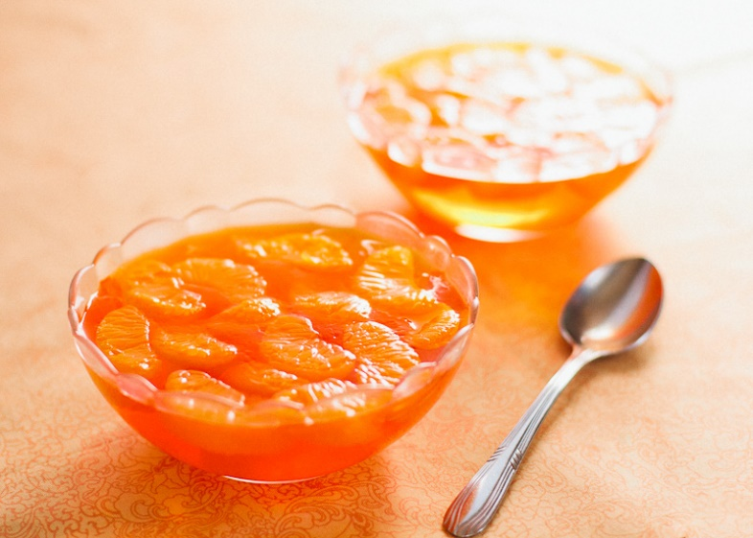

**Ingredients**

1 Orange Jelly Tablet

1 Can of Mandarin Segments with Juice

**Method**

Cut up and place the jelly cubes in a medium-sized microwaveable bowl, add the reserved juice from the mandarin segments and heat in the microwave for approximately 1 minute (based on a 750 watt oven).

Stir until completely dissolved, then add cold water to take the total liquid to 1 pint and stir to combine.

Pour into a trifle bowl; add the mandarin segments, and place in the fridge overnight to set.

Once set, serve the desired amount of jelly in a bowl. For those needing to increase their calorific intake, serve with cream or ice-cream.

**Pizza on Toast**

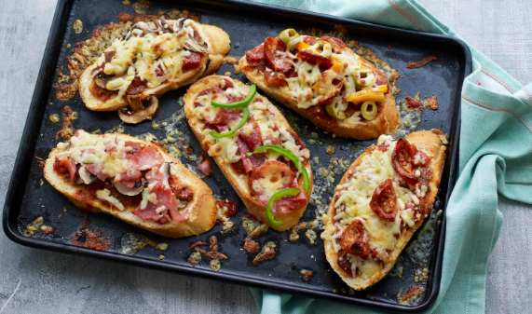

**Ingredients**

1 thick slice white or brown [bread](https://www.bbc.co.uk/food/bread)

2 tbsp [pasta sauce](https://www.bbc.co.uk/food/pasta_sauce), pizza topping, tomato salsa or passata

thinly sliced chorizo, salami, ham, [mushrooms](https://www.bbc.co.uk/food/mushroom) or roasted peppers, sun-dried tomatoes, olives, jalapeños

30g/1oz cheese, such as grated Cheddar, ready-grated [mozzarella](https://www.bbc.co.uk/food/mozzarella_cheese), or a mixture

**Method**

Preheat the grill to a medium-high setting. Place the bread on a baking tray or grill pan and grill on one side until lightly toasted.

Turn the bread over and spread with the tomato sauce and top with the chorizo, mushrooms, or any other topping. Sprinkle with the cheese.

Return to the grill for a further 2–3 minutes, or until the cheese melts and the toppings are hot.

**Quick n Hot Banana Pot**

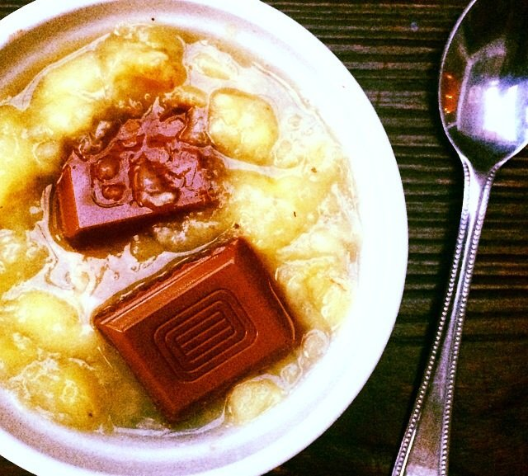

**Ingredients**

1 Banana

2 squares dark chocolate or milk or white chocolate if preferred

**Method**

Thinly slice your banana and pile into a ramekin dish or a small microwave proof.

Microwave on full power for 30 seconds leave to stand for 30 seconds and microwave again for 30 seconds. It should be soft and hot and juicy if it isn’t pop it in another

stir to make a hot smooth puree.

Pop your chocolate on top and stir gently to melt it in

**Quiche in a mug**

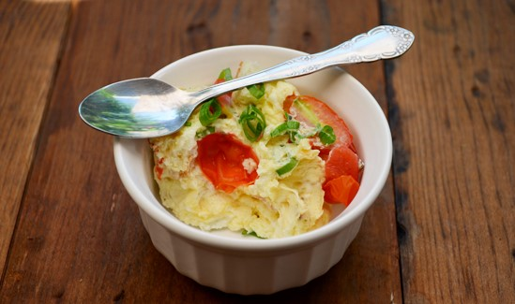

**Ingredients**

1 large egg  
1 1/2 tablespoons whole milk (substitutes: half and half or heavy cream)  
1 teaspoon melted unsalted butter  
Pinch of salt  
Pinch of freshly ground black pepper  
4 small cherry tomatoes, halved  
1/8 cup torn pieces of fresh bread  
1 tablespoon grated cheese (e.g., cheddar cheese, mozzarella, etc.)  
1 teaspoon chopped fresh herbs, plus more for garnish (e.g., green onions, Italian parsley, chives, etc.)

**Method**

In a microwavable mug, add egg, milk, melted butter, salt, and pepper and whisk until thoroughly mixed and egg whites are completely broken up.

Add halved tomatoes, torn bread, grated cheese, and chopped herbs on top of egg mixture, making sure ingredients are evenly dispersed and have not settled to bottom of mug.

Ingredients will stay settled within the quiche mixture better if you do not whisk ingredients into egg mixture.

Place mug in microwave, and cook on high for 1 minute, just until egg is completely cooked and quiche is slightly puffed. Garnish with fresh herbs and serve immediately

**Sweet Honey Apple toast**

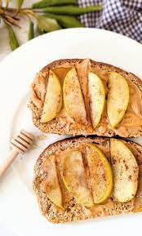

**Ingredients**

Toasted bread

Sliced Apple

Honey

Soft cheese

**Method**

Toast 1 or 2 pieces of wholegrain bread (use white if preferred)

Layer with a spread of soft cream cheese and sliced apple

Drizzle with honey to serve