**Falls Prevention** 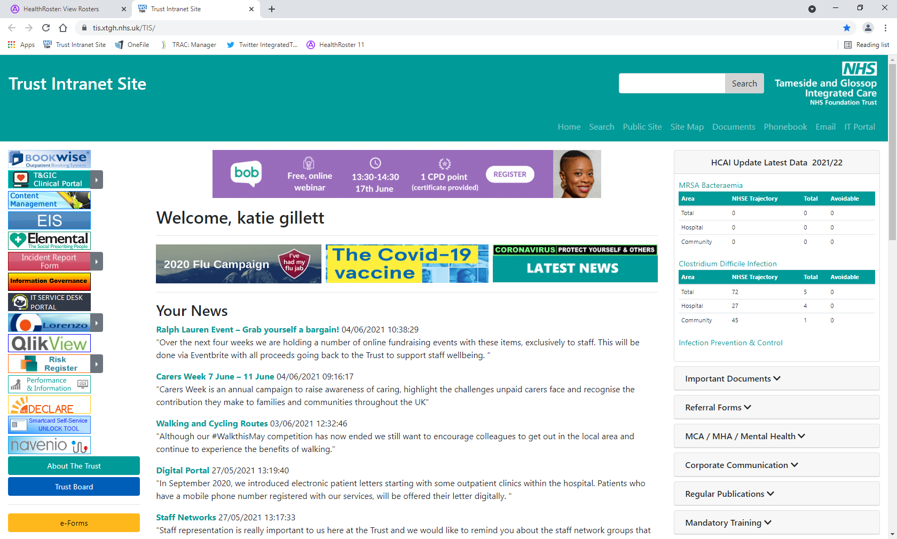

**Leaflets**

**Videos**

**Prevention Programmes**

**Websites**

**L**

**E**

**A**

**F**

**L**

**E**

**T**

**S**

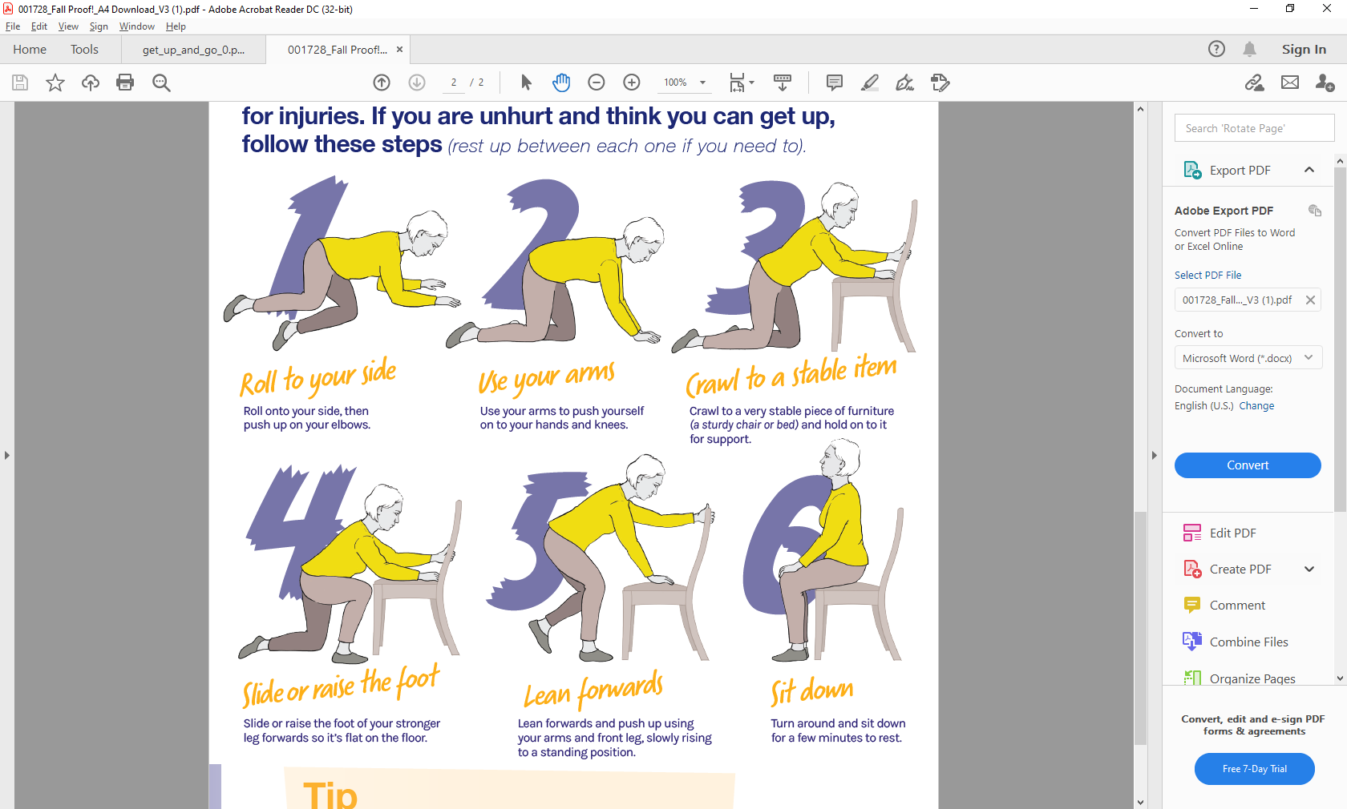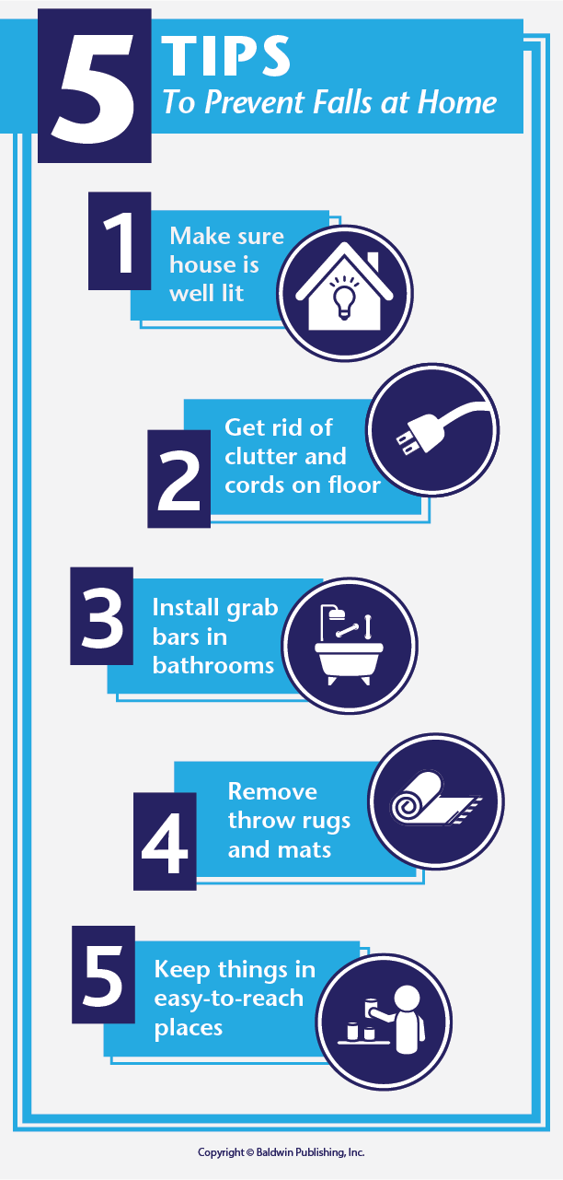

|  |
| --- |
| **Get Up & Go**  **• Risk of falling**  **• Reduce the risk of falling**  **• Fall proof home**  **• Stay safe out and about**  **• Keep moving for a balance life**  **• Strength and balance exercises**  **• Getting up from a fall / can’t get up**  **• Prevent others from falling**  **• How to help someone who has fallen** |
| **Fall Proof**  **• Keep moving**  **• Prevent falls at home**  **• Getting up from a fall** |
| **Staying Active at Home**  **• Simple steps to help you stay active at home** |



**V**

**I**

**D**

**E**

**O**

**S**

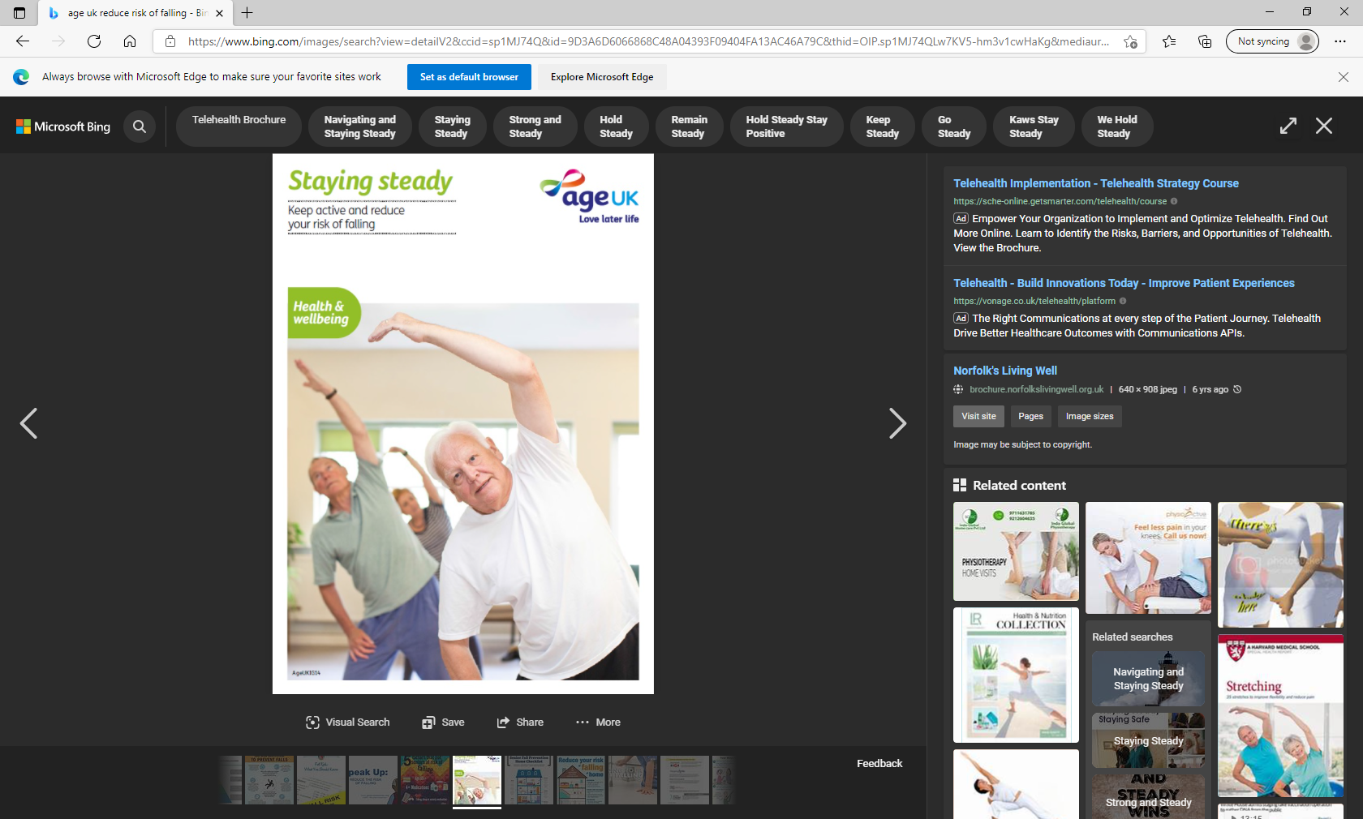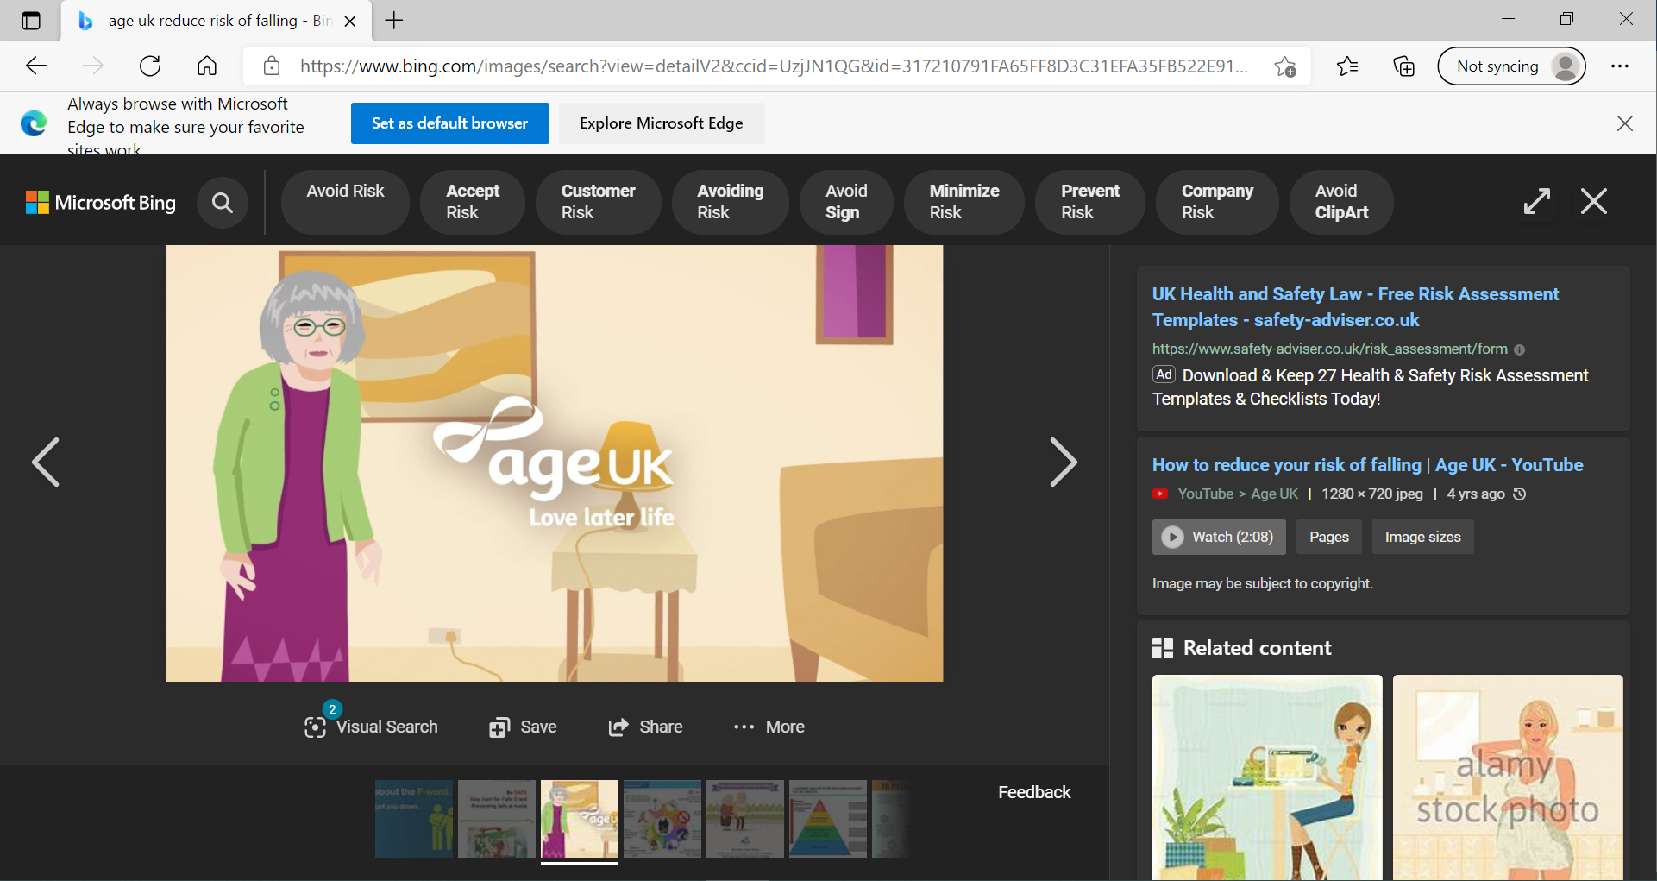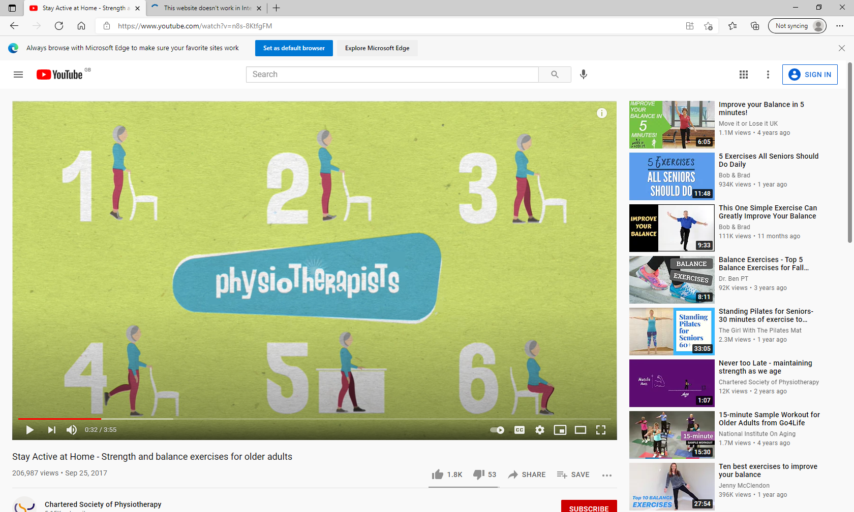

|  |
| --- |
| **Strength & Balance Exercise**  [Stay Active at Home - Strength and balance exercises for older adults - YouTube](https://www.youtube.com/watch?v=n8s-8KtfgFM) |
| **Age UK**  [How to reduce your risk of falling | Age UK - YouTube](https://www.youtube.com/watch?v=XnLXiJzYmEQ) |

|  |
| --- |
| **Tameside Age Uk**  **How to refer:**  <https://www.ageuk.org.uk/tameside/our-services/step-up/>  Example of Tameside Age UK Programme  **Derbyshire.gov**  **Here is a self-designed Action Plan to help prevent falls:**  <https://www.derbyshire.gov.uk/site-elements/documents/pdf/social-health/adult-care-and-wellbeing/help-to-live-at-home/falls-prevention-action-plan.pdf> |

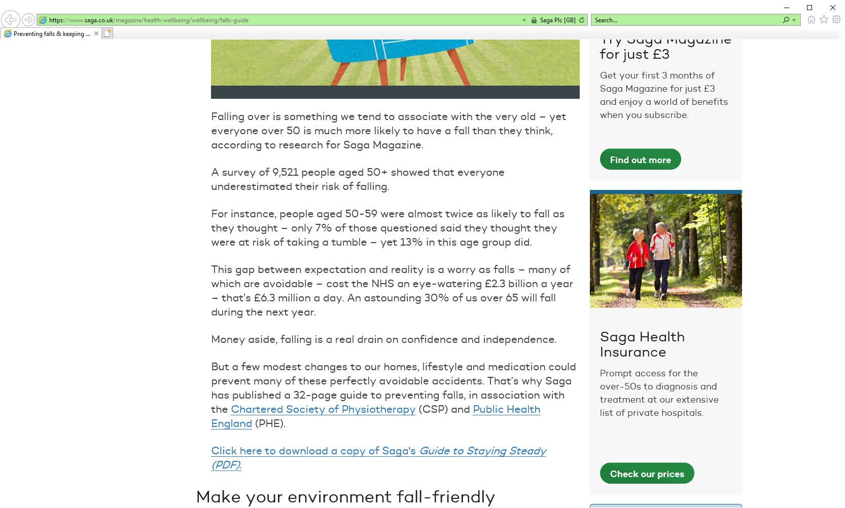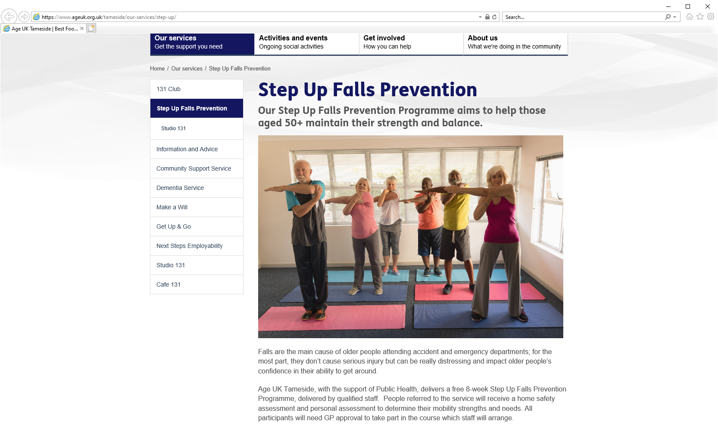

**P**

**R**

**O**

**G**

**R**

**A**

**M**

**M**

**E**

**S**

|  |
| --- |
| **Nice Guidance**  <https://www.nice.org.uk/Guidance/CG161> |
| **NHS Falls Prevention**  <https://www.nhs.uk/conditions/falls/> |
| **GOV.uk Falls prevention**  <https://www.gov.uk/government/publications/falls-applying-all-our-health/falls-applying-all-our-health> |
| **SAGA**  <https://www.saga.co.uk/magazine/health-wellbeing/wellbeing/falls-guide> |
| **Age UK**  <https://www.ageuk.org.uk/information-advice/health-wellbeing/exercise/falls-prevention/> |
| **NHS Eye Care**  <https://www.nhs.uk/live-well/healthy-body/eye-health-tips-for-older-people/> |
| **RCN Falls**  <https://www.rcn.org.uk/clinical-topics/older-people/falls> |
| **CSP Falls**  <https://www.csp.org.uk/publications/physiotherapy-works-falls-community-approach> |

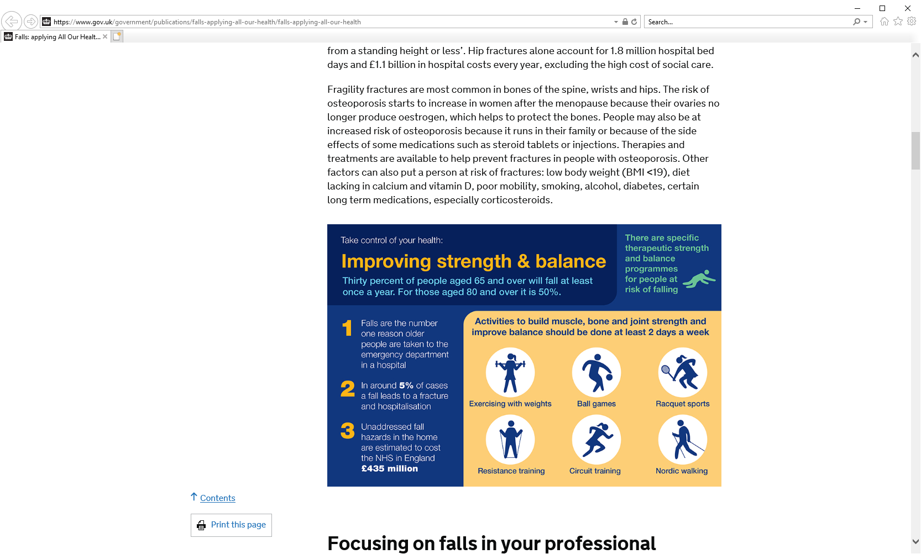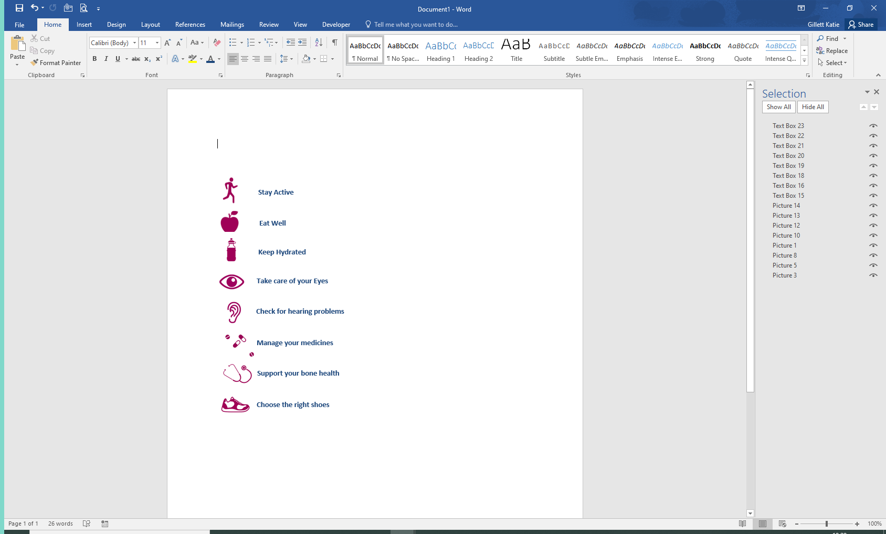

**W**

**E**

**B**

**S**

**I**

**T**

**E**

**S**