Guidance

Hoarding
Prevention

Contents
Contents
Document Details 3
Guidance Statement 4
Scope 4
Definitions 4
Guidance 4
Background 4
Introduction………………………………………………………………………………4
Aims and Objectives 5
Hoarding Disorder 5
Types of Hoarding………………………………………………………………………6
Identifying Hoarding Behaviour and Using the CIR………………………………………7
Hoarding Assessed At Level 1 ….…………………………………………………….8
Hoarding Assessed At Level 2 … 8
Hoarding Assessed At Level 3 9
Recording And Monitoring Systems.. 10
Safeguarding 10
Mental Capacity...................................................................................................11
Health and Safety … 12
Assessing Hoarding Behaviour 12
Appendix 1 - Clutter Image Rating Scale Pictures……………………………………. .13
Clutter Image Rating Scale Pictures Kitchen…………………………………...….13
Clutter Image Rating Scale Pictures Bedroom…………………………………….14
Clutter Image Rating Scale Pictures Living room............................................... 15
Clutter Image Rating Guide for Rear of Pictures……………………………........ 16
Appendix 2 - Flowchart to be used when hoarding is identified……………………….17
Appendix 3 - Understanding Hoarding Behaviour ……………………………………...18
Appendix 4 – Best Practice whilst carrying out a S&W visit at a Hoarders Property..19
Appendix 5 – Information to Help Hoarders Reduce The Risk Of Fire…………….…20
Appendix 6 –Helping Hoarders ………………………………………….…………….…21
Resources…………………….………………………………………………………..21
How To Let Go Of Unwanted Possessions.........................................................21
Charities………………………………………………………………………………..22

Document Details
If this Guidance requires updating or editing please contact the Author.

Document Version Control
Document Version | Date | Author
Version 1 | 04/06/2015 | Phil Greenwood

Approval Process
Approval agency | Extended Leadership Team
Guidance Owner | Wayne Shields

Consultation & Engagement
Involved | Consulted
- Phil Greenwood | - London Fire Brigade  - CFOA Hoarding Group

Related Documents
Policy & Procedure | - Not Applicable
Guidance | - Not Applicable
External | - Not Applicable

Guidance Statement
This document provides guidance around carrying out prevention activities in homes where hoarding is present;
It will provide clarity on:
• How to identify and assess the level of hoarding in a home using the Clutter Image Rating scale (CIR);
• What actions to take following identification of hoarding;

Scope
This Guidance applies to all employees and any persons representing Greater Manchester Fire and Rescue Service whilst carrying out prevention and response activities irrespective of their role.

Definitions
Hoarding behaviour was previously seen as a symptom of Obsessive Compulsive Disorder (OCD) but it has now received a separate clinical definition of ‘hoarding disorder’ and is defined as:

“A psychiatric disorder characterised by persistent difficulty discarding or parting with possessions, regardless of their actual value resulting in significant clutter that obstructs the individual’s living environment and produces considerable functional impairment."

Guidance

Background
- Fire and Rescue Services in the UK have seen a number of fatal fires where hoarding disorder was present due to the increased risk of fire loading associated with hoarding disorder.

- The document acknowledges that whilst we cannot expect to prevent a person from hoarding, we can reduce the risk of fire and the impact that hoarding can have on a person’s functioning and wellbeing, through prevention activities by involving the person at all stages, and in partnership with local agencies.

Introduction
- The potential for a serious fire to occur for somebody who has hoarding disorder is greater due to combustible materials being more likely to be stored close to, or in contact with, heat sources such as cookers and heaters.

- This risk further increases when clutter in the home reaches extreme levels, utilities may be disconnected, which can lead to unsafe practices being carried out such as, the use of candles for lighting, and camping stoves for cooking.

- A person’s escape may be significantly slower or even prevented due to restricted access and egress from the home.

- The increased fire loading adds to the severity of the fire with the increased risk of it travelling to neighbouring properties, and this should prompt a discussion with the Station Manager on the most appropriate course of action to address the risk to the resident/neighbouring properties.

- In addition to the increased risk to the occupiers and their neighbour’s properties, it also presents an increased risk to fire fighters attempting rescues and bringing the fire under control.

Aims and Objectives
- The aim of this guidance is to assist staff when working with people who may have hoarding disorder, by providing guidance on how to help a person with this disorder, whilst reducing risk when carrying out Safe and Well visits.

- We also aim to reduce the associated fire risks for their neighbours, firefighters and the local community.

- We will work collaboratively with our partners to reduce duplication by providing sustainable outcomes for those people who have hoarding disorder.

- We will achieve this by:

- Including the occupier in the process at every stage;
- meaningful and coordinated partnership working;
- Through early identification and awareness raising of the fire risks associated with hoarding to people who exhibit hoarding behaviour, before this becomes a problem;
- providing people who hoard with advice specific to the risks associated with their hoarding;
- familiarising staff on the purpose and use of the Clutter Image Rating (CIR) and raising their awareness of how to respond to and record instances of hoarding when visiting premises;
- working with our partners to identify people who hoard, and to work together for effective and positive outcomes;

Hoarding Disorder
- Individuals who experience hoarding difficulties are known to be impaired in several areas of everyday functioning such as cooking, washing up, paying bills, and performing well at work.

- Hoarding is distinct from the act of collecting, and is different from being just messy or generally untidy.

- The difference between a hoarder and a collector is that a hoarder will have strong emotional attachment to their items that is well in excess of their real value.

- It becomes impossible for the hoarder to use living spaces as they are intended due to the level of clutter.

- The level of clutter present causes significant distress or impairment in an individual’s ability to function.

- There is no distinct type of person who may have a hoarding disorder as it can be common to all genders, cultures, ethnicity, etc., and can be triggered by a stressful life event such as bereavement.

- Hoarding disorder is often associated with other conditions such as depression, dementia, autistic spectrum disorder, anxiety or social phobia.

- A person is more likely to hoard if they have experienced deprivation in the past, or if there is a family history of hoarding.

- Hoarding disorder often begins when a person is a teenager and reaches extreme levels around the mid-30s, and is complex, chronic and progressive.

- Help is not often sought until around the age of 50 which may be because people with hoarding disorder are typically socially isolated, and often reluctant to allow access to their home.

Types of Hoarding

- Hoarding can generally fall in to three types:

Inanimate Objects

This is the most common and could consist of one type of object or a mixture of objects, including such things as newspapers, old clothing and containers.

Data Hoarding

This is a new type of hoarding with little research done on this matter, and can present itself as a collection of data storing equipment, such as computers, paper, and electronic storage devices. The hoarder will feel a strong need to store copies of emails and paperwork, which can provide them with the same issues as other types of hoarding.

Animal or Pet Hoarding

This type of hoarding is on the increase and can be described as the obsessive collecting of animals, often with an ability to provide minimal standards of care for themselves or their animals. There are also additional health risks from the presence of animal faeces and insect infestation.

Identifying Hoarding Behaviour and Using the CIR

- Identifying and classifying hoarding behaviour can be subjective as what it means to have a cluttered home can vary from person to person; and the layout of each home is different, clutter may be stored at different levels within a room.

- To ensure that we work in line with other professionals, the Clutter Image Rating (CIR) was developed by psychologists specialising in the treatment of people with hoarding disorder.

- This assessment tool is internationally recognised and is used by psychologists who work with people who hoard, and commonly used by the health and social care sector in the UK.

- GMFRS has adopted this assessment tool to assist staff in identifying and assessing levels of hoarding behaviour, whenever it is encountered (Appendix 1).
- The CIR is a visual assessment tool that allows objectivity when assessing the level of hoarding that we are presented with.

- It provides consistency using a common language and reference point when discussing concerns with occupiers and partner agencies, and when notifying them of hoarding concerns.

- It shows a rising pictorial scale of nine equidistant photos showing clutter in three rooms – living room, bedroom and kitchen.

- The CIR should be used to assess the level of clutter in the home by selecting the image which best matches the clutter in each room.

- The information on the reverse of the CIR pictures provides brief bullet point guidance of what actions are necessary for the different levels of clutter.

- Single rooms should not be taken in isolation to assess hoarding behaviour, and the level of clutter throughout the entire home should be taken into account.

- In assessing the level of clutter present we are also considering the occupiers health and wellbeing and it is therefore essential to consider the general state of repair of the home, including that they have access to essential utilities such as sanitation, water, and electricity or gas for cooking and heating.

- The actions to take will depend on the level of clutter in the property, and how this hoarding behaviour affects the health and safety of all occupiers.

- With the exception of statutory requirements, any intervention or proposed action must be with the occupiers consent.

- In all cases consideration must be given on how to carry out Safe and Well checks in hoarding properties. For this reason, best practice guidance for carrying out a Safe and Well check at a hoarding property has been developed with assistance from subject matter experts (Appendix 4).

- Fire safety advice specific to the risks associated with hoarding behaviour has also been developed with assistance from subject matter experts (Appendix 5).

- All home safety bags must carry laminated copies of the CIR, and a further set should be kept on each appliance at all times.

Hoarding Levels

Level 1 Hoarding assessed at levels 1– 3
- This is considered as a standard household environment where no specialised assistance is needed. If the resident would like some assistance with general housework or feels they are declining towards a higher clutter scale, appropriate referrals can be made subject to age and circumstances.

Level 2 Hoarding assessed at levels 4 – 6
- Whenever clutter is evident you should use the CIR pictures, and follow the advice on the rear to identify the level of clutter and any actions that are required.

Identified at an incident
- Where possible, carry out a Safe and Well check at the time of the incident giving specific advice around reducing the fire risks associated with hoarding behaviour, and fitting smoke alarms in all rooms.

- If possible, arrange for a family member to be present, so that they can support the occupier following the incident, and in applying the advice given.

- On return to station a PAIROF referral should be sent to the Community Safety Team for further action, and recording on the PAIROF register.

Identified through a referral from a partner agency
- Carry out a Safe and Well check giving specific advice around reducing the risks associated with hoarding behaviour, and fitting smoke alarms in all rooms

- If possible, arrange for a family member to be present, so that they can support the resident in applying the advice given.

- Once the Safe and Well check has been carried out, the partner agency that made the referral should be contacted and you should explain the fire safety advice given to the person with hoarding disorder.

Identified at a Safe and Well check
- Carry out a Safe and Well check giving specific advice around reducing the risks associated with hoarding behaviour. Ask the occupier if it is possible, to contact a family member who may be able to support them in applying the advice given, following the visit.

- On return a PAIROF referral should be sent to the Community Safety Team for further action, and recording on the PAIROF register.

Level 3 Hoarding assessed at levels 7 – 9
- Whenever clutter is evident you should use the CIR pictures, and follow the advice on the rear to identify the level of clutter and any actions that are required.

Identified at an incident
- Where possible, carry out a Safe and Well check at the time of the incident giving specific advice around reducing the risks associated with hoarding behaviour, and fit smoke alarms in all rooms.

- If possible, arrange for a family member to be present, so that they can help and support the resident following the visit and in applying the advice given.

- Discuss options with the resident regarding referral to a partner agency for help with managing their hoarding behaviour, and if permission is given on return to station a PAIROF referral should be sent to relevant partners and the Community Safety Team for further action, and recording on the PAIROF register.

Identified through a referral from a partner agency
- Carry out a Safe and Well visit giving specific advice around reducing the risks associated with hoarding behaviour, and fit smoke alarms in all rooms.

- If possible, arrange for a family member or someone from the partner agency to be present, so that they can support the resident in applying the advice given, following the visit.

- Once the Safe and Well has been carried out, the Fire Fighter involved should inform the Community Safety Manager. And the partner agency that made the referral and explain the fire safety advice given to the person with hoarding disorder, and discuss what further interventions may be appropriate to improve the occupiers health and wellbeing.

Identified at a Safe and Well check
- Carry out a Safe and Well check giving specific advice around reducing the risks associated with hoarding behaviour. Ask the occupier if it is possible, to contact a family member who may be able to support them in applying the advice given, following the visit.

- Discuss options with the occupier regarding referral to a partner agency for help with managing their hoarding behaviour, and if permission is given on return to station a PAIROF referral should be sent to relevant partners and the Community Safety Team for further action, and recording on the PAIROF register.

Recording and monitoring systems

Operational Information System (OIS)
- Once hoarding has been identified as being at or above level 3 on the CIR at a property, the information should be passed to the on duty watch officer and recorded on the OIS, under ‘Site Hazard’ (other), and ‘Hoarding’ must be entered in the free text box.

- As circumstances and residents at a property can change, entries on the OIS regarding hoarding should be kept under regular review.

- Where we have not been able to carry out a Safe and Well revisit, an update should first be sought from the local partners/referring agency who are in contact with the person with hoarding disorder.

- Where partners are unable to assist, the Watch Manager should consider the most appropriate solution (e.g. a revisit) to determine if the OIS entry is still warranted, accurate and sufficient.

- Where hoarding has been identified at level 3 and the person with hoarding disorder has declined a Safe and Well revisit or will not allow access to their home, this should prompt a discussion with the Station Manager on the most appropriate course of action to address the risk to the resident/neighbouring properties.

Safeguarding
- Hoarding disorder on its own will not automatically trigger a safeguarding adult or child at risk referral, however where it is identified as level 3 it is likely that their safety, physical and mental wellbeing is significantly compromised. This may trigger a safeguarding referral.

- In these circumstances, it is important to take into account a person’s mental capacity.

- However, where the person’s hoarding disorder puts their independence and well-being at risk, and/or will lead to deterioration in their ability to protect themselves from harm, a safeguarding referral should be made.

Link to Safeguarding Policy
http://dms/cdc/CorporateDocs/All%20Users/Safeguarding (Policy%20and%20Procedure).docx

- In cases where persons under the age of 18 are identified as being at risk within the scope of the safeguarding process, the matter would automatically become a child protection issue and should be dealt with accordingly.

Mental Capacity
The Mental Capacity Act 2005 provides a statutory framework for people who lack capacity to make decisions for themselves. The act has 5 statutory principles that underpin the legal requirements of the act.

    - A person must be assumed to have capacity unless it is established that they lack capacity.

    - You should not treat a person as being unable to make a decision unless all practical steps have been taken without success.

    - A person should not be treated as unable to make a decision merely because they make an unwise decision.

    - An act done, or decision made, under this act for or on behalf of the person who lacks capacity must be done, or made in his or her best interests.

    - Before the act is done or the decision made, regard must be had to whether the purpose for which it is needed can be effectively achieved in a way that is less restrictive of the person’s rights and freedom of action.

Health and Safety
- It is essential that you have read and understood the contents of risk assessments, and any other associated policies before carrying out a Safe and Well check.

- Staff must always consider their health and safety before entering the home of a resident. If the resident is a hoarder, a dynamic site risk assessment must be carried out on arrival at the home and control measures implemented where required.

Assessing Hoarding Behaviour

Appendix 1 - Clutter Image Rating Scale Pictures

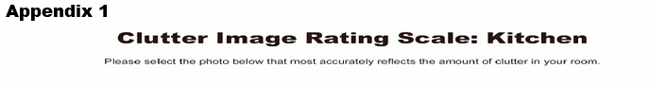
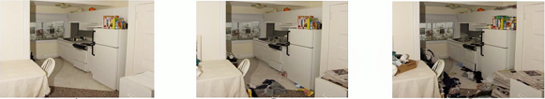

Appendix 1
LEVEL 1 1 2 3
Appendix 1
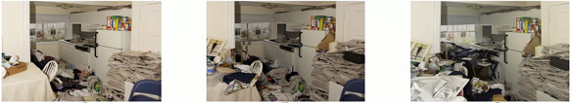
LEVEL 2 4 5 6
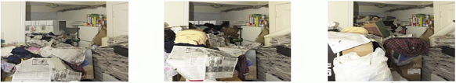

LEVEL 3 7 8 9

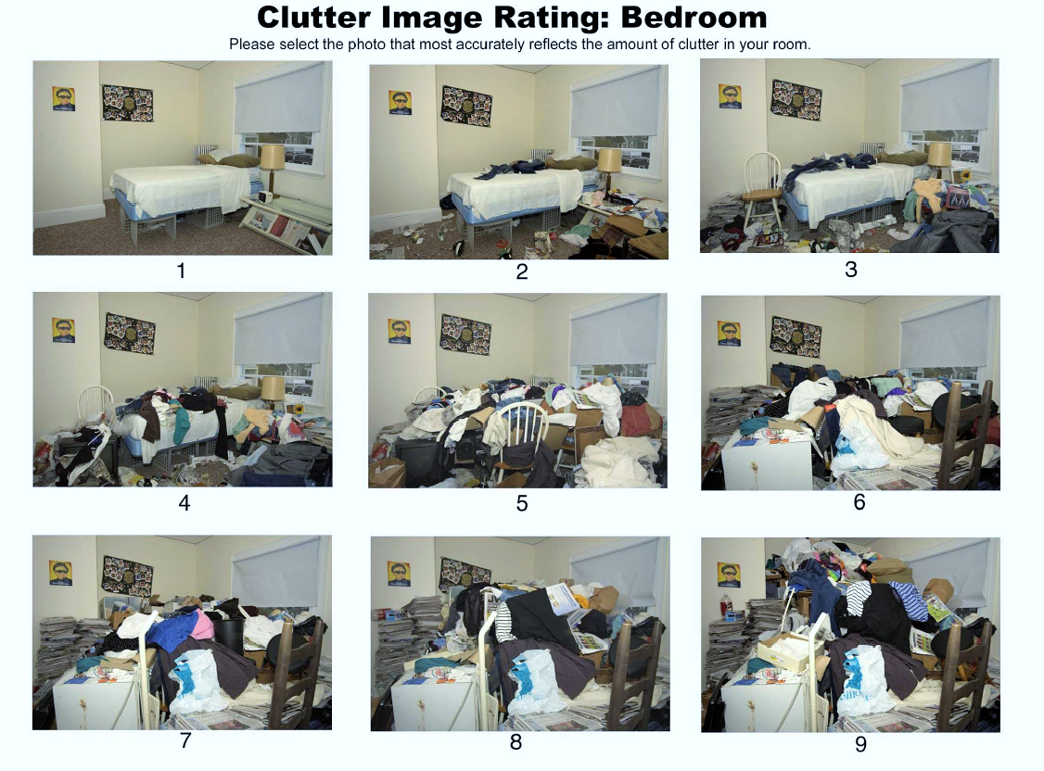
LEVEL 1 1 2 3
LEVEL 2 4 5 6
LEVEL 3 7 8 9
Appendix 1
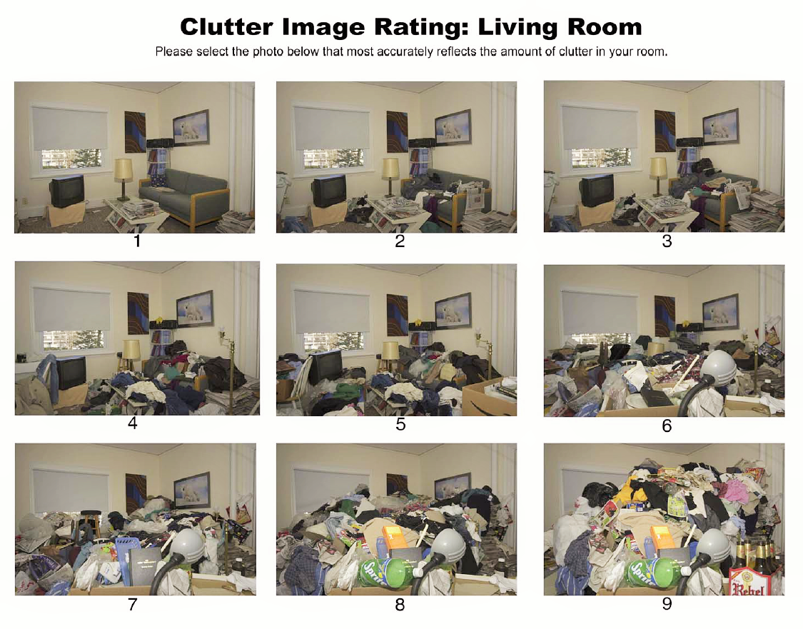
LEVEL 3 7 8 9
LEVEL 1 1 2 3
LEVEL 2 4 5 6
Appendix 1
LEVEL 1 CLUTTER IMAGE RATING 1 - 3  No specialised assistance is needed. If the resident would like some assistance with general housework or feels they are declining towards a higher clutter scale, appropriate referrals can be made. | LEVEL 2 CLUTTER IMAGE RATING 4 – 6  Household environment requires professional assistance to resolve the clutter and the maintenance issues in the property. | LEVEL 3 CLUTTER IMAGE RATING 7 - 9  Household environment will require a collaborative multi agency approach involving a wide range of professionals. This level constitutes a Safeguarding alert due to the significant risk to health of the householders, surrounding properties and residents.
1. Property structure, services & garden area  All entrances and exits, stairways, roof space and windows accessible.  All services functional and maintained in good working order.  Garden is accessible, tidy and maintained  2. Household Functions  No excessive clutter, all rooms can be safely used for their intended purpose.  All rooms are rated 0-3 on the Clutter Rating Scale  No additional unused household appliances appear in unusual locations around the property  Property is maintained.  Property is not at risk of action by Environmental Health.  3. Health and Safety  Property is clean with no odours, (pet or other)  No rotting food  No concerning use of candles  No concern over flies  Residents managing personal care  No writing on the walls  Quantities of medication are within appropriate limits, in date and stored appropriately.  4. Safeguard of Children & Family members  No Concerns for household members  5. Animals and Pests  Any pets at the property are well cared for  No pests or infestations at the property  6. Personal Protective Equipment (PPE) Household environment is considered standard.  No PPE required  No visit in pairs required. | - Property structure & services  Only one major exit is blocked  Only one of the services is not fully functional  Concern that services are not well maintained  Garden is not accessible due to clutter, or is not maintained  Evidence of light structural damage including damp  Interior doors missing or blocked  2. Household Functions  Clutter is causing congestion in the living spaces and is impacting on the use of the rooms for their intended purpose.  Clutter is causing congestion between the rooms and entrances.  Some household appliances are not functioning properly and there may be additional units in unusual places.  Evidence of outdoor items being stored inside  3. Health and Safety  Kitchen and bathroom are not kept clean  Offensive odour in the property  Resident is not maintaining safe cooking environment  Some concern with the quantity of medication, or its storage or expiry dates.  No rotting food  Resident trying to manage personal care but struggling  4.Safeguard of Children & Family members  Hoarding on clutter scale 4 -7 doesn’t automatically constitute a Safeguarding Alert.  Please note all additional concerns for householders  Properties with children or vulnerable residents with additional support needs may trigger a Safeguarding Alert under a different risk.  5. Animals and Pests  Pets at the property are not well cared for  Resident is not able to control the animals  Animal’s living area is not maintained and smells  Light insect infestation (bed bugs, lice, fleas, cockroaches, ants, etc.)  6.Personal Protective Equipment (PPE)  Latex Gloves, boots or needle stick safe shoes, P3 particle mask hand sanitizer, insect repellent. PPE required | 1. Property structure, services & garden area  Limited access due to extreme clutter outside the property  Garden not accessible and extensively overgrown  Services not connected or not functioning properly  Property lacks ventilation due to clutter  Evidence of structural damage including damp  Interior doors missing or blocked open  Evidence of indoor items stored outside  2.Household Functions  Clutter is obstructing the living spaces and preventing the use of the rooms for their intended purpose.  Beds inaccessible or unusable due to clutter or infestation  Entrances, hallways and stairs blocked or difficult to pass  Toilets, sinks not functioning or not in use  Resident at risk due to living environment  Household appliances are not functioning or inaccessible  Occupier has no safe cooking environment  Occupier is using candles  No evidence of housekeeping being undertaken  Concern for declining mental health  Property is not maintained  Property is at risk of notice being served by Environmental Health  3. Health and Safety  Human urine and or excrement may be present  Excessive odour in the property, may also be evident from the outside  Rotting food may be present  Evidence of unclean, unused and or buried plates & dishes.  Broken household items not discarded e.g. broken glass or plates  Concern with the integrity of the electrics  Inappropriate use of electrical extension cords or evidence of unqualified work to the electrics.  Concern for declining mental health  4. Safeguard of Children & Family members  Hoarding on clutter scale 7-9 constitutes a Safeguarding Alert.  Please note all additional concerns for householders  5. Animals and Pests  Animals at the property at risk due the level of clutter in the property  Resident may not able to control their animals  Animal’s living area is not maintained and smells  Hoarding of animals at the property  Heavy insect infestation (bed bugs, lice, fleas, cockroaches, ants, silverfish, etc.)  Visible rodent infestation  6.Personal Protective Equipment (PPE)  Latex Gloves, boots or needle stick safe shoes, P3 particle mask, hand sanitizer, insect repellent. Visit in pairs required

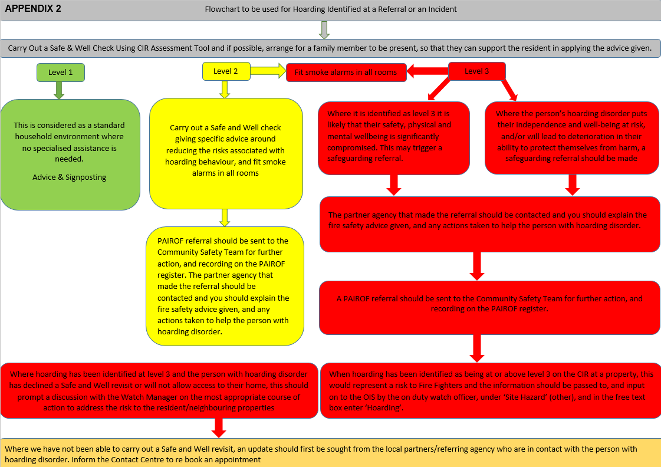

Appendix 3

‘Understanding hoarding behaviour’

Hoarding behaviour is typically manifested in three ways:

Acquisition
52. Compulsive buying and/or the accumulation of free items such as newspapers, junk mail and items left at the side of the road. This can be motivated by the belief that having an item will bring comfort and make the person happy or that they are ‘rescuing’ items so that they are not wasted or lost. It can also provide a sense of security (especially where the person has been a victim of crime).
Saving
53. there are three reason for saving: ‘sentimental’ which can be motivated by grief and refers to the emotional attachment a person feels toward an object i.e. it may become linked to a happy memory or someone they love and miss; ‘instrumental’ which can often stem from a history of having experienced deprivation, or of having had possessions forcibly taken from them in the past and so items are saved ‘just in case I need them’ or to guard against ‘being without’ again in the future; ‘intrinsic’ or ‘aesthetic’ where items are saved because they are seen as too beautiful to be discarded.
Disorganisation
54. Items of value are mixed in with rubbish and items of no apparent value. People who hoard often have difficulty with information processing, categorisation, sequencing tasks and decision making. They may also believe that they have a poor memory which leads to items being stored where they are visible instead of put away in cupboards i.e. ‘if I put them away, I won’t be able to see them and if I can’t see them I won’t remember I have them and they will be lost to me’.
55. The complexities around the reasons why a person hoards and their emotional attachment to the items hoarded means that simply ordering or telling a person to clear their home will likely have no effect and/or may increase the person’s anxiety, potentially exacerbating the problem.
56. The emotions stirred up when attempting to discard hoarded items can be too distressing and/or leave the person feeling vulnerable and insecure. In addition, difficulty with decision making and not being able to break a task down into smaller steps could mean that the process of clearing hoarded items is overwhelming for the person and so avoided.
57. It is also common for people who hoard not to recognise the severity of the problem and ignore, or not see, the clutter in their home. Conversely, the person who hoards may be acutely aware of the issue and feel embarrassed, leading them to feel defensive and/or deny that there is a problem. All of this can prevent a person from discarding hoarded items.

Appendix 4

Best practice whilst carrying out a Safe and Well check at a hoarders property

58. To reduce the risks associated with hoarding, it is important to deliver messages in a way most likely to influence a change in behaviour.
59. A staged, goal oriented approach to clearing high risk areas in the home is more likely to be successful as it reduces anxiety by providing the person who hoards with a sense of control.
60. The focus should be on small, simple steps i.e. agreeing to store items away from heat sources such as cooking appliances and heaters and keeping escape routes clear.
61. To support this approach, the following best practices have been developed in consultation with psychologists who specialise in working with people who hoard.

Do not:
62. Make assumptions or judgments about a person’s reasons for hoarding or whether they suffer from a mental health condition,
63. Use judgmental expressions, either verbal, e.g. referring to clutter as ‘junk’, or non-verbal, e.g. shaking your head or tutting, use expressions such as ‘squalor’, ‘dirty’ or ‘filthy’,
64. Tell the person what they should and should not keep, or how they should dispose of possessions,
65. Touch belongings without permission.

Do:
66. Seek to understand the hoarder’s perspective by asking interested questions; match the person’s language e.g. referring to items as ‘collections’ or ‘things’,
67. Explain the process clearly; help give the resident control by asking permission before moving around different areas of the property
68. Give clear and direct advice following the ‘top tips’ to reduce the risk,
69. Stay focused on shared solutions that benefit both the person who hoards and us and our partners.
70. Approach the situation as a collaborator i.e. you are working with the person who hoards to identify risks and finding ways to reduce them, and
71. Acknowledge small changes e.g. reaching an agreement to keep escape routes clear.

Appendix 5

Information to help hoarders reduce the risk of fire

72. If you store large amounts of possessions in and around your home, you can help keep yourself safe from fire by following the advice below. Our ‘top tips’ are small, simple steps that can easily be included in your regular weekly/daily clearance sessions.
Top tips
73. Whether you use a traditional oven/hob, or other methods of cooking such a portable stove, make it a priority to keep the cooking area clear.
74. Do not place items on or close to heaters, lamps or other electrical equipment.
75. Do not store cylinders in your home as they are a serious hazard during a fire.
76. If you have a medical need for cylinders, they should be kept upright and outdoors where possible – never store cylinders in basements, under stairs or in cupboards with electric meters/equipment.
77. If you smoke, use a proper ashtray that won’t burn and put it on a flat, stable surface so that it can’t tip over easily. Don’t leave your lit cigarettes unattended.
78. Put candles/tea lights in heat resistant holders that hold the candle/tea light firmly and ensure it is placed on a flat, stable, heat resistant surface.
79. Keep candles/tea lights away from anything that can catch fire, and never leave them unattended.
80. Make sure you have a working smoke alarm and test it weekly.
81. Plan and practise how to escape from your home in case of a fire.
82. Choose an escape route and keep it clear of possessions – in the event of a fire this will help you to escape quickly or allow fire fighters to reach you if you are unable to escape.
83. Ensure possessions are stored on stable surfaces and do not stack items to a height that they become unstable – they could fall over blocking your escape.
84. Newspapers and mail stored in bulk are highly combustible and will cause a fire to spread rapidly.
85. Sort mail and newspapers on the day you receive them and recycle them on a regular basis.
86. In the event of a fire, do not attempt to put it out yourself – leave your home straight away and call the fire service once you are safely outside.
87. Do not stop on your way out to collect possessions and do not go back inside once you have escaped.
88. If you feel that you need some help or assistance with the above, there are many organisations that will support you through the process.

Appendix 6

Helping Hoarders

Resources
Medical

89. In May 2013 Hoarding Disorder was officially recognised in the DSM-V (the fifth edition of the Diagnostic & Statistical Manual of Mental Disorders). The NHS has published a page on Hoarding, click here for more details.
90. Your GP is your first point of contact. Take a trusted friend with you to help explain the situation, you could even take photographs or ask for a home visit.
91. You can get reduced priced therapies with no waiting lists by joining www.anxietyuk.org.uk/get-help and they also have a helpline open Mon-Fri 09.30-17.30 Tel: 08444 775 774
92. Emotional Freedom Technique can be effective and combines tapping on specific acupressure points with structured dialogue.
93. Find certified practitioners in the UK on www.aamet.org , www.eftregister.com or www.eftuniverse.com .
94. Cognitive Behavioural Therapy can be helpful in changing your thought process with regard to hoarding. To find a therapist in your area go to www.cbtregisteruk.com or ask your Doctor.
95. Find information & details of counsellors or psychotherapists that deal with hoarding on www.counselling-directory.org.uk/compulsive-hoarding.

How to let go of your unwanted possessions

Websites
96. www.apdo-uk.co.uk is the Association of Professional De-clutterers and Organisers who can put you in touch with professionals in your area that are willing to work with hoarders
www.cluttergo.co.uk
www.clutterclearing.net
www.clearcareco.com
www.ginalawrie.co.uk/empatheticdecluttering
www.clutterclinic.co.uk
www.declutterdivas.co.uk
www.life-pod.co.uk
97. Stuff U Sell will collect, sort and sell your items on eBay, donating to charity or disposing of anything that can't be economically sold.
See www.stuffusell.co.uk, or free phone 0800 046 1100.
98. Other options include local recycling or house clearance companies.
99. Some house clearance companies may be willing to buy your stuff, and some local authorities may be able to collect large items for recycling or disposal.
100. Charity shops are usually very happy to take donations that they can sell on, and some may even be able to arrange collection.
101 Clothing or other items which are not suitable for re-sale could be donated to aid charities, or recycled at a recycling centre.
102. Car Boot or Jumble sales can be a good way of letting items go.
103. www.uk.freecycle.org is a good way of matching the things you would like to part with, with people in your area who will use them, thus keeping them out of landfills.
104. www.unuseditems.com believes that "One man's trash is another Man's treasure", and offers you the opportunity to sell your unwanted and unused items.

Charities
105. www.mind.org.uk is a national charity which provides somewhere to turn for help and support with mental health disorders.
www.careandrepair-england.org.uk
www.foundations.uk.com/home
106. Not for profit organisation www.hoardinguk.org offer phone, email and advocacy support free of charge.
107. Your borough may also have a local charity or enabling team which can provide practical help, some of these charities are NHS funded.

