Tameside Celebrations for International Day of Older Persons 2021
There were several events and sessions taking place to mark International Day of Older Persons on Friday 1st October 2021. Many of our friends and colleagues from across the borough have been working together with Population Health for months to mark the day.
Gorse Hall Primary School in Stalybridge first yarn bombed the Age Friendly Tameside Talking Bench, which is part of the Couch to Out and About project, with red yarn and images with a Lest We Forget theme to mark the day. This was a project that the children thoroughly enjoyed being a part of and now get to see their work when they walk past the area with family and friends.
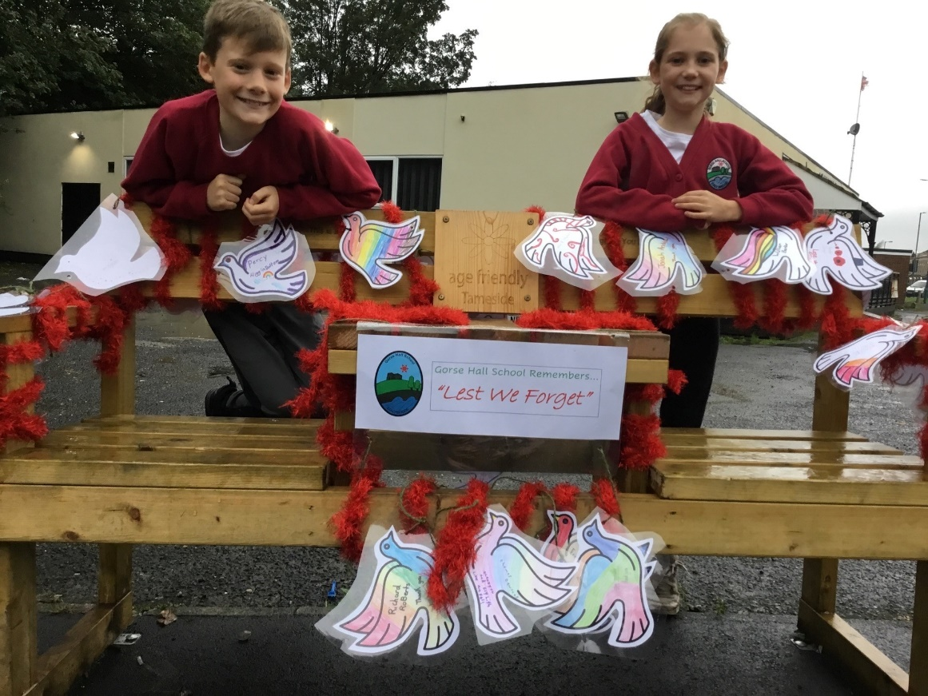
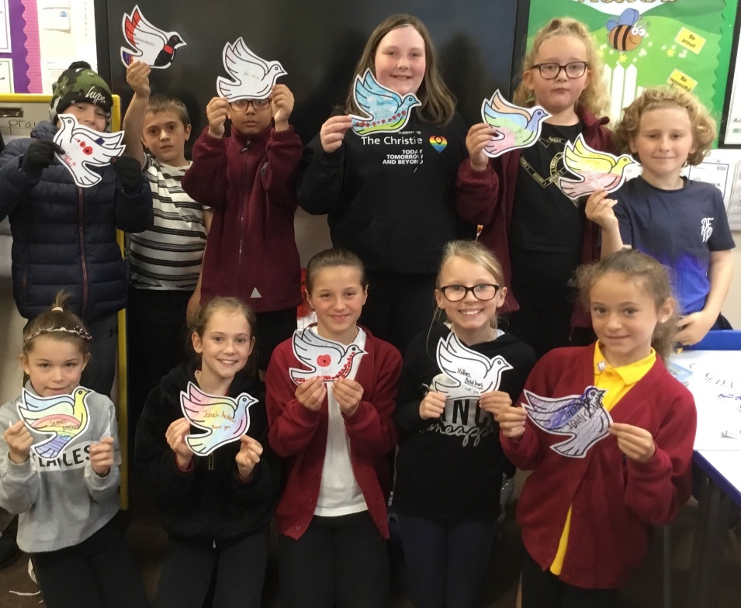
Secondly, a fantastic joint project between the Complex Care Team from the Dukinfield, Mossley and Stalybridge Primary Care Network, Population Health, The Youth Justice Service, and Millbrook Care Home in Stalybridge came to fruition. Local organisations and cafés had donated food and plants as part of this project for the care home, including locally grown vegetables donated by the Allotment Café in Mossley, home-made bird houses, feeders and letters of kindness from the Tameside Youth Justice Service and plants donated by DB Nurseries in Hyde. The Care Home made a lovely, hearty soup for dinner with the vegetables for the residents to enjoy and Deputy Mayor Councillor, Michael Glover and Ian from the Tameside Youth Justice Service, planted the plants in the Care Home garden for the residents to watch grow. The residents enjoyed reading the letters of kindness from the Tameside Youth Justice Service and some residents have started to write notes to send back to the children. The Tameside Youth Forum plan to visit the Care Home in the next few weeks with children from the Forum who are going to plant some more flowers in the garden with the residents.
Jennifer Crozier, Complex Care Nurse spoke about the day, “Such a special day, you can see the happiness and smiles on the ladies faces and it makes me feel so proud to be a part of this team and a part of supporting this Care Home. The relationships that will be built following this with the children and the residents are going to be amazing, the ladies are so happy to receive the letters of kindness, one lady has wrote back and wants to be a pen pal, thank you so much everyone.”
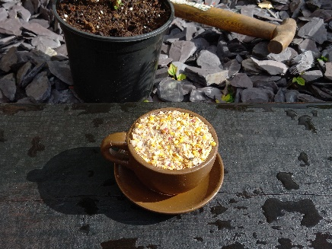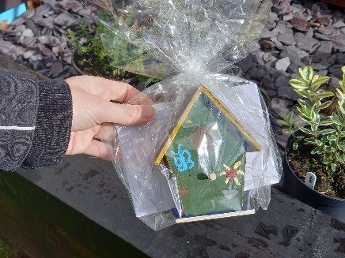
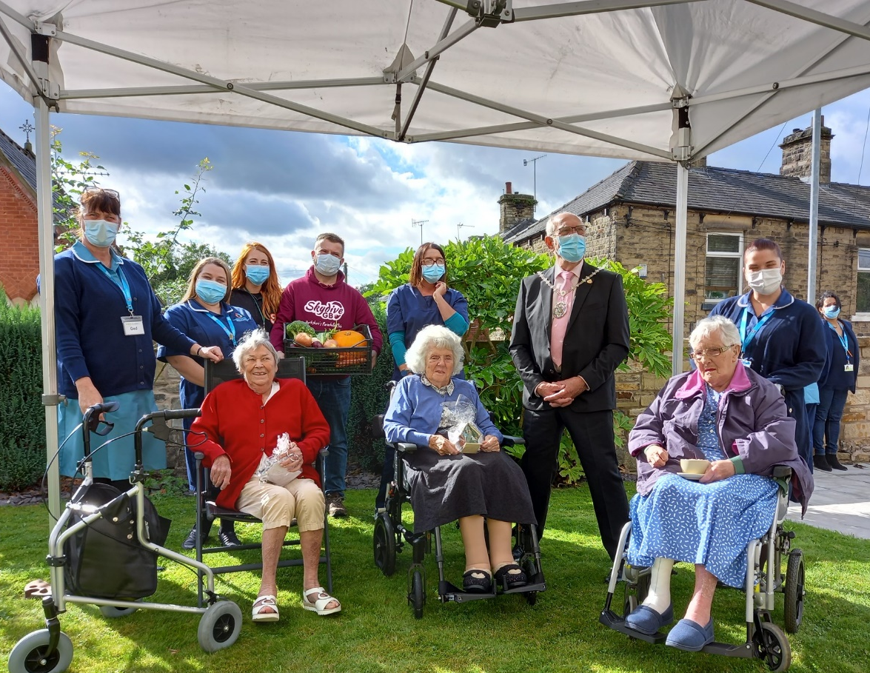
Lastly, Eclectic Avenue café which is based in the newly opened 4C Community Hub in Ashton-under-Lyne hosted a Tea Dance for the residents of Tameside & Glossop. The Tea Dance included a live singer, a delicious buffet and dancing. The Event room at the Hub was beautifully dressed with china dinner sets, flowers and lots of sparkles. Around 20 people came along to the Tea Dance and had a lovely afternoon.
Eclectic Avenue café plan to host lots more of these events, with the next being close to Christmas.
Feedback from the event was very positive, one of the guests at the Tea Dance said; “You have done a smashing job putting this Event on”. Another guest commented ‘This is a very high end tea party’, and a 3rd guest said ‘This is much more than I was expecting and much more than I could have asked for, and with such nice waitresses, it goes a long way, thank you. I’ve had such a wonderful time and can’t wait for the next one’.
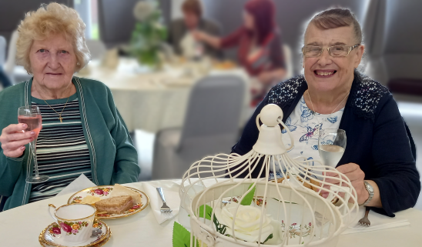
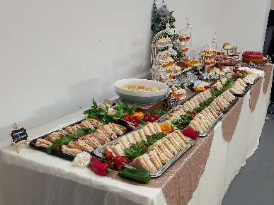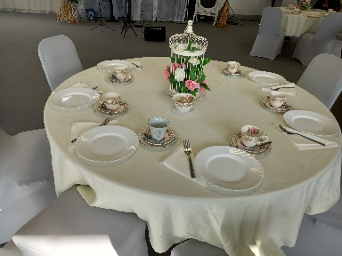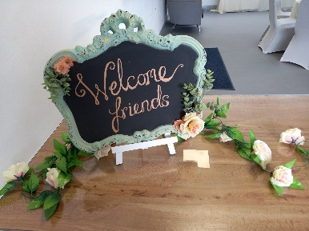
Feedback from the manager at Joseph Jennings from the residents that attended: ‘The tenants who went to the Tea Dance from Joseph Jennings said they had a lovely time and thoroughly enjoyed it.
They said they could not fault anything; it was all lovely and the singer was really good and they would definitely go to another event like that.
It was nice to see them looking forward to going out after such a long time.’
I would like to say a huge thank you to all of our partners who have marked this special day this year and for your tireless efforts and hard work in making each day count for all the other days in the year too for our older residents.
A special thank you goes to the Complex Care Nurses at DMS, Daryl-Anne Baguley from Youth Justice, Kathleen and Alex from Gorse Hall School and Jodylee from Eclectic Avenue Café- thank you so much, it has been amazing working with you for these events.
If you would like to mark International Day of Older Persons 2022, and be included in next years’ edit, please email Lauren on lauren.foster1@tameside.gov.uk a month before the day, which is on 1st October each year.
Please also email me if you would like to become an Age Friendly Champion!
Kind regards,
Lauren.

