Malnutrition Awareness Week 2021:
Tameside and Glossop

It was Malnutrition awareness week last week (11-17th October) and we were busy promoting good nutrition and hydration throughout the life-course and into older age, and giving advice on how to prevent these avoidable conditions and how to look out for the signs and triggers.

Cooking demonstration

We had our star Chef Noel Goulding from Veterans Food Co. perform a cooking demonstration for people at George’s Kitchen at St George’s Church, Stalybridge on Thursday 14th October for the On Your Marks, Cook Smart session. Noel cooked up a storm, including a very nutritious and hydrating butternut squash soup made with coconut milk and croutons, and a chickpea curry with rice, which went down very well with the 15 attendees who were all over 60. The food cost less than £10 and easily fed 15 people, with many going home with leftovers. The food is locally sourced where possible, and the session focused on batch cooking with foods that are good for the environment, which is a crucial topic for our current and future generations. We talked about food swaps including staple ingredients like tinned lentils, chickpeas, butterbeans, tomatoes etc. These are great pantry items that last for a long time and save multiple trips to the shops, but also contain many nutrients, fibre and protein and can be a great alternative to meat, which is cheaper and healthier, not to mention better for the environment.
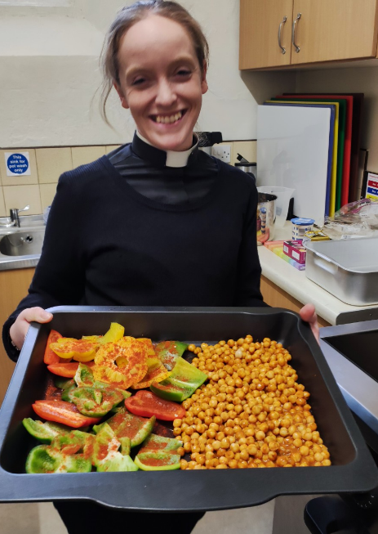
With the energy crisis, fuel crisis and the pandemic, many people and families are feeling the pinch and are having to tighten their belts or even rely on food banks for their weekly shop, which makes it even more important to save money where possible and these little swaps, can really help.

We had some great quotes from attendees including:

‘I have really enjoyed it today, it has been interesting and informative and really friendly’
‘Just really good’
‘Very interesting, I enjoyed the food’
‘It was great, nutritional food on a budget’
‘That was beautiful, thank you’.

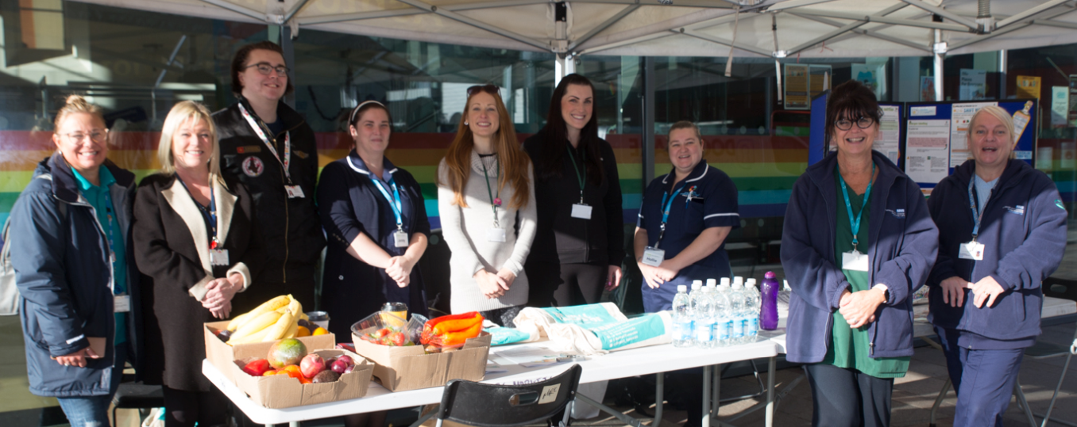
Malnutrition Awareness Stall at Ashton Outdoor Market
In addition, we were joined by many professionals from across the borough on Friday 15th October for the Malnutrition Awareness Week stall at Ashton outdoor market, including Population Health, Be Well Tameside, Infection Prevention (ICFT), Jigsaw Homes, Community Safety, DMS Primary Care Network and Eclectic Avenue Café as well as local Councillors who showed their support for this great project. We spoke to 100 groups of people on the day and gave out advice and information on how to have good nutrition and hydration all the way through into older age and how to prevent malnutrition. We also gave away lots of fruit and vegetables for FREE which were kindly donated by Dave at Wilson’s Fruit and Vegetable Stall in Ashton Market, Lesley at Heyrod Food and Floral, as well as water donated by Wilko in Ashton and a lovely homemade apple and plum crumble made by Jodylee and the team at Eclectic Avenue café at 4C community Centre, Ashton.
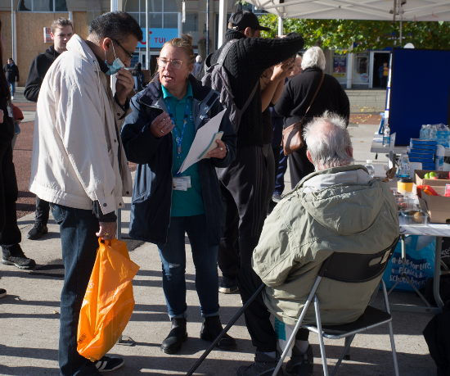
One member of the public said: ‘This is fantastic and something you don’t hear about often, in fact my brother could really do with some help so I will take this back to him’.

Another said: ‘What a great thing you are doing, this doesn’t apply to me but I know it will for many others’. Through awareness raising and advice, we hope that even if this doesn’t apply to someone right now, it can help to prevent it in the future and spot the signs before the person begins to suffer or is at risk.

DirectCare Malnutrition Awareness Week

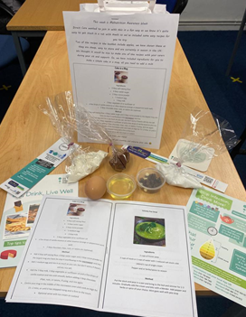
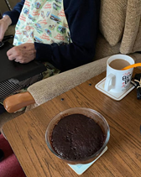
DirectCare, based in GeeCross, Hyde are great supporters of the Nutrition and Hydration programme with most of their employees being Nutrition and Hydration Champions. For this years MAW, the team sent out packs to clients which included tips on ways to get good nutrition, portion size, food presentation and balanced meals as well as ways to keep hydration levels up and signs to look out for. They also included all the ingredients for the ‘cake in a mug’, that you just add water to and pop in the microwave to entice people to the pack!
Thank you again to everyone who has supported Malnutrition Awareness Week 2021. Please do continue to keep raising awareness about good nutrition and hydration, and the triggers and signs of malnutrition and dehydration; Together we can help to prevent these avoidable conditions. If you know of anyone who would like to become a Nutrition and Hydration Champion and complete the training, please pass on my contact details: lauren.foster1@tameside.gov.uk. Equally, please also contact me if you or someone else would like to become an Age Friendly Champion.

Further reading: GM Nutrition and Hydration; Bapen; Malnutrition Task Force and Older People

Lauren Foster
Population Health Programme Officer, Age Friendly

