Tameside and Glossop Autism Service
Hollingworth Clinic
Market Street
Hyde
SK14 8HR
Telephone: 0161 304 5860

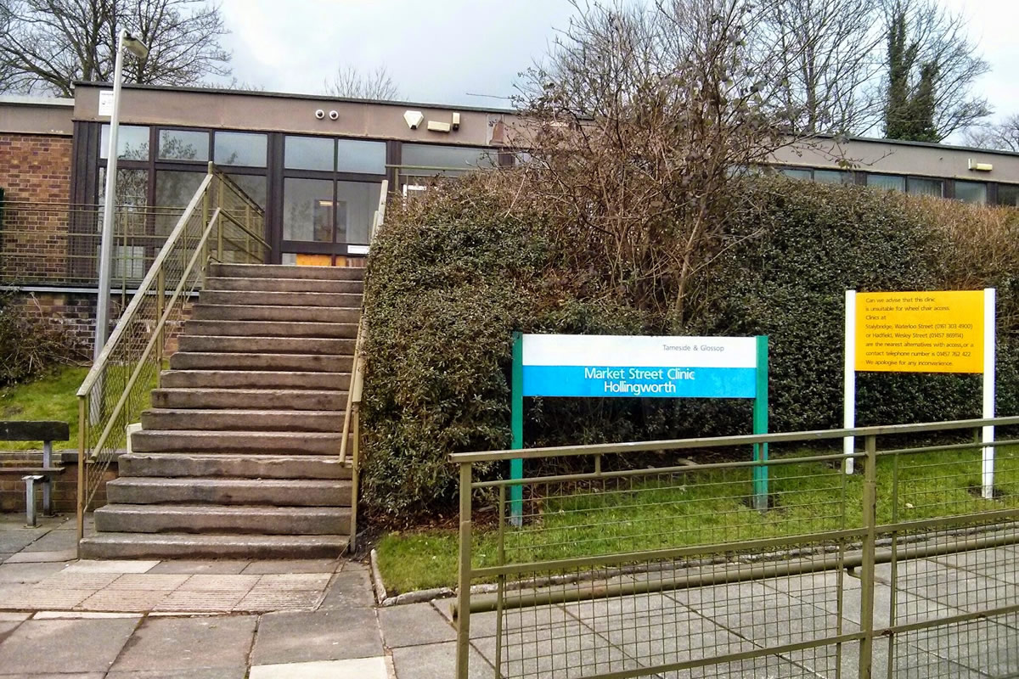

Post Diagnostic Pack
Introduction
You have been given this pack following your diagnosis of Autism Spectrum Condition (ASC). Many People think receiving a diagnosis as a major life event. You may have questions about the diagnosis and want to know more; or perhaps you do not feel ready to look into this yet and may need more time to get used to the idea.
Many people experience a range of different feelings as they reflect upon their diagnosis and may find themselves thinking about past events in a new way. There is no right or wrong way to respond to a diagnosis of ASC. It can be helpful to allow yourself time to come to terms with this new piece of information, and be patient with yourself while you are thinking things through.
This pack contains information which you may find helpful in understanding your diagnosis. There is also information, advice, support and resources for people who have autism.
Please note that mentioning a service or product in this pack does not mean that Tameside and Glossop Autism Team endorse it above other providers. The resources listed have been helpful to individuals in the past, but things change day-to-day online, and TGAT cannot be responsible for the content of eternal websites.

Table of Contents
Topic | Page
The National Autistic Society | 3 – 4
Employment Information | 5 – 7
Education Information | 8 – 9
Your rights | 9 – 10
Benefits | 10
Sensory Information | 10 - 11
Useful Websites | 11 – 12
Useful Books | 12 – 15
Support in Tameside | 16 – 17

The National Autistic Society
The National Autistic Society offers information for the following individuals:
- People with an Autism Spectrum Condition or who suspect they may be on the Autism Spectrum.
- Parents, carers, guardians and other family members of individuals with an Autism Spectrum Condition.
- Professionals working with or for people with Autism Spectrum Conditions such as health and social care professionals, those working in education, or legal workers.
- Researchers.
- Potential employees or volunteers.
- Potential fundraisers, donor and sponsors.
- Legislators and policy makers.
- Journalists.
National Autistic Society Website www.autism.co.uk
This provides information around Autism Spectrum Condition, benefits, autism alert cards, books, support groups, local services etc. You can also find the below services on the website:
The National Autism Society Services Directory
The Autism Services Directory is an online UK database to help people with Autism, their families and the people who work with them professionally to find out more about the services available to them. It harnesses 40 years of experience and expertise of the National Autistic Society.

Through simple searches and browsing, users will be able to find their nearest school, adult centre, respite service, play scheme or other type of local or national services. Here is a list of potential services that can be searched for:
- Advice and Advocacy
- Assessment and Diagnosis
- Education
- Local Government
- Health
- Organisations
- Support Groups and Networks
- Training and Events
Autism Helpline:
0808 800 4104
Opening Times: Monday – Friday 10am - 4pm
This is for people with an Autism Spectrum Disorder, family members and carers, offering impartial and confidential advice, information and support around Autism and related issues, including local support and services, diagnosis, early intervention, therapies and behaviour management.
Education Rights Service:
0808 800 4102
This gives advice and support on educational provision and entitlements throughout the UK. Trained volunteers will guide parents and carers through education law and support them through what can often be a complex and difficult process. They also help parents prepare appeals to educational tribunals.
Parent to Parent Service:
0808 800 4106
This is a confidential telephone service which provides emotional support for parents, and carers of an adult or child on the Autistic Spectrum. A message can be left on the 24 hour answer phone and a volunteer will then call back as soon as possible, at a time which suits, including evenings and weekends.
Welfare Rights Service
The Welfare Rights Service offers advice, information, and support on all aspects of social security benefit entitlement. This includes advice on which benefits you may be entitled to, general advice on completing claim forms, what to do if you think a decision is wrong and how to appeal to a tribunal.
To use the service:
• Call the Autism Helpline (number above). The Helpline will take details of your query and arrange a telephone appointment for you with a Welfare Rights Advisor who will call you back at an agreed time to discuss your query in detail.
Or:

• Email your enquiry to welfarerights@nas.org.uk. The National Autistic Society mention that it would be helpful if you could confirm the name of the benefit you are enquiring about and provide as much detail as possible regarding your query.
Autism Passport
The National Autistic Society provides a ‘Hospital Passport’ resource which is for those with Autism who may need hospital treatment. It is designed to help you communicate your needs to health professionals.
Employment Information
Jobcentre Plus:
Jobcentre Plus provides two specialist schemes to provide disability support at work. These are called Work Choice and Access to Work. These schemes offer support in getting into work, staying in work, or accessing reasonable adjustments in the workplace. You can access the schemes either when starting work, or to access support at a job you have already. You can use the schemes even if you did not use Jobcentre Plus to find your job.
To find out more about Work Choice and Access to Work, contact your local Jobcentre and ask to speak to a Disability Employment Advisor (DEA). They can also provide support in making reasonable adjustments when attending the Jobcentre.

National Autistic Society:
0808 800 4104
www.autism.org.uk
A free workbook, ‘Finding work’, is available to download from the NAS website, in the ‘Adult Life / Employment’ area. This provides guidance on identifying your interests, skills and strengths, job searching, applying for jobs, and accessing support at work.

Routes to Work
0161 342 2400 – ask to speak to Routes to Work
Key contacts; Lorraine Pattison or Julie Grimes
Routes to Work are supported employment team, which is a service provided by Tameside MBC.

Routes to work offers advice, support and practical assistance to local residents with a disability, or mental health condition or a substance misuse which is a barrier to employment, training, or volunteering, this service can help you to find work or keep a job because of a disability.

Juniper Training
0161 830 0595
https://www.junipertraining.co.uk/centres/ashton/
Juniper offer supported Traineeships and Apprenticeships; they also have the capability to support you to further improve on your grades by taking a GCSE or BTEC refresher course. Their training centre is situated in the heart of Ashton on Stamford Street, within walking distance to the local bus and train stations.

Ingeus
0161 240 0285
Ingeus specialise in creating and delivering services in employment, health, education, justice and youth.
Ingeus are based in Ashton-Under-Lyne on the 1st floor innovation suites in the Tameside Centre for Enterprise.
Ingeus has a strong history of delivering high quality services that support people to find suitable, lasting work. They do this by studying evidence of what works, rethinking public services and building alliances with expert partners around the needs of citizens today. For 15 years we have been delivering employment services in the UK, including New Deal, Flexible New Deal and Pathways to Work among others.

Remploy
0300 456 8110
employmentservices.osc@remploy.co.uk
www.remploy.co.uk
Remploy is a specialist employment service for people with disabilities. They work nationwide and they can support you with:

- Job hunting and Applications
- Support with CV writing, application forms, interview techniques and job search tips.
- Volunteering opportunities
- In-work support
- Advice and support for your employer to help them to implement reasonable adjustments.

National Careers Service:
www.nationalcareerservice.direct.gov.uk
This website provides a range of resources to help you chose what kind of work might suit you. This includes:
- Job Profiles – Find out what skills, experience and qualifications are required for specific job roles.
- Skills healthcheck – A self-assessment tool to help you to identify any gaps in your skills.

Works4u
0161 303 1069
Works4u@normanmackie.com
Works4u is an Independent Specialist Provision Centre that offers an alternative to mainstream education. The centre is based in Stalybridge they work to promote a safe and nurturing learning environment for young people between the ages of 14 and 24 and provide one to one support in developing their academic, social and independent living skills.
We support young people who find accessing a mainstream school or college environment too much and require different levels of care. At Works4U they show understanding that the circumstances of each learner are different but under the right guidance, all young people can flourish.

Education Information
Disabled Students’ Allowance (DSA)
https://www.gov.uk/disabled-students-allowances-dsas/overview
Higher education students living in England can apply for DSA to help them to pay the extra costs they may have because of their disability. For example, DSA can pay for specialist computer software, or fund non-medical helpers such as note-takers. DSA does not have to be repaid. The support you get depends on your individual needs and not on income.

Disabled Students’ Support
If you are attending college or university, consider contacting your organisation’s disabled students’ support team. They can help you to access and coordinate any support you need to help you to get the most from your studies.

Education, Health and Care Plans (EHC / EHCP)
https://www.gov.uk/children-with-special-educational-needs/extra-SEN-help
An education, health and care plan is for children and young people aged up to 25 who need extra support to reach their educational goals. EHC plans identify educational, health and social needs and set out the additional support to meet those needs.
A young person can request an assessment themselves if they’re aged 16 to 25. To do so, contact your local authority. You can find out how to do this through the above website

Education Rights Service
0808 800 4102 - Option 1 for our Education Advice Line and option 2 for our Tribunal Support Line
The Education Rights Service provides impartial and confidential information and support to families on school education rights and entitlements.
They can; offer confidential information, advice and support by phone or email. Explain education law and your rights and entitlements. Help you explore your options so that you can make informed decisions about your child’s school education. Help you communicate effectively with your child’s school and education professionals and explain complaints and appeals process and support you if you are making an appeal.

They cannot; provide face-to-face support. Attend meetings and appeal hearings with you, but they can help you prepare for them. Contact educational professionals or write to them on your behalf, but they can write letters with you. They will also not promise that you will get all you want but they will certainly help you try.
Your rights
The Equality Act (2010)
This piece of legislation protects people from discrimination on the grounds of disability. The Act protects you at work, in education, as a consumer and while accessing services.
The Act also gives you the legal right to ‘reasonable adjustments’ to make work or education more accessible to you. You can request reasonable adjustments if any aspect of; the working arrangements (e.g the hours or the method of working) or the building or place where you work (e.g steps or doorways) makes it much more difficult for you to do your job / participate in education because of your disability than it would for a non-disabled person.

The Autism Act (2009)
The Autism Act 2009 was the first every disability-specific law in England. This led to the publication of a national strategy for adults with autism, published in March 2010.
Under the Act, all staff in health and social care should receive autism training. All care staff are required to be able to make reasonable adjustments to their working practice for people with autism. All adults with autism to be eligible for a community care assessment, and adults with autism should receive support for gaining and maintaining employment.

Citizens Advice
03444 113 111
www.citizensadvice.org.uk
Citizens Advice, sometimes called Citizen’s advice Bureau or CAB, is a nationwide network of independent and impartial advice services. They can provide advice and support on your rights and responsibilities on topics such as:

- Benefits, work, debt & money, consumer rights problems in relationships, house, law & rights, discrimination, tax, healthcare and education.

Benefits
Personal Independence Payment (PIP)
www.gov.uk/pip/overview
PIP is a benefit payment which helps with some of the extra costs caused by long-term ill-health or a disability for people aged 16-64. You’ll need an assessment to work out the level of help you get. Your rate will be regularly reassessed to make sure you’re getting the right support. Do not be surprised if your claim is rejected in the first instance, as many people have to go through the appeals process. If you need help with applying for PIP or appealing a decision contact Citizens Advice or Welfare Rights – 0800 074 9985.
Employment and Support Allowance (ESA)
www.gov.uk/employment-support-allowance/overview
ESA is a benefit payment which is available to people with disabilities or long-term health conditions. It provides financial support if you’re unable to work, or personalised help so that you can work if you are able to. You can apply for ESA if you’re employment, self-employed or unemployed. As part of the claim process, you must have a Work Capability Assessment, to determine to what extent your illness or disability affects your ability to work.

Sensory Information
Many people with autism experience difference in how the perceive and process sensory information. This is the information we take in through out senses; sight, sound, touch, hearing, taste, vestibular (the sense of balance) and proprioception (the sense of where our bodies are in space).

Everybody, autistic or not, has a unique ‘sensory profile’. This means that we each have different preferences about the levels of input we need for each of the senses. Many people with autism find that they are more (hyper) or less (hypo) sensitive to certain types of sensory input than other people they know.
In order to feel comfortable and able to concentrate, you may find it helpful to make some adjustments to your environment to change the sensory input you are getting. For example, some people find that they are more able to focus on a task while listening to music through headphones, or that using a fidget or sensory toy can help them to relax in stressful situations.
There are a number of sensory items that are available to buy.

Useful Websites
Departments of Health
www.dh.gov.uk
The Department of Health is a ministerial department. Its website has information on a range of services such as benefits, disabilities, education, employment, housing and tax.

Ted Talks
www.ted.com/talk
TED is a non-profit organisation that tries to spread ideas in the form of short, powerful talks (about 18 minutes or less). It covers almost all topics and you can search on its website for a topic such as Autism.

Carers Direct
0808 802 0202
www.nhs.uk/carersdirect
Carers direct is a national information, advice and support service for carers in England. It is a free confidential helpline, open seven days a week.

Apps – The DART Project
www.dart.ed.ac.uk
The DART project, based at the University of Edinburgh, provides reviews of a wide range of apps which may be helpful for people with autism. Categories include autism-specific apps, visual schedules and adult living skills. Go to the ‘ASD Tech’ area of the site and click onto ‘App reviews’. Reviews can also be found on twitter @SueReviews

Forums
www.wrongplanet.net
www.asperclick.com
These two websites are online forums for those with a diagnosis of Autism. Although some may find these forums useful, feedback has been mixed and not all feedback has been mixed and not all feedback we have received has been positive. As mentioned earlier, things change day-today online and TGAT cannot be responsible for the content of external websites.

Books
Autism Spectrum Condition
Appreciating Asperger Syndrome, Looking at the Upside with 300 positives by Brenda Boyd
Asperger Syndrome by Tony Attwood

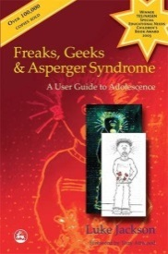 Freaks, Geeks and Asperger Syndrome by Luke Jackson

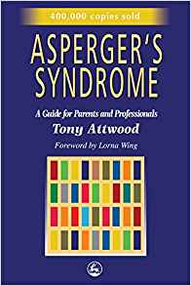 Asperger Syndrome: A Guide for Parents and Professionals by Tony Attwood

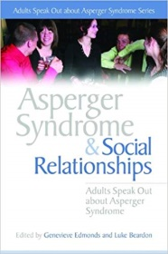 Asperger Syndrome and Social Relationships by Genevieve Edmonds and Luke Beardon

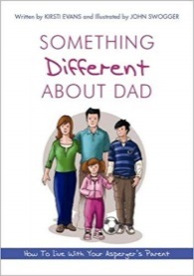 Something Different about Dad by Kristi Evans and John Swogger

Like Colour to the blind by Donna Williams

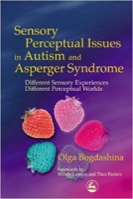 Sensory Perceptual issues in Autism and Asperger Syndrome by Olga Bogdashina

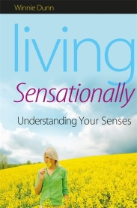 Living Sensationally: Understanding your Senses by Winnie Dunn
Too loud, too bright, too fast, too tight by Sharon Heller
Nobody Nowhere by Donna Williams
Asperger’s and Girls by Tony Attwood and Temple Grandin

Support available in Tameside
The Tameside Autism Group;
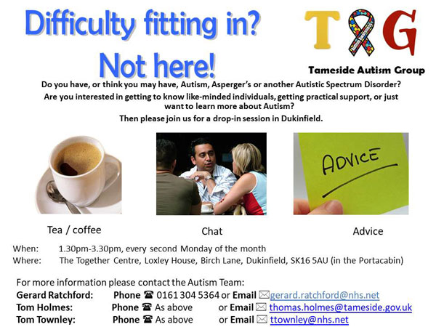

Parents Group:
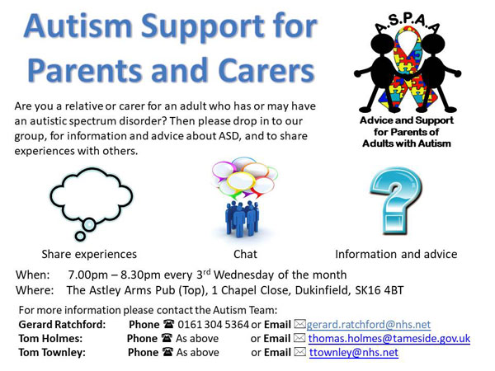

“Autism Packs” are available!
There are “autism packs” available at Tameside One in Ashton. They are available at the Library desk on the ground floor. These packs consist of; ear defenders (ear plugs also available) sunglasses and, if wanted, a hidden disability lanyard.
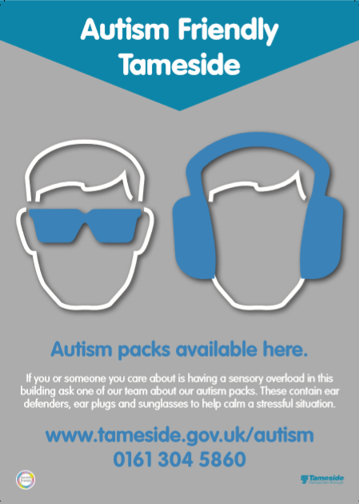
These packs will soon be available in the majority of GP practices and A&E. Please do identify to reception staff at any place you visit of your diagnosis. They will do their upmost to implement reasonable adjustments to make your experience much better.

The pack will be reviewed on 01/02/2019 and the updated version will be available on the following website: www.tameside.gov.uk/autism

