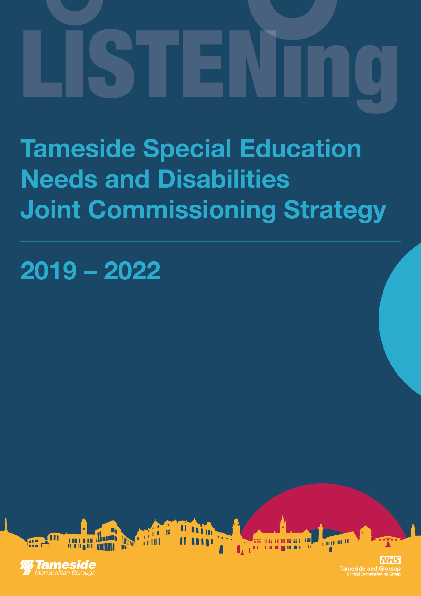
FOREWORD

This Joint Commissioning Strategy sets out our ambition for children and young people with SEND in Tameside and their families.

It will play a vital role in making sure that we will have a transparent and open sharing of our priorities enabling every child or young person aged 0-25 with Special Educational Needs Disability to reach their full potential and to feel that they are contributing to our local community.

The Strategy outlines the principles, approaches and key actions we will take to deliver our vision and will evolve as we progress. We will work towards the principles of co-production outlined in our LISTENing in Tameside co-production framework and seek to embed them at all stages of joint commissioning work.

We are committed to reviewing the strategy annually so we can continue to drive the improvements needed and to make the strategy a ‘live’ document that responds to the needs of children and their families.

CONTENTS

INTRODUCTION 3
SCOPE 4
DEFINITION 5
GUIDING PRINCIPLES 7
LOCAL POPULATION 8
CO-PRODUCTION 8
COMMISSIONING INTENTIONS 9
GOVERNANCE 10

INTRODUCTION

This document sets out the strategic direction of commissioning for Children and Young People with Special Educational Needs and Disability (SEND) in Tameside, including health services for Glossop.

The strategy sets out how we will work together to ensure through commissioning we achieve good outcomes for our children & young people in Tameside.

In line with vision of the Tameside and Glossop Strategic Commission this Strategy aims to ensure a fully integrated approach to the commissioning and delivery of services for children and young people with SEND.

Our Strategy meets the requirements of the Tameside and Glossop Corporate Plan 2018 – 2025:

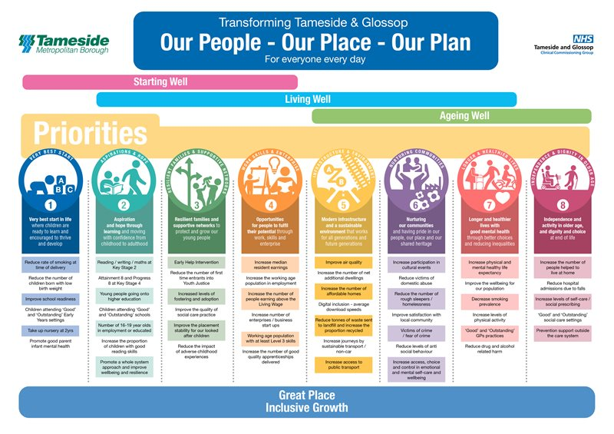

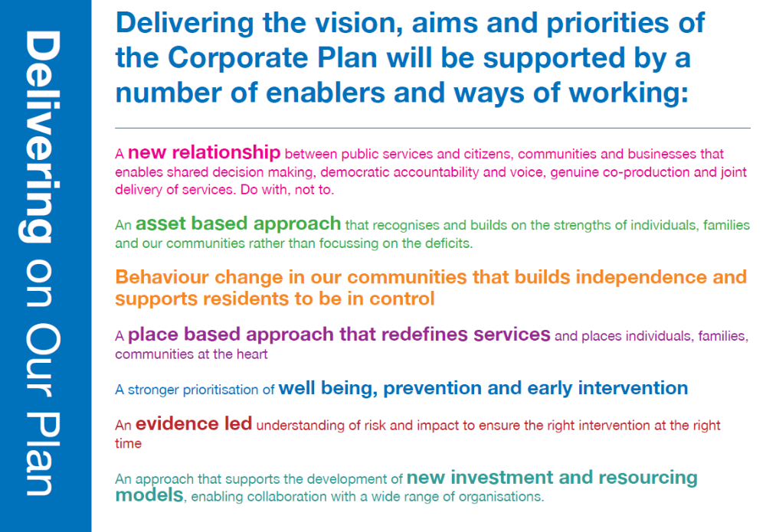

“Aspiration and hope through learning and moving with confidence from childhood to adulthood.”

We want all our young people to live in a safe and supportive environment and have the opportunity to reach their full potential.

Ensuring we provide the right service in the right place, at the right time, supporting people to live healthily and to achieve their true potential:

Its development has been informed by national policy including the Children and Families Act (2014) [specifically the SEND reforms], Future in Mind, the NHS Long Term Plan, the Transforming Care Programme and local policy including the Tameside SEND Strategy, Tameside and Glossop Children and Young Peoples Emotional and Mental Wellbeing Local Transformation Plan, Tameside JSNA (2017) and the Tameside Health and Wellbeing Strategy. It also seeks to draw on feedback from parents, carers and young people.

SCOPE

This strategy covers Children and Young People with Special Educational Needs and Disability who are aged 0-24 (up to their 25th birthday).

DEFINITION OF SPECIAL EDUCATIONAL NEEDS

A child is defined as having Special Educational Needs (SEN) if he or she “has a learning difficulty or disability which calls for special education provision to be made for him or her”. [Children and Families Act 2014 Section 20].

A child is considered to have a learning difficulty if she or he:

- has a significantly greater difficulty in learning than the majority of others of the same age; or
- has a disability which prevents or hinders them from making use of facilities of a kind generally provided for others of the same age in mainstream schools or mainstream post-16 institutions

Disability is defined in the Equality Act 2010. A person is disabled if they have a physical or mental impairment that has a substantial and long-term adverse effect on a person’s ability to carry out normal day-to-day activities.

This definition provides a relatively low threshold and includes more children and young people than many realise: ‘long-term’ is defined as ‘a year or more’ and ‘substantial’ is defined as ‘more than minor or trivial’. This definition includes sensory impairments such as those affecting sight or hearing, and long-term health conditions such as asthma, diabetes, epilepsy, and cancer.

Children and young people with such conditions do not necessarily have SEN, but there is a significant overlap between disabled children and young people and those with SEN. Where a disabled child or young person requires special educational provision they will also be covered by the SEN definition.

The Special Educational Needs and Disability Code of Practice, DfE, July 2014 states:

“EHC plans can be put in place from birth, and up to 25 where it is agreed that a young person requires more time to complete their education, and has not yet met the outcomes agreed as part of their plan. In the case of a young person who reaches their 25th birthday before their course has ended, the EHC plan can be maintained until the end of the academic year in which they turn 25’

Children, young people and their families are at the centre of our work. Supporting their interests and welfare is paramount. The following principles guide our approach to commissioning:

- We will keep children and young people safe through effective safeguarding practice
- We will work with children, young people and families meaningfully at all stages of the commissioning cycle.
- We will work within a framework of fair, open and transparent processes.
- We will make evidence-informed decisions about the commissioning and decommissioning of services.
- We will strive to continual improve outcomes for children, young people and their families.
- We will focus on early intervention and prevention to reduce high cost services in the future.
- We will promote equality (including equality of access to services) in relation to age, disability, gender/gender reassignment, race, religion or belief and sexual orientation.
- We will deliver efficiencies and quality through robust risk, contract and performance management.
- We will work in a spirit of co-production and partnership with parents and their children and young people with SEND, involving them in all key decisions.
- We will work in partnership with partner agencies and schools to deliver an effective SEND system that ensures effective early identification of need followed by robust assess- plan-do-review processes and clear pathways.
- We will have the highest expectations for children and young people with SEND, ensuring that they are fully included in all educational settings and that their needs are met by high performing local schools.
- We will ensure a rigorous focus on the preparation for adulthood outcomes and life after school.
- We will ensure that resources are fairly and consistently allocated according to needs.

We are committed to the arrangements for safeguarding and promoting the welfare of children and young people through the Tameside Safeguarding Children Board (https://www.tamesidesafeguardingchildren.org.uk).

We work in accordance with the Equality Act 2010, which consolidates protection against discrimination on the grounds of age, disability, gender reassignment, pregnancy and maternity, race, religion or belief, sex and sexual orientation. It also put in place a public sector equality duty, which gives public authorities a legal responsibility to provide this protection and make decisions which are fair and transparent, including the allocation of public money.

We will achieve value for money by securing effective services which meet local needs and deliver improved outcomes.

GUIDING PRINCIPLES

We are committed to the following principles in our commissioning activities:

This will mean:

- A focus on outcomes that we are trying to improve for the child or young person, the level of response required and assertive monitoring of whether their life is improved as a result

- A shift towards neighbourhood working - reinforced by a wide range of support options

- Continuing the shift to more flexible arrangements that encourage responsiveness to the needs and choices of children and young people based on affordability, choice, quality, and accountability in service provision in line with Universal Personalised Care (2019).

- Focusing on the needs of children and young people and their families rather than defining them by service user group. Understanding local needs and preferences as well as reducing demand longer term lies at the heart of effective commissioning.

- Making commissioning decisions based on evidence and using innovation in performance to ensure that we are getting the most from all of our commission and contracting arrangements.

- Emphasising co-production principles at all stages of commissioning with children and young people, providers, partners and professionals communities.

- Challenge & review service delivery (make, shift, buy, share, share, stop) to make sure value for money is achieved.

This will require:

- a firmer evidence base, informed by more effective monitoring of outcomes and feedback to shape future commissioning intentions

- a close relationship which continues to share market intelligence to further understanding of any potential gaps in provision and clarification of respective roles in responding to need

- an increasing emphasis on the provider’s ability to demonstrate productivity, cost effectiveness and value-for-money

- the potential for commissioning on an experimental basis (accepting some risks) in order to encourage new models of delivery and providers into the market

- full transparency on funding within commissioning and provider block contracts.

THE LOCAL POPULATION NEED

Children with special educational needs and disabilities are a diverse group, where some children require minimal support and others require multi-agency intervention across the three sectors of education, health and social care. In order to ensure the best outcomes for these children and young people, it is vital to understand their needs to ensure that these children and young people feel fully part of society and are never excluded from any part of life’s experience or opportunities.

We will use our data to inform our commissioning intentions. Our JSNA and SEND strategy for example are data sources that we will use as part of our commissioning cycle.

CO-PRODUCTION

We are developing a co-production framework in Tameside, called LISTEN. We will use this as part of the commissioning cycle to inform our commissioning intentions.

We have co-produced our Local Offer (https://www.tameside.gov.uk/localoffer) to ensure accurate description of services for CYP aged 0-25. Our local offer will be reviewed annually using our LISTEN framework. This review will inform the commissioning cycle for SEND.

The learning from engagement tells us that most families receive good support and care, however there are some things families say needs to improve:

- Information on local activities and support
- Transition between services, schools and from children’s to adults services
- Services are not always joined up and don’t work together
- I don’t want to have to tell my story lots of times to lots of people
- Waiting times for diagnosis are too long

In addition families would like to see:

- Better signposting where to get help and local activities
- More support with the EHCP process
- Improved coordinated care
- Information to be better shared across services
- More say and control over the care they receive
- Improved support through schools

COMMISSIONING INTENTIONS

In the creation of the Strategic Commissioning Function we took a large step to joining up care and treatment with ambition to improve outcomes, symbolised by the creation of a Section 75 pooled budget. We will utilise our learning to develop a phased approach to integrating services for children and young people with disabilities and their families; ensuring positive experience of services and ensure they are timely, accurate and in the right place.

The SEND Joint Commissioning group have developed joint commissioning intentions as follows:-

Priority 1 - To review the ISCAN service and explore opportunities to build on current evidence of integrated delivery with a view to establishing a service comprising of Education, Health and Social Care staff with the aim to improve the experience and outcomes the of those using the service.

Priority 2 - To develop more neighbourhood working. We will be increasing the opportunities for children and young people with special educational needs and/or disability to be educated in, and supported by, their communities.

Priority 3 - To develop more resourced provision in mainstream schools and colleges and examine increased delivery from our special schools through mainstream based satellite provision to ensure there is sufficient Special School provision.

Priority 4 - To review current transition arrangements between services and from children’s to adult provision.

Priority 5 - To review the integrated neurodevelopmental pathway with a view to streamlining processes and reducing waiting times for diagnosis and improving pre and post diagnostic support.

Priority 6 - To develop a plan to take forward integrated personalised care for children with complex needs, including integrated personal budgets.

Priority 7 - Transforming Care – To develop a comprehensive support offer to families where children have complex needs including challenging behaviour, taking learning from the Ealing Model.

To enable us to deliver the following outcomes over the next 3 years:-.

- Outcome 1 – our families, children and young people report a positive experience of our SEND systems and support, feel empowered and confident to engage and to make decisions.
- Outcome 2 – timely and accurate assessment and identification of SEND across education, health and care services.
- Outcome 3 – inclusive and equitable access to good quality local education.
- Outcome 4 – smooth and effective transitions happen at key points for the child and young person.
- Outcome 5 – creative partnership working delivers effective, fair and transparent systems and services.

GOVERNANCE

NHS Tameside and Glossop CCG and Tameside Metropolitan Borough Council have formed a Single Commissioning Function. Within this function a Strategic Commissioning Board has been developed. Informing the Strategic Commissioning Board on SEND is the SEND Strategic Group. A Joint Commissioning Group has been established to ensure delivery of the Commissioning Intentions for the SEND Strategic Group.

