Safeguarding Adult Manager Development Session
18th November 2020

Purpose
To gain a better understanding of what is Complex Safeguarding

Outcomes
- Understanding transitional safeguarding/Modern Slavery/Cuckooing/County Lines

- Awareness of local activity in response to complex safeguarding

- When is complex safeguarding a section 42 enquiry
- Understanding complex safeguarding and who are
the people at risk
Anna Jenkins, Principal Social Worker, Adults, TMBC

- Understanding Transitional Safeguarding - An overview of transitional safeguarding, key concepts and practice considerations
Lisa Smith. Assistant Director, Research in Practice

Q&A’s and Chat…..

- Loss of Panel with Police has increased the gap…..

- Special needs enrichment class encompasses all items on slide to build confidence

- Staff working in adults have a huge contribution to make in changing working practices in Children’s services

- Lack of Sure Start Centres, family centres and youth clubs-. These help in supporting children and families in need. Could pick up early child safeguarding problems-provide parenting choices
- Early help is available on Tameside website and Facebook

- Captures dilemmas-Human costs v Financial costs

- Need a local community hub to support people to live well

- Strength based practice in Adults is a good thing

- How to get expertise in prison settings and transitional safeguarding –to get expertise in the wider system
- Really powerful message coming through

- Mentally vulnerable offenders pack is available. Tameside has a criminal justice liaison worker-Phillip Wolfenden-attends a fortnightly panel

- Local Activity –Children’s
Lynette Morgan, Service Unit Manager, Children’s Services, TMBC

Q&As and Chat

Useful to have details of staff to contact and would be easier than going through MASH

Telephone number for to contact specialist group to report info on drugs line…

If only mother could see….
I love it…
I am a superior waste of time
‘

Local Activity-Adults
Sandra Whitehead, Assistant Director, Adults, TMBC
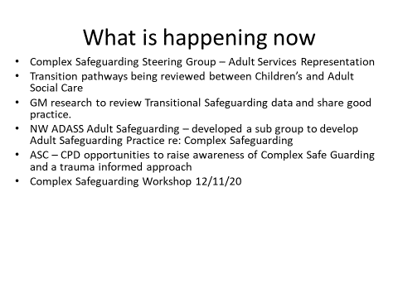
Case study - “Andrea” A Case Study about Sexual Exploitation,

Helen Moore, Specialist Safeguarding Families Practitioner
Catriona Harley, Specialist Safeguarding Families Practitioner
Pennine Care Foundation Trust

Q &A’s and Chat

For many children you know about there are many that you don’t know

Cases can be brought for discussion to the SAM group for support and guidance

Powerful story-lots to take away and share…..

- Do you have a high percentage of same sex exploitation? –understand termed boyfriend model- Answer from Catriona Harley -We don’t have a particularly high number but it does occur .As you know we have our internal reporting systems that are available and an internal safeguarding team to offer consultation

- Answer from Catriona re MARMT question-This is for professionals.

- Pennine Care are looking at transition from Child to Adult Mental Health services

- Thanks to Helen and Catriona and the team –really approachable and helpful when needing to ask for guidance

- Concerns that the cycle will continue for ‘Andrea’ and future children –sexual exploitation networks may have access to younger children and babies and agencies may be powerless to stop this

- When is complex safeguarding a section 42 enquiry?
- How will this impact on your practice in the future and what are the challenges?
Anna Jenkins, Principle Social Work, Adults, TMBC

Discussion from the Group Work
  - Challenges when working in Mental Health services for safeguarding-other services and their understanding of Mental Health –different thresholds in different organisations

- Challenges around capacity assessments-waiting for assessment-is this just unwise decisions? Capacity around decision making?

  - Lots of good work-interesting and informative morning but long way to go.

- People are falling through the cracks

- Positive to see the work moving forward

- Can be a challenge in information sharing

  - Gap between Children’s and Adults-risk of falling through the services

- Adult’s criteria for support can be quite high-how can that gap be bridged?-how do they access and engage with the services?
- Close
Gill Gibson, Director of Nursing, Quality & Safeguarding,
Tameside & Glossop Strategic Commission
    - Excellent morning-lots of discussion and thoughts.

Key points from the session

- Engagement with the Justice System is paramount-Gill will pick this up further

- To progress the local activity-really useful discussion about the transitional safeguarding and this will progress
- How can staff be supported in these difficult cases?

- Promote the MARMT and don’t work in isolation

- How to make people confident to spot early signs, engagement with the 3rd Sector

- How do we support people to live a better life in the community?

Comments after the session

- Fantastic session’

- ‘Thankyou everyone-this morning has been such a valuable session’

- ‘Thanks everyone-really informative’

- ‘The GAP is so important –Thank you Anna’

- ‘Very interesting and helpful sessions’

- ‘Interesting and powerful’

- ‘Very informative’

- ‘Good Session’

- ‘Informative’

- ‘Really good session’

- ‘Thought provoking’

Tameside Adult Safeguarding Partnership Board would like to thank all Key Speakers and staff attending the event for their contribution to a successful Safeguarding Adult Manager Development Session 2020.

