Anti-social Behaviour Case Request Online Form
The ASB case review gives victims the right to require action is taken where an ongoing anti-social behaviour problem has not been addressed. This asks agencies such as the local council, police and housing providers to review collectively how they have responded, by conducting an anti-social behaviour Case Review.
You can use this form if you as an individual, group or business have reported 3 separate incidents to any local agency relating to the same or similar issue of Anti- social behaviour within the last 6 months.
Please note that the ASB case review process does not replace individual organisations’ own complaints procedures, which should be used if you are dissatisfied with the service of an individual agency.
Please provide as much information as you can on this form to allow us to investigate your case as quickly as possible.
Please return this form to ASB@Tameside.gov.uk
You can request a community trigger if:
You have complained to Tameside Council, the police and/or a registered housing provider (social landlord) on 3 or more occasions about separate incidents in the past 6 months.
or
Five people in the local community have complained separately in the last six months about similar incidents
or
You (as an individual) has complained in the last 6 months about an incident or crime motivated by hatred (hate / crime)
Do you consent to relevant information regarding your ASB complaints being shared within the Community Safety Partnership?
By answering Yes to this question, you are consenting for us to request and share information with other statutory partners.
Yes or No (please delete as appropriate)

Contact Form
Contact Details
Title
First Name
Surname
Address
Post code
Preferred contact method
Contact number
Email Address

Incidents
Please attach any emails/contact forms you have sent to Tameside Council regarding your complaint to this form or send to ASB@Tameside.gov.uk
Anti-Social Behaviour case reference (this can be found on any correspondence via letter)
Date of your first report
Any further details
(include details of the incident and the date it occurred)
Date of your second report
Any further details
(include details of the incident and the date it occurred)
Date of your third report
Any further details
(include details of the incident and the date it occurred)

Who did you report to?
Who did you make your first report to?
Please provide details of the response to this report
Who did you make your second report to?
Please provide details of the response to this report
Who did you make your third report to?
Please provide details of the response to this report

Have your reported this to any other agencies?
Please provide details of your complaints:

Please describe how these incidents are effecting you

If you are completing this form on behalf of somebody else, please give your name and relationship to the person affected by this situation
Confidentiality: This form its contents and any attachments are intended only for the above named. As this form may contain confidential or legally privileged information, if you are not, or suspect that you are not the above named or the person responsible for delivering the message to the above named, delete or destroy the form and any attachments immediately. The contents of this form may not be disclosed to nor used by anyone other than the above named. Security and Viruses: please note that we cannot guarantee that this message or any attachment is virus free or has not been intercepted and amended. Monitoring: The Council undertakes monitoring of both incoming and outgoing e-mails. You should therefore be aware that if you send an e-mail to a person within the Council it may be subject to any monitoring deemed necessary by the organisation from time to time. The views of the author may not necessarily reflect those of the Council. Access: As a public body, the Council may be required to disclose this e-mail (or any response to it) under the Freedom of Information Act 2000, unless the information in it is covered by one of the exemptions in the Act.

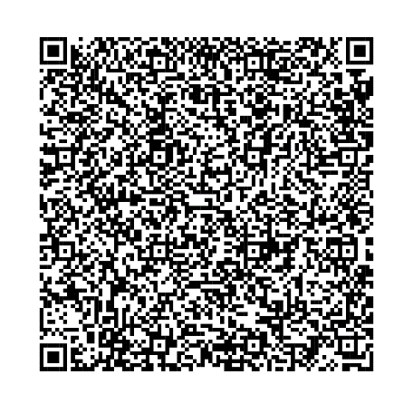
For more information regarding the ASB case review please visit our website https://www.tameside.gov.uk/CommunitySafety/asbcasereview or scan the QR code below:

