Access Statement for Astley Cheetham Art Gallery
2018-19

This access statement does not contain personal opinions as to our suitability for those with access needs, but aims to accurately describe the facilities and services that we offer all our guests/visitors.
Access Statement for Astley Cheetham Art Gallery
Introduction
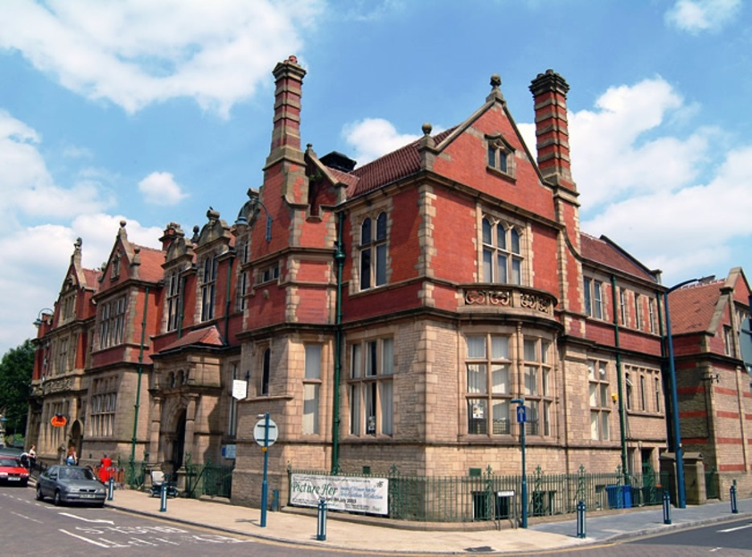
Astley Cheetham Art Gallery is located above Stalybridge library on Trinity Street, Stalybridge. The art gallery is approximately 9 miles/14.5km east of Manchester City Centre and approximately 1/4 miles/0.8km north of Stalybridge Railway Station and approximately 400 metres/0.4km away from Stalybridge Bus Station.
The gallery is only accessible via a stairway from inside Stalybridge library and directly off the main road (Trinity Street). The gallery itself is all on one level without any ramps, steps or internal doorways.
The gallery operates limited opening times throughout the year so please call for more information or see the website at: www.tameside.gov.uk/museumsgalleries.
There are no cafe facilities on site. Staff are able to suggest nearby places for refreshments and other attractions. An attendant is on duty within the gallery should you require assistance. The gallery’s full range of exhibitions, events and activities can be found on our website at: www.tameside.gov.uk/museumsgalleries
We look forward to welcoming you. If you have any queries or require any assistance please phone 0161 343 2878 or email portland.basin@tameside.gov.uk

Pre-Arrival
- For maps of how to reach us and to help plan your journey by car and public transport please use a journey planning website; simply enter your postcode and our postcode SK15 2BN to get directions.
- The nearest railway station is Stalybridge, which is approximately 1/4 miles/0.8km away (5-10 minute walk). Taxis are available at the station.
- Stalybridge Bus Station is approximately 400 metres/0.4km away.
- Car parking in Stalybridge can be seen on: www.tameside.gov.uk/carparksmap/stalybridge
Car Parking and Arrival
Main Entrance to the library and base of stairway leading to the Art Gallery:
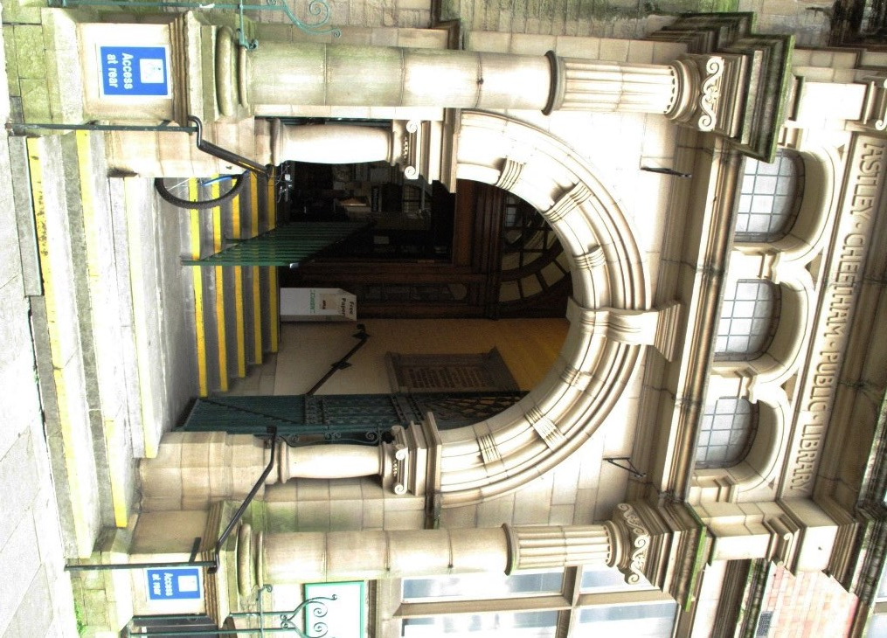
- There is limited, free, on-street parking immediately outside the Art Gallery accompanied by the sign: 'Mon-Sat 8am-6pm 1 hr no return within 2 hrs'.
- When facing the main entrance there are 8 fairly even stone steps, leading into the main reception area of the library and the stairway that leads to the Art Gallery where the flooring is a short-pile carpet.
- There is a handrail on both sides of the steps along with a central handrail.
- This entrance way is 207cm/82" wide.
- The area benefits from natural daylight.
- This entrance comprises of 2 double doorways. The first double doors open inwards and are fairly lightweight to manually operate. The 2nd double doors are usually kept open. The doorways measure 140cm/55" at their widest point.
- Once in the library reception area grey vinyl lettering 'Upstairs to Astley Cheetham Art Gallery' directs visitors to the Art Gallery, from the base of the stairway to the gallery.

Stairway leading to the Art Gallery:
- Access to the Art Gallery is via a stairway only. THERE IS NO LIFT ACCESS.
- 3 flights of stairs (13 * 13 * 6), lined with a blue short-pile carpet, lead to the entrance of the art gallery.
- There is a handrail on either side of the stairway throughout.
- The stairway measures 219cm/86cm wide.
First flight of stairs Second flight of stairs Third flight of stairs
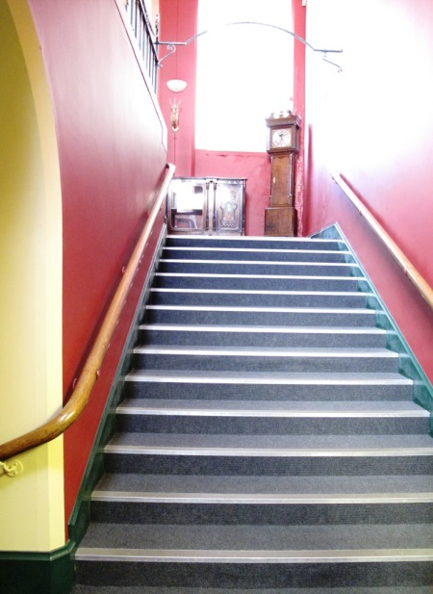
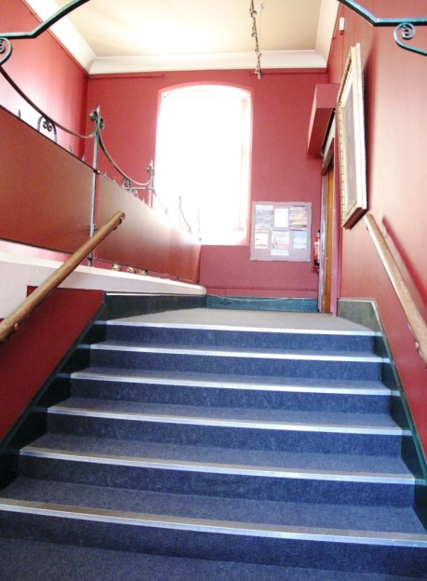
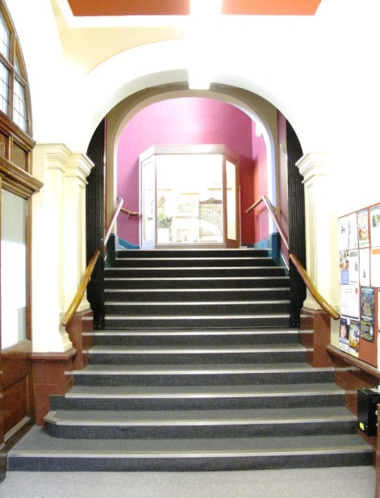
Main Entrance, Reception and Ticketing Area
- Admission to the art gallery is free to everyone.
- The art gallery is located on one level with step free, level access, throughout the public areas.
- Wooden double doors leading into the art gallery are always open when the gallery is open and measure a width of 138cm/54".
- The gallery is well lit with spot lamps. No natural daylight is present.
- A red short-pile carpet runs throughout the gallery.
- There are plentiful free standing chairs around the craft table in the gallery.
- A lowered section of the reception desk measures 76cm/30" high.
- A member of staff is always on duty when the gallery is open to offer assistance.
- No wheelchair loan is available.

Attraction (displays, exhibits, rides etc.)
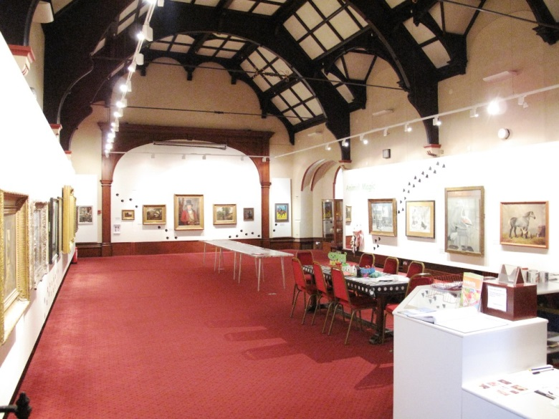
- Astley Cheetham Art Gallery is located above Stalybridge library on Trinity Street, Stalybridge. The gallery was a gift to the town by John Frederick Cheetham and his wife Beatrice Astley in 1901. The family bequeathed the collection in 1932 and the collection has grown with gifts and donations since then. The gallery mounts annual exhibitions of works from the collection. Please see the website for latest information about exhibitions, events and activities: www.tameside.gov.uk/museumsgalleries.
- Each work of art is usually accompanied by a simple object label as well as a small introductory panel outlining the nature of the exhibition.
- There is a free self-led craft activity within the gallery, a small 'dressing-up' area for young children and a play teepee with children’s books about artists inside.
- The gallery houses a small collection of locally important furniture on the stairway landing leading to the art gallery.
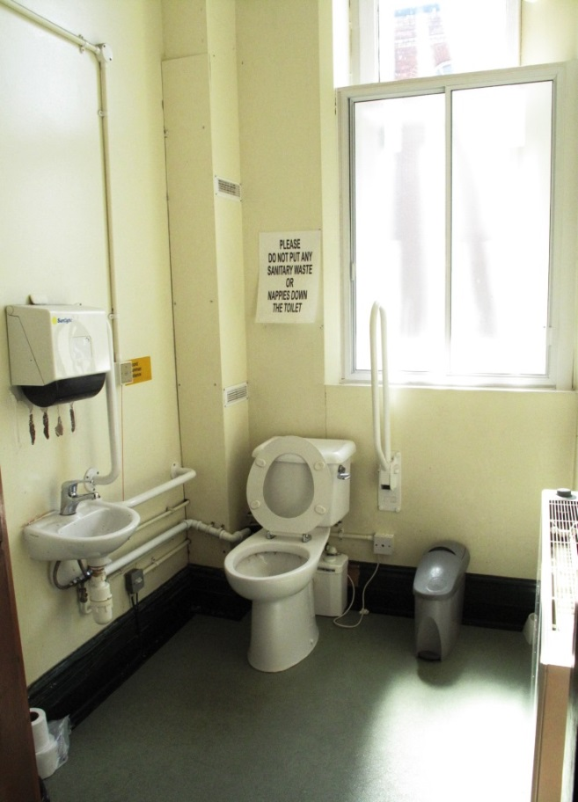
- A display case within the gallery houses a small collection of Egyptian artefacts known as the 'Radcliffe Collection' which are accompanied by simple object labels.
Public Toilets
- There are no toilets within the Art Gallery.
- The nearest toilet is located to the right of the library's main reception desk and is maintained/operated by the library staff.
- The library toilet is a unisex accessible toilet with a green non-slip laminate flooring and well lit with artificial and natural light.
- The door to the toilet opens outwards into the library with a width of 86cm/34" and is fairly light to manually operate.
- Inside are both horizontal and drop down grab rails as well as hand rail behind the door.
- Inside there is a lever tap above the washbasin, hand towels, baby changing mat and toilet.
- The toilet is 45cm/18" from the floor.
- The hand basin is 73cm/29" from the floor.
- There is an emergency pull cord to the right of the toilet with emergency lighting in place.
Additional Information
- Selected staff have received equality awareness training and dementia awareness training.
- We have a set of evacuation procedures - should you require it someone will assist you with evacuation out of the building.
- We welcome trained assistance dogs.
- Reception staff can offer guidance on other local and regional points of interest.
- We have no hearing loop system in the art gallery.
Future Plans
- We constantly review the content of our website, endeavoring to make it as accessible as possible.
Contact Information
Address (Inc postcode): | Astley Cheetham Art Gallery, Trinity Street, Stalybridge, Tameside, SK15-2BN.
Telephone: | 0161 343 2878 (Portland Basin Museum).
Email: | portland.basin@tameside.gov.uk.
Website: | www.tameside.gov.uk/museumsgalleries/astleycheetham.
Grid Reference: | SJ 963 985.
Hours Of Operation: | Open the first and third Saturdays in the month 10am-3pm and every Saturday in August. See website: www.tameside.gov.uk/museumsgalleries or telephone 0161 343 2878.
Local Accessible Taxi: | 1. Radio Cabs - 0161 330 2090 2. Cavalier Radio Cars - 0161 338 5500 3. Stamford Cars UK - 0161 339 4411.
Local Public Transport: | 1. Transport for Greater Manchester - www.tfgm.com/Pages/default.aspx 2. Rail enquiries - 08457 484950.

