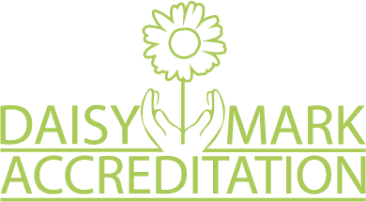
DIGNITY IN CARE TRAINING DATES

Daisy Accreditation Training
The morning session is a Dignity awareness session – the afternoon session covers the Daisy Accreditation and how your service can achieve this

Monday 16th September 2019 (9.30 – 4pm)
Community Room at Ashton-under-Lyne fire station, M34 5FS

OR

Tuesday 12th November 2019 (9.30 – 4pm)
Community Room at Ashton-under-Lyne fire station, M34 5FS

Dignity Train the Trainer Day
To be eligible to attend the module the delegate must have attended the full day Daisy Accreditation training. Training tools to deliver the Dignity awareness session ‘in house’ to your team will be provided.

Monday 30th September 2019 (9.30 – 4pm)
Community room – Ashton-under-Lyne fire station

OR

Wednesday 27th November 2019 (9.30 – 4pm)
Community room – Ashton-under-Lyne fire station

To book a place or for further information please email Alison Harrison (Alison.harrison4@nhs.net)

