Guest speaker and workshop facilitator:
Jane Evans
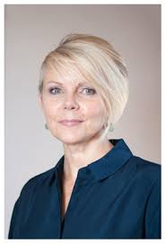
Jane Evans began working in early years care and education 22 years ago. Jane now regularly delivers training to Early Years settings and speaks at conferences focusing the impact of childhood trauma and anxiety on early development.
She now shares her own journey in her inspirational and captivating speaking, coaching, writing and training. Jane will be speaking on and delivering a workshop about understanding the impact of childhood trauma and anxiety on early development.

