Tameside & Glossop HYMS Early Help Access Point- A new children’s mental health referral pathway via Multi Agency Request for Service Pathway (MARS)

The new multi-agency referral pathway has been designed as a central referral point for all services that support families, including, children’s mental health referrals across Tameside & Glossop. We will have access to good quality information from a variety of agencies which will enable joined up working and information sharing to ensure that the child receives the most appropriate support so that their needs are best met at the point of referral. Importantly families will experience one referral with a support plan being put in place following this referral.

Which services are part of the Early Help Access Point?
Once a referral is received at EHAP the referral will be triaged and the most appropriate service will be identified to best meet the needs of the young person. The following services form part of the CAMHS Partnership umbrella:

Healthy Young Minds
TOG Mind
42nd Street
Off The Record
Mental health locality
Mental health consultation
Children’s eating disorder service (CEDS)
Perinatal & Parent infant mental health (PPIMH AKA Early Attachment Service)
Rapid response team (RRT)
Commissioned and non-commissioned VCSE Sector organisations

Please note that the Anthony Seddon Fund Drop-in service, the Early Help Assessment (EHA), Neurodevelopmental Pathways and Early Attachment Service( EAS) referral routes that will remain in operation.

Who can refer?
The new referral pathway accepts referral requests from all professionals working with a child/young person. Please remember to gain consent from the Parent/Carers prior to making a request for service for Early Help Support for them. All usual services across the EHAP and MASH pathway are also available via the MARS.
https://secure.tameside.gov.uk/forms/mars/f1312mars.asp
If your referral request is about a child/young person’s emotional/mental health then please ensure you select the amber button called Child/Emotional/Mental Health, this will ensure that the Healthy Young Minds Early Help Access Team receive the MARS.
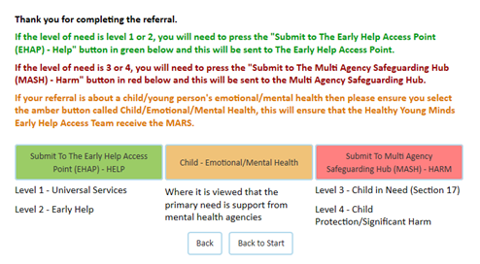
How to refer?
- If you have any urgent concerns that you wish to discuss please contact us on 0161 716 3600
- Through the MARS process which will require the above referral form completing if a mental health need is identified during the process. https://secure.tameside.gov.uk/forms/mars/f1312mars.asp
- The MARS referral form will need to be completed with as much detail as possible to help us offer the appropriate support.

What happens once the referral has been sent?
Your referral will be screened by one of our clinical triage team. Once a decision has been made about which service can best support the needs of the child and their family we will write to you, as the referrer, to let you know the decision. The family will then be contacted by the appropriate service to discuss next steps and offer an appointment. This may be by letter, e-mail or phone.
Contact us
If you have any questions please contact us by phone on 0161 716 3600 or email pcn-tr.hymsearlyhelpaccess@nhs.net

Covid Recovery Plan
Our plans have changed due to Covid. We will be moving forward to a co-located multi-agency Early Help Access Point as soon as we are able. Please note the pathway will not change but contact details are likely to be different in the near future.

