Wellbeing Return to Education – Training Programme
Wellbeing for Education Return is a nationally developed training and resources programme that has been locally adapted to support the wellbeing of teachers and their pupils in response to the pandemic.
The Wellbeing for Education Return training has been developed by the e-learning platform MindEd, working closely with the Anna Freud Centre for Children and Families. In Tameside, the Educational Psychology Service will be leading this programme locally in consultation with other providers.
The training is intended to support education staff to promote children and young people, teachers and parents and carers' mental wellbeing and resilience and aid mental health recovery. The session will provide staff with the confidence to support pupils, and know how and where to access specialist support where needed.
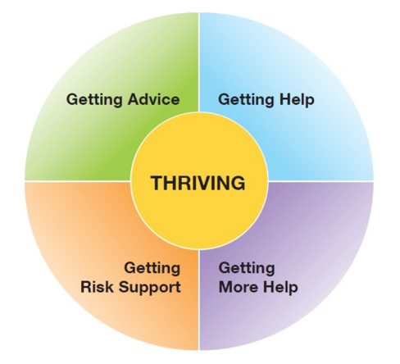
The training will be delivered in two 90-minute webinars
Please book on to a session for BOTH webinar 1 and webinar 2:
Webinar 1: the first sessions covers whole school and college approaches to wellbeing and recovery. This is an evidence based session to ensure settings have the building blocks in place to support recovery and build resilience across the school or college community.
Webinar 2: The second session covers issues that are likely to be prevalent in schools and colleges among staff and pupils bereavement, anxiety, low mood and trauma. It supports staff to understand what they can be doing within school or college about those issues and what support might be available locally.
The sessions will be delivered online via ZOOM.
Tameside Webinar 1:
4th November 2020 | 3:30-5:00 | Tameside ONE
10th November 2020 | 4:30-6:00
16th November 2020 | 3:30-5:00
19th November 2020 | 4:30-6:00
Tameside Webinar 2:
25th November 2020 | 4:30-6:00 | Tameside TWO
1st December 2020 | 3:30-5:00
7th December 2020 | 4:30-6:00
10th December 2020 | 3:30-5:00

The webinars will be followed up with smaller group weekly themed sessions facilitated by the Educational Psychology Service, CAMHS and other guest experts form local organisations. These sessions will provide the opportunity to problem solve and ask specific questions.

Alternative Webinar Dates
Please note: the Tameside EP Service will also be delivering the webinars across Salford and Bury local authorities, if you are unable to attend any of the Tameside dates then please book onto a session in another area, dates as follows:
Webinar 1:
Bury | 2 November | 3.30pm - 5.00pm | Bury ONE
 | 5 November | 4.30pm - 6.00pm
 | 11 November | 3.30pm - 5.00pm
 | 17 November | 4.30pm - 6.00pm
Salford | 3 November | 3.30pm - 5.00pm | Salford ONE
 | 9 November | 4.30pm - 6.00pm
 | 12 November | 3.30pm - 5.00pm
 | 18 November | 4.30pm - 6.00pm
Webinar 2:
Bury | 24 November | 4.30pm - 6.00pm | Bury TWO
 | 30 November | 3.30pm - 5.00pm
 | 3 December | 4.30pm - 6.00pm
 | 9 December | 3.30pm - 5.00pm
Salford | 23 November | 4.30pm - 6.00pm | Salford TWO
 | 26 November | 3.30pm - 5.00pm
 | 2 December | 4.30pm - 6.00pm
 | 8 December | 3.30pm - 5.00pm

