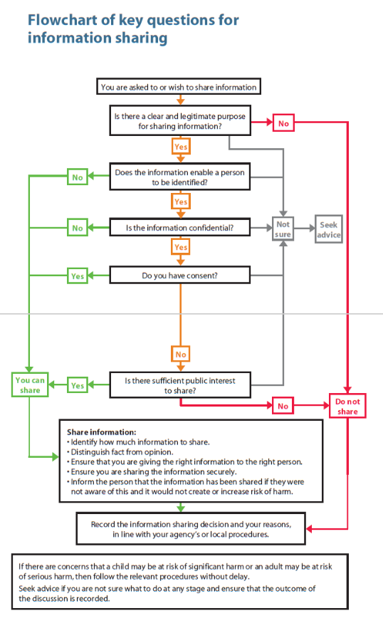

**Are there sufficient Safeguarding concerns to share?**