Acorn Centre News
2017-18
The Acorn Centre continues to offer information, and training and support opportunities around Early Years and Special Educational Needs for practitioners within Early Years settings, and families of children with additional needs.
Over the course of the 2017-18 academic year, we are proud to have hosted the following events, activities and training opportunities within The Acorn Centre:
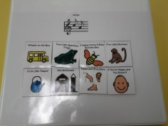
‘Come and See’ opportunites:
The Acorn Centre has continued to offer termly opportunities for practitioners within PVI settings to ‘come and see’ excellent practitioners within Oakdale School supporting children with additional needs/disabilities within continuous provision and directed tasks and activities.

‘Person Centred Planning’ Training – Twilight:
Termly opportunities for practitioners to explore how to use person centred planning tools effectively in order to assess, plan, do and review has continued to be a popular training session. Over the course of the year, The Acorn Centre has responded to delegates’ evaluations and suggestions, and now runs this training as a twilight opportunity, in order to ensure as many practitioners as possible are able to attend.
Development and Support Opportunities:
The following training opportunities for practitioners working within PVI settings took place at The Acorn Centre during the 2017/18 academic year:
Autumn Term – ‘Links Between Communication and Behaviour’.
Spring Term – ‘Annotations and Observations’.
Summer Term – ‘Autism and Eating – Supporting ‘Fussy and Resistant’ Eaters.
At The Acorn Centre we are always keen to further develop our practice and the learning opportunities we provide. Following evaluations and suggestions from delegates who have attended the Development and Support Opportunities during the 2017/18 academic year, we are pleased to announce that for the 2018/19 academic year, such training sessions will be held as Twilights, and will run from 6:30-8:30pm. It is hoped that this change of times will enable even more delegates to attend!

Sunbeam Group:
Throughout the year, The Sunbeam Group has continued to meet every Tuesday afternoon from 1:00-3:00pm at The Acorn Centre. This wonderful support group continues to provide parents, grandparents and carers with the opportunity to meet up with other families who have children with additional needs.

Coffee Morning & Boardmaker Workshop:
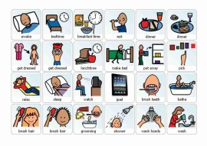
For parents of children who attend Oakdale School, our weekly coffee morning and Boardmaker Workshop continues to be a highly popular opportunity! As well as providing Oakdale parents with the chance to meet other parents whose children also attend the school, the coffee morning also enables parents to access the Boardmaker software and create symbols and visual resources with which to support their children at home.

Over the course of the 2017/18 academic year, Jane Young and Julie Leah (Oakdale School’s Early Years Outreach and Family Support Team) have also organised exceptional speakers and outside agencies to share information with parents and carers. The following are just a sample:

- Windmill Car Seats
- STARS Group
- Aspire
- NHS – Who provided a ‘wellness’ morning!

Stay and Play Opportunities:

Held every Wednesday afternoon, the Stay and Play sessions continue to provide support to the parents of those children with additional needs who are known to the Early Years Panel. The Stay and Play opportunities provide planned, supported play activities for the parent/carer and child to engage with, and help them to share the fun ways they are able to support their child at home, and help them to learn and develop.

Lea’s Lending Hub:

The Acorn Centre is proud and privileged to be home to Lea’s Lending Hub – a highly resourced room filled with toys and equipment which has been generously donated by the family of Lea Louise Hunsley, a little girl (and a pupil at Oakdale School) who sadly passed away in 2016.
Once a month, children from the local community who work with Tameside Sensory Services Hearing Impaired Team, have been coming together with children from the Sunbeam Group for music and song activities within Lea’s Lending Hub. These sessions have been highly successful and enjoyed by children and parents alike!

Coming Soon – Dates for your Diary!

- The Acorn Centre Programme for the Autumn Term 2018 is now available and contains dates of all the training and development opportunities for this term. Please contact vicky.jarvis@oakdale.tameside.sch.uk to receive an electronic copy of this.
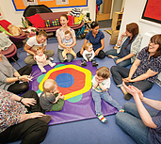
- It is with great pleasure that we announce the return of T21 Ducklings to The Acorn Centre! The Ducklings meet every other Wednesday morning as a support group for parents of children with Down Syndrome.

