**Children in Care Council (CICC) Meetings**

**What?**

The CICC meetings are sit down meetings with Aisling Bouketta (who is a Participation Officer).

The meetings give young people aged 11-16 a chance to have a say about the things that really matter in their lives, helping to shape the plan for cared for children and young people.

When?

Meetings are held every two

weeks - 5:30pm – 7pm.

Here’s a list of upcoming dates:

6th Feb

6th March

20th March

3rd April

1st May

15th May

29th May

12th June

26th June

3rd July

17th July

14th Aug

11th Sept

25th Sept

6t6th Feb

6th March

20th March

3rd April

1st May

15th May

29th May

12th June

26th June

3rd July

17th July

14th Aug

6t6th Feb

6th March

20th March

3rd April

1st May

15th May

29th May

12th June

26th June

3rd July

17th July

14th Aug

11th Sept

25th Septh March

20th March

3rd April

1st May

15th May

29th May

12th June

26th June

3rd July

17th July

14th Aug

11th Sept

25th Sept

**Where?**

**The meetings are held at:**

**Copley Youth Base  
Huddersfield Road  
Stalybridge  
SK15 3ET**

[](https://www.bing.com/images/search?view=detailV2&ccid=cJB3esCr&id=51DBDAF6308CF8586D00634B130C38678109C59F&thid=OIP.cJB3esCrwSewrA-OpqF_xAHaHa&mediaurl=http://clipartix.com/wp-content/uploads/2016/04/Calendar-clipart-clipartion-com-3.png&exph=1000&expw=1000&q=Animated+Calendar&simid=608007160635197061&selectedIndex=2)

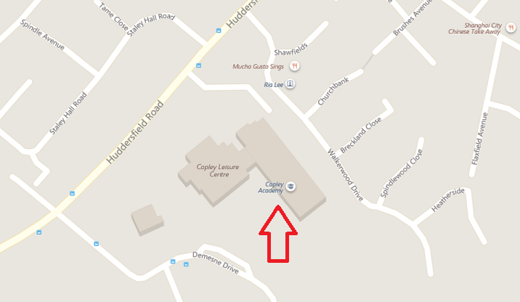

**Drinks and biscuits provided!!**



If you have any further questions, please contact Aisling Bouketta 0161 342 4283 / 07971072255

aisling.bouketta@tameside.gov.uk on or speak to your social worker or carer.

[](https://www.bing.com/images/search?view=detailV2&ccid=CFHw5Cw1&id=06CAEA2E21762CCB420C01E5C9348CEA60BC45DE&thid=OIP.CFHw5Cw1HMaZIWgKxDZsUgHaHc&mediaurl=http://moziru.com/images/biscuit-clipart-snack-1.jpg&exph=1300&expw=1294&q=busciut+cartoon&simid=607994885651170730&selectedIndex=4)