**Care leaver forum **

**What?**

The care leaver forum is a sit down meeting with Aisling Bouketta (who is a Participation Officer).

The meetings give young people aged 16-25 a chance to have a say about the things that really matter in their lives, helping to shape the plan for care leavers.

When?

Meetings are held every month

Here’s a list of upcoming dates:

Jan 28th 12-2pm

Feb 25th 12-2pm

March 31st 12-2pm

April 28th 12-2pm

June 2nd 12-2pm

July 7th 12-2pm

Feb

6th Marc3rd April

1st May

15th May

29th May

12th June

26th June

3rd July

17th July

14th Aug

6t6th Feb

6th March

20th March

3rd April

1st May

15th May

29th May

12th June

26th June

3rd July

17th July

14th Aug

11th Sept

25th Septh March

20th March

3rd April

1st May

15th May

29th May

12th June

26th June

3rd July

17th July

14th Aug

11th Sept

25th Sept

**Where?**

**The meetings are held at:**

**Clarence Arcade**

**Stamford Street**

**Ashton-under-Lyne**

**Tameside**

OL6 7PT

[](https://www.bing.com/images/search?view=detailV2&ccid=cJB3esCr&id=51DBDAF6308CF8586D00634B130C38678109C59F&thid=OIP.cJB3esCrwSewrA-OpqF_xAHaHa&mediaurl=http://clipartix.com/wp-content/uploads/2016/04/Calendar-clipart-clipartion-com-3.png&exph=1000&expw=1000&q=Animated+Calendar&simid=608007160635197061&selectedIndex=2)

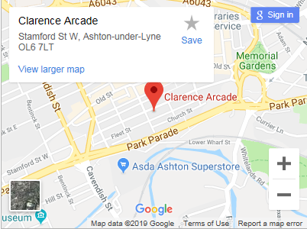

**Drinks and pizza provided!!**



If you have any further questions, please contact Aisling Bouketta 0161 342 4283 / 07971072255

aisling.bouketta@tameside.gov.uk on or speak to your social worker, Personal Advisor or carer.