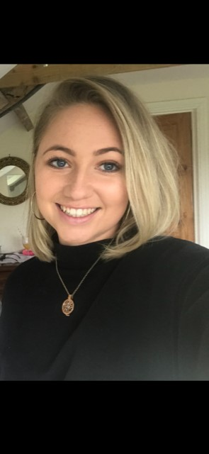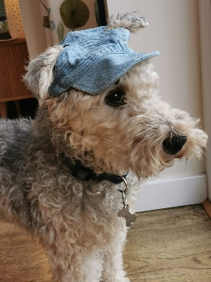 Liv

**What people like about me?**

I am honest

I am kind

I am positive

**What is important to me?**

My dog

My friends

Travelling

Playing netball

Cooking

Baking



**What we might do…**

When I come to meet you, I will introduce myself and I will tell you what we might do together.

This might be a chat about what is important to you and what you like and dislike. We might also do some games, drawing or questionnaires.

**What happens if you don’t want to work with me…**

If you don’t want to meet me or do any work, you don’t have to. We will only meet and do as much as you want to. After we have worked together, I will ask you what you thought of working with me.

If you have any questions, you can ask me or another adult in school.

You can contact me on: **Olivia.mcmurray@salford.gov.uk**

**What I would like to get better at…**

Running

Drawing

Dancing

**My Job…**

I work with children and young people like you, to find out what they are good at and what they sometimes find hard.

I use this information to work with lots of different people to try and make the changes you would like.

I work in schools in Salford.

My job is called an ‘Assistant Psychologist’, but you can just call me **Olivia.**