**47th SIKHS War Records: The Great War 1914 -1918**

MR4/3/1/93

*A* *detailed account of their war service in France and Flanders, Mesopotamia and Palestine. Includes appendices detailing lists of officers of the regiment on mobilisation showing how they stood on Armistice Day, battle order 3rd Lahore Division on mobilisation, strengths etc. during the campaign, list of officers including dates of joining or rejoining etc., and a list of casualties.*

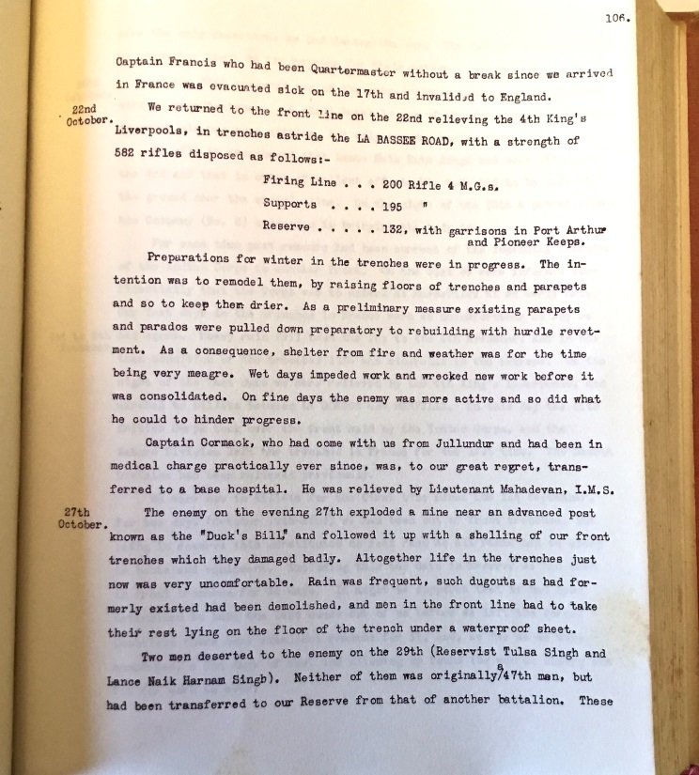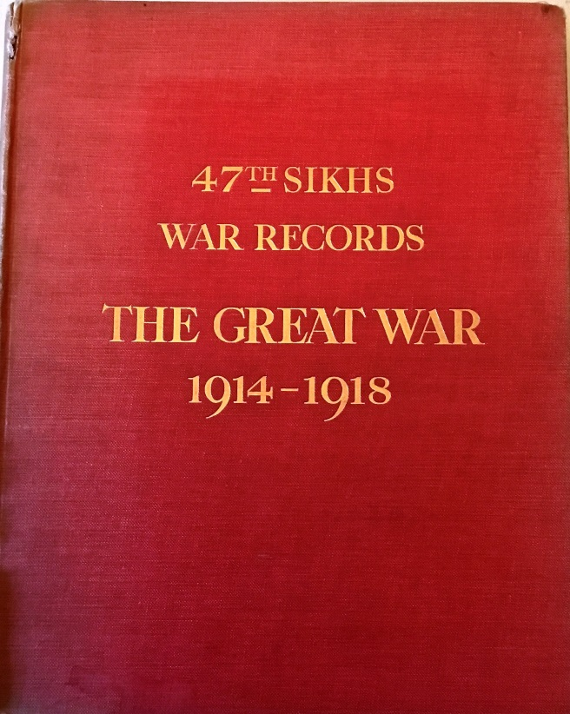

**Foreword**

The 47th SIKHS was raised as a Class Regiment of Jat Sikhs in 1901 and previous to the date of the Great War had served in Sialkote North China, Dera Ismail Khan and Jullunder but as a regiment had not been on active service.

From the day of formation a high standard of military efficiency had always been aimed at and as far as demonstration of results without the acid test of War can show, had been attained. Above all things esprit de corps amongst all ranks was undoubtedly excellent…

…they glory in having taken a full share…in stemming the German rush to the Channel Ports- the second vital thrust for early victory- and they claim that their records shows no need for apologies during any portion of the long drawn out War. One special disability there was and one which at times gave rise to anxiety, and this was the failure in the supply of drafts both as to quality and readiness when required. This was undoubtedly a handicap in that a Regiment was often depleted when it required its full strength and morale was endangered. On many occasions it was only esprit de corps that pulled things through.

The proudest boasts of the regiment are that no Regiment of the Indian Army did more actual front-line work and hard fighting, that it never lost a yard of trench in any theatre of War, that on no occasion was it ever withdrawn for reconstruction though reconstruction was often rendered advisable by casualties, that no Regiment was more often specially mentioned in orders and despatches, and, finally, that on returning to India after the conclusion of War it was the only unit of the Indian Army given the honour of a Royal Colonel In Chief in recognition of its services during the War…

**Part 1**

**Chapter 1**

**India to France**

**1914**

**August** In August 1914, the 47th Sikhs was stationed in Jullunder where it had been since 1910. It formed part of the 8thJullunder Brigade of the 3rdLahore Division. The Brigade consisted of the 1stManchester Regiment, 59thScinde Rifles, 47thSikhs, all stationed in Jullunder, and an Indian Battalion stationed in Ferozepore…

At this time of year- the hot weather- the greater part of the Regiment, Officers and men, were on furlough or leave. The daily news from Europe quickly working up to the climax of War was eagerly watched and the possibilities of taking part in a European War discussed by all.

**8th August** Eventually on the 8th of August Mobilization of the Division was ordered, though of course no hint was given of the theatre to which it would be sent.

Mobilization of an Indian Battalion in the hot weather when only a proportion of all ranks is present at Headquarters is no light task. The recall of all ranks is in itself a heavy Labour, but no labour is grudged on such an occasion and it was an encouraging sign that not a single man failed to rejoin. The Reservists were also called up and 4 Havildares and Naiks were sent to the Regiment to the Reserve Centre at Rawalpindi to assist in their training…

**12th August** On the 12th of August, the first intimation was given that the Regiment was destined for service abroad, in the shape of orders forming an Indian Expeditionary Force, to consist of the 9th Cavalry Brigade and the 3rdLahore and the 7th Meerut Divisions. No destination was announced of course, and speculation had full scope…

On the 18th of August at 2.44 a.m. the Regiment entrained at Jullunder Cantonment Station. En route to Karachi some carriages containing Supply and Transport personnel were attached to our trains. Cholera broke out amongst these men, and consequently arriving at Karachi at 5 p.m. on 20th August the Regiment was sent to the Pilgrim Rest Centre for segregation. This was a source of terrible anxiety for had cholera broken out the Regiment would undoubtedly have been left behind. Luckily no such fatality occurred, but the incident was seized upon as an opportunity for mischief making by seditionists who spread the rumour in the Punjab that the 47th had mutinied and refused to embark.

**23rd August** On the 23rd of August the following message from H.M. the King Emperor was received and promulgated to all ranks:

*“ Officers, Non-Commissioned Officers, and Men: I look to all my Indian Soldiers to uphold the Izaat [1]of the British Rajah against the aggressive and relentless enemy. I know with what readiness My loyal and brave Indian soldiers are prepared to fulfil this sacred trust on the field of battle, shoulder to shoulder with their comrades from all parts of the Empire. Rest assured that you will always be in my thoughts and prayers. I bid you go forward to add fresh lustre to the glorious achievements and noble traditions of courage and chivalry of My Indian Army, whose Honour and Fame are in your hands.”*

**28th August** No case of cholera having occurred in the Regiment it was released from segregation camp and embarked on 28thAugust on the S.S. Akbar, a small pilgrim ship of the Indo Persian S.S. Company. Almost anything that could float was being taken into the service for transportation of troops and the Akbar had no superfluous comforts for anyone. The rations put on board were of poor quality, for already the War Profiteer had begun his nefarious work in the East, but such minor details of discomfort were as nothing; the Regiment was hastening to the War.

Part of the Division was embarked from Bombay and part from Karachi and the ships were collected into Convoy in the Indian Ocean and proceeded thus under escort to Suez. The seas were not clear of German warships, the Konigsberg being known to be at large.

**13th September** The Akbar arrived off Suez at 7 p.m. on 13thSeptember but as a large number of transports had to be dealt with and facilities were meagre the Regiment was not disembarked until the 15th. Major Davidson who had come by P. & O. mail Steamer was acting Embarkation Commandant. Up to this time, the destination of the Force was unknown. All British Troops has been withdrawn from Egypt and the depressing impression prevailed that we were destined for the inglorious role of Garrison Duty in that country. Such news as appeared in the local press was, as we afterwards discovered, unduly optimistic. From the tale of victories by sea and land it appeared that even if we did go on to France the War might be over by the time we got there.

**15th September** The Regiment left Suez in two trains at 4 and 6 p.m. on 15th September, arriving at Abbasieh Station, Cairo, at 11.30 p.m. and 1.a.m. and at daybreak marched to camp at the Race-course at Heliopolis. Major H. E. Browne and Captains Combe and Talbot, who on the outbreak of War were on furlough in England and had been sent out in the S.S. Dongola, rejoined here, as did Major General P.M. Carnegy, C.B., Commanding 8thBrigade.

On the 17th orders were received for the 7th and 8th Brigades to proceed to Alexandria, the 9thBrigade to remain in Egypt. These orders were received with tremendous joy as it appeared certain that France was our destination.

**18th September** On the 18th the Regiment left Palais Qubba Station in two trains at 9 and 11.15 a.m. and arriving at Alexandria Docks the same afternoon, by 10 p.m. was re-embarked on the Akbar. Major Davidson on completion of his temporary duty rejoined.

**19th September** The Akbar left Dock at 10 a.m. on the 19th and the Convey of 21 ships under escort of H.M.S Weymouth sailed about 1 p.m.

**23th September** On the 23rdwe met a Convoy of 13 ships carrying a Territorial Division to Egypt, and realised that our seemingly useless wandering from Suez via Cairo to Alexandria covered the hiatus between the departure of the Regular British Garrison and the arrival of the Territorials.

The voyage up the Mediterranean was uneventful, the chief occupation of all ranks from Colonel to Bugler being to get fit and hard by means of such physical exercise as was possible on a very crowded ship…

**27th September** The Regiment disembarked on the evening of the 27thSeptember and marched to camp at Parc Boreli through streets lined with enthusiastic Marseillaises. To the French, depressed with the dread of the advancing Hun, this arrival of troops from distant India seemed to offer an assurance that the British Empire was indeed coming to their assistance with all its far flung Power. The enthusiastic welcome given us was the result of genuine feeling and not mere excitement over a novel sight. It was not without embarrassment either for the… or his British Officer, neither being accustomed to the embraces of the fair sex “coram populo.”[2]

Camp was reached after dark, transport had gone astray, and rain came on; an uncomfortable beginning.

A few days’ stay in Marseilles was necessary and welcome. Kits had to be sorted, surpluses were to be left here as this Port was constituted the base for the Indian Force. Deficiencies were made good from the Ordnance. Dept. and a preliminary shaking down to European conditions took place. Three Interpreters joined the Regiment, Lt. Kemmis, British Adjutant Enselme, 27th Chasseurs Alpins and Private Gaz, 22ndColonia Infantry, French. Without them there would have been many more difficulties and we were soon to find them indispensable and to owe them a deep debt of gratitude.

On the 29th such troops of the Division as were available were marched through the town and were reviewed by the French G.O.C., General Serviers…

**30th September** On the 30th of September the Regiment entrained at 11.30 a.m. for Orleans, the Place of Assembly for the Indian Corps, which was reached at 6.45 p.m. on the.

**2nd October.** Long halts were made en route at Bezieres and Cahors, and at the latter place motors were placed at the disposal of the British Officers to enable them to see the sights. The French people all along the line gave us a stirring welcome. At every halt presents of fruit and flowers were showered on us and large and enthusiastic crowds were collected at the stations. Before long the compartments were decked with flowers, and souvenirs from us were in great demand- buttons being the most popular, but even signatures were welcome.

At Orleans we were camped at Cercottes, 6 miles from the town, a French Artillery practice ground and as such very suitable for our requirements, which were a final and intensive training to get fit and settle into Platoon organisation and drill. We remained here at work for 15 days. Rumours were a constant source of interest. The commencement of the Allies’ abortive attempt at envelopment of the German Right Wing came to us as a victorious advance which was sweeping the Enemy back to Berlin and making it doubtful if after all we should be in time to share in any fighting. The next four and a half years were to cure those of us who survived of this thirst for War and its glories. “Dulce bellum inexpertis.”[3]

Among other equipment taken over was Regimental transport in the form of vans and waggons drawn by heavy draft horses. The Driver establishment for these was found from the ranks and astonishment, not to say awe was at first the feeling of the Drivers when asked to handle “hathis.” i.e.elephants! They soon became accustomed to them and quickly learned the care and management of them.

The Ration question for Indian Troops in France was from the first a difficult one. Supplies of atta, rice, etc., could be got from the East but meat was a difficulty and yet essential if the men were to be kept fit for the work and climatic conditions ahead of them. One solution proposed was the issue of frozen mutton. Our men agreed to this but other units objected. Later on the issue of tinned mutton was suggested and again agreed to by our men. Unfortunately the first consignments that were brought up were decorated with the trade mark of the supplying firm, which was a picture of a fine upstanding bullock! After this unfortunate beginning it was hard to inspire the men with the necessary confidence as to the good faith of the responsible authorities and the experiment was abandoned. Goats were obtained, and each unit had slaughtering parties at [the] railhead for its own supply, an arrangement that held good as long as we remained in France. Our men took to ration biscuits at once and indeed preferred them to atta, except when cooking facilities were simple.

**18th October** On the 18th October we left Orleans for the Front. A wet and windy morning made us all feel that we had put behind us the conditions of comparative comfort in which our progress had hitherto been conducted. Our tents were left behind but a billeting party under Capt. A. M. Brown had been sent forward on the previous day.

Halts for cooking, etc., were made at Mantes and Abbeville. Skirting round Paris the men saw their first aeroplane. Further north we had continual and prolonged halts as we came to the tail of Sir John French’s army in its move from the Aisne to the north. The line was blocked by the troop trains in front of us of which many were visible at times. The French crowded to the stations and were most enthusiastic and free-handed. Fruit, coffee, etc. were freely pressed on our troops and by significant gestures they were shown the methods with which the ‘Boches’ were to be treated. They were all optimistic and told us that the English Army had already recaptured Lille, a premature statement not be verified for more than four years.

**20th October** About 1.20am on the 20thof October we arrived at Arques, two miles S.E. of St. Omer, and marched to our first billets in France. These were in a large monastery near St. Omer and Longuenesse. Many of the older monks were still in residence and did all they could for our comfort. The location of a Battalion of Sikhs in an old French Religious House was indeed a sign of the times. The men were greatly puzzled by the statues of the Twelve Apostles ranged across the main corridor but accepted our explanation that they represented the Gurus of the Christians. It was here in the evening that we first heard the distant thunder of the guns. The last time we were to hear the guns In the Great War was also to be in a religious atmosphere, at Samaria.

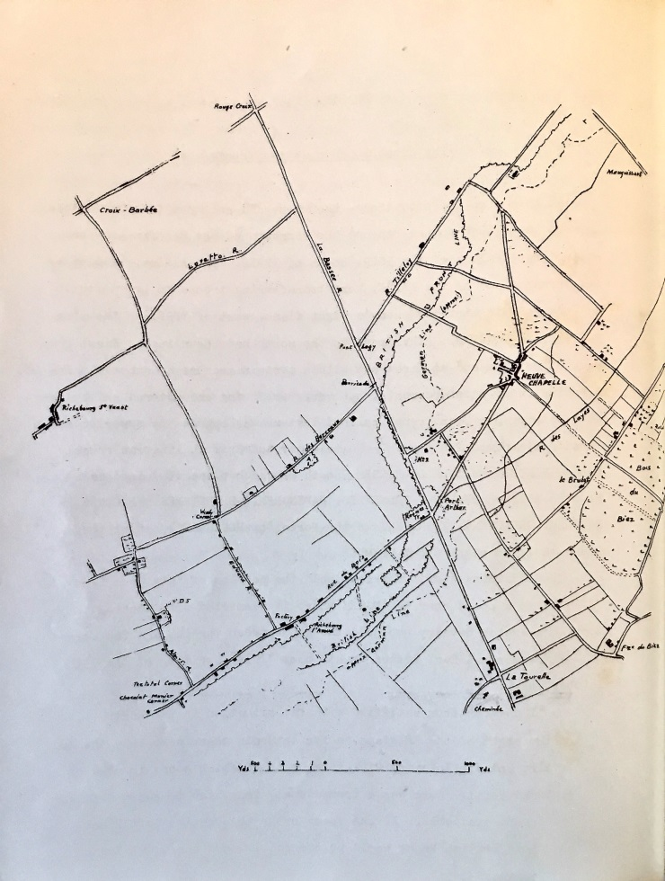

The British Line

**Chapter II**

**The first ten days at the Front**

**20th October 1914.** At this time the situation – though we did not know it – was critical. Antwerp had fallen on the 9th and the remnants of the Belgium Army had retired to the line of the YSER, north of YPRES. The Allies, held up by the German stand on the AISNE, were transferring troops to the north in an endeavour to turn the enemy’s right flank, east of YPRES on the line ARRAS-LILLE-COURTRAI. This move to the north had begun in the first week of October and at first met with a certain measure of success. Increasing enemy reinforcements, however, were being encountered and by the 19th October Sir John French realised that he was opposed by superior and constantly increasing forces. On this day the British line ran roughly from GIVENCHY (west of La BASSEE, south of which place it joined the French) through HERLIES, FROMELLES, RADINGHAM, ARMENTIERES, MESSINES, HOUTHEN, GHELUVELT, ZONNEBEKE to the Forest of HOULTHULST joining the Franco- Belgian right about DIXMUDE.

The 2nd Corps (Smith Dorrien)[4] held the portion of this line from GIVENCHY to a point near

RADINGHEM where it connected with General Conneau’s French Cavalry who held the gap between the 1st and 2nd Corps.

Field Marshall Earl Frenon in his book “1914”, writing of the 19th October, says,

“ I was far from satisfied with the situation in the north… on the right of the Belgians as far as Menin there were only the 3rd Cavalry and 7th Infantry Divisions, both of which stood in need of rest and refit. Ours was a tremendously long line to guard with so few troops available. If the enemy broke through the Left Flank the whole British Front would be turned… and the Coast Towns would be gone. Further South the prospect was no better. The Enemy was daily and almost hourly getting stronger in front of our line, which was held up by the Cavalry and 2nd and 3rd Corps. The endurance of these troops had been heavily taxed and I had practically no reserves.”

In this state of affairs the early arrival at the Front of the Indian Divisions was anxiously awaited at Headquarters. We were in ignorance of the real state of affairs but were keen to get up. Even now our equipment was in some respects incomplete; to have rushed us earlier would have been unwise.

**21st October.** On the 21st October the Division under Major General Watkins, C.B., marched from ARQUES to RENESCURE, a distance of 6 miles. Here the Regiment was billeted in and around a fine Chateau. On the 22nd the march was continued to METEREN, a distance of 16 miles, and farmhouse billets were allotted. No. 3 Coy. found night out-posts. We had no information as to the enemy’s position or as to the line held by own troops and were still in hope of participating in a march through Belgium. This idea was strengthened by our having been supplied with maps of the country as far as the Rhine. At METEREN we first saw traces of the enemy who had only recently been driven from there. His trenches were a source of intense interest. Actually on this day the 2nd Corps had been severely attacked and as a result had been withdrawn to a line GIVENCHY-NEUVE CHAPELLE-FAUQUISSART.

**23rd October** At 6a.m. on the 23rd the 8th Brigade marched as Advanced Guard to the Division via VIEUX BERQUIN to ESTAIRES, 10 miles. After arrival, and whilst billets were being allocated, urgent orders were received at 3.30 p.m. for the Manchesters and 47th Sikhs to take up a position in support of the 19th (British) Brigade and a French Cavalry Brigade of Conneau’s Division. These two Regiments accordingly pushed on and on arrival at LAVENTIE, 4 miles distant, reported to the French Brigade Commander. LAVENTIE was frequently shelled but was still occupied by its civilian inhabitants. The French never vacated their homes until the last possible moment.

Our orders were now altered to the effect that we were to take up a line along the RUE TILLELOY, the right to connect with the 8th British Brigade (3rd British Division) near FAUQUISSART, and the left at the cross roads on the RUE DU BOIS, a front of 1½ miles.

The French Cavalry were holding a line parallel to and about 600 yards east of the RUE TILLELOY and the two Battalions were to support them in the event of their being driven back. Colonels Richardson and Strickland, the two C.O.s, accompanied by Major Davidson, rode ahead to FAUQUISSART and there met a French staff officer who guided them on a hasty ride round the front line. The staff officer was very contemptuous of German marksmanship, moreover at this point the contending lines were 600 yards apart. The reconnaissance was carried out without unnecessary delay and proved superfluous, for on return the C.O.s. received yet another change of orders under which we were to move further south and relieve certain French units in the front line. The 47th moved through FAUQUISSART, here coming under shell fire for the first time, and marched down the RUE TILLELOY. An enemy aeroplane flying over dropped signal lights to disclose our position to the Germans. Our own aircraft were rarely seen in those days and the enemy had undoubted superiority in the air. When marching through FAUQUISSART we had our first casualty, Sepoy 1335 Nikka Singh being wounded by a stray bullet. It was now getting dark, and at 6 p.m. we relieved a French Chasseur Regiment in the front line.

On the 22ndthe 7th (Ferozepore) Brigade had sent the 129th Baluchis[5] and 57th Rifles in support of Haig’s Cavalry. These two Regiments went into action about midday on the 23rd and thus beat us by a few hours for the honour of being the first Indian troops in the firing line in France.

It is a curious coincidence that the Regiment fired its first shot in the war was on 23.10.14. These figures added together again the Regimental number - 47. The last shot fired in the war by the Regiment was on 20.9.18. These figures added together again give the Regimental number – 47.

The French line taken over consisted of a few disconnected lengths of shallow trenches unwired and with no communication or support trenches. One of the French Officers when handing over the line to our companies took particular care to explain that at a certain point in the trench one of his dead had been buried in the parapet and requested that he should not be disturbed. The man’s arm sticking out indicated the site.

**23rd October** It was now quite dark; a hasty reconnaissance by Colonel Richardson and Company Commanders was made. The Germans were about 1000 yards distant and only a few bullets were coming over. The French Chasseurs were supposed to remain in support till relieved by the British Troops but disappeared immediately after we had relieved them. Most of the night was spent digging in, a difficult task as owing to recent rain the ground was water logged. We had been on the move since 6.a.m. on the 22nd but it was surprising how quickly the men adapted themselves to the conditions. The Quartermaster, Capt. Francis had established his myrmidons[6] in a farmhouse close behind us and during the night distributed hot rations. The Officer’s Mess had hardly got into working order, but an enormous bowl of ham and eggs was brought round from which each took his share “en passant.” The table manners over this are best left to the imagination.

The Manchesters were now on our left, and the Gordons (8th British Brigade) on our right. Conditions were unknown and little information had been gleaned from the French. We were on the alert all night, more especially as about 11p.m. we received a message from the Division telling us to stop work as an attack was imminent and we must be prepared to hold our line at all costs. Actually as far as we were concerned the night was uneventful, though heavy firing broke out on the right, on the Gordons front. The Germans attached this Regiment the following night, breaking their line and taking many prisoners. Opposite to us the Germans occasionally opened fire and made demonstrations of advance. Return fire was held except for a few well-controlled bursts and presumably the enemy concluded that we were not to be trifled with.

**24th October** At 6.40a.m. on the 24th October the Manchesters and ourselves were relieved by the 59th Rifles and 15th Sikhs and we moved back to Brigade Headquarters near LAVENTIE.

So ended our first entry into the firing line in France. At a time when the operations had not crystallised into the static conditions of trench warfare, what afterwards became a well-ordered routine had to be carried out in the light of our previous theoretical training only. Later on we were ourselves to initiate newly arrived units into the conditions of front line work and the contrast was great. For us there were not the preliminary “Cook’s Tours” of Officers, and the training of the rank and file by attachment piecemeal to units in the line, nor the well-ordered system of trenches and code of fool-proof regulations for the benefit of those privileged to occupy them!

At Brigade Headquarters we had a short halt for cooking but after this respite had to move on. The process of disintegration of the 3rd Lahore Division was to continue. In Egypt the 9th Sirhind Brigade had been left behind, the 7th Ferozepore Brigade had been moved north to Messines and our Brigade was now to leave two of its Battalions in the line at FAUQUISSART (15th and 59th) and move on. The British line was being hard pressed on many places, and we were moved about in answer to urgent calls for reinforcements only to be moved on elsewhere in response to still more urgent calls. During the day, the Manchesters were put into the line and Brigade Headquarters remained with them. We continued our wanderings till after dark, when we went into billets at LE TOURET for the night and appreciated a rest after 36 hours of marching and digging. To complete the tale of “disintegration” it may be mentioned here that, before the Brigade was to come together again, the 47th was divided into half battalions and was to have 2 day’s heavy fighting as such at different points in the line.

**24th October**. At 8 a.m. next day we marched to LACOUTURE and Col. Richardson was sent for to attend a conference at Brigade Headquarters. We were set to work digging a support line at this point but at noon were ordered to move at one to CROIX BARBEE in support of the 8th British Brigade. Col. Richardson rejoined en route having received totally different orders from our own Brigade. At this time too we received information from our own Division that VIELLE CHAPELLE had been captured by the enemy and that the situation was critical. This information was entirely incorrect as regards VIELLE CHAPELLE.

On arrival at CROIX BARBEE about 2.30 p.m. we took up a position in ditches and trenches 1000 yards north of the village. Here we had our first experience of [7]“crumps.” Our movements had been observed and we treated to a dose of 5.9’s. General Shaw standing at the cross roads was very complimentary about the phlegmatic reception by our men at these terrifying novelties.

At 5 p.m. we received orders to move to LAVENTIE and had moved off when fresh orders came through to leave half the Battalion where it was. Accordingly Nos. 1 and 4 Companies under Major Davidson were detached and Headquarters with Nos. 2 and 3 Companies moved to LAVENTIE. On arrival at Brigade Headquarters which had returned to LAVENTIE we were ordered (7p.m.) to take up a position to support the British line. This line was about 300 yards east of the RUE TILLEROY extending from Fauquissart to a point about 500 yards S.E. of the crossroads in Ru du Bois (map 1) and was held from right to left by 15th Sikhs, 34th Pioneers (temporarily attached to the Brigade as Divisional Troops) and 59th Rifles. The orders directed that the 47thSikhs should only be used for a counter-attack in the event of the line being broken, the front line trenches were not to be reinforced.

The Regiment (less 2 Companies) moved to a position 50 yards in rear of the 15th Sikhs near FAUQUISSART and dug in during the night. It was stormy, wet and cold, and the ground was boggy; the digging was no light work. There was much fire both from the front and snipers behind the line, and seven casualties occurred during the night. Owing to the frequent changing of orders our food arrangements had been upset, the men had been marching or digging all day, and now had to dig all night with hardly any food. An amusing incident occurred here in connection with an Officer of the 34th Pioneers. He had been sent to the rear on an errand and in returning to his unit passed through our No. 3 Coy. He was captured by the men who had been specifically warned against a German spy. He was wearing a dark overcoat and the mistake was a natural one. Taking him before the Coy. Commander the men reported that he could not talk Punjabi and that on knocking off his turban to get a better look at him they saw he had close cropped hair. They had been told that this was one of the characteristics of a German. The Officer was dishevelled after his treatment and explained that his inability to talk the language was due to the fact that his temper had so got the better of him that he had not been able to talk coherently in any language.

At this time the disposition of the Brigade was as follows: 15th Sikhs, 34th Pioneers and 59th Rifles in the line, with half a Battalion 47th Sikhs in support. The 15th Lancers (Divisional Cavalry) were in reserve to the Brigade near LOCON, and the 18th Battery R.F.A and a Heavy Battery were the Artillery support.

The other half Battalion 47th Sikhs were detached at CROIX BARBEE and the Manchesters were near FESTUBERT with the 5th Division.

**26th October** At 6.40 a.m. on the 26th a verbal message was received through Lieu. Beetham, 15th Sikhs, that the 34th Pioneers on the left of the 15th Sikhs were being driven in. Colonel Richardson ordered No. 3 Coy. under Capt. Combe to move to the left and be prepared to counter-attack the 34th Trenches. On assembling in the open the Company came under heavy fire and suffered casualties, including Capt. Combe who was wounded. His orderly Sepoy[8] (afterwards Jemardar), who tried to carry him off the field was also wounded. Capt. Ralston then took command and moved the Company north along the FAUQUISSART-PICANTIN road to the rear of the 34th Pioneers. On arrival here it was found that the attack had failed to materialise and the Company then returned to its trenches.

The enemy bombarded our trenches from 10.30.a.m. till noon and again from 3 – 5 p.m. Many snipers were active in houses and trees near the position and were very difficult to locate. Information as to our movements was almost signalled to the enemy by spies behind the line and this led to an order that all civilians were to be evacuated from the Brigade Area. At about 5 p.m. Colonel Richardson was wounded by shrapnel whilst moving across to see the C.O. of the 59th Rifles and Capt. Hogge took command of the half Battalion. About midnight heavy firing chiefly on the right broke out, and sniping was heavy all night. Our casualties during the 26th were 3 I.O.R[9] killed, 2 B.O’s and 30 I.O.R wounded.

**27th October** Continuous firing went on all the morning of the 27thand the sniping grew worse. A house about 500 yards to our right front was the source of much of it. The guns were directed on to it and demolished it. About 8.30 a. m. heavy artillery fire was opened on our position. About 11 a.m. Brigade Headquarters telephoned that the 59th Rifles were heavily attacked and that if they should be driven in the 47th were to counter-attack. The Brigade Line was to be held at all costs. Capt. Hogge decided to move to the left to be in readiness. During the move the Companies were heavily sniped and on arrival to the rear of the 59th took cover behind some farm buildings. It was then found that the 59th had not been attacked but that the enemy was entrenching on their front. They opened a heavy shrapnel fire and our Companies were withdrawn to some trenches near the RUE TILLEROY losing 2 men killed and 17 wounded during the short move. The rapidity with which the enemy had noted the presence of the two Companies in rear of the 59th was remarkable and their fire was very accurate.

Capt. Ralston now went back to Brigade Headquarters to report on the situation and returned with orders to the effect that the half Battalion was only to be used in case of an attack upon the right of the line held by the 15th Sikhs and one Company 34th Pioneers. Three Companies of French Infantry were to be brought up in support of the left.

To return to the right of the line was impossible during daylight as the enemy spotted and punished all such movements and it was not till after dark that the half Battalion returned to its original position in rear of the 15th Sikhs. An attack was made against this latter regiment about 1.45 that night but was easily repulsed. About this time some 300 of the 15th Lancers (dismounted) joined us but returned to LOCON at daybreak. They were the last available reserves, and a really determined attack by the Germans at this time would have had very chance of success against our thinly held line.

In the evening the following message was received:

“ *The Corps Commander (Smith Dorrien 2nd Corps) desires to convey to the 8th Indian Infantry Brigade his congratulations on their splendid fighting powers shewn [shown] to-day. He regrets their losses, but feels sure that they will maintain to the utmost their present position*.”

**28th October** The 28th was quieter but heavy firing continued on our right. The 15th Lancers again joined us as an additional support for the night. At 2 a.m. the 15th Sikhs were threatened and our Companies warned to be in readiness to counter-attack. This state of

affairs lasted till 6.a.m.

**29thOctober** The Germans had pushed out machine guns in front of their line, to support their infantry, but had not pushed the attack. The following message was received:

“*Convey to the 15th Sikhs, 34th Pioneers, 59th Rifles and 47th Sikhs General Watkin’s*

*(G.O.C. 3rd Lahore Division) high appreciation of the gallant manner in which they have held their positions during the last few days*.”

Either by means of spies or by aeroplane observation the enemy located positions of reserve ammunition of all regiments, for they all received artillery attention. Houses were searched by us for spies, and a number of suspects were arrested and sent back.

The 15th Lancers joined us again at night. Several houses in FAUQUISSART were set on fire by enemy shells and blazed merrily, lighting up our positions, and our mules bringing up rations had a lively time.

**30th October** The 30th was a comparatively quiet day, but FAUQUISSART was heavily shelled during the afternoon.

In order to concentrate the 34th Pioneers whose Companies had been in different parts of the line, at 3.a.m. No. 3 Coy. (Capt. Talbot) relieved the right Coy. of the 59th who in turn relieved one Coy. of the 34th and they on the 31st relieved Capt. Talbot’s Coy.

On 30th Major Davidson rejoined Headquarters and took over command. The Manchesters also rejoined the Brigade, relieving the 15th Sikhs who went back to ESTAIRES.

Sir John French sent the following message to the Corps:

“*Congratulate Indian Troops on their gallant conduct. Express my gratitude to them*.”

**31st October** On the 31st the enemy renewed his shelling of FAUQUISSART. The 47th moved to a position in reserve, 500 yards west of the RUE TILLEROY, and had to dig themselves into cover which they were not to occupy for long.

Our casualties in the half battalion, from 23rd to 31st October, were 2 B.Os and 118 I.O.R.

It is now time to turn to the doings of the other half Battalion which had been detached under Major Davidson on the 25th.

**Chapter IX**

**The Second Battle of Ypres**

**20th April 1915.** On the 20th April the Germans began yet another effort in the YPRES neighbourhood with the object of thrusting their way through to the Channel ports. Their attacks were now for the first time in warfare accompanied by the use of poison gases.

At the commencement the heaviest attacks were against the French, North of YPRES, who were holding a portion of the line that had shortly before been captured by the British.

**23rd April** The pressure on that part of the line was very heavy, and on the 23rd of April the Lahore Division was warned to be in readiness to move North by train. We could hear the heavy gunfire from that direction as we had heard it in November,1914, during the first battle of YPRES. Eventually the Division was not moved by train, but on the 24th marched to BOESCHEPE. The Brigade, moving from L’EPINETTE at 1.45 p.m., marched via ESTAIRES-BERQUIN-MONT DES CATS and having covered 24 miles, reached its destination at about 11.30 p.m., the transport not arriving till daybreak owing to the hill. The march was a very trying one over bad roads, mostly cobbled.

**25th April** Little rest was possible, for the march was continued at 7.a.m. the next day to the “Hutments” at OUDERDOM, a distance of 9 miles. The men were very footsore and tired after this march of 33 miles; rain had made the cobbled roads slippery, and marching conditions were at their very worst.

The Division now came under the orders of General Plumer, who was in immediate command under Headquarters 2nd Army (Sir H. Smith-Dorrien).

The enemy had on this day renewed their attacks round YPRES, employing at least 3 Corps. After desperate fighting they had gained possession of St. Julien, but their attacks further North were repulsed. Precautionary orders were issued that should gas be used against us a moist handkerchief or flannel should be placed over the mouth. Soaking the handkerchief in urine was recommended.

**26th April** Early on the 26thorders for an attack to be made that afternoon were issued; the gist of these was as follows:-

The French were to attack Northwards with their right on the YPRES-LANGEMARK road. That portion of the 2ndArmy facing North was to co-operate in the attack. The Lahore Division was to attack with its left in touch with the French right, and the 5th Corps was to co-operate on the right of the Lahore Division. Accordingly the Jullunder Brigade marched at 7.30 a.m.by a road skirting the South and East of YPRES to WIELTJE. This road was under shell fire which caused us some 40 casualties.

About noon the Regiment was halted, and took cover in some trenches about 200 yards South of the ST-JEAN-WIELTJE road. Whilst in this position we were shelled with “tear” shells.

At about 12.30 p.m. attack orders were issued verbally to C.O.s as follows:-

The Jullunder Brigade on the right and the Ferozepore Brigade on the left will attack the enemy position North of ST. JEAN.

Sirhind Brigade in Reserve.

Order of Attack:-

On right Manchesters, frontage 225 yards

Centre 40th Pathans “ 150 “

Left 47th Sikhs “ 150 “

Direction of attack due North, but more slightly West at starting.

The right of the Brigade at starting was to be just West of a farm West of WIELTJE.

Artillery bombardment from 1.20 p.m. for 40 minutes, under cover of which the Infantry were to get as close as possible to the enemy’s position.

At 2pm the bombardment was to become intense for 5 minutes, and at 2 p.m. the Infantry were to assault.

A new line was to be established as far as possible beyond the enemy line.

Two officers per unit were sent ahead to reconnoitre the ground, but had not returned when the advance began. No information was obtainable as to the exact position or distance of the German trenches, which subsequently proved to be over 2,000 yards away from our starting point.

The country to be crossed was open, and devoid of cover; for the first 500 yards, it rose slightly to a crest, thence dipping for another 500 yards, and ascending in a glacis-like slope to the German position.

The Regiment was formed up with Nos.4 and 2 Companies in 1st Line, and Nos 3 and 1 Companies in 2nd Line. Units had only the vaguest idea as to the position of their objective. Our Artillery fire was meagre and ineffective, the gunners having no better information than us as to the objective.

The brigades came under shell and rifle fire on crossing the ST JEAM-WIELTJE road, and on reaching the first crest the fire of all kinds, including the tear shells was terrific. As was inevitable, direction was soon lost, and the two Brigades became much mixed up. The enemy’s fire was overwhelming, casualties were very heavy and the attack was held up a short distance North of the farm… No reinforcements reached the front to give fresh impetus. Small parties from various Regiments pushed on gallantly, working forward by ditches North and East of the farm and some reached to within a few yards of the enemy’s trenches.

Major Talbot, commanding the Regiment, fell mortally wounded just East of the farm, and most of Battalion Headquarters also became casualties. Captains Cook, Scott and Allardyce (Adjutant) were killed, and Captains Turnbull, Abbay (mortally), Storey, and Lieut. Anderson were wounded. Lieut. Drysdale was now left in command. “ He rose most nobly to his task, cheering the men forward, and led them under infernal fire to a point within 70 yards of the enemy, where he held on, and by his most determined courage gained the M.C…The losses of the 47th reduced the Regiment to a mere shadow of its former self, its total casualties being 78 per cent. No Regiment could wish, and none in the Army possesses, a prouder record than that of the 47thSikhs at the attack on NEUVE CHAPELLE in March 1915, and the second battle of YPRES. ( The Indian Corps in France, Merewether)

After the battle of NEUVE CHAPELLE Major Talbot had been given the local rank of Major to enable him to continue in command. He was a most capable and talented officer and shouldered the responsibilities that fell on him in a manner that would have ensured marked recognition had he survived. His all round capabilities and cheery disposition made him a most popular officer and his loss left a great blank in the Regiment.

The 5th Corps had made no further progress on our right, nor had the French on our left, who had been met with cylinder gas, and had retreated in some disorder. The position was now critical. The only cover available was that which the men were able to throw up whilst lying down exposed to heavy fire at close range. Units were terribly reduced in strength, and were hopelessly mixed up, British, Indian, and even some French, in extricable confusion. The farm and ground in its neighbourhood was shelled continuously with 11 inch shell. At about 2.30p.m. ominous signs of gas had been seen coming from the German trenches, and in a moment clouds of yellow vapour were blown across by the wind along our lines from right to left. Being in the right Brigade we did not suffer as much as the Ferozepore Brigade, or the French on the left, who got most of it. The latter were forced to retire in some confusion, having no means of protection against the fumes, and in doing so, carriec some of the British line with them. The main part, however, stood firm, and repelled a German counter-attack which developed shortly afterwards. Many individual acts of bravery were performed during this time. No 2382, Havildar Mula Singh and No.2425, Sepoy Rur Singh went forward to help Captain Turnbull who was lying wounded in the open, North-East of the farm. Mula Singh then assisted another wounded man, carrying him back to cover. No. 1090, Havildar Dewa Singh, went out with Lieu.Drysdale to help Lieu.Brunskill, who was lying with a shattered leg close to the front, and between them they dragged him under cover.

The Regiments of the Jullender and Ferozepore Brigades hung on to their precarious positions through the night. At 3.a.m. the Sirhind Brigade came up in the rear of the Jullender Brigade, and the latter withdrew to LA BRIQUE.

Lieu. Drysdale was the only British officer left with the Regiment when it was taken out of the line who had been present during the attack.

Although the attack had failed, it had effected its object, which was to prevent further attacks by the Germans, their preparations for which were broken up by our advance.

**27th April** On the 27th the attack was renewed by the Ferozepore and Sirhind Brigades, in co-operation with the French, but no success was achieved.

Captain Combe (wounded 2nd time on 11th March) rejoined from Hospital and Lieut. Schofield, 18th Infantry, and 2nd-Lieut. Wallace, I.A.R.O., joined as reinforcements on the 27th.

**28th April** On the 28th the Regiment remained in trenches at LA BRIQUE in support of the Sirhind Brigade. We were heavily shelled all day, and many heavy shells were put into YPRES, which was fast crumbling to ruins. These shells were the famous 42 Centimetre ones – then called the “Wipers Express”; a hole made by one of these in the ground near YPRES measured 72 feet across and 48 feet deep.

**29th April** On the 29th we moved back to the Hutments. As these were intermittently shelled by day, we lay out in the open, returning to the Huts at night.

**1st May** Shelling on the early morning of the 1st May caused a stampede amongst the transport.

**2nd May** We marched that day for L’EPINETTE, where we arrived, after a short halt at FLETRE, at 2.a.m. on the 2nd

The following message to the Brigade was sent by Sir H. Smith-Dorrien:

“Your Brigade took a very prominent part in the operations, and I hereby congratulate you, your C.O’s and all ranks. I am indeed proud to have the honour of such troops in my command.”

Later on, he wrote to the G.O.C. Lahore Division:-

“ Having read the very excellent and complete report on the work of the Lahore Division in the heavy fighting near YPRES on the 26th and 27th of April, the Commander is confirmed in the views he formed at that time, that the Division had been handled with great skill by Major- General Keary.”

1. Izaat –Honour, reputation or prestige
2. In Coram Populo – in the presence of the people ie publicly
3. Dulce bellum inexpertis – war is sweet to those who have never experienced it
4. General Sir Horace Lockwood Smith-Dorrien was a British Army General who served in 1914/15, commanding the 2nd Corps.
5. Beluchis- Infantry regiment of the British Indian Army
6. Myrmidons –known as Achilles’ soldiers in the *Iliad.* The term in the nineteenth century refers to a subordinate to a powerful person -in this context the relationship between a subordinate and an officer.
7. Crumps –a dialect word that in World War 1 came to mean a heavy artillery shell
8. British Indian Army Sepoy was equivalent to a British Army Private, Jemardar was equivalent to Lieutenant
9. I.O.R - Indian Other Rank, B.O. British Other Rank