MR4/17/304 Letter dated 2nd April 1901 from Pte J.A. Park 7147 2nd Vol. Active Service Manchester Regiment, Field Forces, South Africa to parents
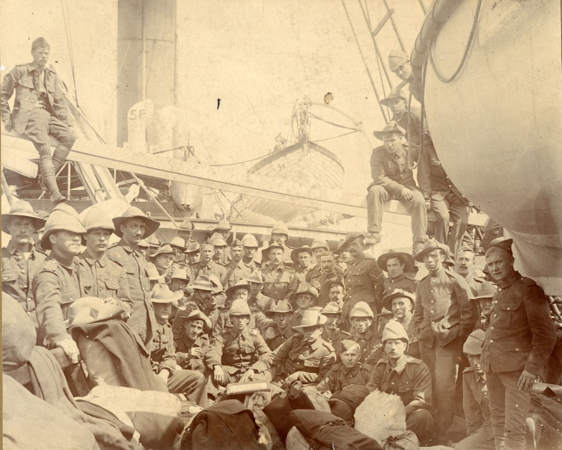

Written on headed notepaper H.M. TRANSPORT (ELDER, DEMPSTER LINER) ‘MONTROSE’
Dear Father and Mother,
Just a line to say I am all right up to now, hoping you are both the same. I have had to write this letter on board the boat as we might not have time when we arrive in Cape Town but it will be posted from there. We passed another trooper last night and she signalled that she the ‘Manilla’ that left Liverpool on the 13th March as we left on the 16th so you can see we are getting along. We have had it rough all night, shipping seas every minute. It is a sight you ought to see, big waves about as high as Trinity School coming rushing at you when up she goes right on the top of it and it is rolling away astern but it would not be all right if it came over our side. As you will see by Mary’s letter, I have been inoculated but her letter will tell you about it. There is nothing much to write about only that Parnell is a [?] and the fellows are getting sick of him. We ae pitching and rolling while I am writing this letter so it is hard work writing. Remember me to Sarah and Sam and tell him I have got a knife for him when I see him again. We shall soon be in South Africa if we have good luck and good [weather?] and then I will write something more. I have got plenty of writing paper and envelops as you will see. The ship runners gave us a writing case and a pound of mixture and 35 Ogdens cigarettes a man. I got a tin of tobacco off one of our fellows for nothing, he was going to throw it away. I have had my towel pinched but that is nothing, some of them have had their money pinched but I have none to pinch. I made a few coppers by shaving but there are plenty that does shaving so I don’t make much. That’s all I have to say this time so I will now close by sending my best. Love you all.
Your loving son
P.S. Look after her and don’t let her be done again by [?]

