Greater Manchester 10 Tips for Talking launch plan

Background
Early year’s speech and language is important part of Greater Manchester’s school readiness programme which aims to ensure every child starts school ready to learn.
As part of this work, Greater Manchester has developed ten key messages for early language development, which highlight the simple things that parents and carers can do to develop children’s speech, language and communication skills from before birth through to starting school.
A leaflet, poster, individual tips and a series of videos have been produced to illustrate each ‘tip for talking’. There is also a series of 10 tips materials translated into some of the additional languages spoken by our Greater Manchester communities.
This plan outlines how we will promote the key messages with parents and families and the ten localities across Greater Manchester.
Videos clips from Tiny Happy People, the well-established resource produced by the BBC, are also used to illustrate the Ten Tips for Talking messages.
The new suite of materials will be launched w/c 27 September. Planned communications activity is outlined below. Partners are requested to share on their own channels and relevant networks.
The appendix to this document outlines how the different resources should be used.
All the resources, including social media assets and videos can be downloaded on WeTransfer.
All the resources can also be found on the GMCA website

Key messages
- Greater Manchester continues to lead the way in tackling the issue of school readiness, working together innovatively, and doing things differently to make sure no child is left behind.
- Greater Manchester had started to close the school readiness gap between children from our most disadvantaged communities and the rest of the country as a result of our investment in early years. However, Covid-19 has had a significant and detrimental impact on children’s development and we are just now starting to see the impact of this. The Greater Manchester 10 Tips for Talking launch, to support families and practitioners understanding of the simple things we can do to support speech and language development, could not be more timely.
- If the first three years of a child’s life aren’t filled with talking and language, they will struggle to thrive in later life. That’s why speech, language and communication is a particular focus of the school readiness work.
- Nearly 20 per cent of all children nationally and nearly 22 per cent of children in Greater Manchester arrive at school without the language and communication ability to thrive. In deprived areas, that figure doubles to almost 40 per cent across the UK. In addition, babies and young children have been disproportionately adversely affected by the pandemic in terms of socialisation and accessing support.
- Greater Manchester’s 10 Tips for Talking are evidence-based and aim to support parents and practitioners to develop the home learning environment and children’s speech and language skills.
- This is complemented by the BBC’s Tiny Happy People campaign, developed in partnership with the GMCA, to help close the pre-school language and communication gap.
- Tiny Happy People is a suite of free digital resources aimed at parents and professionals working with pre-schoolers, and comprises tips and advice, activities and short films about the science and facts behind language development.

Communications activity
Website – the GMCA website will host the videos and related information. This includes links to THP content videos. Partners are asked to link to this page from their own websites.
Social media content – suggested social media posts are outlined below. These will be shared on the main GMCA social media accounts on Twitter, Facebook and Instagram. This also includes quotes from parents and practitioners on how the Ten Tips have been used.
Pop-up library sessions at some localities across GM – details in plan below.
Press release/media opp – explore options to invite media to a local event. Tie in with press release to launch the new suite of resources.
We request that partners share the Ten Tips for Talking on their own channels where possible. As well as social media, this can include newsletters, internal comms channels and other relevant networks.

Social media plan
Please note: when sharing the videos, it is advised that you upload the video to the relevant social media platform rather than just sharing the YouTube link. This will help with engagement on the social media platform.
Account | Date | Message | Asset/weblink
FB | Monday 27 September | Calling all families and professionals who work with young children!  Greater Manchester’s 10 Tips for Talking have been developed to support grown-ups to ensure that children experience rich language models.  This will help them to learn and use speech, language and communication.  Lots of research has gone into the development of the tips so you know these are the right things to do.  Find out more about Greater Manchester’s Ten Tips for Talking: greatermanchester-ca.gov.uk | USE 10 TIPS GRAPHIC  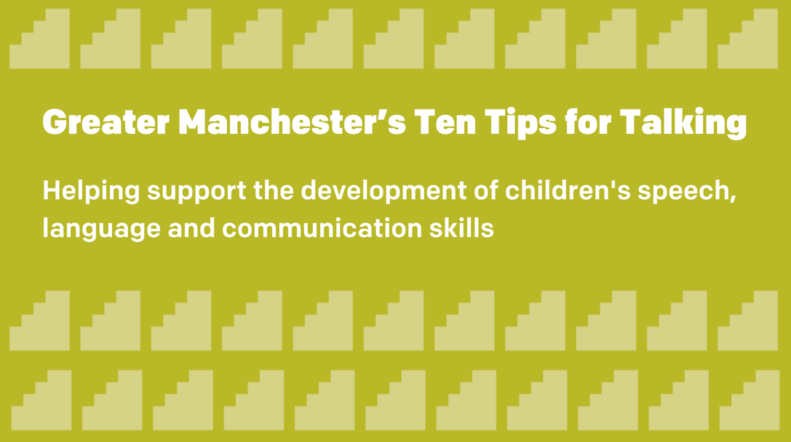
Twitter |  | THREAD  1/2  Calling all families & professionals who work with young children!  Greater Manchester’s 10 Tips for Talking have been developed to support grown-ups to ensure that children experience rich language models.  This will help them to learn & use speech, language & communication.  2/2  Lots of research has gone into the development of the tips so you know these are the right things to do  Find out more about Greater Manchester’s Ten Tips for Talking  greatermanchester-ca.gov.uk//GM10TipsForTalking | USE 10 TIPS GRAPHIC
Twitter |  | In parts of Greater Manchester more than 40% of children start school without the understanding and talking skills which help them learn.  Help us change this by having a watch of our Ten Tips for Talking  greatermanchester-ca.gov.uk//GM10TipsForTalking | USE 10 TIPS GRAPHIC
 |  | Tip 1  Talking to your unborn baby helps them to recognise your voice and builds a bond between you. Babies will know you as soon as you are born.  Find out more about Greater Manchester’s Ten Tips for Talking  greatermanchester-ca.gov.uk//GM10TipsForTalking | LINK TO VIDEO 1  https://youtu.be/fTjqQcaveZw
 |  | Tip 2  Your tiny baby might not be able to talk yet but they will respond in their own way. That might look you hard at your face, moving their mouth when you talk or waving their arms and legs. This is their way of chatting.  Find out more  greatermanchester-ca.gov.uk//GM10TipsForTalking | LINK TO VIDEO 2  https://youtu.be/qaja3X5L6dI
 |  | Tip 3  Talk about what interests your baby. This shows your child that you understand them.  Find out more about Greater Manchester’s Ten Tips for Talking  greatermanchester-ca.gov.uk//GM10TipsForTalking | LINK TO VIDEO 3  https://youtu.be/ZDEQ5sHj7wE
 |  | Tip 4  Put your phone away, turn off the TV and chat to your baby.  Creating a bit of quiet helps your baby to become a good listener and talker.  Find out more about Greater Manchester’s Ten Tips for Talking  greatermanchester-ca.gov.uk//GM10TipsForTalking | LINK TO VIDEO 4  https://youtu.be/f3zRSZj6Q7w
 |  | Tip 5  Play or look at books together. Follow your child’s lead when they are playing and let them use their imagination.  Find out more about Greater Manchester’s Ten Tips for Talking  greatermanchester-ca.gov.uk//GM10TipsForTalking | https://youtu.be/L78RhvdlLaA  LINK TO VIDEO 5
 |  | Tip 6  Talk to them all the time about whatever you are doing.  It doesn’t matter if you say the same things over and over again babies love it. This is how they learn.  Find out more about Greater Manchester’s Ten Tips for Talking  greatermanchester-ca.gov.uk//GM10TipsForTalking | LINK TO VIDEO 6  https://youtu.be/rGA-PCE2NAI
 |  | 👧🏾 Tip 7  Play talking tennis. You say something and give your baby time to respond. Counting to 10 in your head before you respond is a good way of giving your child space for them to reply. This is how your child learns to take turns.  Find out more 👇  greatermanchester-ca.gov.uk//GM10TipsForTalking | LINK TO VIDEO 7  https://youtu.be/DVm0973dAN4
 |  | Tip 8  Help your baby learn new words by repeating what they say and adding a new word or two.  Find out more about Greater Manchester’s Ten Tips for Talking  greatermanchester-ca.gov.uk//GM10TipsForTalking | LINK TO VIDEO 8  https://youtu.be/zeGx0WPJhlU
 |  | 👧🏻 Tip 9  Dummies get in the way and stop children from talking. Remember to take your child’s dummy out when they are talking or when you are talking to them.  Find out more about Greater Manchester’s Ten Tips for Talking 👇  greatermanchester-ca.gov.uk//GM10TipsForTalking | LINK TO VIDEO 9  https://youtu.be/kNoesjXqx9M
 |  | 👧🏼 Tip 10  Use the language you know best to talk to your child. This helps their brain to grow.  Find out more about Greater Manchester’s Ten Tips for Talking 👇  greatermanchester-ca.gov.uk//GM10TipsForTalking | LINK TO VIDEO 10  https://youtu.be/dDlgQbooeqc
Coming soon…
Webinar – how to use the Ten Tips for Talking effectively with families.

More details will be released soon so watch this space

Find out more about Greater Manchester’s Ten Tips for Talking

greatermanchester-ca.gov.uk//GM10TipsForTalking

 |  | Families across Greater Manchester are already benefitting from using the Ten Tips for Talking.  Find out more about Greater Manchester’s Ten Tips for Talking  greatermanchester-ca.gov.uk//GM10TipsForTalking | USE QUOTE GRAPHIC 1  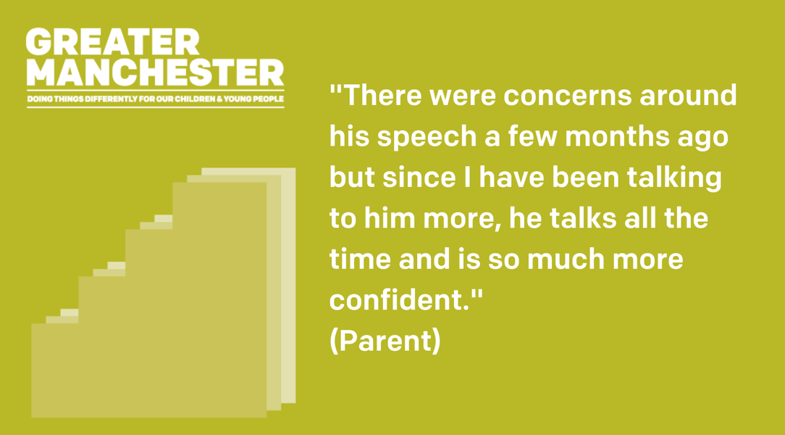  "There were concerns around his speech a few months ago but since I have been talking to him more, he talks all the time and is so much more confident." (Parent)
 |  | Early years workers and practitioners have been using the Ten Tips for Talking to support families across Greater Manchester.  Find out more about Greater Manchester’s Ten Tips for Talking  greatermanchester-ca.gov.uk//GM10TipsForTalking | USE QUOTE GRAPHIC 2  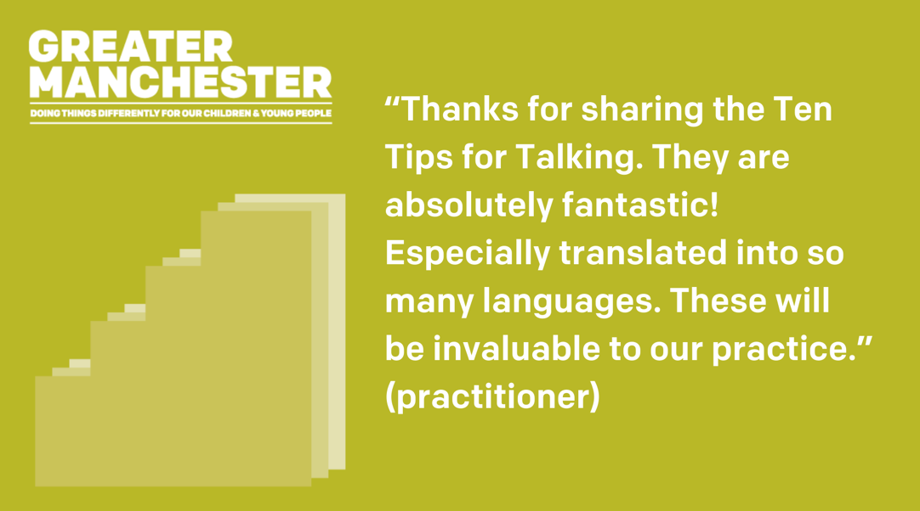  “Thanks for sharing the Ten Tips for Talking. They are absolutely fantastic! Especially translated into so many languages. These will be invaluable to our practice.” (practitioner)
 |  | The Greater Manchester Ten Tips for Talking are being used to support parents and practitioners to develop children’s speech and language skills.  Find out more about Greater Manchester’s Ten Tips for Talking  greatermanchester-ca.gov.uk//GM10TipsForTalking | USE QUOTE GRAPHIC 3  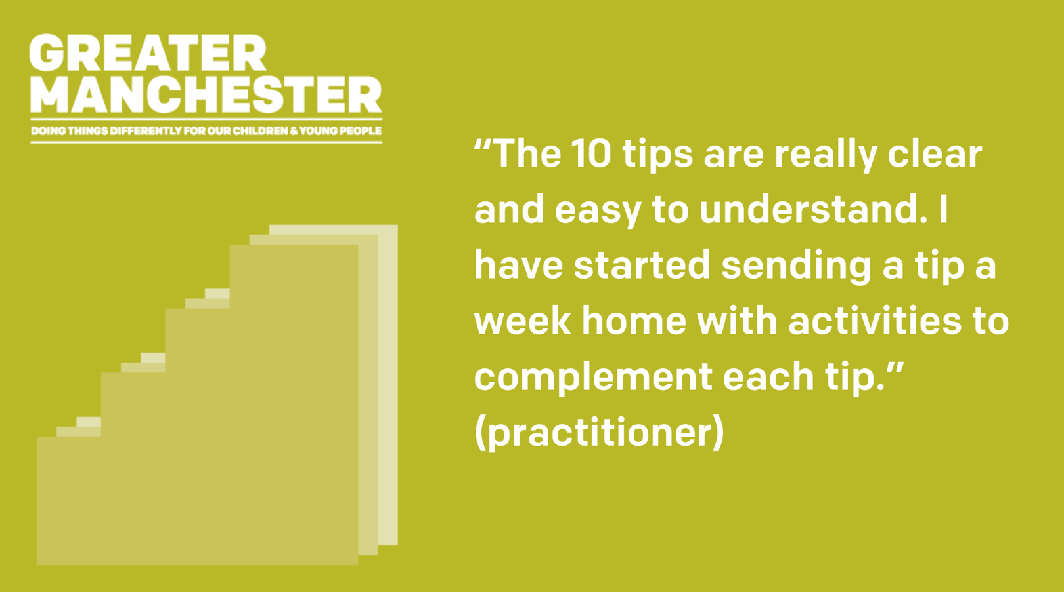  “The 10 tips are really clear and easy to understand. I have started sending a tip a week home with activities to complement each tip.” (practitioner)
 |  | Greater Manchester’s Ten Tips for Talking are available in a number of languages to help us support as many families as possible to develop their child’s speech, language and communication skills.  Download the resources at greatermanchester-ca.gov.uk//GM10TipsForTalking | USE QUOTE GRAPHIC 4  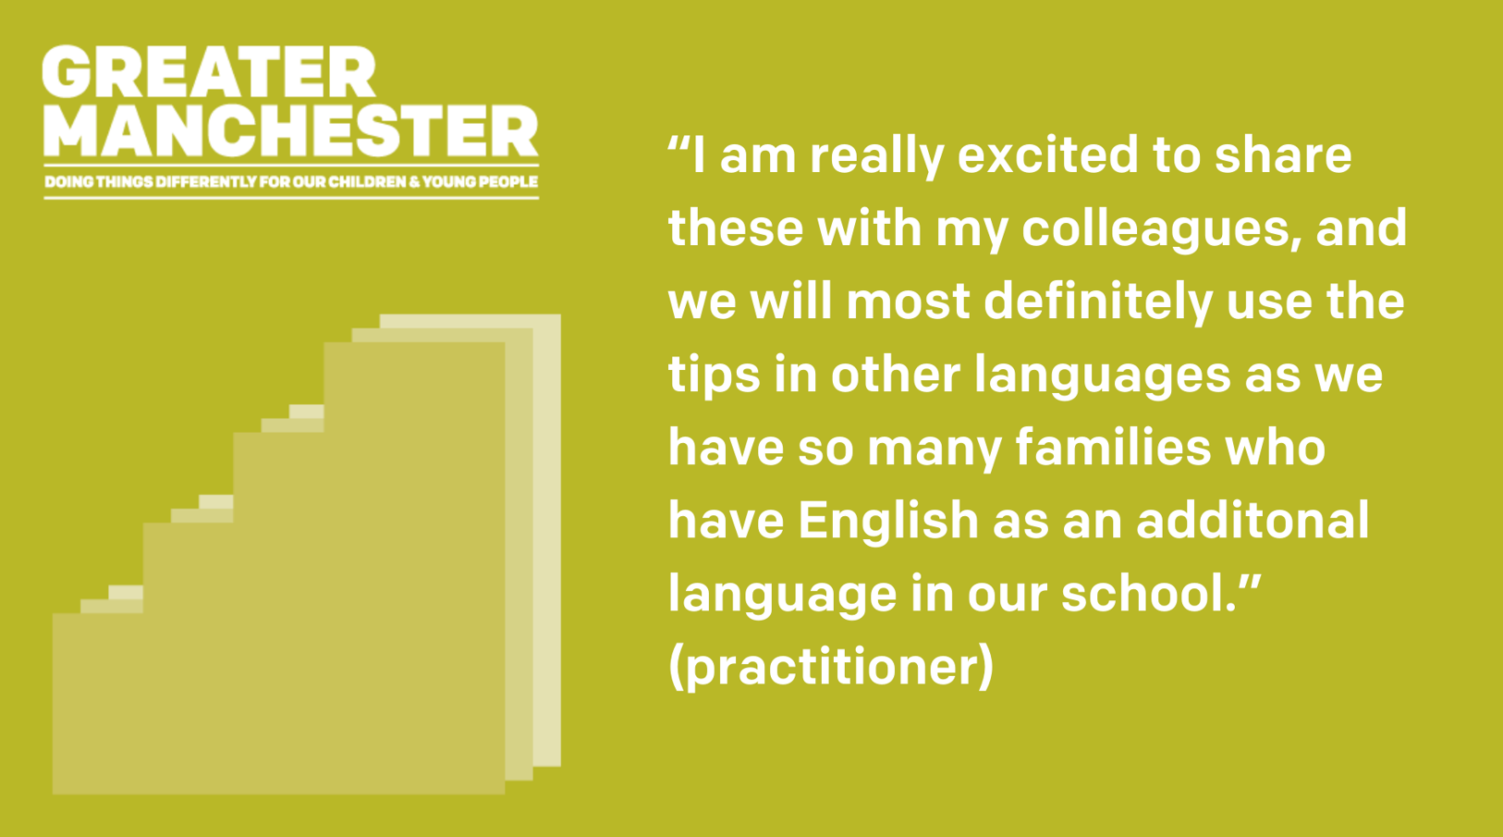  “I am really excited to share these with my colleagues, and we will most definitely use the tips in other languages as we have so many families who have EAL in our school” (practitioner)

Locality Library Pop-up sessions
Rochdale – GM10 roadshow with Bookstart Coordinators. Sharing of GM10 leaflets and posters at libraries with the GM10 clips on loop on a laptop. Activities and books linked to the tips available. (Alison Mitchell and Helen Underhill)
Wigan – Involve library services in launch week. Details TBC (Beki Lavelle)
Bury – Stay and play sessions via library services and EH teams organising things (Sharon Walton)
More events TBC

Contacts
For more information contact Claire Smith in the GMCA Communications and Engagement Team – claire.smith@greatermanchester-ca.gov.uk

Appendix 1- Resources available and how to use them
All of the resources can be downloaded via WeTransfer but they can all also be found on the GM10 website –
greatermanchester-ca.gov.uk/GM10TipsForTalking

Introduction
- The GM 10 Tips for Talking are an evidence informed set of key messages for families and professionals to support children’s language and communication development from pregnancy onwards. They are worded in the voice of the child because we know that this style of delivery increases the weight of the message with families
- Each message has two parts: the headline and some additional information
- Some of the resources below contain all the information and others just the headline. It is important that you think who you intend to share the message with and what information they need.
- Some people will require the full message, others may require a simplified message

GM10 Leaflet
- This illustrates the whole tip (heading and additional information).
- This has been designed so it can be shared online, or it can also be printed to A4 size and folded.
- Please use this for supporting families or professionals.
- To make sure that the information is provided in the most evidence informed way, please talk through each of the tips and give the leaflet out to help the recipient remember the message.
- Your explanation will help to consolidate and embed the highlighted concept.
- Please do not give out the leaflet without explanation as research indicates there is almost no value to this.

GM10 Poster
- This illustrates just the heading of each tip.
- This has been designed so it be shared online, or it can be printed to A3 size.
- This can be used in settings and schools to provide some basic messages.

GM10 Printable PowerPoint
- This illustrates the whole tip (heading and additional information) with an accompanying image related to the tip.
- This can be shared online or printed.
- These are best used individually when you want to provide a specific piece of advice.
- Please use this for supporting families or professionals.
- To make sure that the information is provided in the most evidence informed way, please talk through each of the tips and give the leaflet out to help the recipient remember the message.
- Your explanation will help to consolidate and embed the highlighted concept.
- Please do not give out the leaflet without explanation as research indicates there is almost no value to this.

GM10 documents in other languages
- The GM10 have been translated into 14 other languages (Arabic, Bengali, Cantonese, Farsi, Hebrew, Mandarin, Polish, Portuguese, Punjabi, Romanian, Spanish, Turkish, Urdu and Yiddish)
- They are saved as PDFs documents.
- These can be shared online or printed.
- This illustrates the whole tip (heading and additional information)
- This has been designed so it can be shared online, or it can also be printed to A4 size and folded.
- Please use this for supporting families or professionals.
- To make sure that the information is provided in the most evidence informed way, please talk through each of the tips and give the leaflet out to help the recipient remember the message.
- Your explanation will help to consolidate and embed the highlighted concept.
- Please do not give out the leaflet without explanation as research indicates there is almost no value to this.

GM10 clips with voiceovers of children
- There is a separate clip for each tip.
- There is a child voice talking through the whole tip (heading and additional information).
- There are accompanying pictures which illustrates the tips at the start and end of the clips.
- These are for sharing online.
- Please use this for supporting families.
- It may be that the recipient’s English makes it impossible to give much of an additional explanation, but it is important for the reasons stated below that you try to do this.
- To make sure that the information is provided in the most evidence informed way, please talk through each of the tips and give the leaflet out to help the recipient remember the message.
- Your explanation will help to consolidate and embed the highlighted concept.

GM10 – THP Matrix
- If families or practitioners need more tailored information, a matrix which links each tip to a series of Tiny Happy People clips which are suitable for different audiences e.g. dads, families of children with additional needs, children from ethnic minority communities
- The links to the THP clips can be found on each tip page of the website, for example you can see the links linked to Tip 1 here.

GM10 – Webinars
- We are providing some free short learning sessions for EY practitioners to explain a little more about the Tips for Talking and how they can be used. The sessions will last between 30 and 40 minutes and are being offered at different dates and times across October and November. Watch this space for dates and times and book on to the one which is most convenient for you – details will be shared in due course!

