INSTRUCTIONS FOR ACCESSING THE LOCAL OFFER IN AUDIO OR ANOTHER LANGUAGE

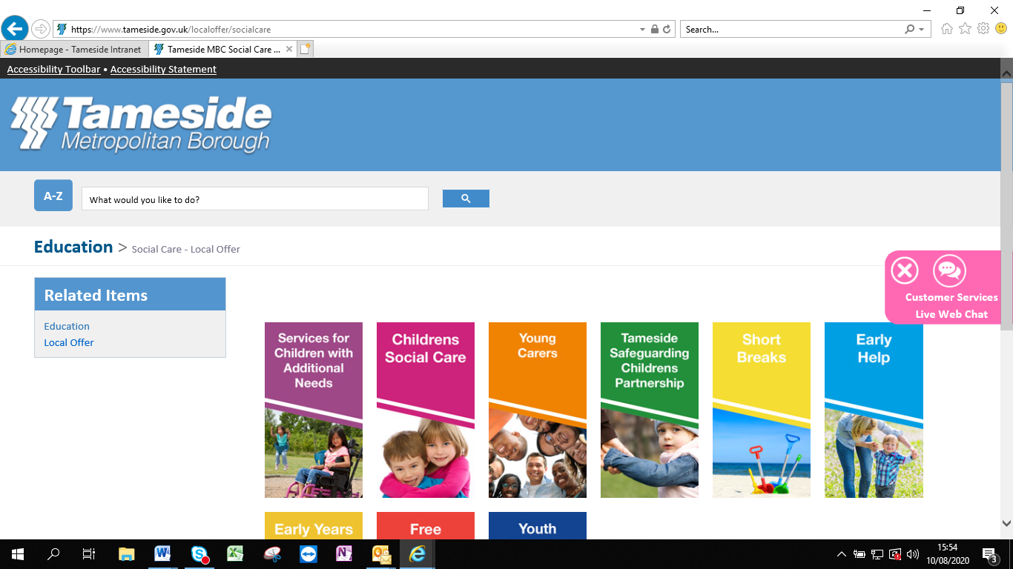
Click on Accessibility Toolbar here

The languages with a speaker next to them are available in audio
Click on the flag symbol and select language

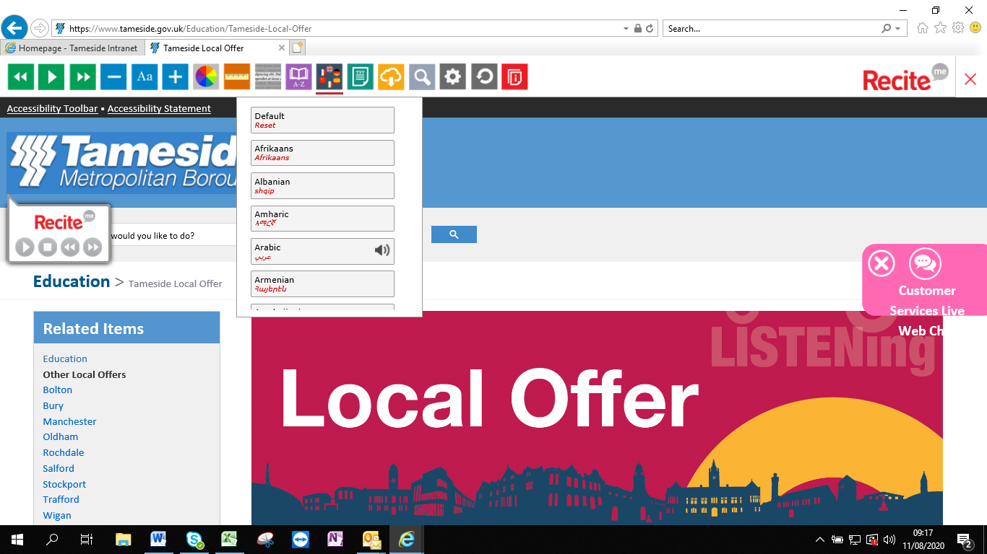

Once langauge is selected the Local Offer will appear translated into your chosen language.

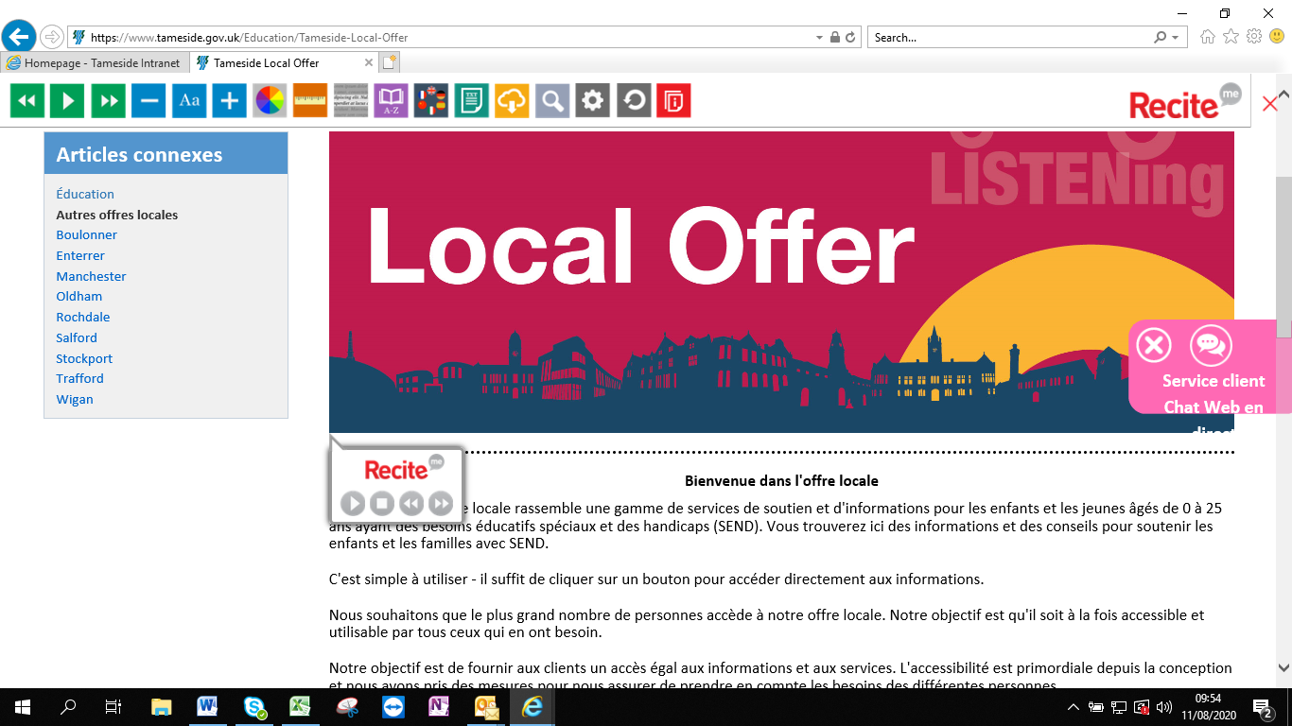

If you click on a button you will see the text underneath will appear in your chosen langauge too
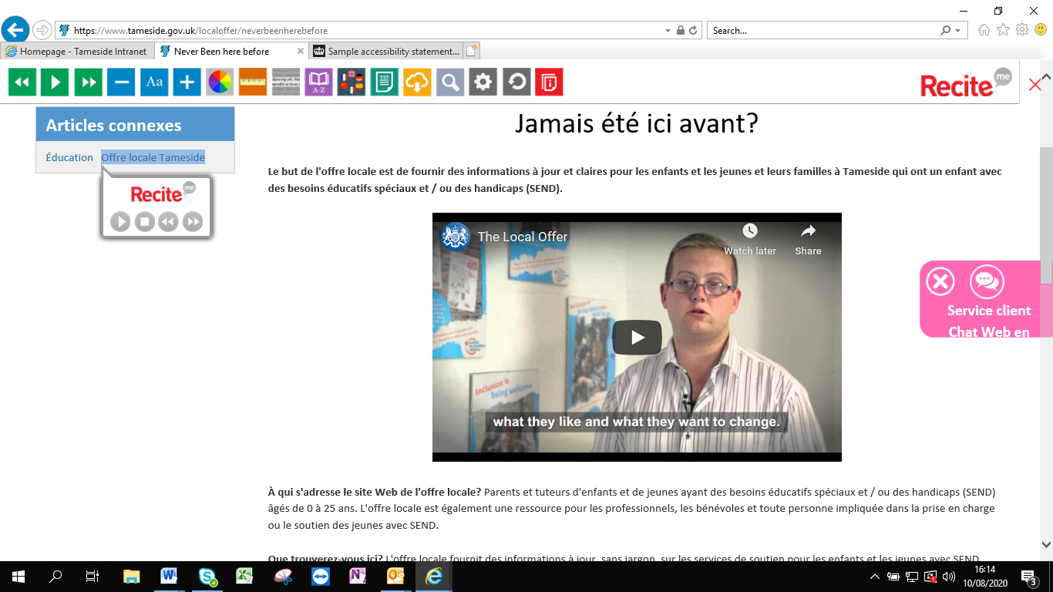

You can use the recite button to play and pause audio in your chosen language. You will need to click on English in the toolbar if you require English language audio. The recite tab will then appear allowing it to be played.

