THRIVE aligned mental health and emotional wellbeing support in
THE SOCIAL COMMUNICATION PATHWAY
THRIVING  (PREVENTATIVE)  Skilling up staff, parents, carers and young people | GETTING ADVICE  (EARLY INTERVENTION)  Signposting/self-management/one-off contact or ongoing support | GETTING HELP  (TARGETED SUPPORT)  Goal focussed/evidence-based and outcome focussed interventions | GETTING MORE HELP  (SPECIALIST SUPPORT)  Extensive treatment/specialised goals-based help | GETTING RISK SUPPORT  (CRISIS RESPONSE)  Immediate risk management
TASCA - Tameside Action and Support for Carers of Children with Autism Group  0161 371 2060/07754873480- Monthly support groups in different locations through Tameside  tascatameside@outlook.com  www.tascatameside.com  OKE - Our Kids Eyes  0161 371 2084 - Tameside charity that helps children and young people with disabilities. Offer advice, information, activities and events for children with SEND and their families.  FACT—Families of Autistic Children Together  07837584424/07817472823  Support and activities for children on the autistic spectrum. Parents can also learn Makaton (Sign language for children) www.factautism.org.uk  MindED Online Training  https://www.minded.org.uk/  HYM Social Communication Needs Document  Approach and strategies for parents/carers and professionals document. Available from https://www.tameside.gov.uk/localoffer/pupilsupportservice  Podcasts  https://www.acamh.org/category/podcasts/?topic_category=asd-autism-spectrum-disorders  Videos for adults:  https://www.youtube.com/watch?v=Lk4qs8jGN4U – National Autistic Society – What is Autism?  https://www.youtube.com/watch?v=K7JbMEyPxHs – Scottish Autism – What is Autism?  Videos for children:  https://www.youtube.com/watch?v=RbwRrVw-CRo – National Autistic Society – Amazing Things Happen  Online resource for managing challenging behaviour: www.positiveapproachestosupport.co.uk | Local Offer  Gives children and young people with Special Educational Needs and Disabilities (SEND) and their parents or carers information about what activities and support are available in the area where they live.  https://www.tamesideandglossopccg.org/your-health/childrens-health-information/local-offer  HYM Social Communication Needs Document  Approach and strategies for parents/carers and professionals document. Available from https://www.tameside.gov.uk/localoffer/pupilsupportservice  Early Attachment Service  0161 716 3569  Offers support to parents from pregnancy until the child’s 5th birthday, to promote healthy attachment and bonding in their relationship.  pcn-tr.eas@nhs.net  Free Solihull parenting course:  http://www.inourplace.co.uk  Access code: SUNFLOWER  Tameside Parenting Team  parentingreferrals@tameside.gov.uk – offer a parenting support helpline and informal parenting groups.  School-Based Support  School nurse, SENCO, Speech and Language Therapy, Educational Psychology  Pupil Support Services  Additional support for children in school through the CLASS team. Accessed via school, referral form on website.  Web resources:  https://www.autism.org.uk/ (NAS)  www.autismgm.org.uk (GMAC) http://w3.cerebra.org.uk (Cerebra) https://youngminds.org.uk/find-help/conditions/autism-and-mental-health/ (Young Minds)  Mental Health Drop In Sessions:  (see THRIVE MED pathway for more information)  Anthony Seddon Fund Talk Shop  0161 376 4439  TOG Mind The Hive  0161 330 9223  Off the Record 1:1 Counselling  0161 355 3553  42nd Street Counselling Offer  0161 228 7321  School/Home Resources:  The Incredible 5-Point Scale (workbook, Kari Dunn Buron)  Exploring Feelings (workbook, Tony Attwood)  Starving the Anxiety/Anger Gremlin (workbook, Kate Collins-Donnelly)  You're a Star: A Childs Guide to Self-Esteem (workbook for 7-11 year olds, Poppy O'Neill)  Self-Esteem Workbook for Teens (Lisa Schaab) | Healthy Young Minds  0161 716 3600  Diagnosis, assessments, support, consultation available from the neurodevelopmental team.  Tameside Families Together  0161 342 4101 - Work with Tameside families to help manage difficulties before they become more serious. www.tameside.gov.uk/cypp/earlyintervention  Glossop MAT (Multi-Agency Team)  01629 533843 - Support children, young people and families who have additional needs aged 0-19.  MAT.NewMC@derbyshire.gov.uk  ISCAN (Integrated Service for Children with Additional Needs)  0161 366 2050 - team of social workers and health professionals who work with children and young people who have a disability or medical condition.  Riding the Rapids  0161 902 3422 - Parent training course  CABS —Child and Adolescent Behaviour Support Team  0161 366 2050 – support for CYP with severe learning disabilities and challenging behaviour.  SENDIASS—0161 342 3383. Tameside service aiding and developing partnership between CYP, parents/carers, schools, the local authority and all other partners who are involved in working to identify, assess and meet the special educational needs of CYP with SEND and going through EHCP process. www.tameside.gov.uk/sendiass  Post Diagnostic Support  Courses commissioned for ongoing parenting support, from Healthy Young Minds  Connex Community Support  Offer short term respite for parents and carers of children with LD and/or Autism and facilitate stay and play sessions for under 5’s with specialist carers. | Children’s Social Care  Tameside:  Public Service Hub  Mon-Fri : 9-5pm  0161 342 4101  Mon-Fri outside office hours, weekends and public holidays  0161 342 2222  Glossop:  Call Derbyshire  Mon-Fri: 8-8pm  01629 533190  Sat: 9-4.30p.m  Out of hours Rapid Response Team  01629 532600  Advice/consultation (Mon-Fri 8-6pm)  01629 535353  Healthy Young Minds  0161 716 3600 – Contact to speak to a duty worker for severe and enduring presentations requiring intensive and/or ongoing treatment and risk management (5-18 emotional and behavioural dysregulation)  Self-harm/suicidal ideation: emergency consultation 9am-5pm Mon-Fri, 0161 716 3600  General Practitioner (16+)  Consult re: access to adult mental health services/physical health screening etc.  Community Paediatric Service  0161 366 2289 - Provides specialist medical input into the management of children with specific vulnerabilities or needs such as children with disabilities, children with special educational needs and ‘Looked After’ children. | Accident and Emergency Department Tameside General Hospital:  For children and young people requiring emergency care (e.g. self-injury requiring treatment and self-poisoning)  with support from the Crisis Care Team  NHS 111  Call if someone needs urgent help but it is not an emergency.  Emergency 999  Call 999 if someone is seriously injured and their life is at risk.  Children’s Social Care  Tameside:  Public Service Hub  Mon-Fri : 9-5pm  0161 342 4101  Mon-Fri outside office hours, weekends and public holidays  0161 342 2222  Glossop:  Call Derbyshire  Mon-Fri: 8-8pm  01629 533190  Sat: 9-4.30p.m  Out of hours Rapid Response Team  01629 532600  Advice/consultation (Mon-Fri 8-6pm)  01629 535353  Inpatient Provision  If it becomes unsafe to manage the CYP within the community due to the severity of their presentation and/or risk, an inpatient intervention might be required at the Hope Inpatient Psychiatric Unit, Fairfield General Hospital.
THRIVE Model for Healthy Young Minds Explanatory Note:
The THRIVE model above conceptualises four clusters (or groupings) for young people with mental health issues and their families, as part of the wider group of young people who are supported to thrive by a variety of prevention and promotion initiatives in the community.

The image (Fig 1) to the left describes the input that offered for each group; that to the right describes the state of being of people in that group - using language informed by consultation with young people and parents with experience of service use. The middle designation of “thriving” is included to indicate the wider community needs of the population supported by prevention and promotion initiatives.

Thrive replaces the tiered model with a conceptualisation of a whole system approach. The framework outlines groups of children and young people, and the sort of support they may need, and tries to draw a clearer distinction between treatment on the one hand and support on the other. It focuses on a wish to build on individual and community strengths wherever possible, and to ensure children, young people and families are active decision makers in the process of choosing the right approach. Rather than an escalator model of increasing severity or complexity.
Fig 1: Thrive Model for CAMHS (Anna Freud Centre & Tavistock and Portman NHS, 2014)

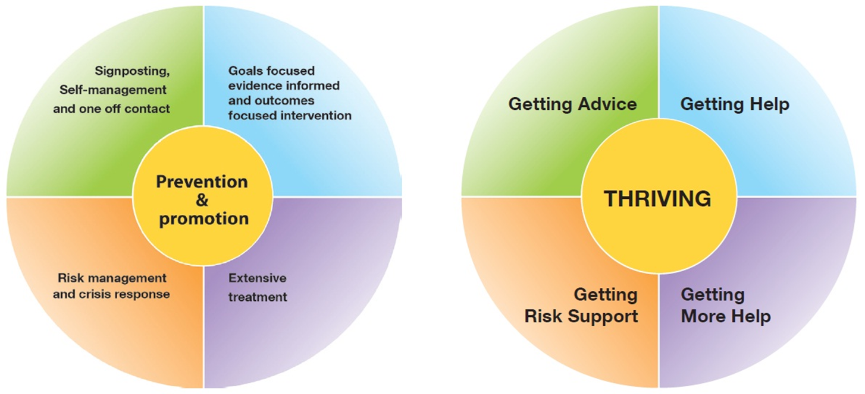

Getting Advice: Within this grouping would be children, young people and families adjusting to life circumstances, with mild or temporary difficulties, where the best intervention is within the community with the possible addition of self-support. This group may also include, however, those with chronic, fluctuating or ongoing severe difficulties, for which they are choosing to manage their own health and/or are on the road to recovery.

Getting Help: This grouping comprises those children, young people and families who would benefit from focused, evidence-based treatment, with clear aims, and criteria for assessing whether aims have been achieved. This grouping would include children and young people with difficulties that fell within the remit of NICE guidance but also where it was less clear which NICE guidance would guide practice.

Getting More Help: This grouping comprises those young people and families who would benefit from extensive long-term treatment which may include inpatient care, but may also include extensive outpatient provision.
Getting Risk Support: This grouping comprises those children, young people and families who are currently unable to benefit from evidence-based treatment but remain a significant concern and risk. This group might include children and young people who routinely go into crisis but are not able to make use of help offered, or where help offered has not been able to make a difference; who self-harm; or who have emerging personality disorders or ongoing issues that have not yet responded to treatment

