**In Brief**

**Researching a Criminal Ancestor**

This guide has been developed to help you research relationships between ancestors and the criminal justice system, including criminal records and prosecutions. The information presented here is designed to serve as a general introduction to this extensive topic. Further advice and tips can be found in the numbered items in the bibliography.

Two useful databases for locating these records are [**Ancestry**](http://www.ancestry.co.uk) and [**Findmypast**](http://www.findmypast.co.uk). Both are available to use at Tameside Local Studies   
& Archives free of charge.

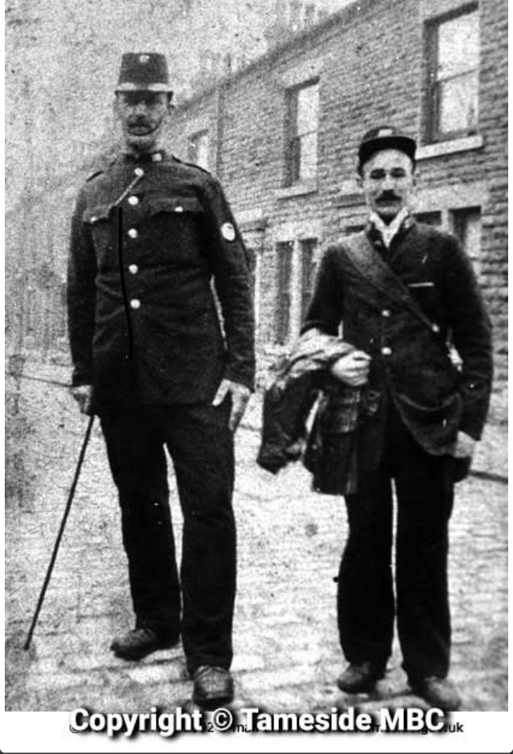

Stalybridge Police (1880s).

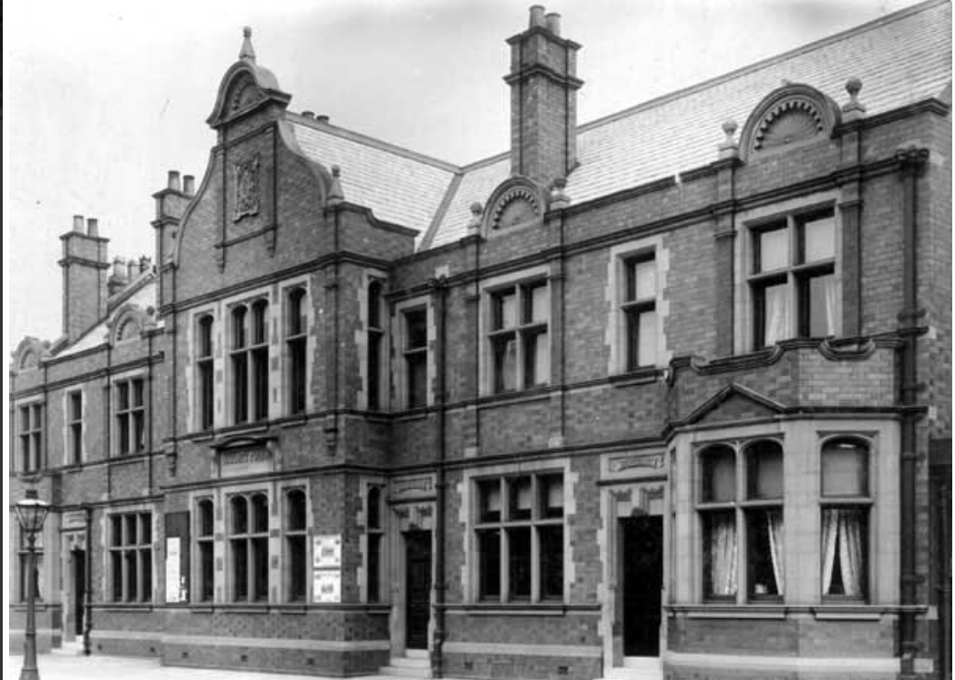

Denton Police Station (late 1890s). The building was constructed in 1896.

**Tracing a Police Officer**

Established in 1829, the London Metropolitan Police Force was the first official law enforcement agency in England. Following the County Police Act of 1839 some other early police forces were established, but it was not until twenty years later in 1859 that it became compulsory for local authorities to form a constabulary. Many records covering these forces have not survived. Those remaining – if not on [Ancestry](https://www.ancestry.co.uk/search/categories/clp_court/) or [Findmypast](https://search.findmypast.co.uk/search-world-records/england-and-wales-crime-prisons-and-punishment-1770-1935) – may be with a local archive centre or with the relevant police force.

**Tameside Local Studies & Archives:** This centre hold records for [Ashton-under-Lyne Police Force](https://localstudies.tameside.gov.uk/CalmView/Record.aspx?src=CalmView.Catalog&id=GB131.1000%2f3%2f219&pos=2) ranging from 1848-1969. These include charge books and registers. Some of these items are restricted access. Other archives held encompass the establishment of Hyde Police Force and Stalybridge Police Force. Contact the [archivist](https://www.tameside.gov.uk/archives#enquiries).

[**Greater Manchester Police Museum and Archives**](https://gmpmuseum.co.uk/research/resources/appointments-search/) **(**57A Newton Street,Manchester M1 1ET)**:** Dating from 1981, the museum holds some personnel records for police forces in Manchester, Salford and other Greater Manchester areas, such as Ashton, Stalybridge and Hyde. Only the Salford records can be searched online. A basic transcript is free of charge, but a fee is required for digital copies of the register. For queries regarding other forces, please contact the museum at the following email address: [gmpmuseum@gmail.com](mailto:gmpmuseum@gmail.com)

[**Manchester Chief Constable Annual Reports**](http://www.gmlives.org.uk/results.html#imu[rid=ecatalogue.214883])**:** These accounts, covering the period 1839 to 1968, are available to view at Manchester Archives+, Manchester Central Library, by personal visit only. At least one day’s notice is required to access the items. Book online [here.](https://www.manchester.gov.uk/info/448/archives_and_local_history/7378/access_our_archives_rare_books_and_collections/2)

[**Manchester Police Index (Findmypast)**](https://search.findmypast.co.uk/search-world-records/manchester-police-index-1812-1941)**:** This catalogue is compiled from the appointment registers maintained by the Manchester City Police. Information may include physical descriptions, religion and career details.

[**London, England, Metropolitan Police Pension Registers, 1852-1932 (Ancestry)**](https://www.ancestry.co.uk/search/collections/61310/)**:** This database provides name, rank, warrant number, division and dates of appointment for former police officers.

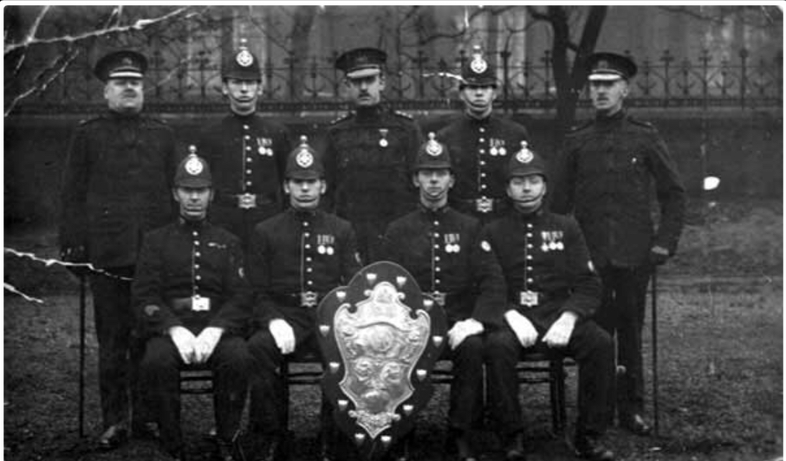

Cheshire Constabulary, Droylesden (1920).

[**Police Roll of Honour Trust**](https://policememorial.org.uk/index.php?page=roll-of-honour)**:** Although this organisation is primarily concerned with researching the history of police officers who died whilst on active duty, more general police history is also covered. The body maintains researchers to assist in searching for police officer relatives for a fee including the cost of relevant archival resources.

[**Museum of Policing in Cheshire**](http://www.museumofpolicingincheshire.org.uk/contacts/contacts.html)**:** This collection preserves items related to law enforcement work in Cheshire, in addition to holding information on the history of a number of forces associated with Tameside, such as Stalybridge. Personal research on individual officers can be commissioned for a small fee. An online catalogue is available for searching [here](http://www.museumofpolicingincheshire.org.uk/Collections/Catalogue/Catalogue.aspx).

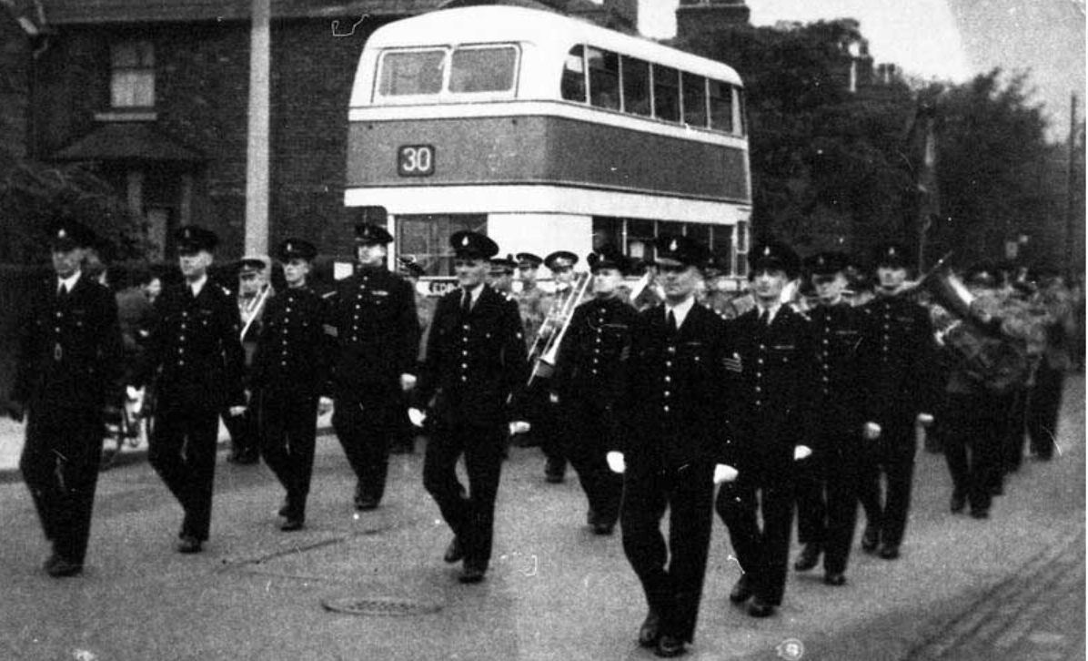

Dukinfield Special Constables on Parade on King Street (1960).

[**Cheshire Local Studies and Archives**](http://catalogue.cheshirearchives.org.uk/calmview/default.aspx)**:** This centreholds an extensive collection of records pertaining to Cheshire police forces, comprising enrolment and records books (1857-1913), a register of married officers (1847-1960) and a register of appointments (1923 -1966). Check the catalogue [online](http://catalogue.cheshirearchives.org.uk/calmview/) and follow the instructions listed [here](https://www.cheshirearchives.org.uk/how-we-can-help/researching-our-records.aspx) to arrange a visit to view. A research fee may be required.

[**Police Records Search – Lancashire County Constabulary**](https://policesearch.lancashire.gov.uk/policesearch.asp)**:** This online database, maintained by [Lancashire Archives](https://www.lancashire.gov.uk/libraries-and-archives/archives-and-record-office/), records police officers who served with the Lancashire Police Force between 1840-1925.

[**Lancashire Archives**](https://archivecat.lancashire.gov.uk/CalmView/Record.aspx?src=CalmView.Catalog&id=PLA&pos=1): This centre holds an extensive collection of material concerning the Lancashire Constabulary, including personnel records. The period covered ranges from 1833 to 1984. Some forces remained separate entities, such as Ashton-under-Lyne which was not incorporated until 1947. The Ashton Police records were transferred to [Tameside Local Studies & Archives Centre](https://localstudies.tameside.gov.uk/calmview/) in 2000. Visit Lancashire Archives by arrangement or contact [online](https://clickquestion.lancashire.gov.uk/runQuestionnaire.asp?qid=474749). There may be a research fee.

**Census:** Since 1841 the census or population count has been taken every ten years for England and Wales (except for 1941). Accessible records date from 1841-1911 as the 100-year closure rule applies. Census entries are available on both [Ancestry](https://www.ancestry.co.uk/search/categories/ukicen/) and [Findmypast](https://search.findmypast.co.uk/search-united-kingdom-records-in-census-land-and-surveys), providing details of everyone in a particular household on ‘census night’, always a Sunday. [Findmypast](https://search.findmypast.co.uk/search-world-Records/1881-england-wales-and-scotland-census) offers an address search facility. Census returns commonly show the occupations of the individuals listed.

[**British Transport Police History Group**](https://www.btphg.org.uk/?page_id=22)**:** This bodyholds archival material concerning the British Transport Police, one of the earliest forces of the nineteenth century. Predating the London Metropolitan Police, the agency is regarded as the first modern police force. Historical staff records of previous employees form part of this collection.

**The London Metropolitan Police Force**: This service preserves historical personnel records. Contact via email:HeritageCentre@met.police.uk

[**London, England, Metropolitan Police Pension Registers, 1852-1932**](https://www.ancestry.co.uk/search/collections/61310/) **(Ancestry):** This index records name, rank, warrant number, division and dates of appointment.

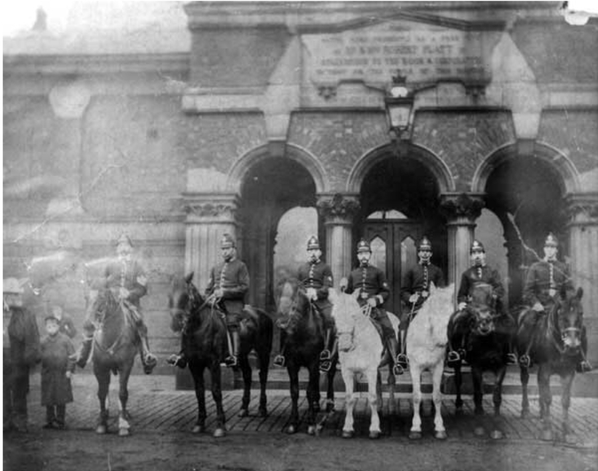

Stalybridge Borough Police outside Stalybridge Swimming Baths (1895).

[**Watch Committee Minutes and Reports 1839-1968**](http://www.gmlives.org.uk/results.html#imu[rid=ecatalogue.214883])**:** These documents in regard to Manchester are available to view at Archives+, Manchester Central Library, by personal visit only. At least one day’s notice is required to access the items. Contact the service [here](https://www.manchester.gov.uk/info/448/archives_and_local_history/7378/access_our_archives_rare_books_and_collections/2)**.** The Watch Committee was comprised of elected councillors who were responsible overall for the operation of the local police force. Their job included the appointment of the chief constable.

[**West Yorkshire, England, Police Records, 1833-1914 (Ancestry)**](https://www.ancestrylibraryedition.co.uk/search/collections/5105/)**:** These records cover the main cities and boroughs of West Yorkshire. Information listed combines appointments, physical and personal details.

[**West Midlands, England, Police Files and Ledgers, 1850-1950 (Ancestry):**](https://www.ancestrylibraryedition.co.uk/search/collections/61651/)This collection covers Birmingham and Wolverhampton, providing details of appointments, career history and personal and physical characteristics.

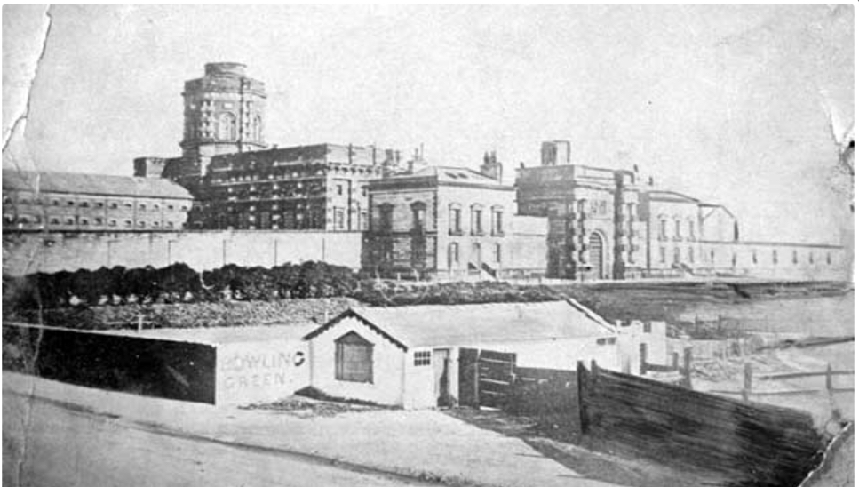

Belle Vue Prison, Hyde Road, Gorton (1860s).

**Criminal Ancestors**

*The Court System*:

**Petty Sessions**: These local courts established in the eighteenth century to deal with minor crimes, were under the jurisdiction of a magistrate. Now known as Magistrates Courts, they are organised within a local justice area, a unit created in 2003 to replace petty sessional divisions.

**Quarter Sessions**: These were local courts held four times a year with trials taking place before a justice of the peace. From 1971 the courts were incorporated into the Crown Court judiciary.

**Assizes**: These historic courts endured until 1971 when they were replaced by the Crown Court. Hearing the most serious charges with regard to civil and criminal law, there were six assize courts to serve England (and Wales from 1830).

[**Prison History**](https://www.prisonhistory.org/)**:** This site, administered by the Open University, maintains a database of nineteenth century prisons. Searches can be carried out by area or county. An e-book guide listing the available archives for particular prisons and their location can be downloaded [here](https://www.prisonhistory.org/further-resources/)**.**

[**UK, Prison Commission Records, 1770-1951 (Ancestry)**](https://www.ancestrylibraryedition.co.uk/search/collections/61810/)**:** These records are comprised from a number of different sources including prison registers, minute books, and visitors’ books. The information may include prison number, age, place of birth, occupation, previous convictions, a physical description and the names of relatives.

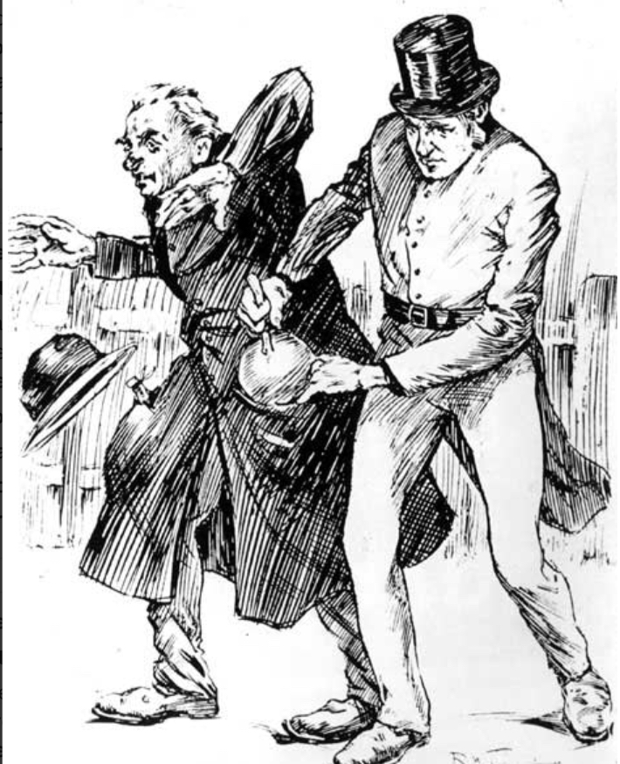

Illustration taken from ‘Reminiscences of a Chief Constable’ by William

Chadwick, Stalybridge Chief Constable (published 1900).

[**The Proceedings of the Old Bailey (Central Criminal Court)**](http://www.oldbaileyonline.org/)**:** Search the online texts for information about individuals tried at this London court. The database contains 197,000 trial proceedings of the Old Bailey held between 1694 and 1913. This resource can also be accessed on Findmypast under the [**Middlesex, London, Old Bailey Court Records 1674-1913**](https://search.findmypast.co.uk/search-world-Records/middlesex-london-old-bailey-court-records-1674-1913)**.**

[**UK, Register of Habitual Criminals and Police Gazettes, 1834-1934 (Ancestry)**](https://www.ancestry.co.uk/search/collections/61812/)**:** This database incorporates a variety of sources, including weekly newspapers, police gazettes and criminal registers. Searches can be carried out using name, occupation, sentence and prison.

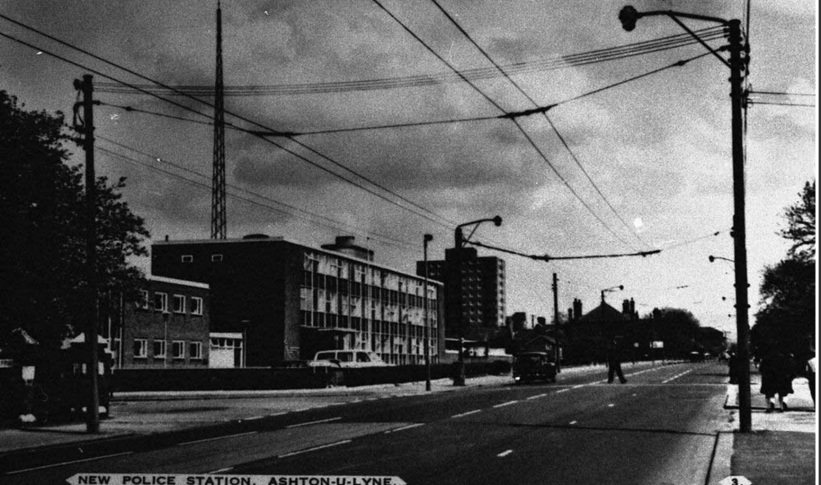Police Station, Ashton (1960s).

[**Home Office, Calendar of Prisoners, 1868-1971**](https://discovery.nationalarchives.gov.uk/details/r/C9004)**:** This register is held at the National Archives and lists prisoners tried at the Assizes and Quarter Sessions. A booking must be made in advance of a visit to access the archives. Check Findmypast and Ancestry simultaneously, as many records have been digitised. The calendars are arranged by year and alphabetically by county. Information recorded includes name, age, previous convictions and sentence.

[**UK, After-Trial Calendar of Prisoners, 1855-1931 (Ancestry)**](https://www.ancestry.com/search/collections/61809/)**:** This index catalogues prisoners tried at the Assizes and Quarter Sessions. The annual lists are arranged by county. Information held may include number, name, age, occupation, previous convictions and the name of the victim.

[**UK, Licences of Parole for Female Convicts, 1853-1871, 1883-1887 (Ancestry)**](https://www.ancestry.co.uk/search/collections/1979/)**:** This database is made up of digitised records held by the [NationalArchives](https://discovery.nationalarchives.gov.uk/details/r/C11499) and can be searched by name, date of birth, court and conviction year.

[**Irish Prison Registers 1790-1924**](https://search.findmypast.co.uk/search-world-Records/irish-prison-registers-1790-1924)**:** This database on Findmypast consists of an image and transcript from the original register for each prisoner. The information includes name, age, address, birthplace, occupation, physical characteristics, details of the crime and the conviction.

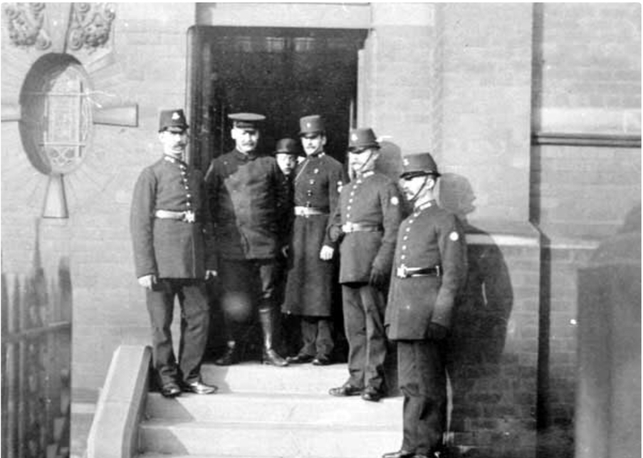Gorse Hall Murder (1909). Group photograph of police who investigated the case, standing on the steps of Dukinfield Police Station.

[**Yorkshire, England, Quarter Session Records, 1637-1914 (Ancestry)**](https://www.ancestrylibraryedition.co.uk/search/collections/6065/)**:** These records detail cases heard by the quarter sessions and are searchable by name, date and place.

[**England & Wales, Criminal Registers, 1791-1892 (Ancestry)**](https://www.ancestrylibraryedition.co.uk/search/collections/1590/)**:** This index holds lists of people charged with a crime. Information recorded may include name, age, place of birth, crime, where and when tried, sentence and date of release.

[**England and Wales, crime, prisons and punishment, 1770-1935 (Findmypast)**](https://search.findmypast.co.uk/search-world-records/england-and-wales-crime-prisons-and-punishment-1770-1935)**:** This resource preserves data derived from a variety of sources. Each record has a transcript and original image. Listed information may include name, address, birth details, age, occupation, court and sentence.

[**British Newspaper Archive**](http://www.britishnewspaperarchive.co.uk/)**:** This database contains a wide range of local and [national newspapers](https://www.britishnewspaperarchive.co.uk/), many of which published details of court trials and accounts of crimes committed. Access is through pay-per-view or subscription. Alternatively, a search can be carried out through [Findmypast](https://search.findmypast.co.uk/search/us-and-world-newspapers). Tameside Local Studies & Archives Centre holds local newspapers on microfilm from 1859.

[**Manchester Prison Registers 1847-1881 (Findmypast)**](https://search.findmypast.co.uk/search-world-Records/manchester-prison-registers-1847-1881)**:** These lists, now unfortunately incomplete, belonged to Belle Vue Prison. The surviving indexes contain name, age, physical description, occupation, last known address, crime, charge and conviction.

[**UK, Police Gazettes, 1812-1902, 1921-27 (Ancestry)**](https://www.ancestrylibraryedition.co.uk/search/collections/60861/)**:** This collection is based on the printed bulletins used by the police. Searching can be by name, date of birth, publication year and place of conviction. The gazettes can also be viewed in the [British Newspaper Archive](https://www.britishnewspaperarchive.co.uk/titles/police-gazette).

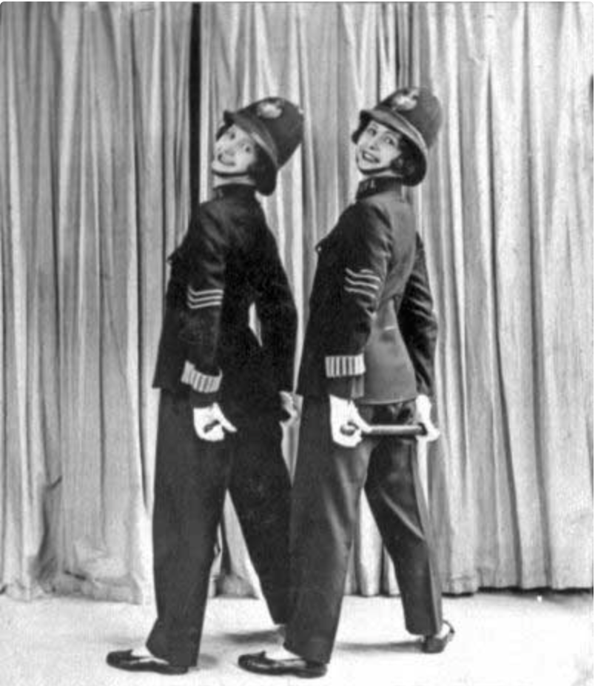

The Pickford Sisters in ‘The Police Force Revue (1920s).’

[**Hue and Cry Police Gazette Index (Findmypast)**](https://search.findmypast.co.uk/search-world-Records/hue-and-cry-police-gazette-index)**:** This register records information taken from the former English police newspaper Hue and Cry on those sentenced for transportation to Australia. Founded in 1772, this now obsolete publication printed the particulars of crimes committed in England, in addition to descriptions of offenders. The digitised gazette can also can be found in the [British Newspaper Archive](https://www.britishnewspaperarchive.co.uk/titles/police-gazette).

**Australian Convict Transportation**

[**Digital Panopticon-Tracing London Convicts in Britain and Australia, 1780-1925**](https://www.digitalpanopticon.org/)**:** This site records over 90,000 London criminals convicted and transported to Australia. Searches can be made by name and occupation. Material from a number of databases is collated here to enable the researcher to find out more about the historical crimes and prosecutions of those forcibly dispatched.

[**Australian Convict Transportation Registers – Other Fleets and Ships, 1791-1868 (Ancestry)**](https://www.ancestry.co.uk/search/collections/1180/): This index encompasses the name of the convict, date and place of conviction, sentence, name of ship and the colony to which the prisoner was sent. Other transportation records covering the [First Fleet](https://www.ancestry.co.uk/search/collections/1177/) of ships (1787-1788), the [Second Fleet](https://www.ancestry.co.uk/search/collections/1178/) (1789-1790) and the [Third Fleet](https://www.ancestry.co.uk/search/collections/1179/) (1791) are also available on Ancestry. The convict transportation registers can also be viewed on Findmypast [here](https://www.findmypast.co.uk/articles/world-records/full-list-of-australia-and-new-zealand-records/travel-and-migration/convict-transportation-registers-1787-1870).

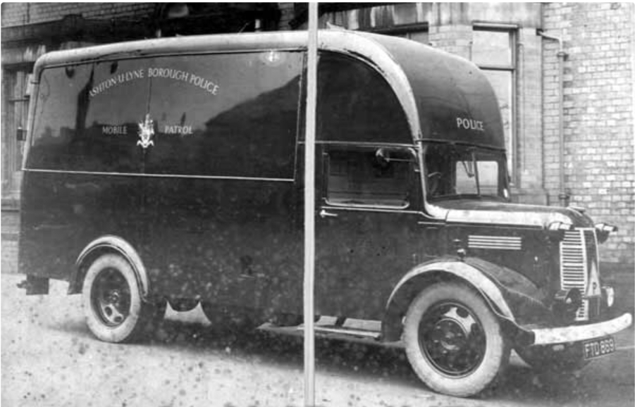

Ashton Borough Police, Mobile Police Patrol Van.

[**New South Wales and Tasmania, Australia Convict Musters, 1806-1849**](https://www.ancestry.co.uk/search/collections/1185/): This database records the numbers of convicts and ex-convicts in the colony. Musters were held periodically to calculate this population by order of the lieutenant governor. See the full list of archives regarding convict transportation on [Findmypast](https://www.findmypast.com/articles/world-records/full-list-of-australia-and-new-zealand-records) and [Ancestry](https://www.ancestry.co.uk/search/places/australia/).

[Convict Records of Australia](https://convictrecords.com.au/): This Australian database maintains a list of transported convicts ranging from 1787-1867. It can be searched by name, aliases, ship names and year.

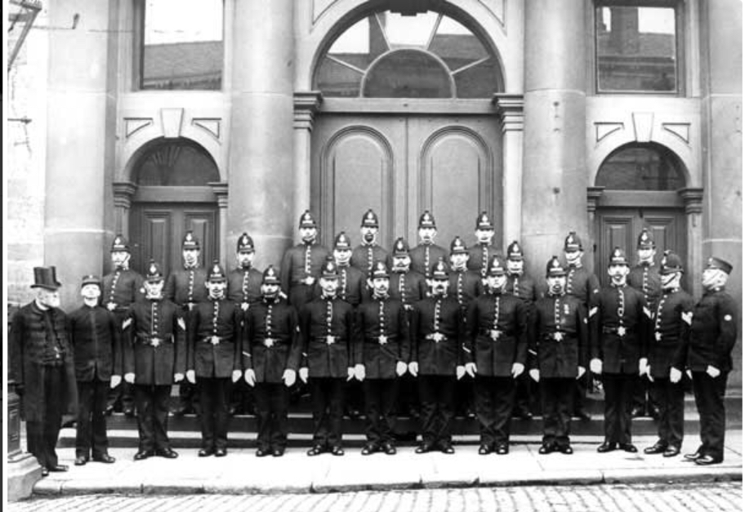

Stalybridge Police Force (c.1900) outside the Town Hall.

**Next Steps**

**1.** Visit the [Police History Society](https://www.policehistorysociety.com/) formed in 1985. The group aims to connect people interested in researching police ancestors and the history of law enforcement. Both individual and group membership is available.

**2.** Consult the [English Crime and Execution Broadsides](https://library.harvard.edu/collections/english-crime-and-execution-broadsides), an extensive collection of criminal bulletins from the 18th and 19th centuries offering a window into attitudes towards those who committed offences and the relationship between criminality and the media.

**3.** Explore the [National Library of Australia: Convict Love Tokens](https://www.nma.gov.au/explore/collection/highlights/convict-love-tokens) online collection for a fascinating and poignant overview of convict love tokens dating from 1762-1856. These were usually engraved for the offender’s family, wife and/or girlfriend and included the name of the convict, length of sentence and a popular phrase of the period.

**4.** Why not investigate the [University of Hull- Our Criminal Ancestors](https://ourcriminalancestors.org/source-guide-for-hull-and-east-riding-sources-for-researching-your-criminal-past/), University of Hull’s public engagement study ‘Our Criminal Ancestors?’ Numerous source guides are available for those researching the history of police forces and exploring archival material relating to criminal records.

**Further Reading**

Emsley, C. (2011) *Crime and Society in Twentieth Century England*. Harlow, Pearson Education.

Godfrey, Barry (2018) *Criminal Women*. Barnsley, Pen & Sword.

Wade S. (2009) *Tracing Your Criminal Ancestors*. Barnsley, Pen & Sword.

**02/21**

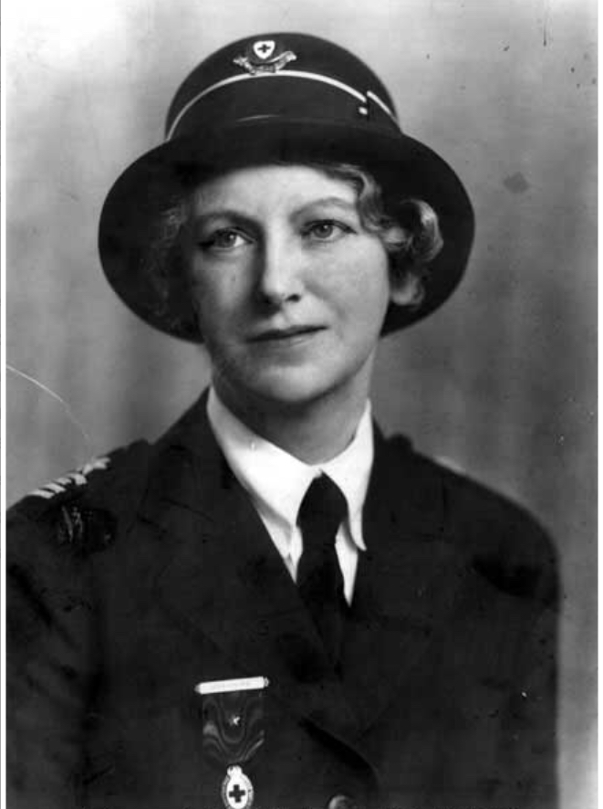

Miss Mary Dorothy Ralphs, JP and Magistrate, 1887-1964.