**The Periscope**

**Being the official organ of a Reserve Battalion Manchester Battalion**

MR1/20/7

**Vol II- No. 1 October 1917 Price 2D**

Its object is to cater for all ranks, and unless the critics are prepared to ventilate their grievances and place their contributions in the editors’ box it is to be hoped that they will give that support to the magazine which represents their views and which has undoubtedly provided some pleasure to the hundreds of men who have served among us.

I shall never forget the enthusiasm at the first meeting of the Committee held on the border of Wales, and I am confident that if our first editor was amongst us here he would be more than delighted with the success achieved despite the many disadvantages the Committee have had to encounter. We are making headway, and my only hope is that when the piping times of peace arrive the *Periscope* will continue to make its monthly appearance.

Again wishing the venture every success

I remain yours faithfully

Sgt. B Robinson

Editor’s Notes

The great march and fight made by our comrades of our second line at the Battle of Poelcapelle, will live for ever in the history of the Great War. I think I may speak not only for our own battalion, but for the whole of our Reserve Brigade, when I say that: when we read of their deeds, the news made us flush with pride and the blood course faster through our veins, for they are men of our own Battalions and Territorials like ourselves. The grit and determination that they showed are worthy of the best traditions of the British Army, and the history of our Army is full of glorious deeds. I know that Manchester and the surrounding towns to which they belong have felt great pride in their achievement. An account of the part they played appears elsewhere in this number. Our first line won their laurels in Gallipoli, our second line have won theirs in France. Most of us have been on active service with one of the other, or soon will be. We are very proud to belong to the East Lancashire Division.

The Pride of Lancashire

Praise for the Territorials

The part played by the Lancashire Territorials in the present war will live long in history. Their conduct has been such to earn admiration from all quarters, and it is gratifying to find that the public press has given publicity to the deeds of heroism, for which the Territorials have been responsible. In the early days of the war these men, often described as Saturday night soldiers, were the first to offer their services to the country, and their worth was indeed put to the test during the Gallipoli campaign. They have performed and are continuing to perform excellent work in Flanders, and their record in the Battle of Poelcappelle will prove of great interest to the people of Lancashire when full details are known. The Lord Mayor of Manchester (Alderman Smethurst) forwarded the following telegram to Sir Douglas Haig upon the receipt of the despatch regarding the great advance in Flanders:-

“ Manchester and the whole of East Lancashire have read with much pride and satisfaction the magnificent achievements of Lancashire Territorials: comprising Manchesters, East Lancashires, and

Lancashire Fusiliers, and send grateful thanks and hearty congratulations to you, them, and all our gallant forces for brilliant and successful operations”

Writing from France Mr. W. Beach Thomas, the “Daily Mail” war correspondent, stated.-

“The battle of Poelcapelle will always be famous for the personal and particular grit and determination of the Lancashire troops forming the second line Territorial Division, mentioned in last night’s *communique*. The troops of a neighbour county did as well, fought as hard, and won as full a success but were saved some of the preliminary hardships which a party of Lancashire and Manchester men endured.

They set off on a good stiff march, with plenty of time, as was reckoned, to arrange matters for the coming charge and to rest and eat on the way. Nothing indicated the super-human trial that they were to endure. An occasional high-velocity shell rattled the fallen rafters and dust of a murdered village they traversed and a little shrapnel from the anti-aircraft guns clattered on the road. Our guns were firing spasmodically, but not in great volume. Rain was falling, but the road was not bad going. They marched in steel helmets, gasbags on the alert, and they whistled and sang scraps of song. The prospect of their first big fight stirred all the ranks to excitement and they threaded the press and tumult of war.

Day fell when they crossed the Yser Canal and darkness fell almost tropically. They now marched over a country absolutely formless and featureless. Miles of it stretched in front of them. The only light was the reflection of the gun flashes from the clouds and the perpetual alarm lights from the distant German lines. Their march from this point was a nightmare: half a mile an hour was almost a gallop, for the night was pitch-dark, lights could not be shown, and the country, already battered into shapelessness, was slimy with the day’s rain and deep with the rain of days caught in the blue, sticky clay of the saucer ridge that enclosed Ypres.

Men fell into foul shell-holes and were pulled out by their friends. They stumbled and caught their feet in the infinite tangles of this sinister country. No man could even guess how near he was coming to the place of assembly. It was impossible to get food and drink, and so slow was the progress that there was no time to rest if they were not to be late for the battle.

So, for hours without food of any sort, they stumbled on and on to their mysterious destination. In all they marched eleven hours, often afraid that they might be too late, sometimes missing their right line for a while, but always stumbling on as quick and steady as might be.

They were in time, and in spite of exhaustion went over with the rest and fought a great battle, winning their first objectives and holding the line against counter-attacks. Tis was on the right centre and the higher ground. The troops north of them had somewhat similar experiences and in the battle itself much worse conditions to face. The whole valley of the Leiter Botebeek, a little burn running down from the ridge we are attacking, was quite impassable over a great width…

The picture of the fighting here baffles all imagination and description. Our men spent half their time in pulling one another out of quagmires. German snipers were scattered about in shell-hole promiscuously, and a good number were on platforms in trees, from where they kept up scattered but well-directed fire on the inhabitants of the shell-holes. They sent up continuously a new sort of magnesium light of extreme brilliance which illuminated No-Man’s Land so that the slightest movement could be detected.

Mr Philip Gibbs, the correspondent of the “Daily Chronicle,” wrote as follows:- The brunt of the fighting fell yesterday in the centre upon the troops of North-country, England, the hard, tough men of Lancashire and Yorkshire, and it was Lancashire’s day yesterday especially, because of those second line Territorial Battalions of Manchesters and East Lancashires and Lancashire Fusiliers, with other Lancashire comrades. There were some amongst them who went over the bags, as they call it, for the first time, and who fought in one of the hardest battles that has ever been faced by British troops with most stubborn and gallant hearts, as I know by hearing from their own lips, to-day and yesterday, the narrative of the sufferings they endured, of the fight they made, and of the wounds they bear without a moan. The night march of some of these men who went up to attack at dawn seems to me, who have written many records of brave acts during three years of war is one of the most heroic episodes in all this time. It was a march which in fine, dry weather would have been done easily enough in less than three hours by men so good as these. But it took eleven hours for these Lancashire men to get up to their support line, and then, worn out by fatigue that was a physical pain, wet to the skin, cold as death, hungry, and all clotted about with mud, they lay in the water of shell holes for a little while until their officers said “Our turn, boys,” and they went forward through heavy fire and over the same kind of ground, and fought the enemy with his machine guns and beat him- until they lay outside their last objective and kept off counter attacks by a few machine guns that still remained unclogged and rifles that somehow they had kept dry. Nothing better than that has been done, and Lancashire should thrill to the tale of it, because their sons were its heroes. Dirty, bloodstained, scarecrow heroes as I met some of them to-day, slightly wounded but hardly able to walk after the long trail back from the line. It was eleven hours’ walking, on the way up, and then after the wild day and half a night under shell fire and machine gun fire eleven hours down again, in shell-holes, and out of them, falling every few yards, crawling on hands and knees through slimy trenches, staggering up by the help of a comrade’s arm and going on again with set jaws, and the cry of ‘No surrender’ in their soul.”

**Vol.II – No. 3 December 1917 Price Threepence**

People We Know- No. 15

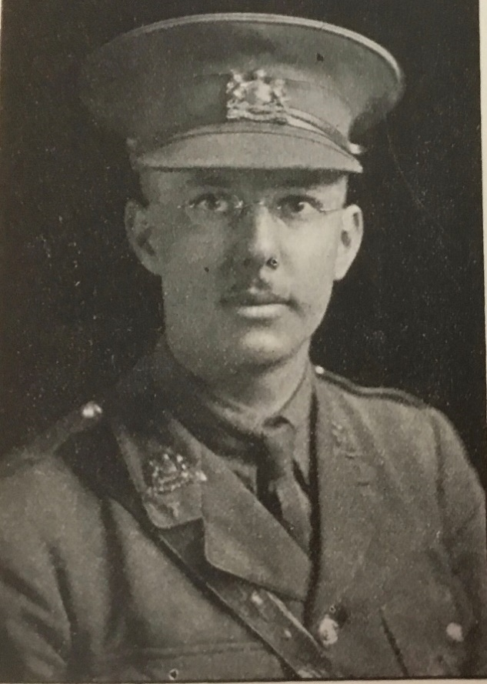

As I sit down to write a foreword for the Xmas number of the *Periscope* I am overwhelmed by the honour of being included in the *Periscope* gallery, and feel it very difficult to express what I want to say.

First, let me wish good success to all who read the *Periscope*, whether they spend their Xmas at home, or out in France. Those of us here with the Battalion send our best wishes to all the boys who have gone out on draft during the past year, and hope that the *Periscope* will reach them wherever they are and remind them we are all thinking of them…

Next I would wish good success to our magazine which has weathered now so many storms, and is still flourishing despite shortage of paper and other problems…

Last, I will wish Good Luck to ourselves. A Happy Xmas and successful New Year to the Battalion…

CAPTAIN C.S.HIGHAM

**Sergeants’ Mems**

The Entertainment Committee is to be congratulated on its recent enterprise. During the last few weeks a number of interesting social events have taken place at the Mess and I think everyone will agree that the venture has been a pronounced success. As was to be expected, there were a few critics, but after a start had been made it was satisfactory to find they were giving the Entertainment Committee all the support possible. The weekly social evening is now regarded as part and parcel of the Mess, and it is to be hoped that whilst we remain here nothing will mar its progress. This weekly festival is one which is eagerly looked forward to both by young and old, and it is the means of increasing that *esprit de corps* which is so essential to the success of the Mess. The Dining Hall is admirably suited for the purpose, and when everything is in full swing the scene is both pleasant and gratifying to the promoters.

The programmes have been such that no one could complain. The Mess possesses a number of talented vocalists and musicians, and they have given their services willingly whenever called upon. The humorous element is also prominent. Sergeant J Moores, the familiar “Jimmy,” undoubtedly heads the list in this respect. His varied repertoire is sure to please, and there is no place where his services are more appreciated than in the Mess. His song describing his career in “The Army” is one which is full of amusement and I should think that by this time his hat has been responsible for the collecting of many coppers to prevent him from “following the wide path of –folly.” Keep smiling, Jimmy, and there can be no complaints.

I think the Mess can congratulate itself on its devotees of the dancing surface. Is it not true that there are one or two prize winners for waltzing. Colour-Sergeant Instructor Galvin is proving a capable M.C. and is always willing to give a helping hand to the so-called amateur. It is satisfactory to note there has been an increase of visitors to the weekly social evenings, and this is ample evidence that these events are proving popular with the people of F-----Y. We have had some excellent pianists, and on numerous occasions we have had the pleasure of an orchestra. In this respect mention ought to be made of the assistance given by Bandmaster Wild and R.Q.M. Sergeant Wilkinson. The latter, an enthusiastic musician, has been the means of introducing music at the dinner table on a Sunday, and this venture has undoubtedly been a success.

The Mess has been made as attractive as possible, and anyone desirous of offering any suggestion with a view to improvement are asked to ventilate their views at any time. A novelty has been introduced of late by two prominent Quarter-Master Sergeants who have I hear been rather successful in “running” a new game. It would be unfair to publish full details of this latest addition to the attractions afforded. Suffice it to say that the writer is of the opinion that the promoters at any rate received rather bad shock at the “opening ceremony” by so many members of the Mess proving themselves to be experts at the game.

In conclusion I desire to take this opportunity to wish all members of the Mess a hearty Xmas and the best of luck in the coming year.

A NEWCOMER

Vol. II- No. 4 January 1918 Price Twopence

CORPORAL BROADHURST – MILITARY MEDAL

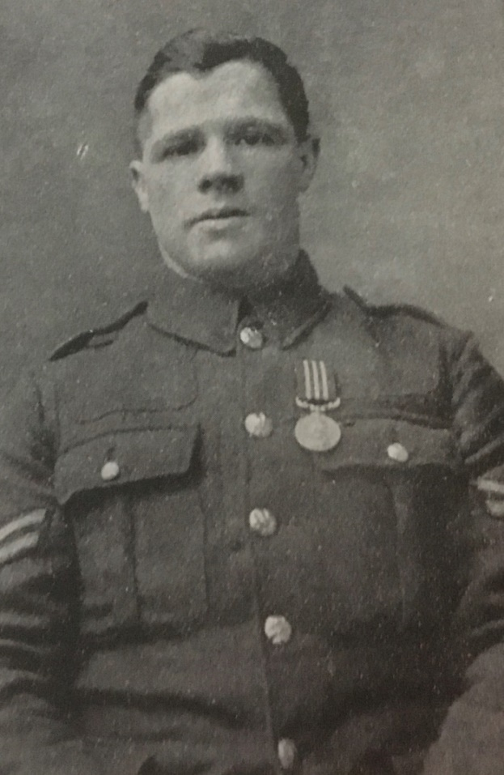

On Sunday 23rd December, before a parade of both battalions here, the Brigadier-General presented the Military Medal to Corporal Broadhurst and to a N.C.O. of our neighbouring Battalion.

In addressing the parade after the medals had been presented, the General explained how the decorations had been won, and said that while there were doubtless many deeds of gallantry and valour that necessarily went unnoticed and unrewarded, he was sure that these decorations had been well earned and he congratulated the recipients. He then called for three cheers for the King.

Corporal Broadhurst won the Military Medal for assisting Lieutenant Forshaw V.C. in holding the North West corner of the Vineyard in Gallipoli, on August 7th- 8th 1915 when they repulsed continuous Turkish attacks, by bombing for over 24 hours. We congratulate Corporal Broadhurst on receiving his Medal at last.

PRESS OPINIONS

The Christmas edition of the *Periscope* was well received by the press judging by their comments and the following extracts are published for the information of our readers.

“The Manchester Regiment” is justly proud of the *Periscope* and the Xmas number, a bumper one, full of bright reading matter and capitally illustrated, reflects great credit on the joint editors”- “*Manchester Evening Chronicle*”.

“ There are any number of bright articles, really witty jokes and smart topical illustrations that go to make the *Periscope* (official organ of a reserve battalion Manchester Regiment), stationed we believe, not a hundred miles from F-----Y and district) the popular magazine it is. It caters for tastes both serious and gay, with sporting chat, open letters, and a dozen other features that will appeal alike to soldiers and civilians, but more especially, of course, to soldiers. There is many a sly dig, and much good-natured chaff at the expense of well-known figures and the “Kanteen Kweries,”are priceless to those in the know. Altogether, in military parlance, it is “the stuff to give them” which speaks for itself.”- Scarborough *Daily Post*

Revolver Competition

On 15th December a team of three officers of this Battalion were successful in winning the revolver competition held at Headquarters: they scored 170 points as against 105 points scored by the next team. The individual scores were Lieutenant Bond (1st), 63: Lieutenant Seal (2nd), 56: Captain Sampson (4th), 51. The competition consisted of a grouping practice, a snapshooting and a odhand continuous firing practice. The secret of the team’s success, was the rapidity of their loading, and the smart way in which they handled their weapons, and this was largely due to the excellent training they had received under Captain Gill at the Revolver Range here. We hope that if any of them have to use their revolver against a Boche the result will be a possible.

The Brigadier- General has presented to the Officers’ Mess a water colour drawing of local scenery, painted by himself as a souvenir of this competition.