Tameside Discretionary Grant Fund
The 3rd round of the Tameside Discretionary Grant Fund is open.
More businesses can now apply for the discretionary small business grants
This is the final round of the grant, the deadline is Thursday 13th August for applications.
The fund is aimed at supporting micro and small businesses with high fixed property costs who have suffered a loss of income due to COVID-19 and who are unable to access other government funding schemes.
Round 3 Eligibility:
· Businesses from any sector with a rateable value of £15-51k
· Businesses awaiting Valuation Office assessment that subsequently were not eligible for a Small Business Grant or Retail Hospitality & Leisure Grant
· Registered charities not supported under the government set priority criteria
· Small businesses in shared offices or other flexible workspaces. Examples could include mills, units in industrial parks, science parks and incubators which do not have their own business rates assessment; exclusions include businesses operating from domestic settings (including Airbnb operators) or those that do not have fixed, property related costs
· Regular market traders with fixed building costs, such as rent, who do not have their own business rates assessment
· Bed & breakfasts which pay council tax instead of business rates; and
· Charity properties in receipt of charitable business rates relief which would otherwise have been eligible for Small Business Rates Relief or Rural Rate Relief.
Businesses in domestic settings are not eligible unless they are Bed & Breakfasts which pay council tax instead of business rates.
It is important that any business considering an application checks their eligibility and reviews the Tameside guidance before applying.
There is limited, fixed funding remaining to the council from the government for this scheme and we aim to support as many businesses as possible with mainly grant allocations of up to £10,000 (grants of £25,000 will be made only in exceptional circumstances).
With a deadline for applications 5pm on Thursday 13th August, and the need to provide robust evidence to support each application, we encourage all eligible businesses to apply as soon as possible to help ensure there are no delays in processing and awards.
If the fund is under/oversubscribed with the applications received, the council reserves the right to amend the grant levels to a pro-rata basis, based on the applications received and approved, as a way of dealing with this situation, should it arise. The council reserves the right to vary the terms of the scheme at any time, and without notice, should it be necessary to do so.
Timeline
- Applications open – 4pm Tuesday 28 July.
- Applications close – 5pm Thursday 13 August
- Payment of grants –19 August onwards
Applications for the grant can be made online or if you are unable to apply online please email tamesidegrant@tameside.gov.uk to request a printed copy.

Supporting the fight against COVID-19
Please follow the new restrictions to help prevent a local lockdown. It’s important, now more than ever, that we continue with our efforts to protect each other.
It’s simple and it works, here’s what you can do to help:
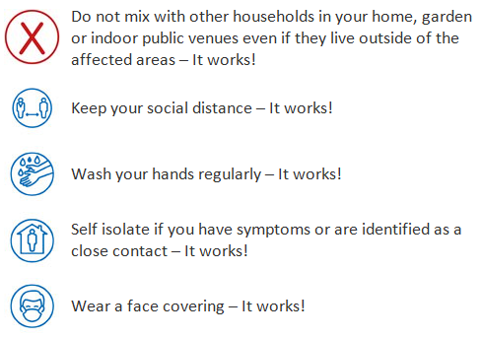
We’re in this together and can overcome this together.

Test and Trace in Tameside

Got symptoms? Get tested
To control Coronavirus, testing and tracing must become a new way of life. If you have any of the following symptoms, no matter how mild, you need to self-isolate and get a test immediately so that it’s within 5 days of being symptomatic;
- a high temperature
- a new, continuous cough
- a loss of or a change in your normal sense of smell or taste
To book a test or order a home testing kit visit:
www.nhs.uk/coronavirus or call 119
There are a number of testing sites in Greater Manchester for you to book an appointment at, but we are making more and more local testing sites available here in Tameside for easier access. You can find out dates and venues on our facebook and twitter pages. It’s simple, safe, confidential and will protect everyone.
If you test positive, NHS Test and Tracing will contact you to trace people you have been in close contact with.
The self-isolation period has been extended to 10 days for those in the community who have coronavirus (COVID-19) symptoms or a positive test result.
If you’re told you have been in close contact with a person who has tested positive for COVID-19, please self-isolate for 14 days even if you aren’t showing any symptoms.
Please play your part so we can safely return to a more normal way of life.

