Tameside Business Resilience Clinic
Tameside's Business Resilience Clinic has recruited two new champions, expanding the help and support we can offer to local businesses. The scheme introduces Tameside companies to local business leaders and experts who are giving peer to peer advice and support free of charge on a range of business topics. Local companies have so far received help with applying for loans, renegotiating finance, HR issues, social media marketing strategies and using Instagram. To find out more and to register for support, visit here.
Small Business Recovery Grants - DEADLINE 5pm TODAY (9 September).
The GM Business Growth Hub is in the process of applying for funds from the government to offer grants to help small and medium businesses to recover from COVID-19. Businesses are expected to be able to access £1,000 to £3,000 of grant to help fund professional advice such as accountancy or HR support, or investment in new equipment. To register interest in the grant visit here.
GM Creative Scale Up programme - final round.
The final round of the Greater Manchester Creative Scale Up programme is now open for applications. The fully funded scheme provides a business support package tailored specifically for the creative sector, including mentoring opportunities, one 2 one support, training and workshops. It helps organisations plan for the future, develop a strategy for recovery and growth as well as providing the tools needed to scale up, access investment and grow post COVID-19.
For further details, and to apply to the scheme, click here.

Support for jobs – Kickstart
The Kickstart scheme, which was announced as part of the Government's Plan for Jobs in response to COVID-19, is now open for applications. Businesses can use the Kickstart Scheme to create new six-month job placements for young people aged 16-24 who are currently on Universal Credit. The job placements should support the participants to develop the experience they need to find work after completing the scheme and to gain employability skills.
Funding is available for 100% of the relevant National Minimum Wage for 25 hours a week, plus associated employer National Insurance contributions and employer minimum automatic enrolment contributions. This is reimbursed at months 2, 4 and 6 of the employment period. There is also £1,500 per job placement available for setup costs, support and employability skills training.
The roles:
- must be a minimum of 25 hours per week, for 6 months.
- must be paid at least the National Minimum Wage for their age group.
- should not require people to undertake extensive training before they begin the job placement
Applications for the scheme can be directly (for 30 roles or more) or via a representative organisation (who will support multiple employers to collate 30 opportunities and then submit the bid to DWP). The representative will receive the financial reimbursements and then pass this onto the employer, and will also receive an additional £300 per job role.
Tameside Council will be working with local employers and business support organisations to ensure that all our businesses who want to create an opportunity for a local young person will be supported to do so, and to help ensure that the young people taking part gain additional skills. If you would like to discuss this please contact us via employmentandskills@tameside.gov.uk or call 0161 342 3111.

Redundancy Support
As the COVID-19 pandemic continues to disrupt the world economy, and national and local lock-downs impact on businesses and workers across the country, it is a sad fact that an increasing number of companies will be faced with a decision about making staff redundant.
Whilst this decision is hopefully the last resort for employers, it is inevitable that in some cases making redundancies will be an unavoidable step. To support our local businesses and residents with this difficult process, Tameside Council have created a web page that pulls together the broad range of support offers available to help businesses and their employees before, during and after the redundancy process. Support available includes training, advice, help with job search and maintaining health and well-being.
To view the support package click here.
If you are a business owner or manager who is considering making redundancies, or is currently going through the process of making staff redundant, Tameside Council is offering to work with you to put together a coordinated support plan from the funded options available. To request a discussion about the support we can offer please contact Employmentandskills@tameside.gov.uk.

Job Retention Scheme

In September the level of government contribution to furloughed worker's pay through the Job Retention Scheme has changed.
For September, the government will pay 70% of wages up to a cap of £2,187.50 for the hours the employee is on furlough. Employers will pay ER NICs and pension contributions and top up employees’ wages to ensure they receive 80% of their wages up to a cap of £2,500, for time they are furloughed.
The level of government contribution will decrease again in next, with the scheme coming to an end on October 31.
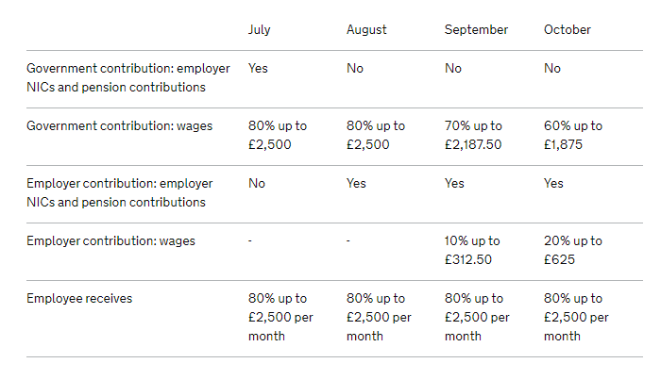
Self-Employment Support Package

The second phase of applications for the Self Employment Income Support Scheme is now open.
Over 2.7 million benefited from the first stage of the SEISS - with the government handing out £7.8 billion of grants to help them through the crisis.
Those eligible will now be able to receive a second and final grant worth 70% of their average monthly trading profits, with the money set to land in their bank accounts within six working days of making a claim.
To check eligibility and apply for the grant click here.
The deadline for applications is 19 October 2020.

Test and Trace in Tameside

Mobile testing centres in Tameside
If you have symptoms of coronavirus – a high temperature, a new, continuous cough or a loss of or a change in your normal sense of smell or taste - please stay at home for 10 days and only leave home to get tested. It’s nothing to be nervous about and the friendly staff will help you through the process - it’s simple, safe, confidential and will protect everyone. Please book a test at www.nhs.uk/coronavirus.
The mobile testing units have now been confirmed for September with extend numbers of dates and appointment times.
Thurs 10 | Curzon Ashton | 1pm - 6pm
Fri 18 | Beeley Street, Hyde | 10.30am - 3.30pm
Sat 19 | Beeley Street, Hyde | 10.30am - 3.30pm
Sun 20 | Beeley Street, Hyde | 10.30am - 3.30pm
Mon 28 | Curzon Ashton | 1pm - 6pm
Tues 29 | Curzon Ashton | 1pm - 6pm
Weds 30 | Curzon Ashton | 1pm - 6pm
Thur 1 Oct | Curzon Ashton | 1pm - 6pm

